**University Practical Exam-2020**

**SRM Institute of Science & Engineering- Kattankulathur Campus School of Computing B.Tech- 3rd Year**

**Date:-01/12/2020**

***FTP***

Jack needs a file to be read from Jane’s system located in different network. Help Jack to access the file from Jane’s local area network. Also enable Jack to update the accessed file and store the updated file in his system memory.

**AIM:** Our aim is to execute the FTP program for client and server using Jupiter notebook

**PROCEDURE :**

* **Open jupyter notebook**
* **Write the server code in python**
* **Write the client code in python**
* **Make a FTPtext.txt file**
* **Upload that .txt file in JupiterNotebook**
* **And the first run the server code**
* **And then run the client code**

1. The server starts and waits for filename.

2. The client sends a filename.

3. The server receives filename. If file is present, server starts reading file and continues to send a buffer filled with

file contents encrypted until file-end is reached.

4. End is marked by EOF.

5. File is received as buffers until EOF is

Received. Then it is decrypted.

6. If Not present, a file not found is sent.

**Server code:**

**import socket**

**importos**

**port = 4444**

**s = socket.socket()**

**host = '127.0.0.1'**

**s.bind((host, port))**

**s.listen(5)**

**print("Server is up")**

**conn, addr = s.accept()**

**print("Connection established")**

**filename = 'FTPtest.txt'**

**print("File to send: {}".format(filename))**

**f = open(filename, 'rb')**

**l = f.read()**

**conn.send(l)**

**f.close()**

**print('File Sent Successfully')**

**conn.close()**

**s.close()**

**Client code:**

**import socket**

**importos**

**s = socket.socket()**

**host = '127.0.0.1'**

**port = 4444**

**s.connect((host, port))**

**print("Client is up")**

**filename = 'FTP_recv.txt'**

**print("File being recieved...")**

**with open(filename, 'wb') as f:**

**while True:**

**data = s.recv(1024)**

**f.write(data)**

**print(data.decode())**

**if not data:**

**break**

**f.close()**

**print('Successfully received the file\n')**

**s.close()**

**Result/Output:**

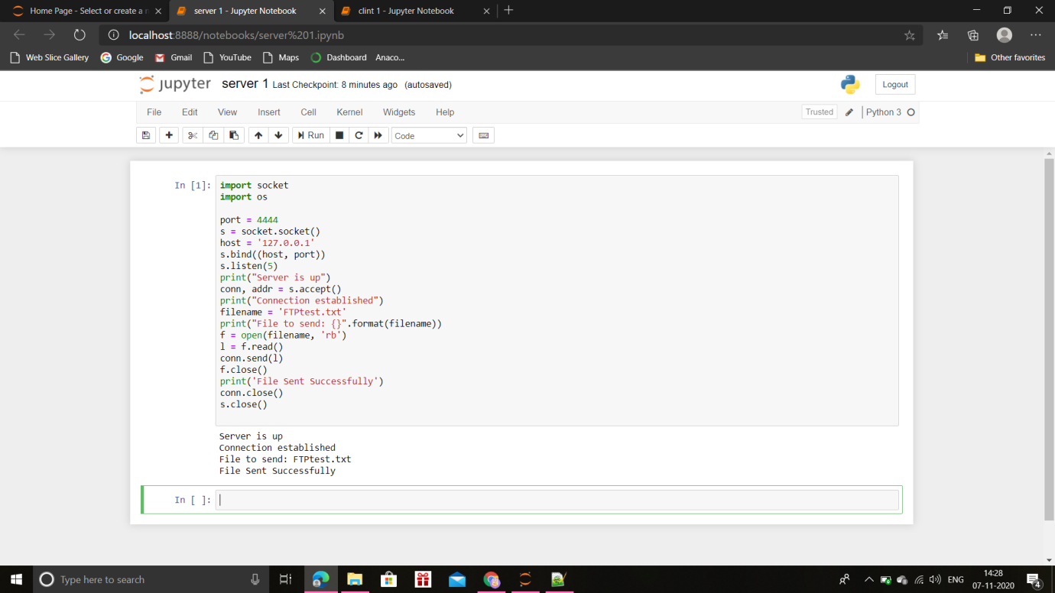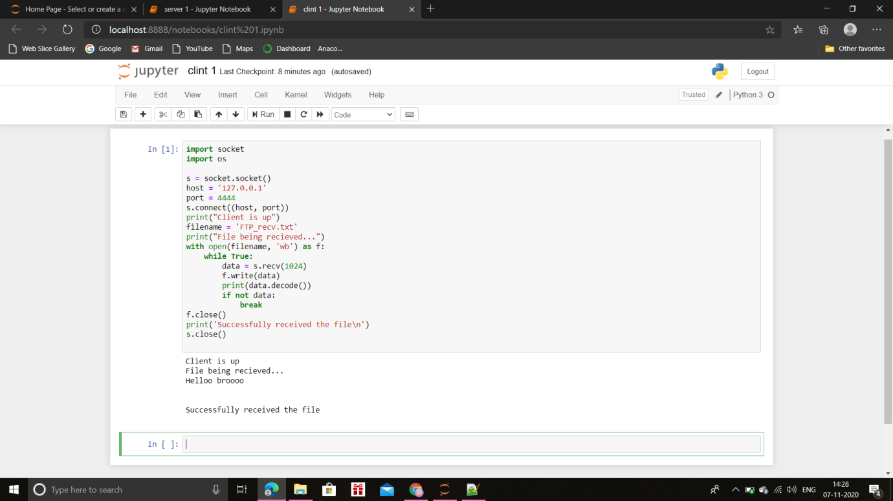

**Name : Krishna Narayan Singh**

**Reg : RA1811003010921**

**Cse G2**