**UNIVERSITY PRACTICAL EXAMS 2020**

***AIM:*Configure a network for a start-up company, protecting the data and ensuring the claimed identity using the relevant protocols.**

***PROCEDURE:***

* **Use the connected laptops to find the DCE and DTE routers. You can connect to the routers using CLI.**
* **Configure the routers with the following parameters :**

**- Clock : 250000**

**- PPP link between the routers**

**- DCE router IP : 192.168.10.5/30**

**- DTE router IP : 192.168.10.6/30**

* **Check IP connectivity between the two routers using the ping command.**
* **In the CLI, write show interface se 2/0 to get the desired connectivity.**

***PACKET TRACER DIAGRAM FOR PPP:***

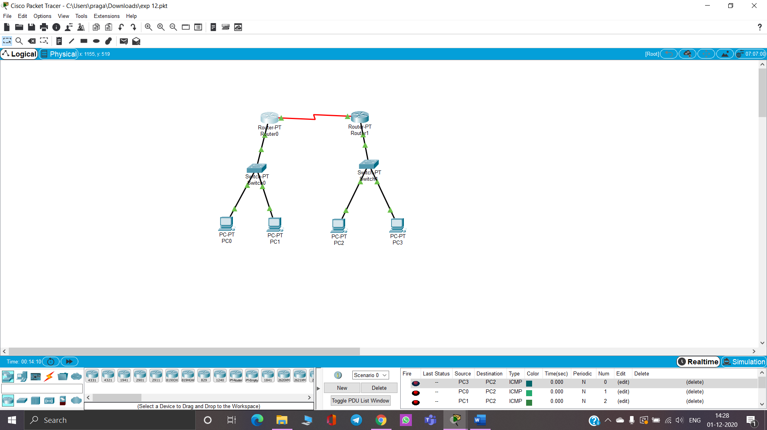

***PACKET TRACER DIAGRAM FOR HDLC:***

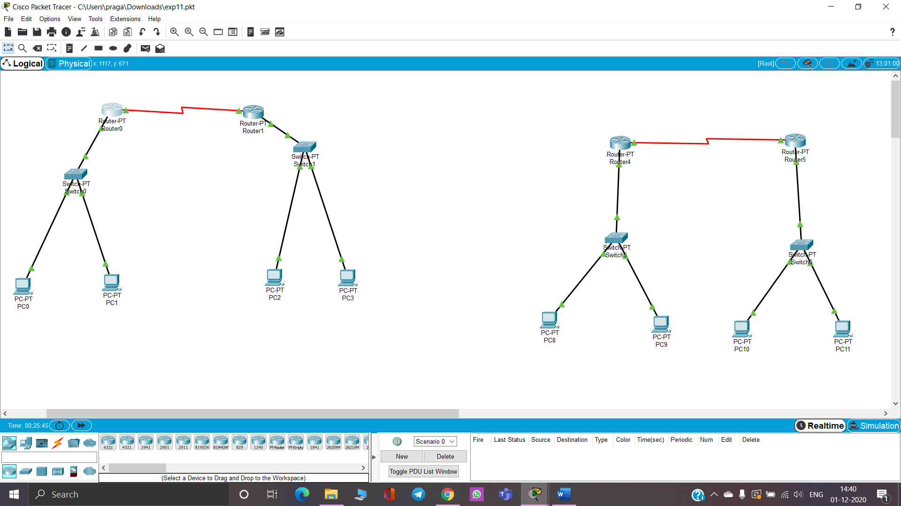

***CLI for PPP:***

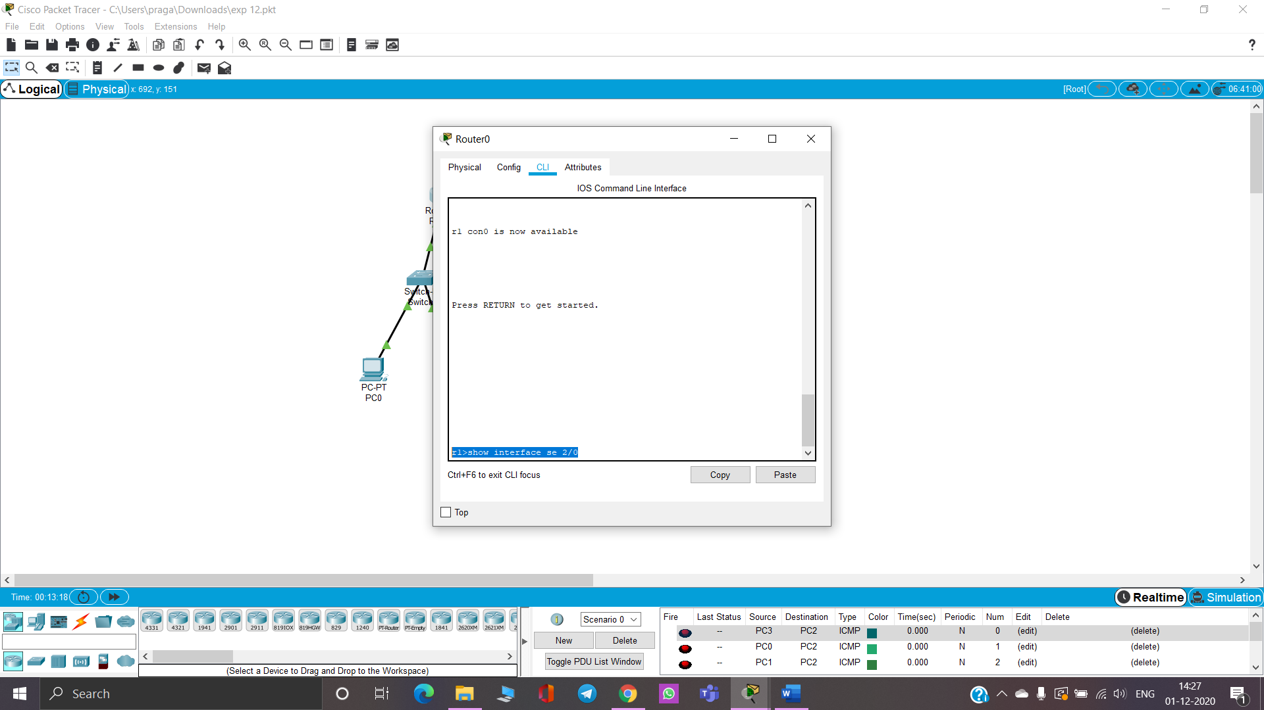

***CLI for HDLC:***

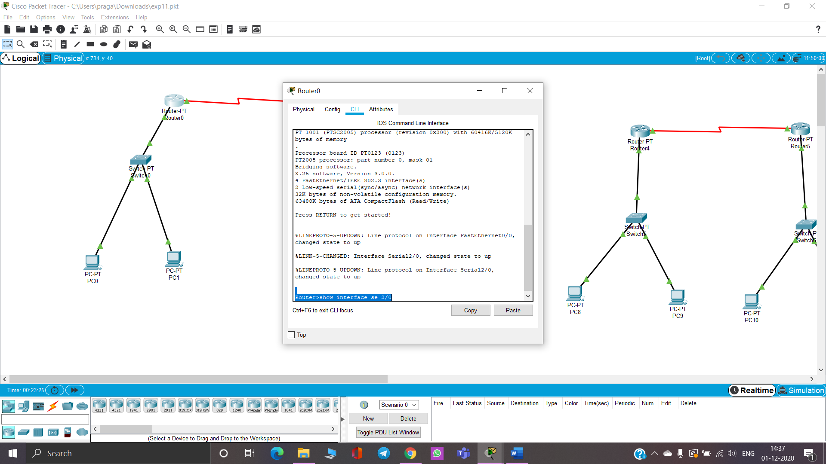

***OUTPUT for PPP:***

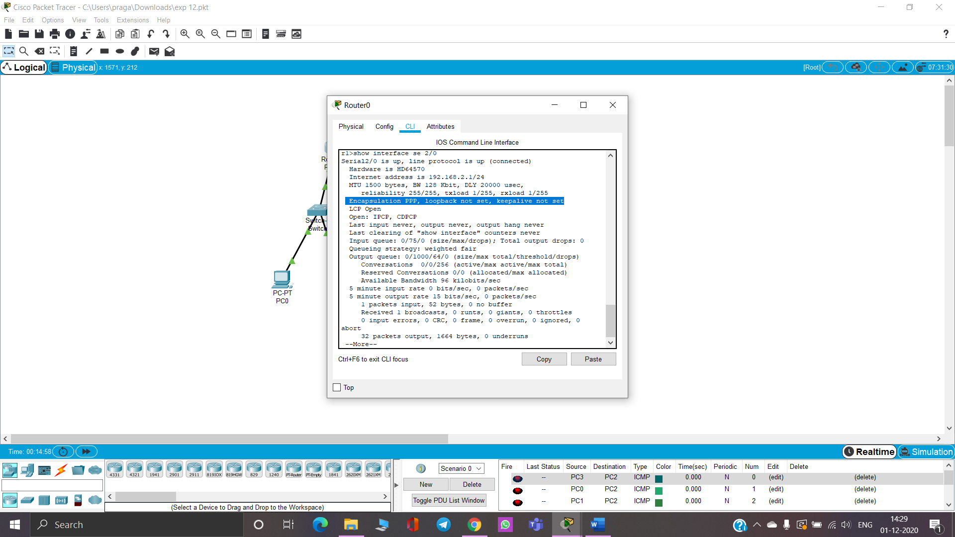

***OUTPUT for HDLC:***

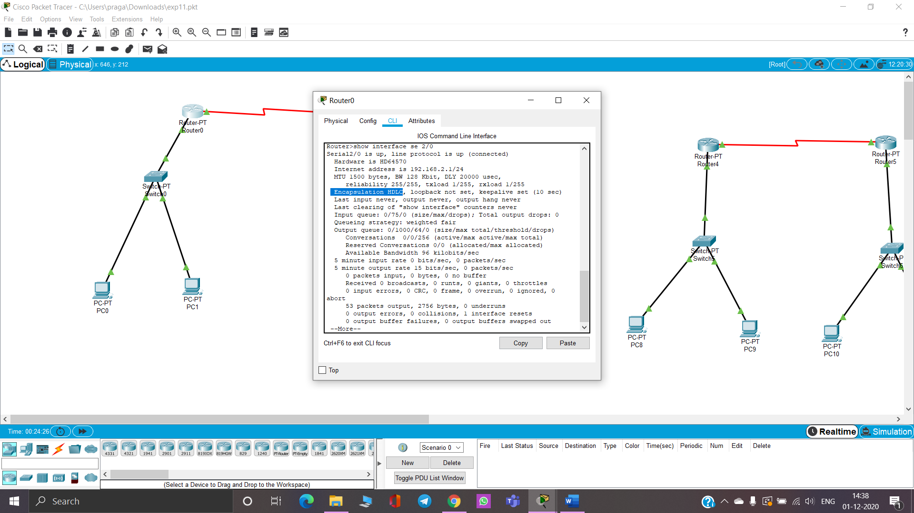

***RESULT:* The connection for PPP and HDLC for a startup company with security ensured was successfully done and the encapsulation was completed using Cisco Packet Tracer.**