**University Practical Exam-2020**

Name:-

Reg. No.:-

Section:- CSE-G2

Subject:- Computer Network

Subject code:- **18CSC302J December 1,2020**

**Configure a network for a start-up company, protecting the data and ensuring the claimed identity using the relevant protocols**.

To configure a network in which the data can be protected we should use PPP configuration to configure a network.

**PPP Configuration**

**Aim:**

To configure a network using PPP encapsulation on serial links for a startup company.

**Description:**

**Point-to-Point:**

Point-to-Point Protocol (PPP) is a [Data link](https://en.wikipedia.org/wiki/Data_link) layer (layer 2) [communications protocol](https://en.wikipedia.org/wiki/Communications_protocol) between two routers directly without any host or any other networking in between. It can provide connection [authentication](https://en.wikipedia.org/wiki/Authentication), transmission [encryption](https://en.wikipedia.org/wiki/Encryption), and [compression](https://en.wikipedia.org/wiki/Data_compression). PPP Authentication is the method of identifying remote device. Through authentication we can find out whether remote party is genuine or imposter.

**PROCEDURE:-**

* There are two routers (R1 and R2) communicating over a serial link.
* Use the connected laptops to find the DCE and DTE routers. You can connect to the routers using CLI.
* Configure the routers with the following parameters :

- Clock : 250000

- PPP link between the routers

- DCE router IP : 192.168.10.5/30

- DTE router IP : 192.168.10.6/30

* Check IP connectivity between the two routers using the ping command.
* Now R1 has some data for R2. But before sending this data, R1 want to be sure that remote device which is claiming itself as R2, is real R2.
* In this case R1 will initiate authentication process. In authentication process R2 will prove its identity.
* In the CLI, write show interface se 2/0 to get the desired connectivity.

**Configuration:**

**Router0:**

Router> enable

Router# configure terminal

Router(config)# interface FastEthernet0/0

Router(config-if)# ip address 11.1.1.1 255.0.0.0

Router(config-if)# exit

Router(config)# int se 0/0

Router(config-if)# ip address 50.1.1.1 255.0.0.0

Router(config-if)# exit

Router(config)# ospf 1

Router(config-router)# network 11.1.1.0 0.0.0.255 area 0

Router(config-router)# network 50.1.1.0 0.0.0.255 area 0

Router(config-router)# exit

Router(config)# exit

Router# show interface serial 0/0/0

Router# config t

Router(config)# int se 0/0

Router(config-if)# encapsulation ppp

Router(config-if)# exit

Router(config)#int se 0/0

Router(config-if)#ppp authentication pap

Router(config-if)#

%LINEPROTO-5-UPDOWN: Line protocol on Interface Serial0/0, changed state to down

Router(config-if)#username r1 password cisco

Router(config)#int se 0/0

Router(config-if)#ppp pap sent-username r2 password cisco

Router(config-if)#

%LINEPROTO-5-UPDOWN: Line protocol on Interface Serial0/0, changed state to up

**Router1:**

Router> enable

Router# configure terminal

Router(config)# interface FastEthernet0/0

Router(config-if)# ip address 12.1.1.1 255.0.0.0

Router(config-if)# exit

Router(config)# int se 0/0

Router(config-if)# ip address 50.1.1.1 255.0.0.0

Router(config-if)# exit

Router(config)# ospf 1

Router(config-router)# network 12.1.1.0 0.0.0.255 area 0

Router(config-router)# network 50.1.1.0 0.0.0.255 area 0

Router(config-router)# exit

Router(config)# exit

Router# show interface serial 0/0/0

Router# config t

Router(config)# int se 0/0

Router(config-if)# encapsulation ppp

Router(config-if)# exit

Router(config)#int se 0/0

Router(config-if)#ppp authentication pap

Router(config-if)#

%LINEPROTO-5-UPDOWN: Line protocol on Interface Serial0/0, changed state to down

Router(config-if)#username r2 password cisco

Router(config)#int se 0/0

Router(config-if)#ppp authentication pap

Router(config-if)#ppp pap sent-username R1 password cisco

Router(config-if)#ppp pap sent-username r1 password cisco

Router(config-if)#ppp authentication pap

Router(config-if)#

%LINEPROTO-5-UPDOWN: Line protocol on Interface Serial0/0, changed state to up

%SYS-5-CONFIG_I: Configured from console by console

**Output:**

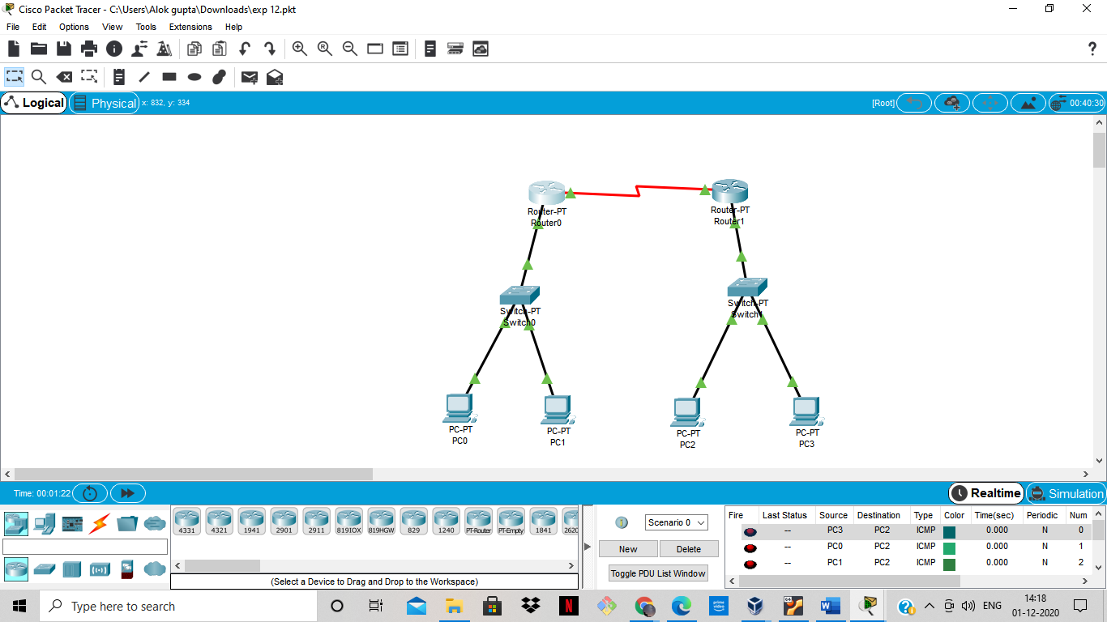

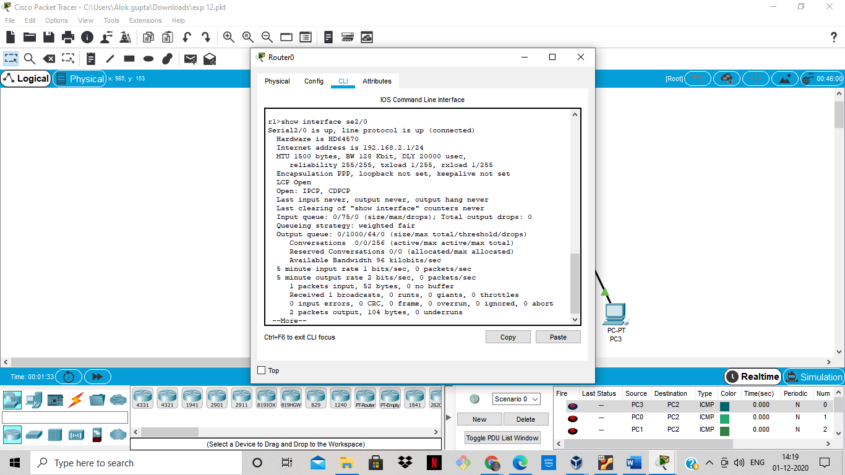

**Result:-**

We have successfully configure a network for a start-up company, protecting the data and ensuring the claimed identity using the relevant protocols by using PPP configuration which is implemented using cisco packet Tracer.