**UNIVERSITY PRACTICALS**

**COMPUTER NETWORKS**

**REMOTE COMMAND CONTROL**

**AIM:**

To establish a connection to attackers to gain control over the target system or device

**LANGUAGE USED:**

Python 3.8

**PROCEDURE:**

Server:-

* Import the socket and subprocess header files
* Create a socket for server
* Use the bind command
* Establish the connection using accept()
* Get the size of the required file and open it in read-only in binary format
* Read the necessary things and close the connection

Client:-

* Create a socket and bind it with the client
* Give the host name and assign the port
* Give the command-bind
* Close the connection after getting

**CODES:**

**SERVER:**

import socket

import subprocess

s=socket.socket(family=socket.AF_INET,type=socket.SOCK_DGRAM)

s.bind(('localhost',9090))

d=s.recvfrom(1024)

print(d[1])

k="{}".format(d[0].decode())

proc = subprocess.Popen([k], stdout=subprocess.PIPE, shell=True)

(out, err) = proc.communicate()

e = str(out)

s.sendto(e.encode(),d[1])

s.close()

**CLIENT:**

import socket

c=socket.socket(family=socket.AF_INET,type=socket.SOCK_DGRAM)

print("Give the command to execute")

c.connect(('localhost',9090))

command=input()

c.sendto(command.encode(), ('localhost',9090))

o=c.recvfrom(24024)

print(str(o))

c.close

**OUTPUT:**

**SERVER:**

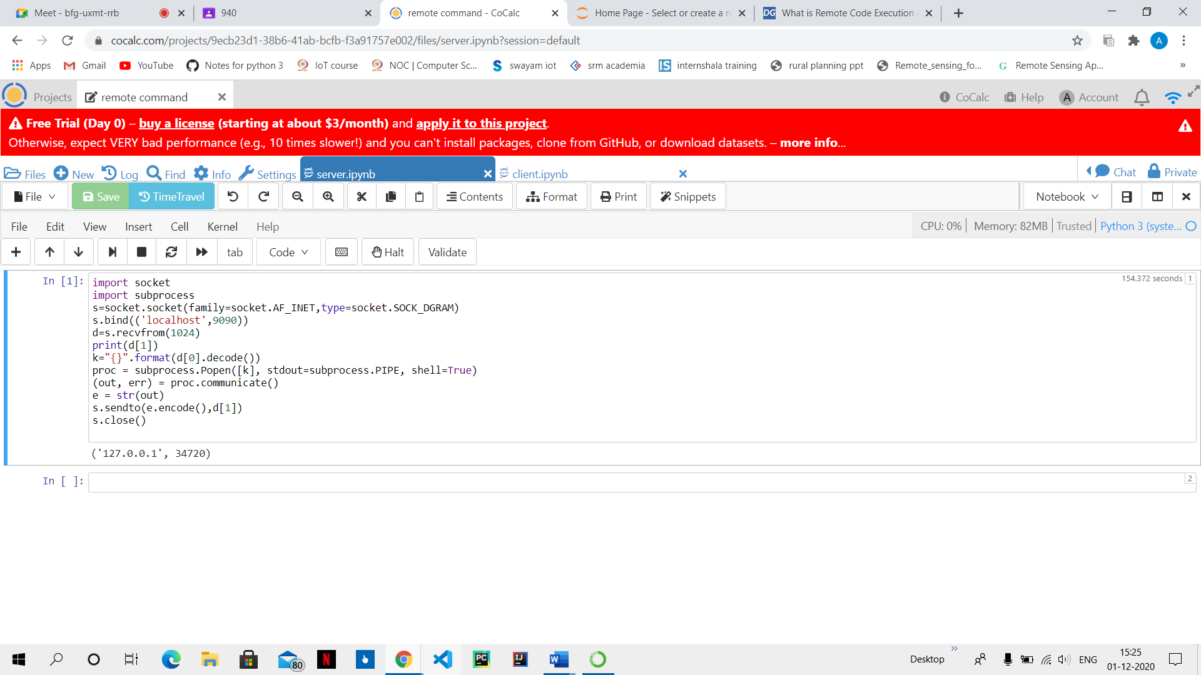

**CLIENT:**

