**UNIVERSITY PRACTICAL EXAM**

**COMPUTER NETWORKS - 18CSC302J**

**Aim: -**

To Help Bob to access the physical address of Alice’s system for the connectionless communication between the two.

**Procedure: -**

¬ Include the necessary header files.

¬ Create a socket using socket function with family AF_INET, type as SOCK_DGRAM.

¬ Declare structures arpreq ( as NULL structure, if required) and sockaddr_in.

¬ Initialize server address to 0 using the bzero function.

¬ Assign the sin_family to AF_INET and sin_addr using inet_aton().

¬ Using the object of arpreq structure assign the name of the Network Device to the data member arp_dev like, arp_dev=”eth0”.

¬ Ping the required Client.

¬ Using the ioctl() we get the ARP cache entry for the given IP address.

¬ The output of the ioctl() function is stored in the sa_data[0] datamember of the arp_ha structure which is in turn a data member of structure arpreq.

¬ Print the hardware address of the given IP address on the output console.

**CODE**

import os

import getmac

ip = ""

while ip != "exit":

ip = input("Enter IP address [or exit]: ")

if ip == "exit":

continue

os.system("ping {}".format(ip))

msg = input("Retreive MAC address? [y/n]: ")

if msg == "n":

continue

mac = getmac.get_mac_address(ip = ip)

print("MAC address: {}".format(mac))

print("Exiting")

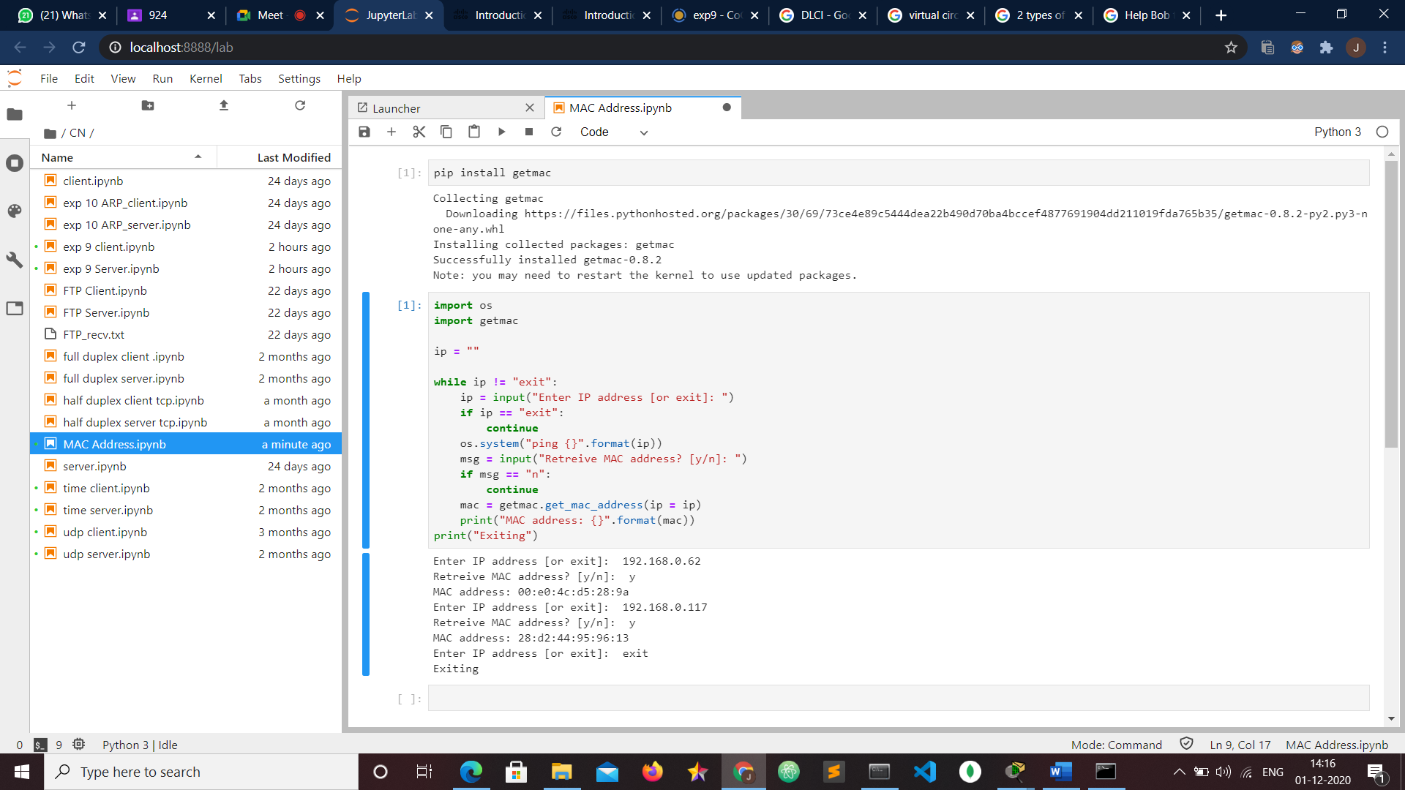

**OUTPUT**

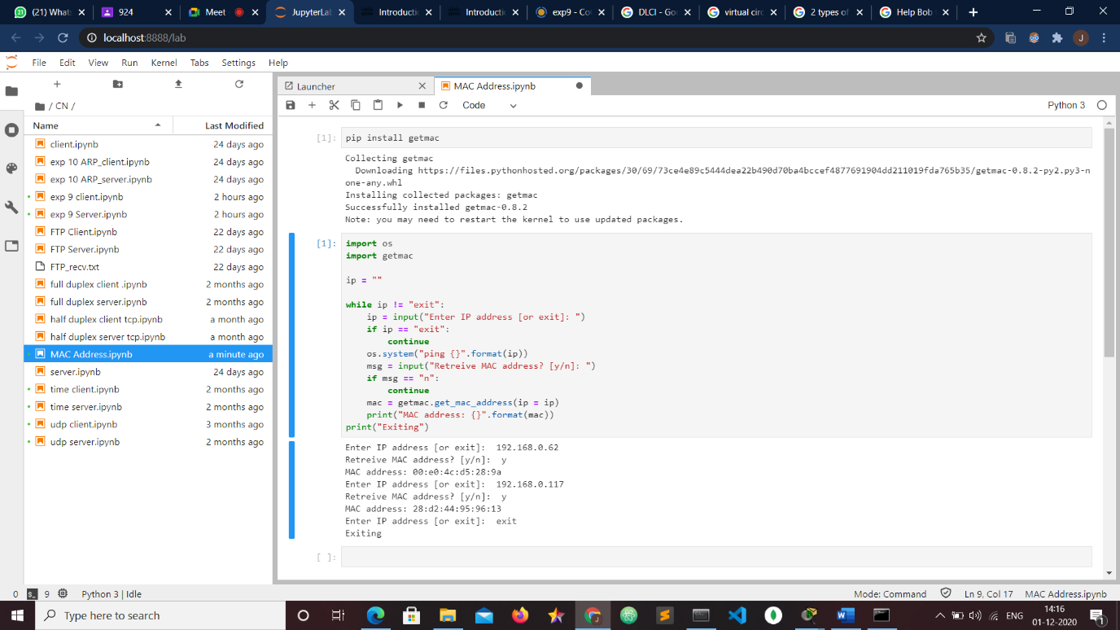

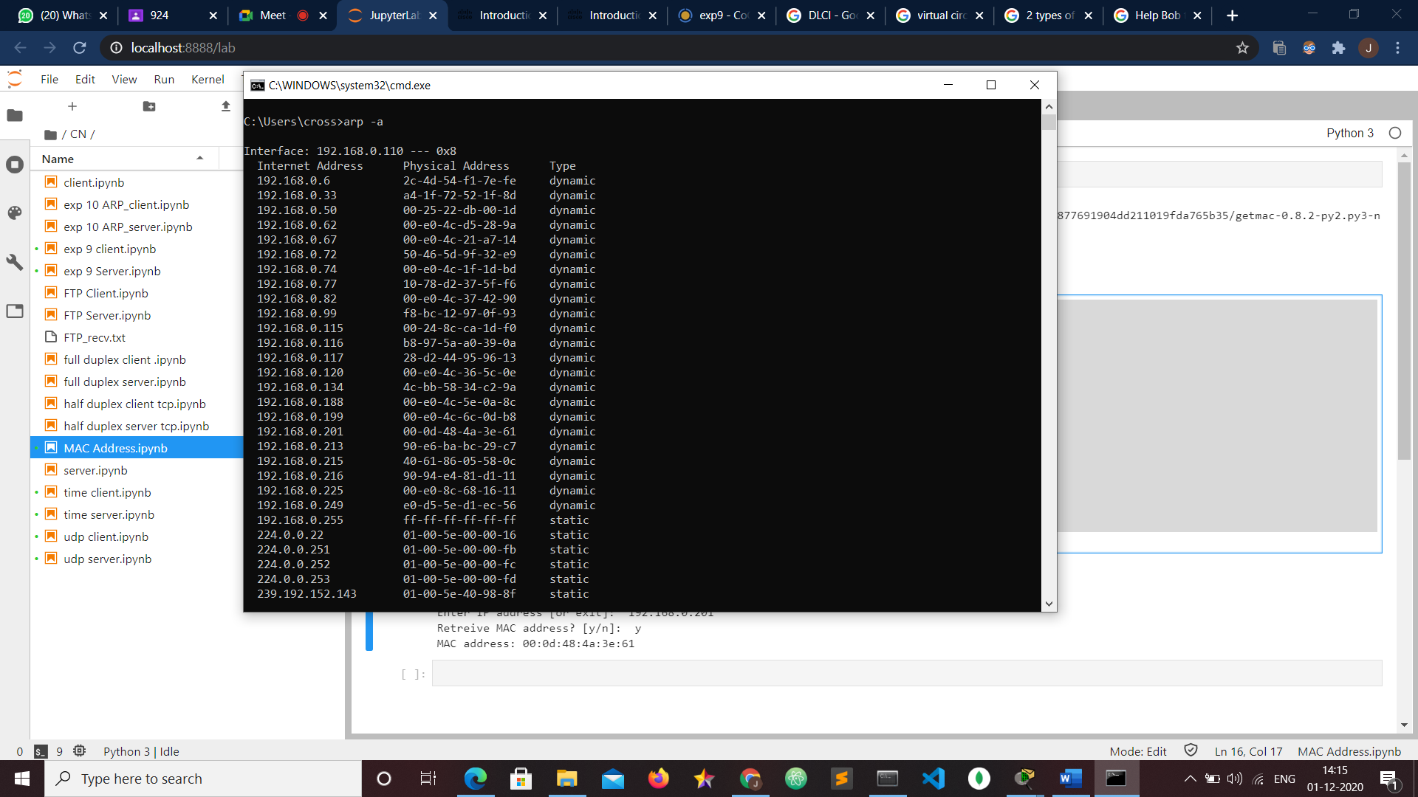

RESULT

Implementation of ARP using UDP was done successfully.