**REMOTE COMMAND EXECUTION USING UDP**

**CSE G2**

**Aim:-** Write a program in python for implementation of Remote Command Execution using UDP.

**Procedure:-**

**Server Side:**

1. Import the necessary libraries i.e. “socket” lib & “sub process” lib and after that create UDP socket.
2. Bind host and port using BIND() function.
3. Receive the command from client using recv() function.
4. Using functions from the subprocess library execute the commands received from the client.
5. Send the result to the client using send() function.
6. Then close the connection.

**Client Side:**

* 1. Import the necessary libraries i.e “socket” lib and after that create UDP socket.
  2. Connect host and port using connect() function.
  3. Input the command and send it to the server using send() function.
  4. Receive the results from the server and print it.
  5. Then close the connection.

**Server Code:-**

import socket

import subprocess

s = socket.socket(family=socket.AF_INET,type=socket.SOCK_DGRAM)

s.bind(('localhost', 4000))

r = s.recvfrom(1024)

print(r[1])

k="{}".format(r[0].decode())

proc = subprocess.Popen([k], stdout=subprocess.PIPE, shell=True)

(out, err) = proc.communicate()

st = str(out)

s.sendto(st.encode(),r[1])

s.close()

**Client Code:-**

import socket

s=socket.socket(family=socket.AF_INET,type=socket.SOCK_DGRAM)

s.connect(('localhost', 4000))

command=input("cmd command ")

s.sendto(command.encode(), ('localhost', 4000))

r = s.recvfrom(24024)

print(str(r))

s.close()

**Output:-**

**SERVER:-**

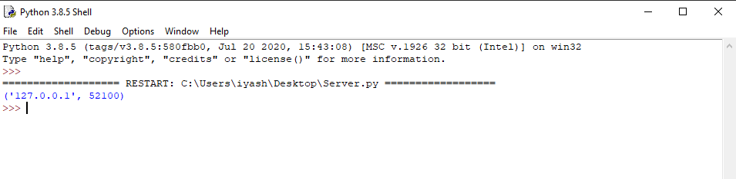

----------------------------------------------------------------------------------------------------------------------

**CLIENT:-**

