***Visual Studio Code Setup:***

Go to <https://code.visualstudio.com>

Click on "Downloads for Windows"

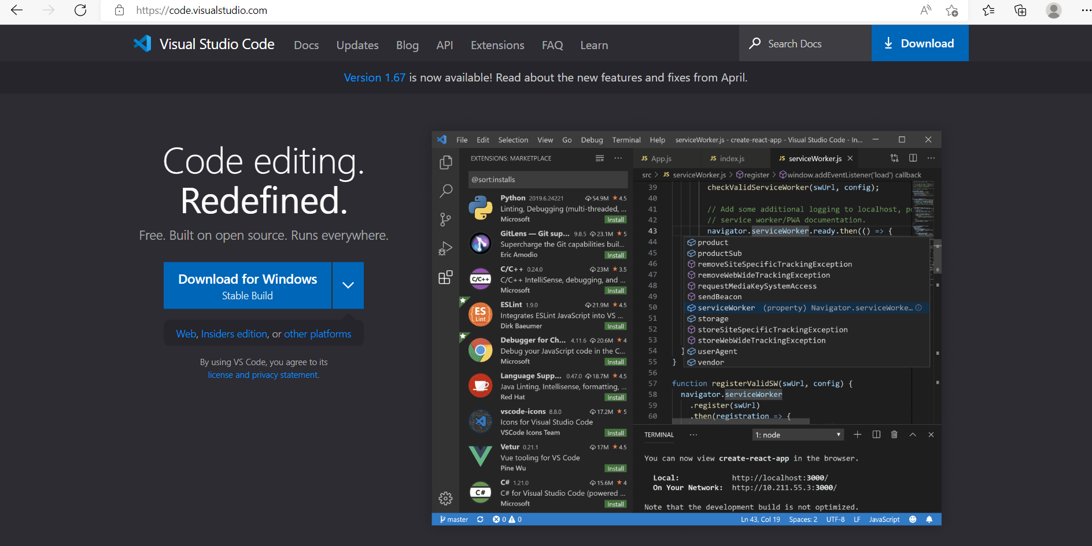

Installation Wizard:

Right click on VSCodeUserSetup-x64.exe

Select “I accept the agreement” and then click next.

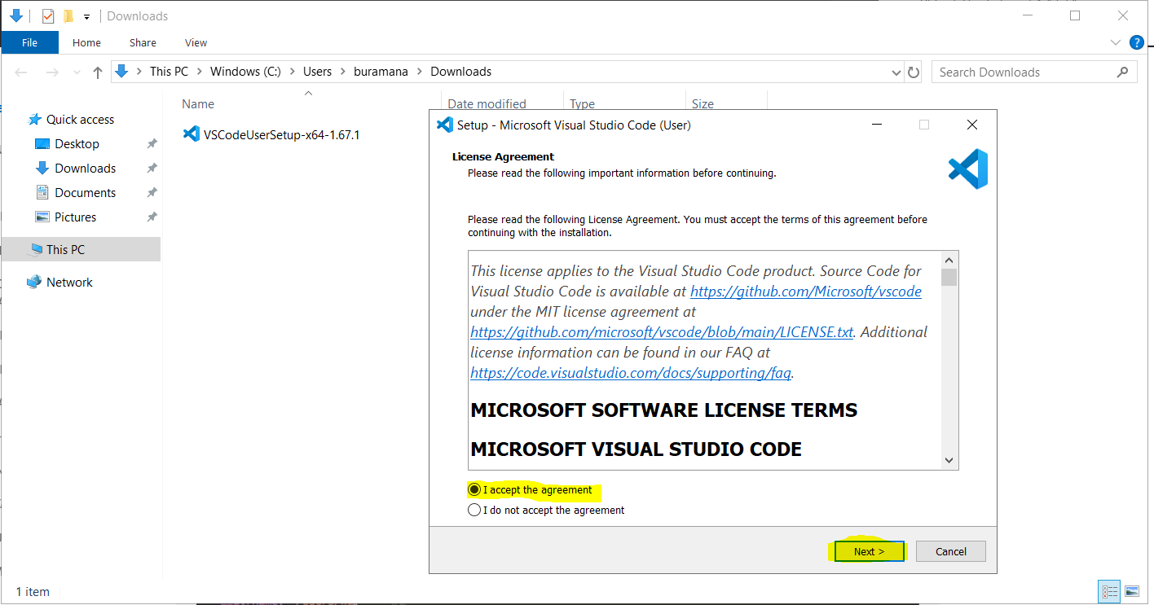

Select the installation location in local system

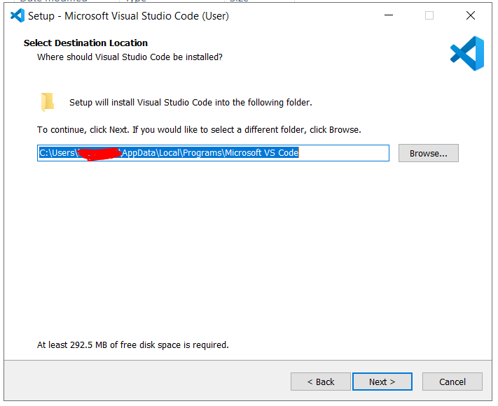

Click Next

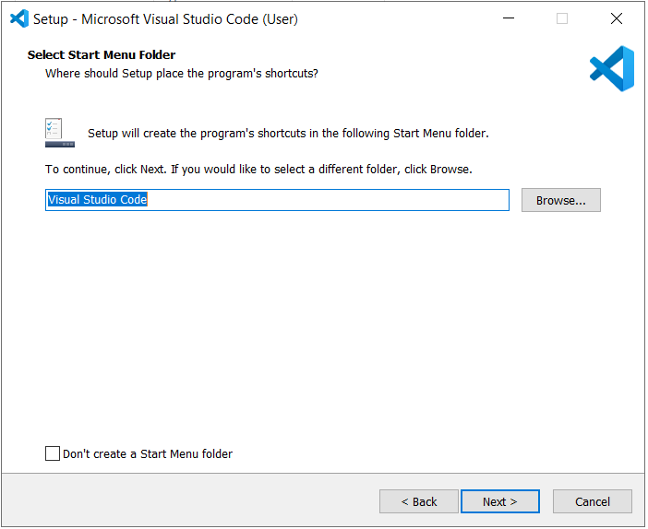

Select Create desktop icon and click next.

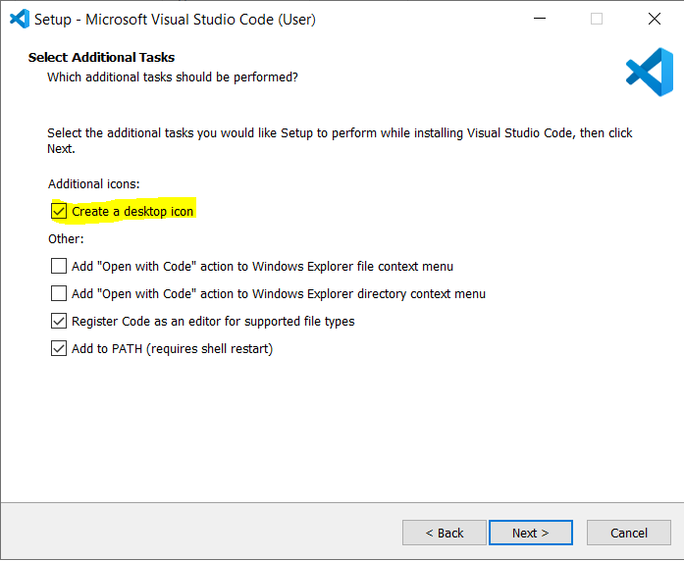

Click on Install

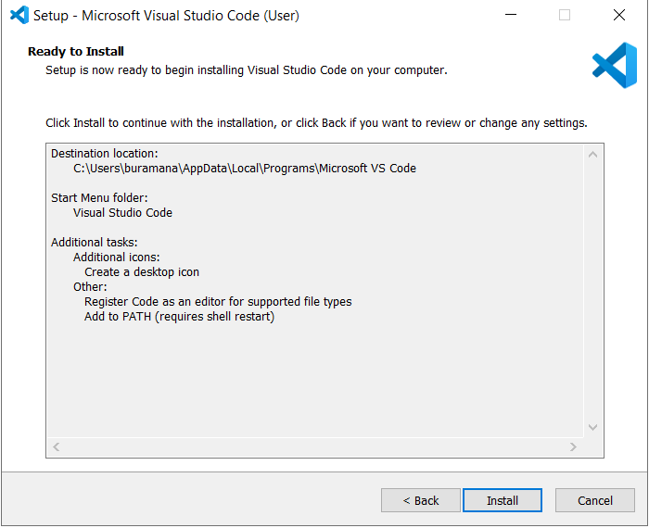

Click On Finish.

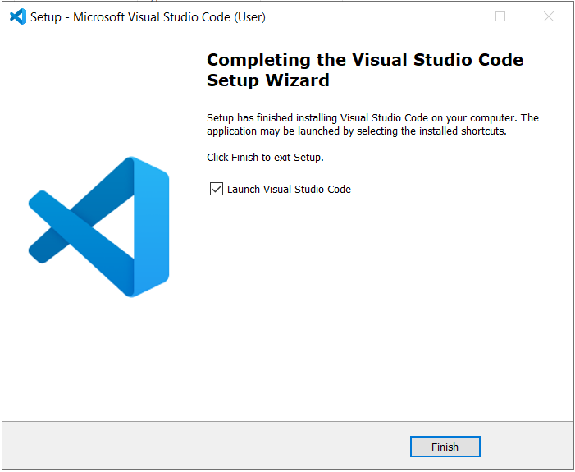

Then it will open VS code app.

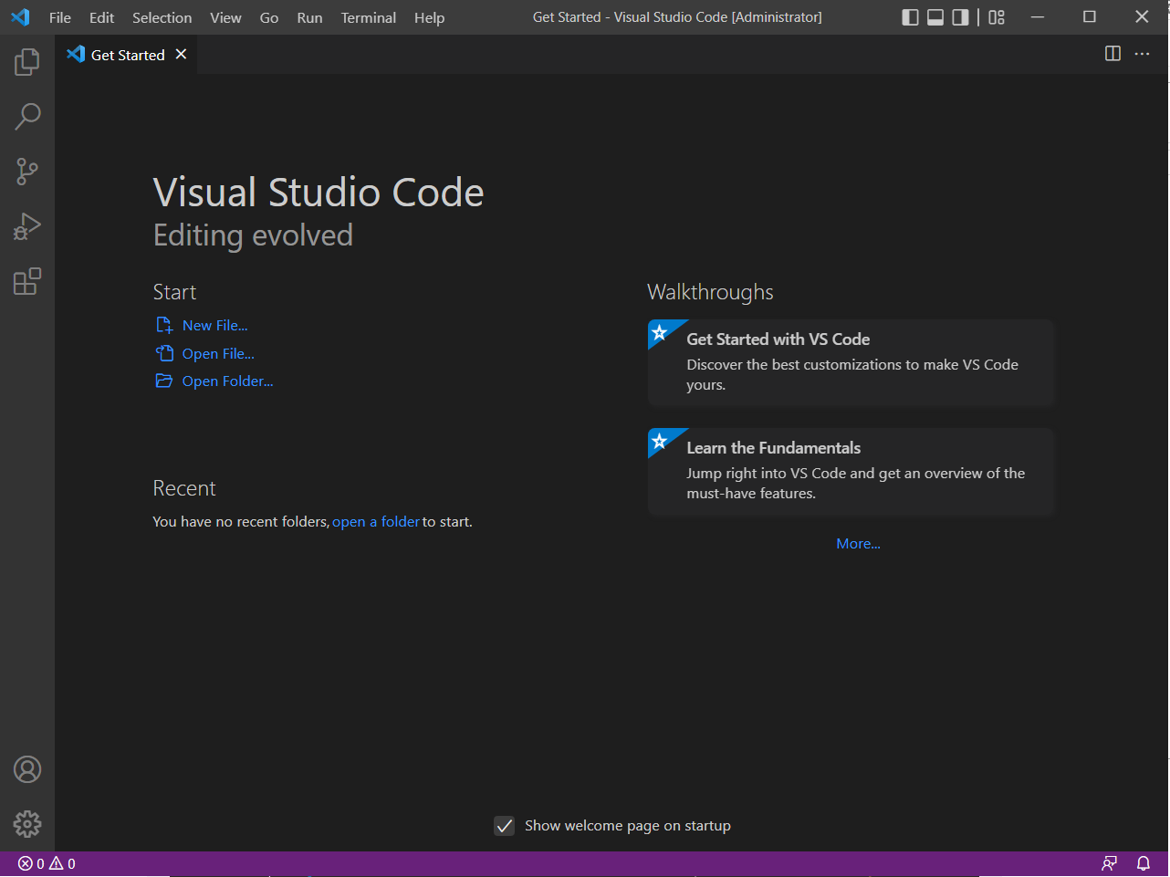

***Terraform Setup:***

Refer url for installing terraform in windows and Linux.

<https://spacelift.io/blog/how-to-install-terraform>

Windows:

Download Terraform binaries form <https://www.terraform.io/downloads>

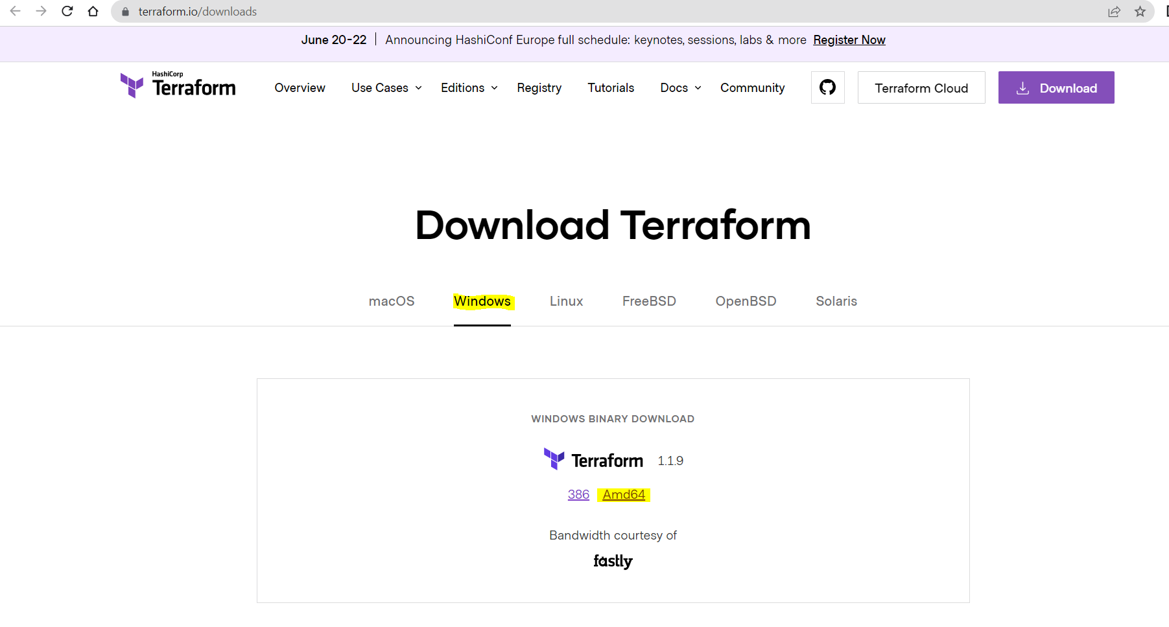

Check the terraform zip file in downloads folder.

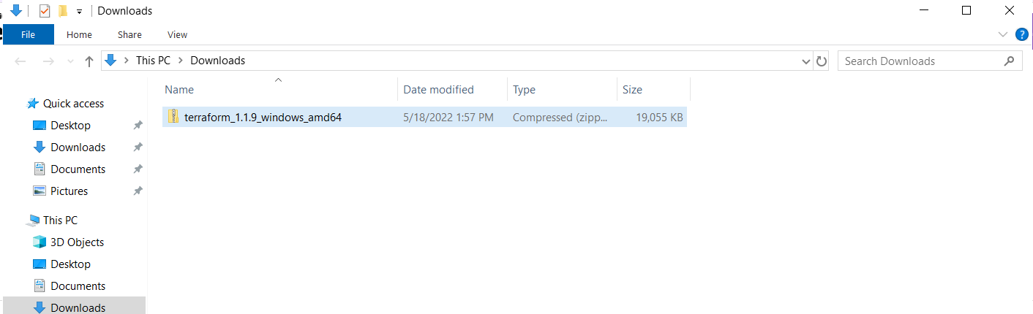

Right click on zip and extract the file to selected folder. You should install zip or rar or 7z software to extract zip file.

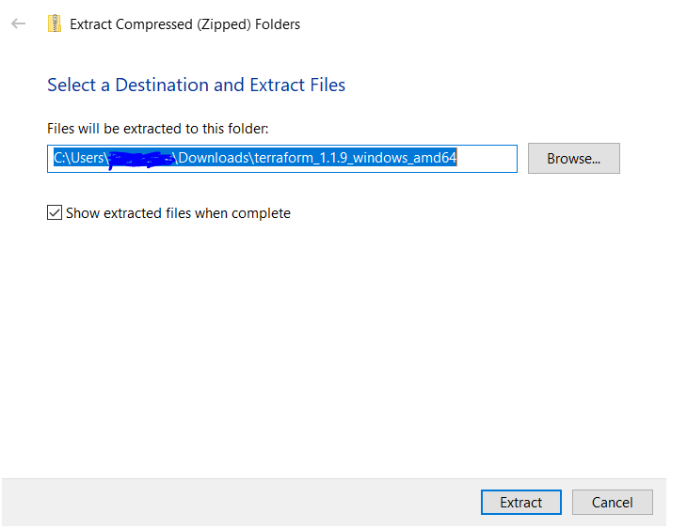

After Extract the file we can see the terraform application.

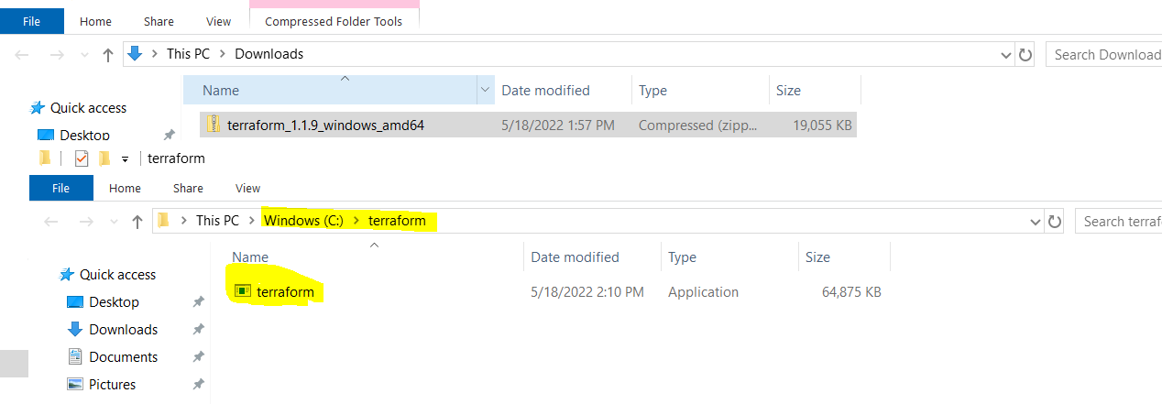

If you run the terraform command from other directory other than terraform application, we will get the error like command not found. If we execute the same command from the directory where terraform application is extracted it will not show the error.

To avoid this error we need to setup terraform application path in the environment variables.

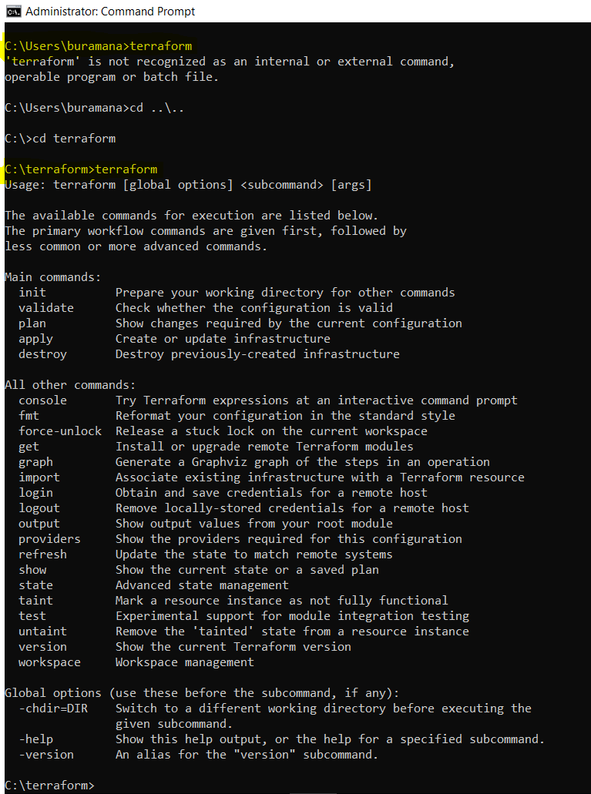

Open start menu and search for environment variables. And click on Environment variables as below.

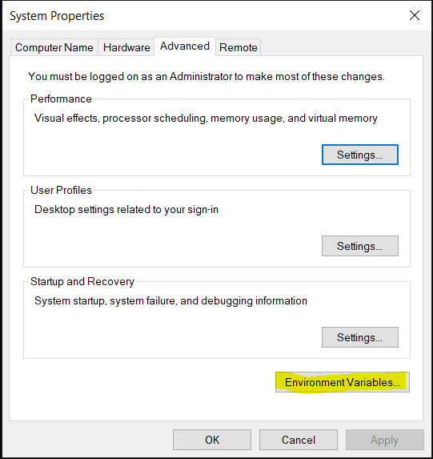

Select ‘path’ from system variables. Click on New and add the terraform application path then click ok.

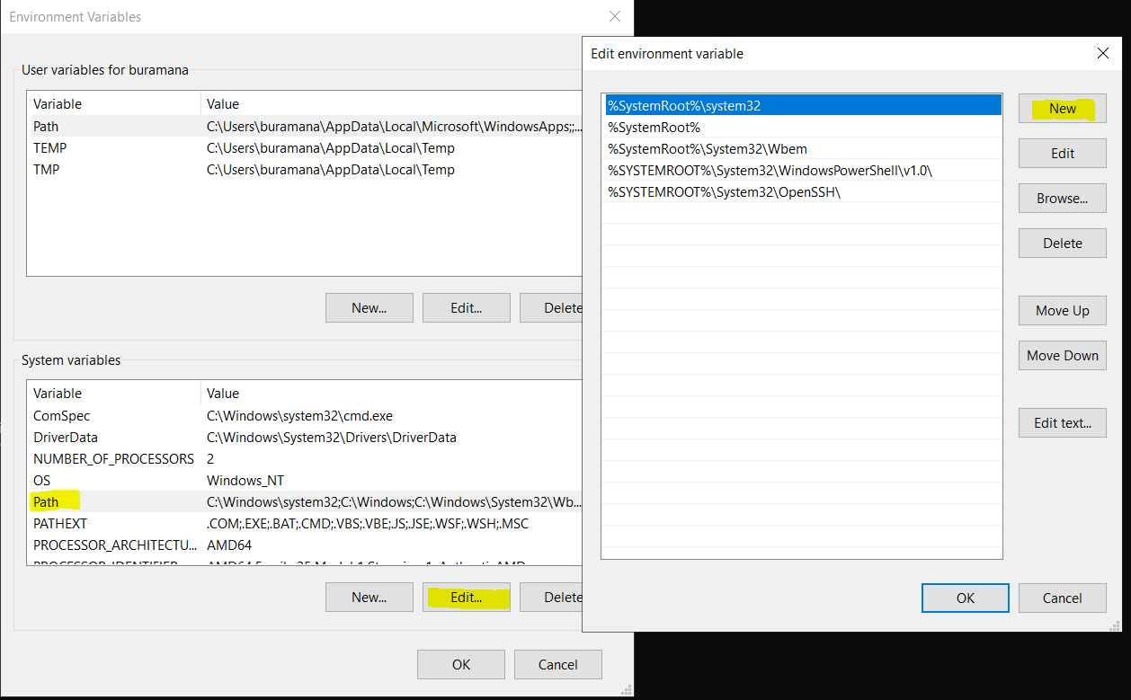

Now, if I run terraform from any other location or directory. It will not thrown any error

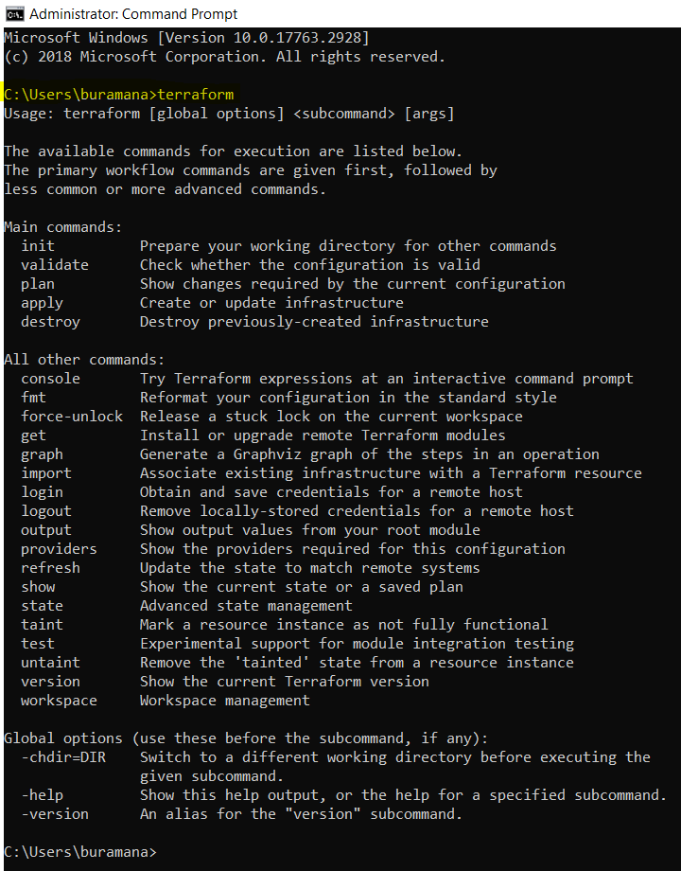

*Azure CLI*

Windows:

Goto [Install the Azure CLI for Windows | Microsoft Docs](https://docs.microsoft.com/en-us/cli/azure/install-azure-cli-windows?tabs=azure-cli) and click on latest release of Azure CLI.

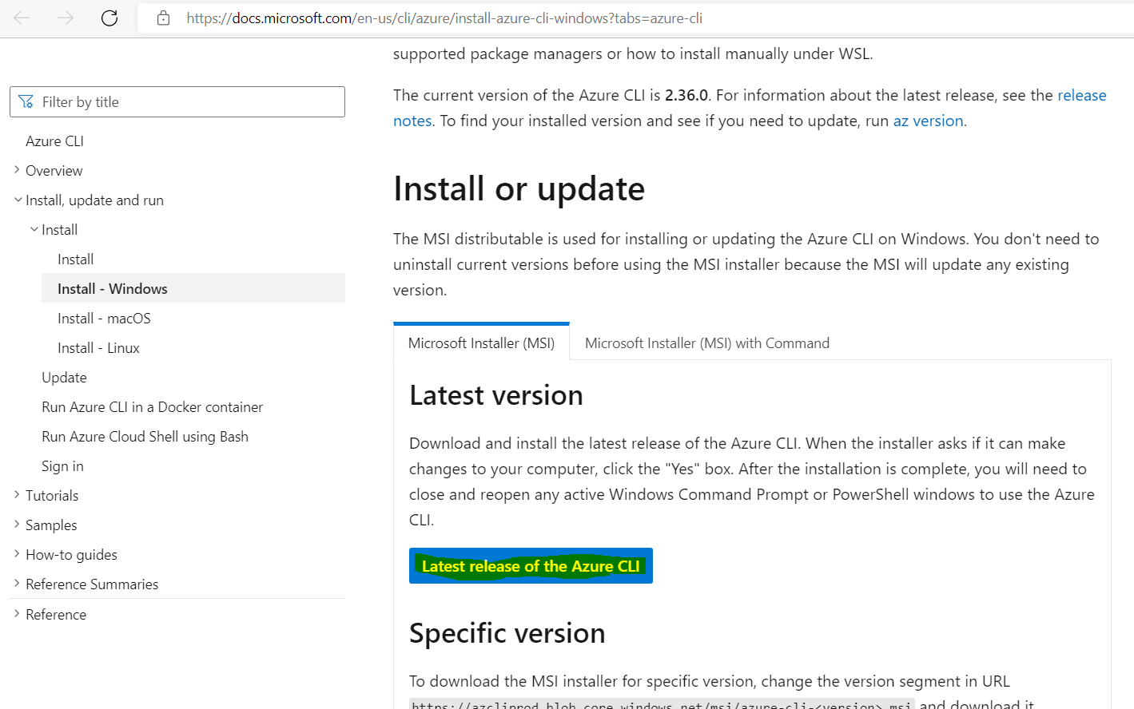

Azure CLI will get downloaded and check the downloads folder or default location.

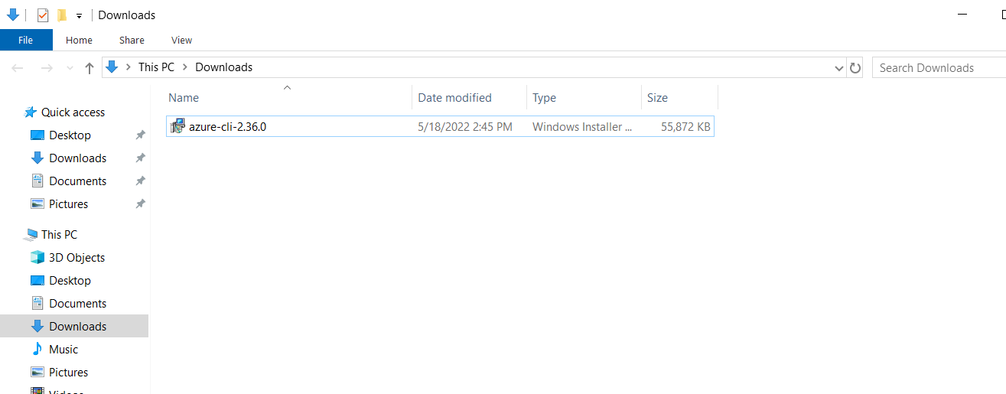

Double click on azure cli app and check Licence agreement. Click on Install.

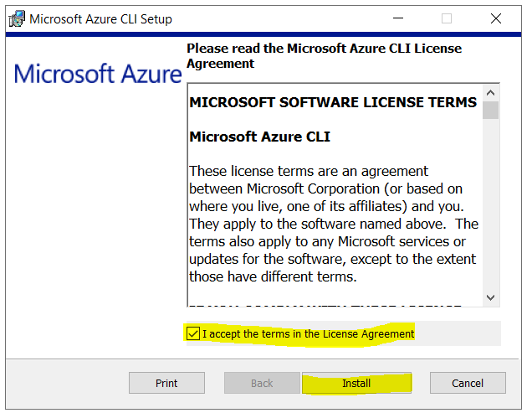

It will take less than 2 mins. For installation. Click on Finish.

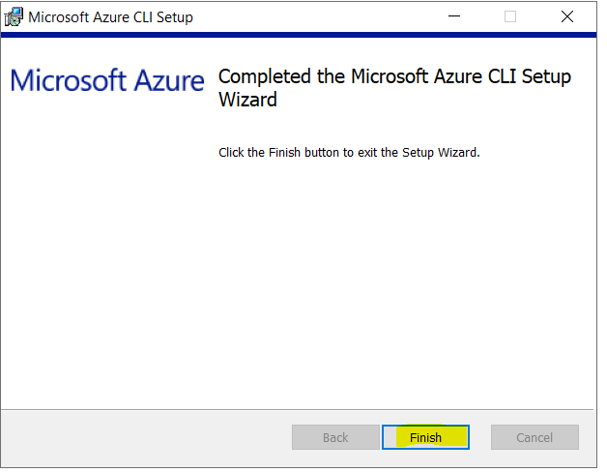  
to verify the azure cli installation, open command prompt then run

***az version***

