***AKS managed cluster creation using Az cli Commands.***

1. Create Azure resource group

az group create -n <name of resource group> -l <location of resource group>

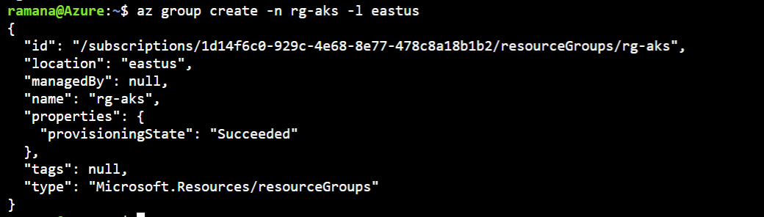

1. Create azure kubernetes service.

**az aks create -n aks-cluster-eus-dev-001 -g rg-aks --node-count 2 --nodepool-name ndpldev001 -s Standard_B2s --generate-ssh-keys**

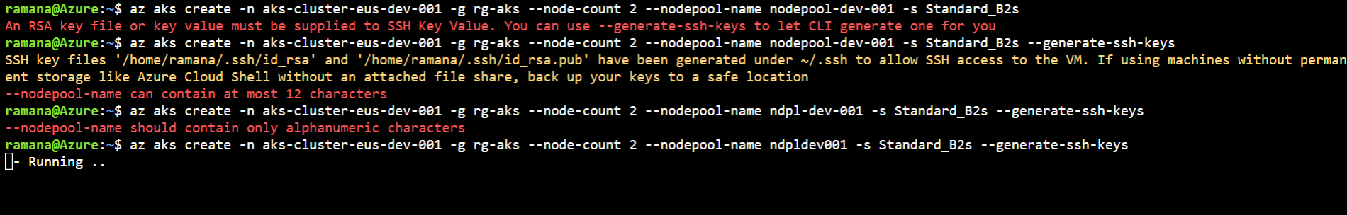

===========================================================

Mandatory options are

-n or –name – name of the aks cluster

-g – resource group name

--node-count – number worker nodes

--nodepool-name – nodepool name to add worker nodes. Name should be 12 characters length only alphanumeric chars allowed.

--generate-ssh-keys – If you don’t have ssh keys we can use this option. If you have ssh keys then you can use

--ssh-key-value /path/to/publickey

Az aks got created.

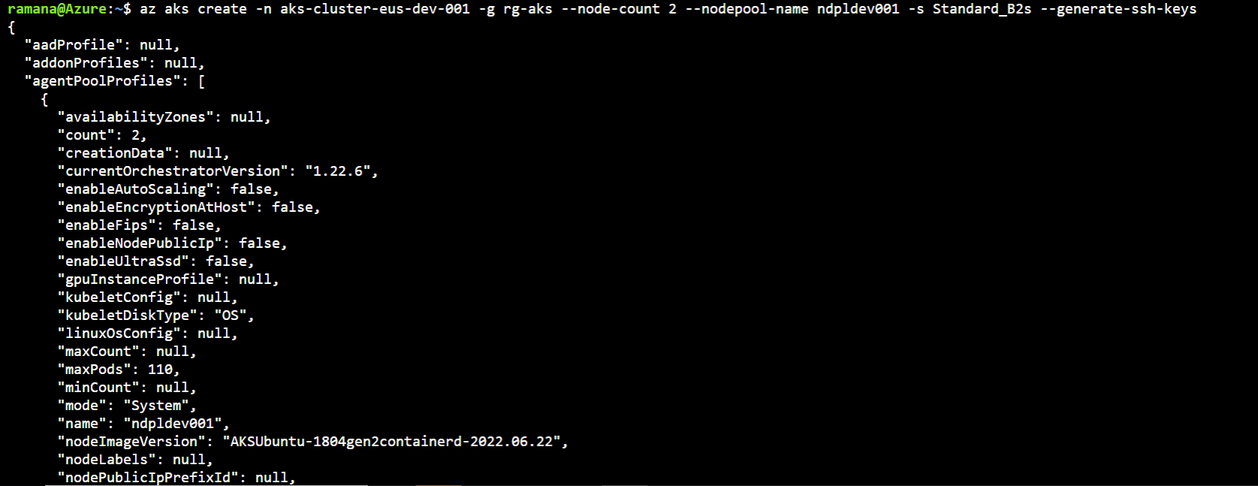

1. To get the aks cluster details in table format

az aks show -g rg-aks -n aks-cluster-eus-dev-001 -o table



Here some screenshots of aks cluster information.

One extra resource group got created for Nodepools.

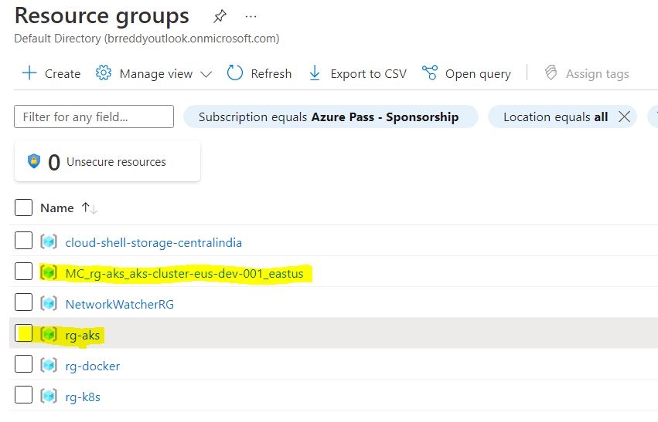

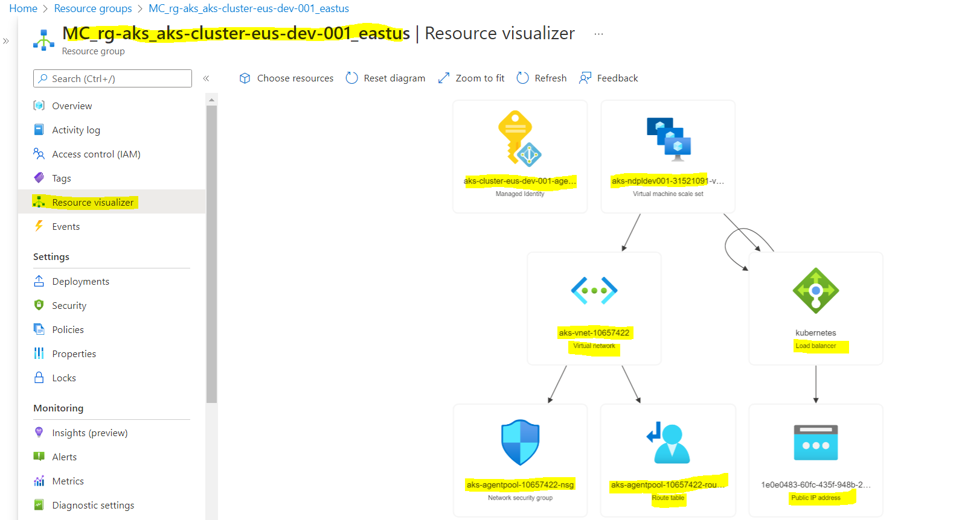

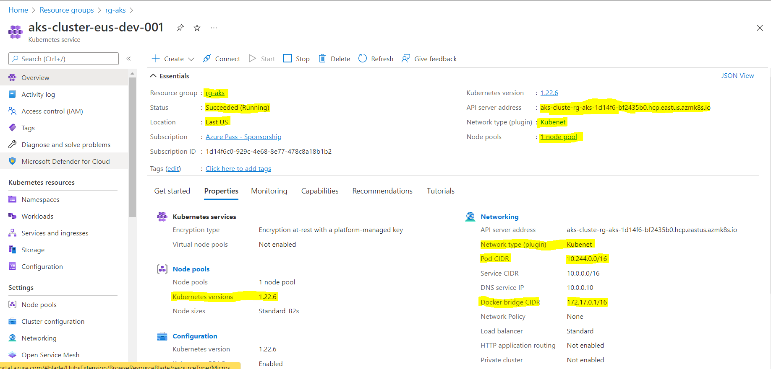

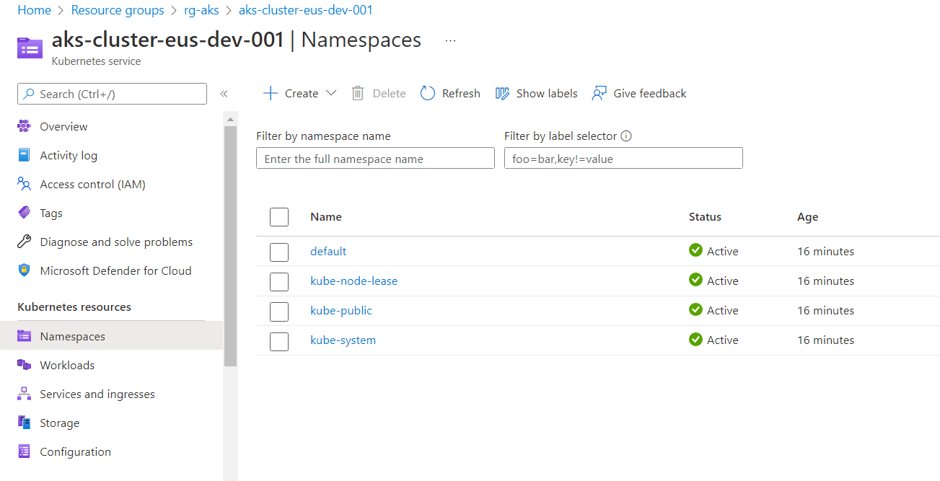

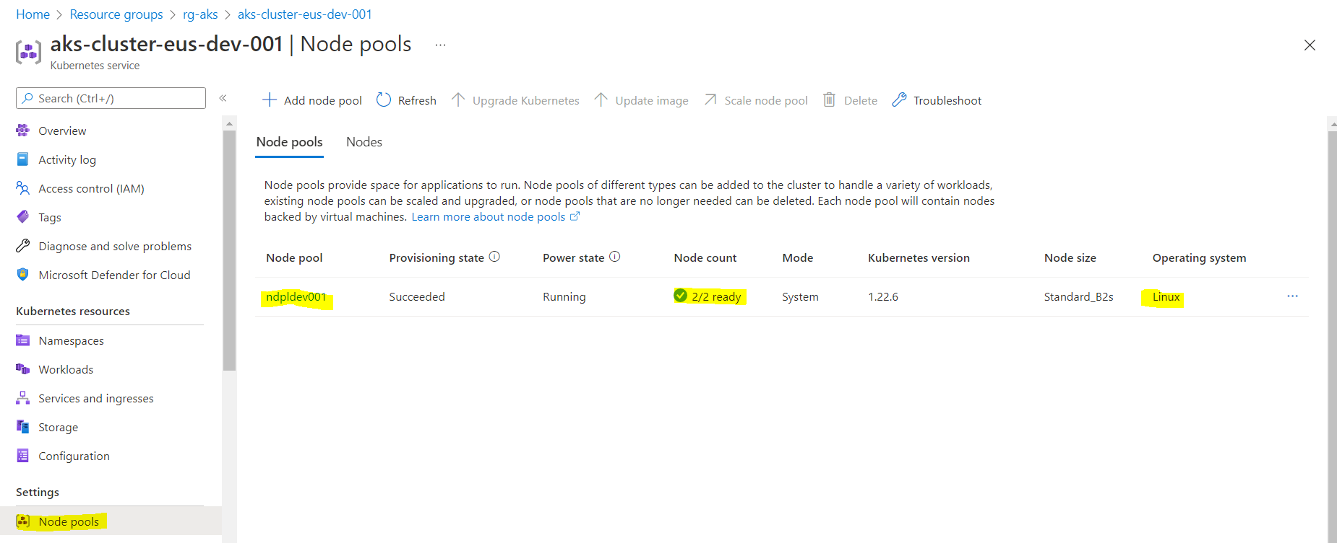

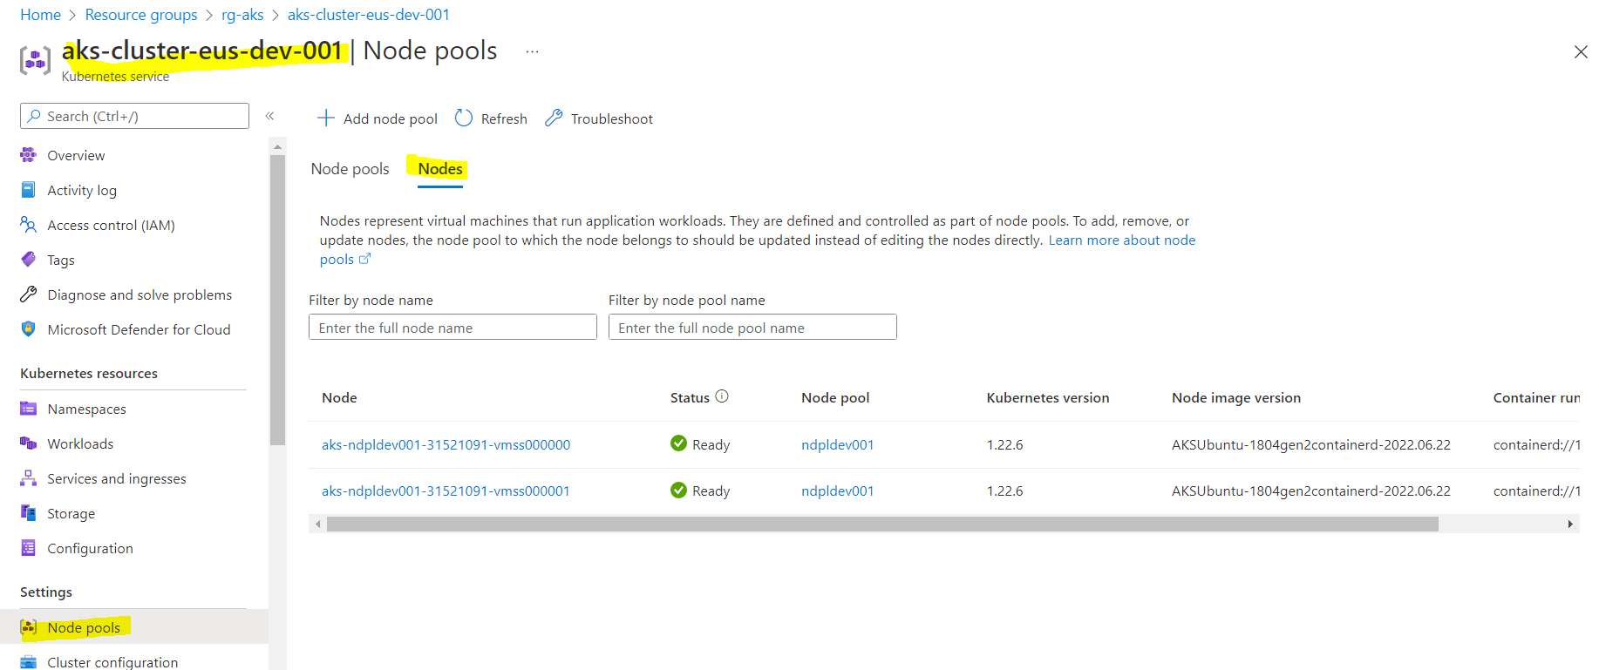

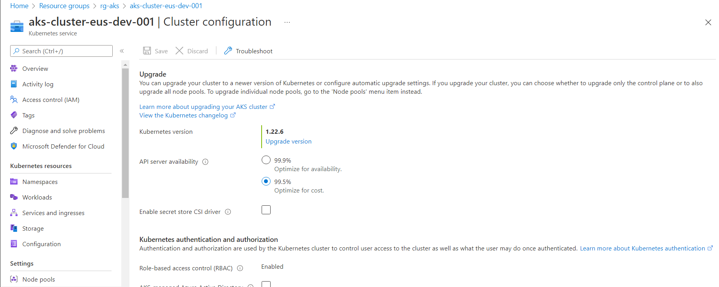

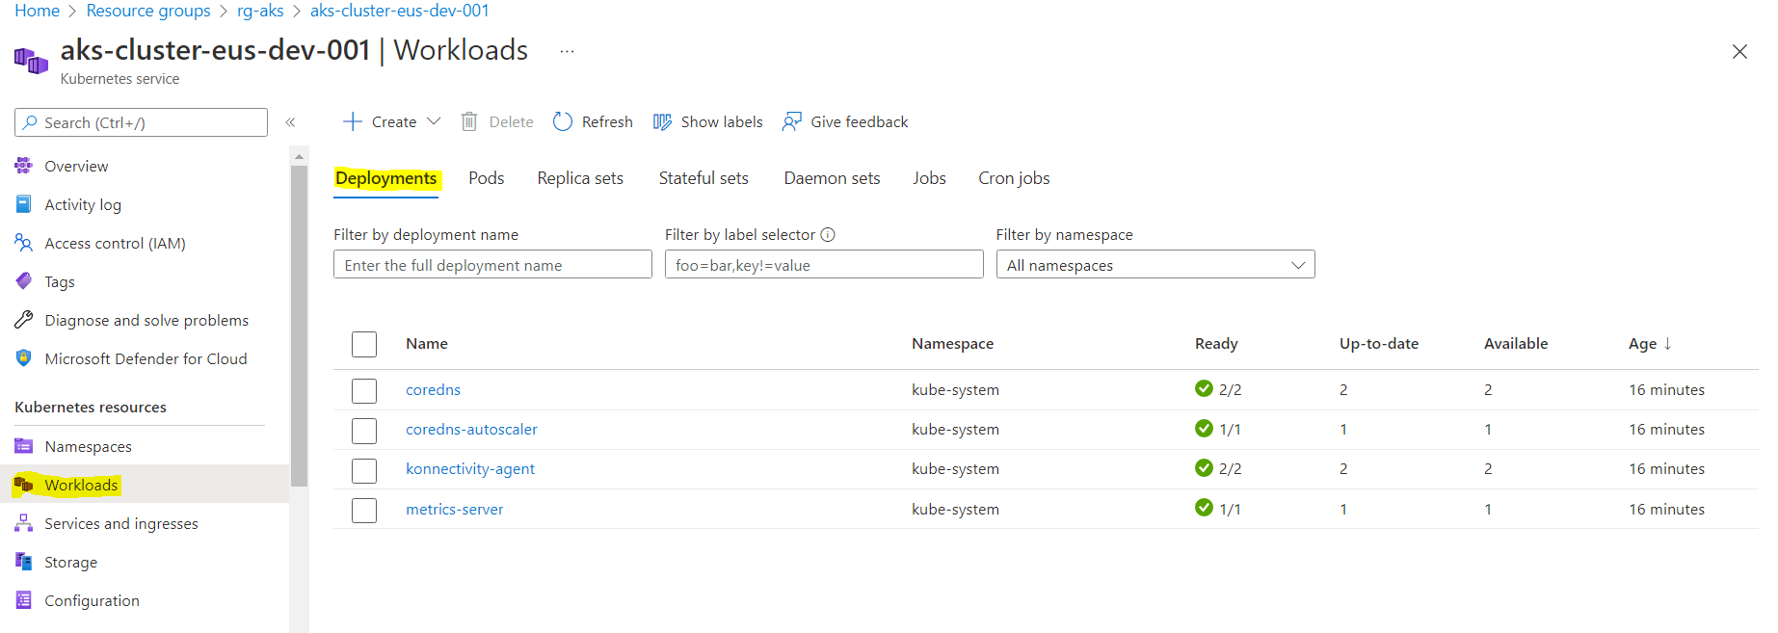

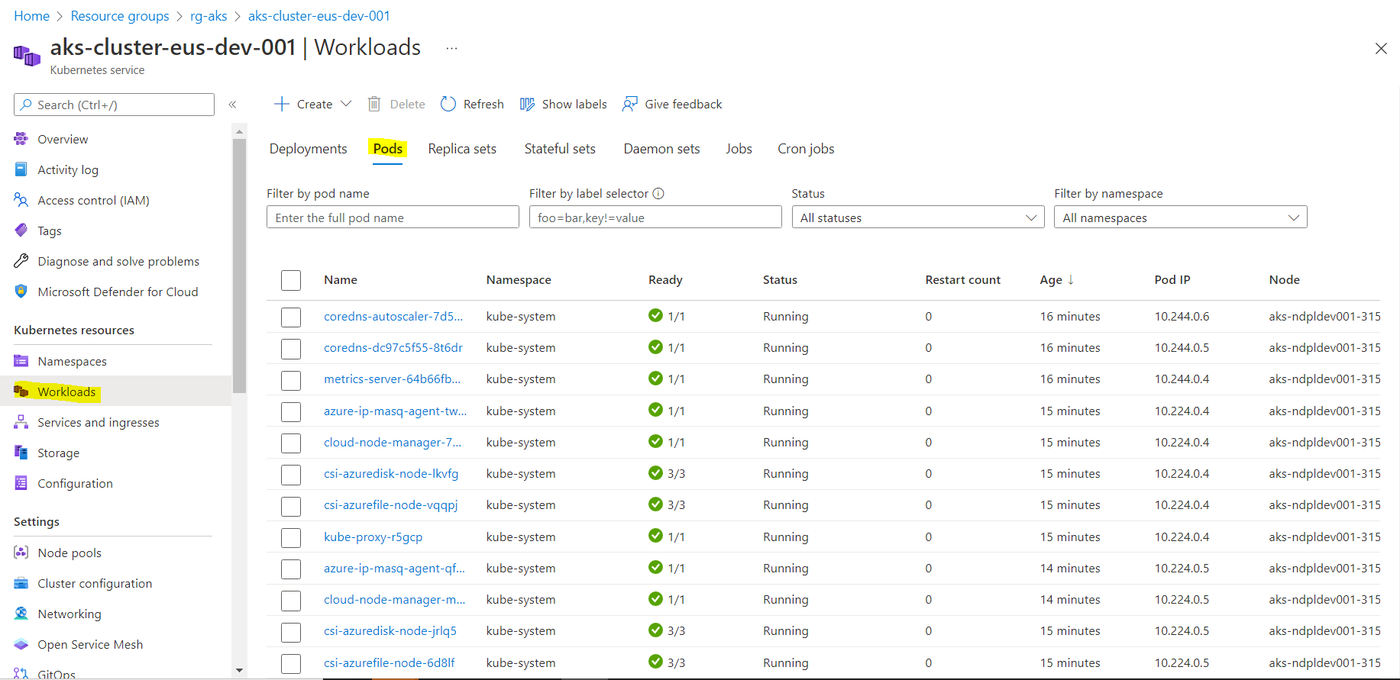

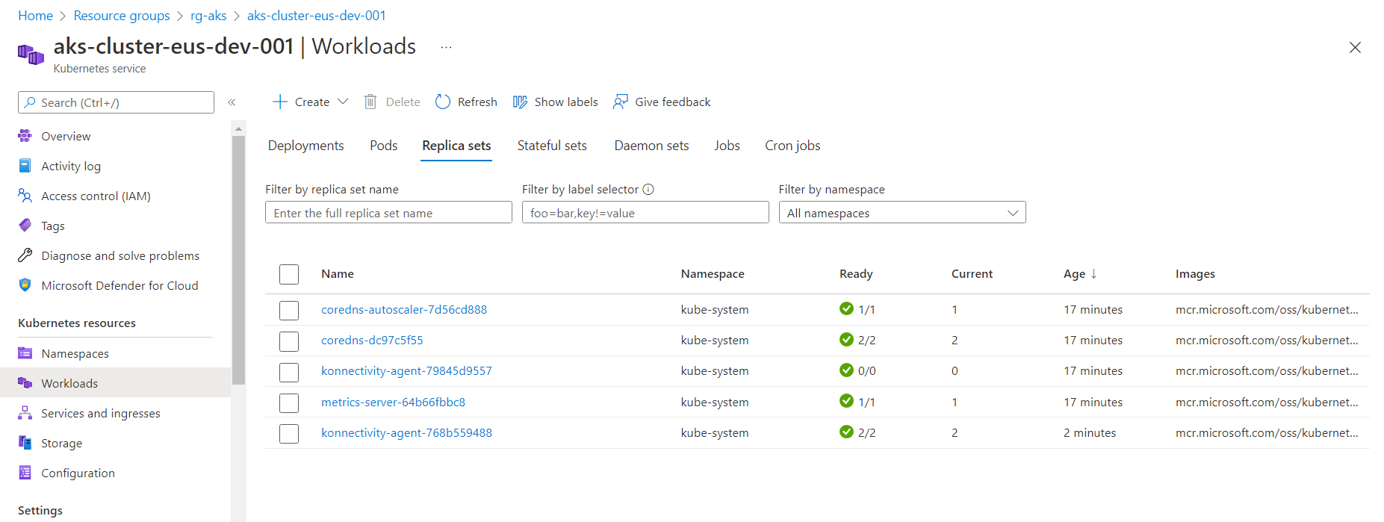

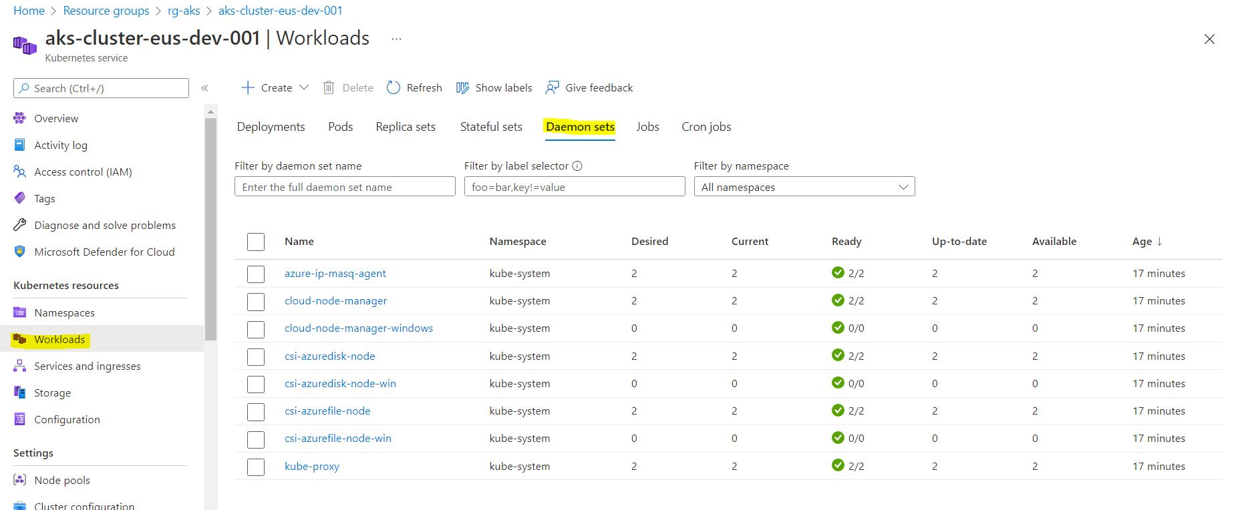

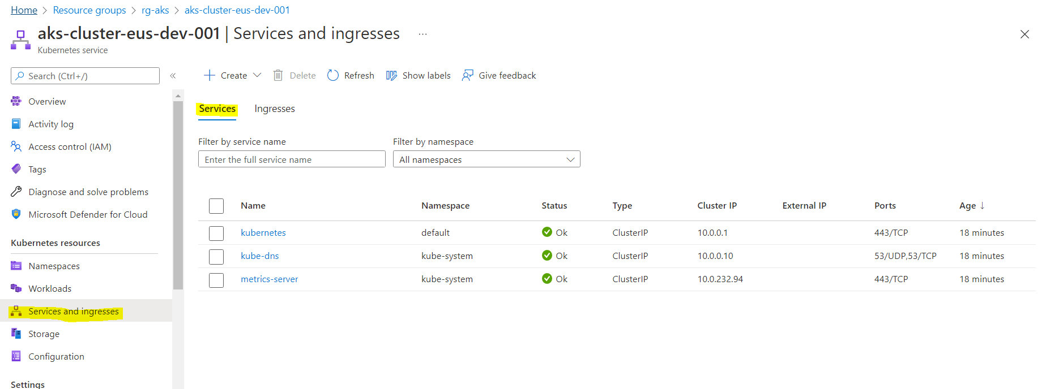

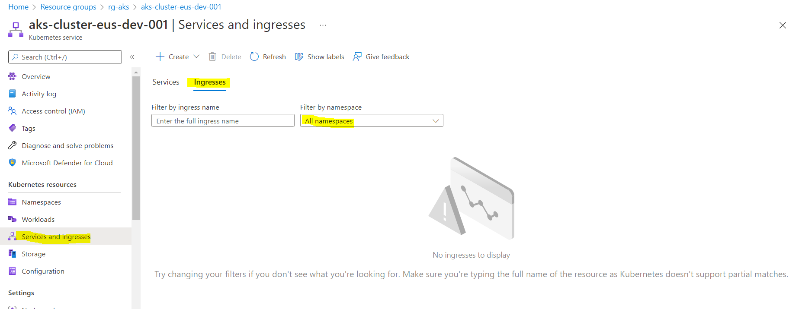

No persistent volumes and persistent volume claims

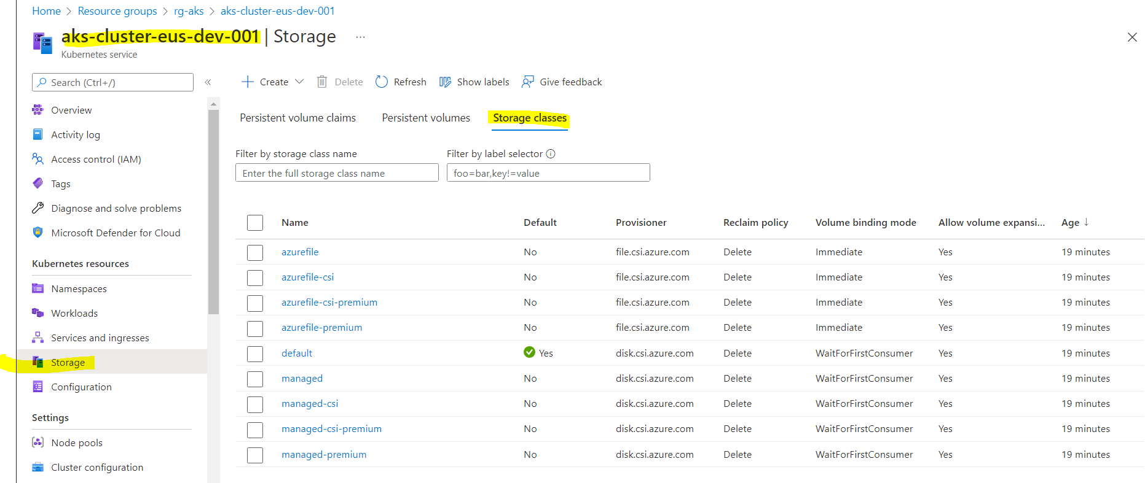

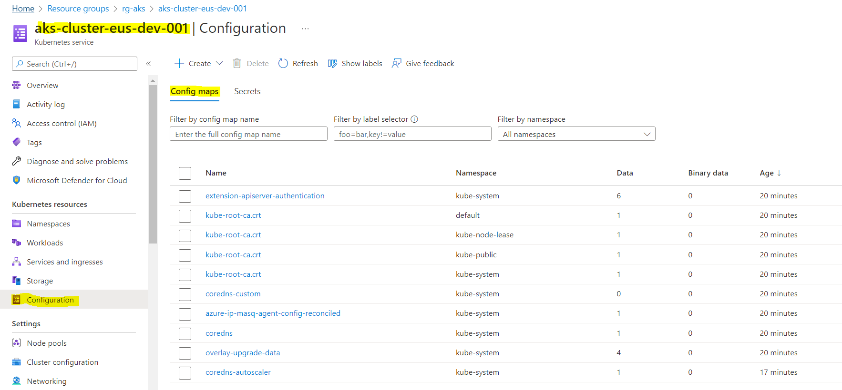

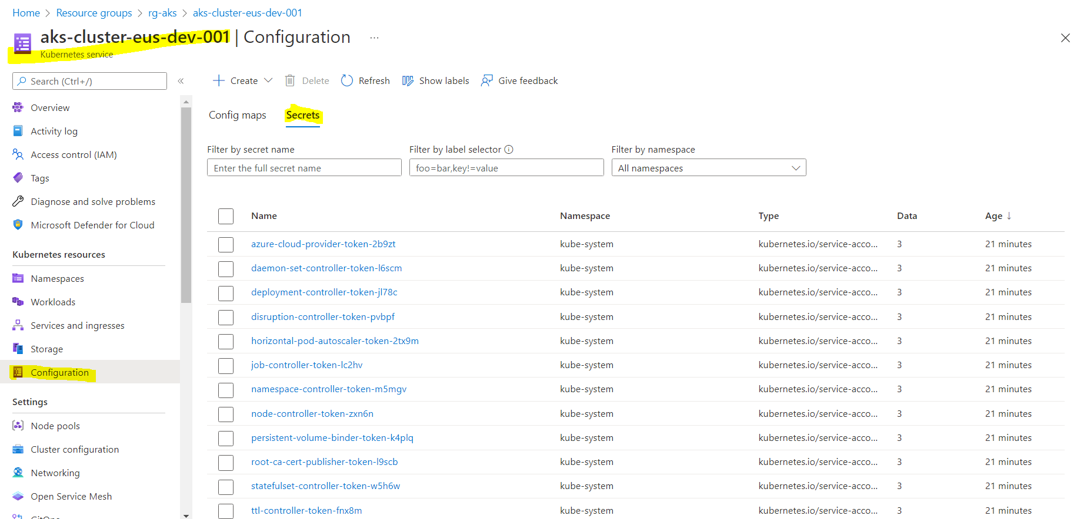

1. How to connect to aks cluster after creation

Need to install kubectl from where you want to connect to AKS cluser.

Run below command.

az aks install-cli

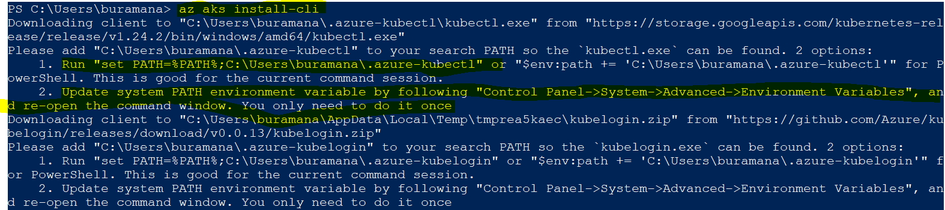

Follow the instructions to setup environment variable to run kubectl from anywhere in your system.

After setting up the path variable close the command prompt and reopen it.

And run the “kubectl version” command to check the kubectl is installed.

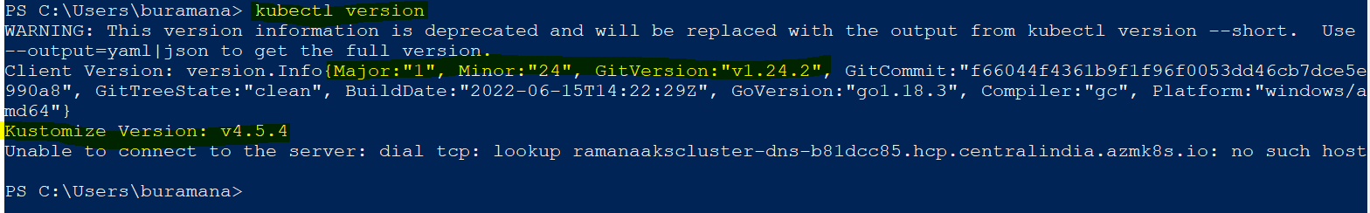

To connect aks cluster first, should get the aks cluster credentials.

By executing below command we will get the credentials. And it will be saved to user default location. (<userhome directory>\.kube\config)

az aks get-credentials --resource-group rg-aks --name aks-cluster-eus-dev-001

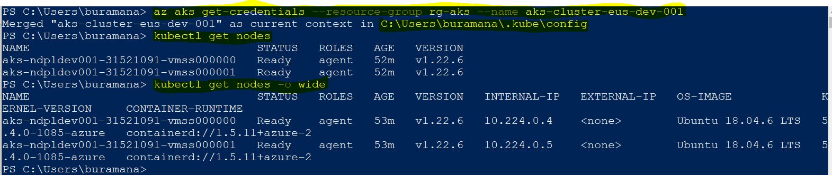

If you want see at the key or creds run below command

cat C:\Users\buramana\.kube\config

Now, we are ready to create or manage the kubernetes objects from local machine.

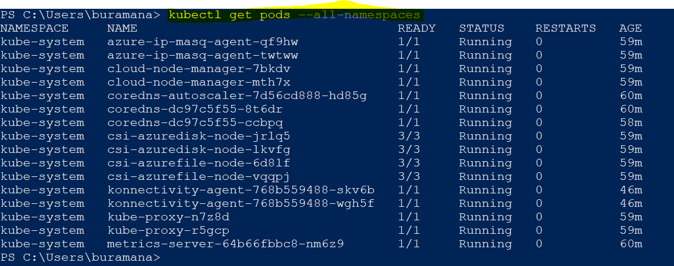

Create Pod and check the details of it in portal and command line

kubectl run myaks-pod –image=nginx



Kubectl get pods

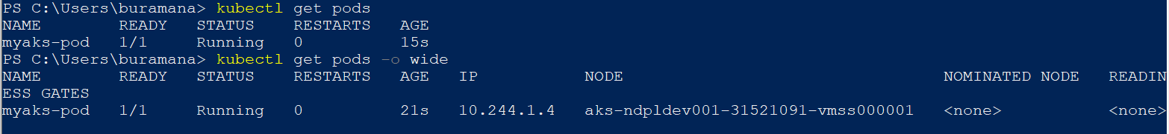

In portal

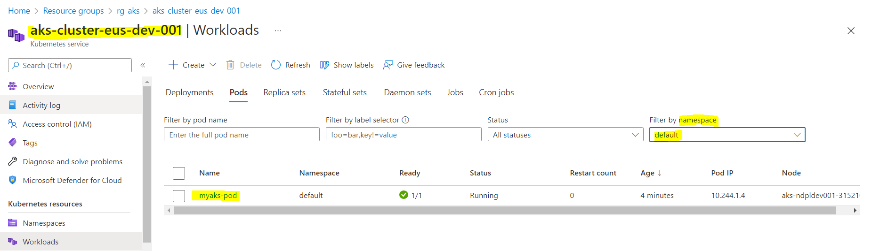

Pod overview

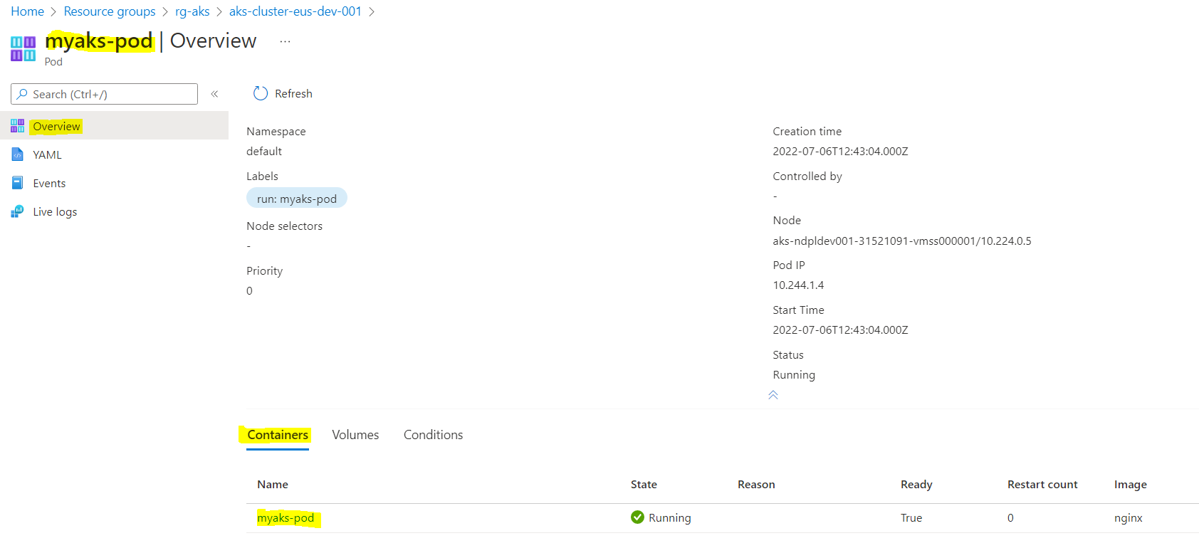

YAML format of POD details

