What is ffmpeg ?
ffmpeg is a set of tools dedicated to decoding, encoding and transcoding video and audio. FFmpeg is based on the popular libavcodec and libavformat libraries that can be found in many other video conversion applications, like VLC,mplayer.
Installation
ffmpeg is free and open source, and it’s cross-platform. You’ll be able to install it on your Windows PC as well as your Linux server. The only thing you need to be comfortable with is using your command line. As it’s actively developed, you should try to update your version from time to time. Sometimes, new features are added, and bugs are fixed.
ffmpeg installation on Linux machine
using apt-get
execute the following command from terminal
sudo apt-get install ffmpeg
from source code
Step1:
download the source code from ffmpeg organization
https://www.ffmpeg.org/download.html#build-linux
Step2:
untar the source file
tar -xvf ffmpeg-2.8.tar.bz2
Step3:
do to source code directory
cd ffmpeg-2.8/
execute the following command
sudo apt-get update
Step4:
Note:
/***************This step is not needed you can skip this step*********/

install some of the dependancys
sudo apt-get -y --force-yes install autoconf automake build-essential libass-dev libfreetype6-dev \
libsdl1.2-dev libtheora-dev libtool libva-dev libvdpau-dev libvorbis-dev libxcb1-dev libxcb-shm0-dev \
libxcb-xfixes0-dev pkg-config texi2html zlib1g-dev
Step5:
then configure with h264 enabled

./configure --enable-gpl -–enable-libx264
if still any dependancys needded install then using following command
sudo apt-get install depenmdency_name
Step6:
then do make followed by make install
make
make install

Which version of ffmpeg currently installed ?
Type ffmpeg command on command line it will give details of it's version and dependancys version
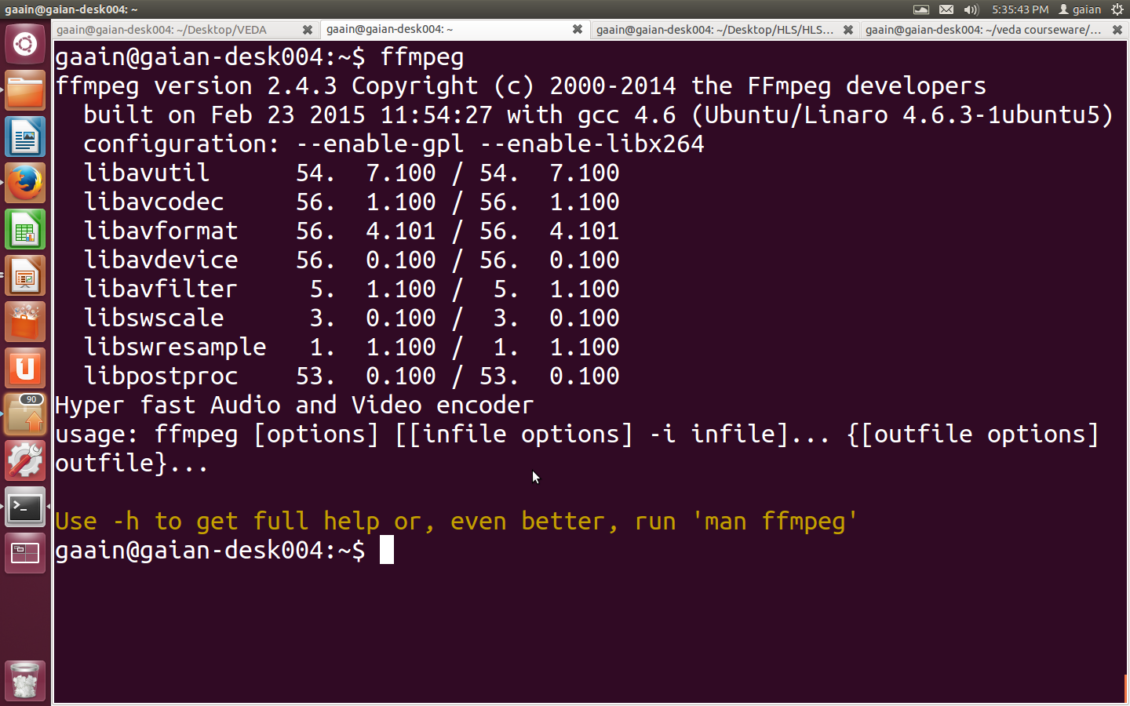
here the installed version is 2.4.3

How to check supported codecs ?
To check which codecs the installed ffmpeg supports then execute the following command
ffmpeg -codecs
sample screen shot
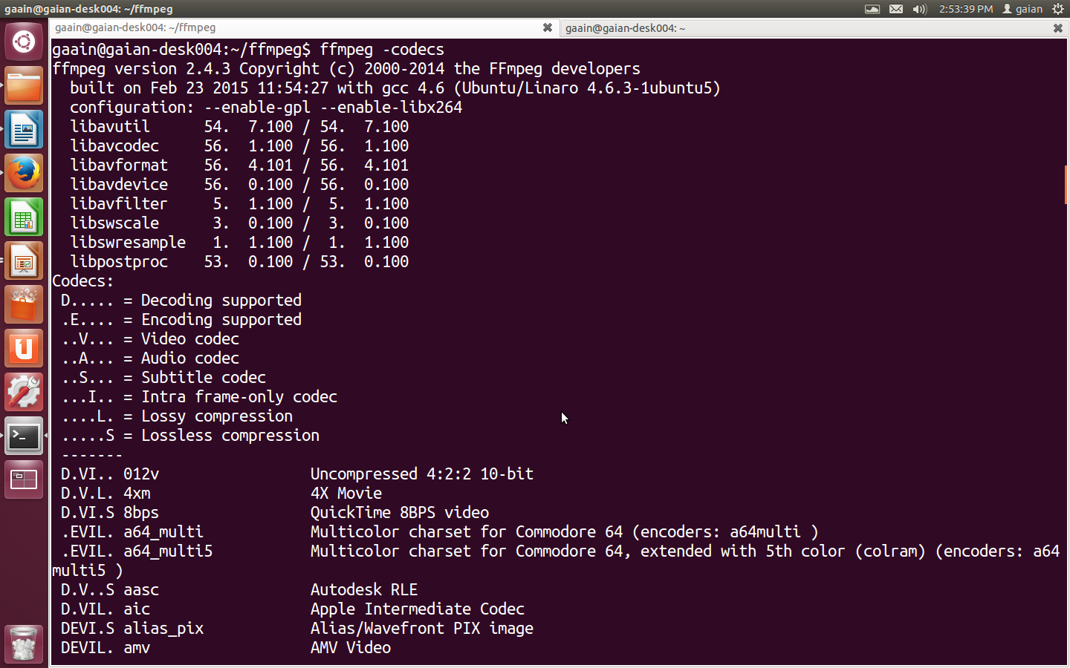

D= Decoding supported
E= Encoding supported
V= Video codec
A= Audio codec
S= Subtitle codec
I= Intra frame-only codec
L= Lossy compression
S = Lossless compression

How to check supported formats of ffmpeg ?
ffmpeg -formats
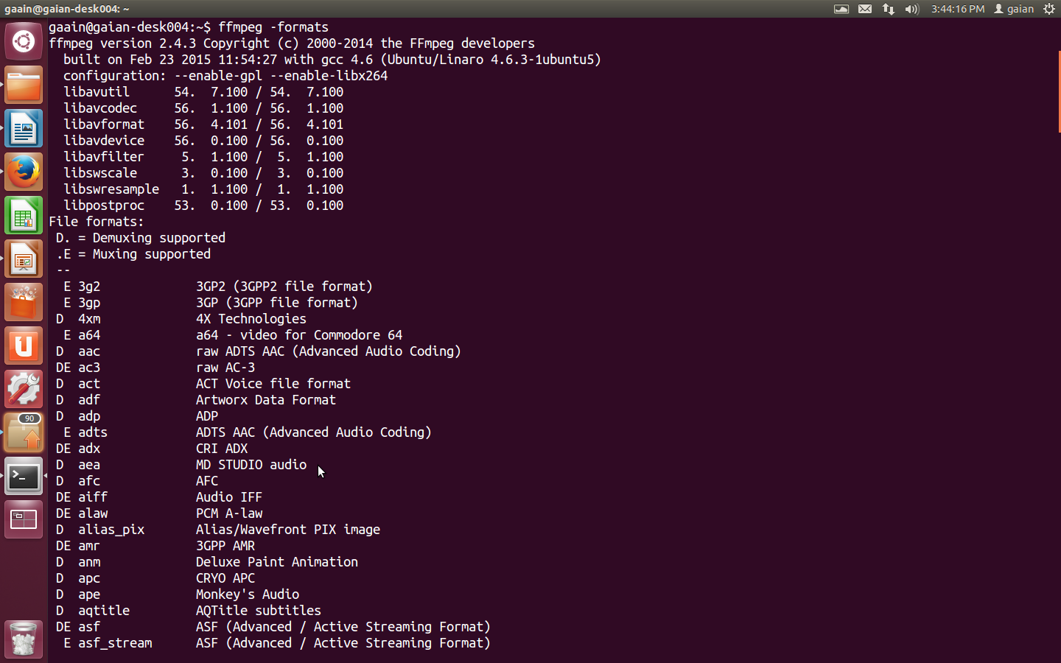
1.)ffmpeg command to get the information about media file
ffmpeg -i video.avi
this command gives information about bitrate,video codec,audio codec,container ,duration and some more information about media file
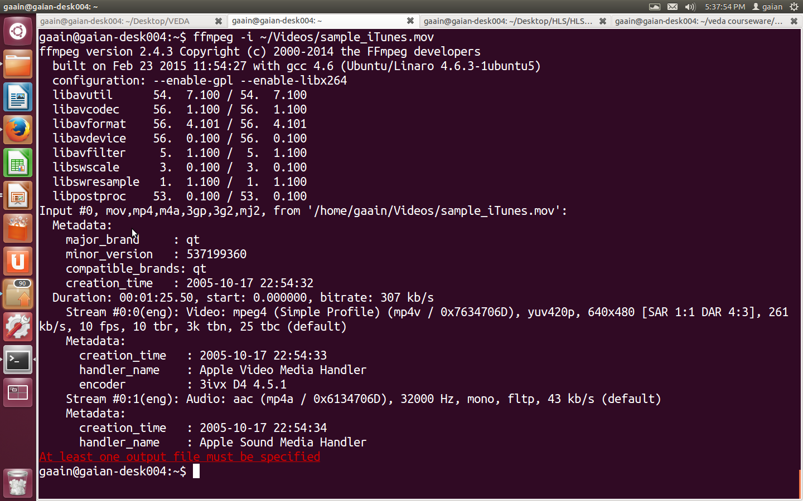

2.)ffmpeg command to convert video into images
ffmpeg -i video.mpg image%d.jpg
this command converts video video.mpg to images (image1.jpg,image2.jpg,image3.jpg,,,,)
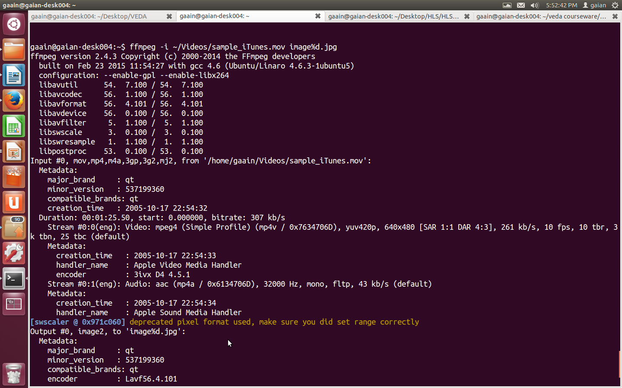
3.)ffmpeg command to extract video from media file
ffmpeg -i yourvideoname.mp4 -an onlyvideo.mp4
4.)ffmpeg command to extract audio from media file
ffmpeg -i yourvideoname.mp4 -vn -ab 128 onlyaudio.mp3
-vn is used to exttract audio and -ab is used to specify audio bitrate in Kbps
5.)ffmpeg command to change the comtainer format keeping video and audio codecs same
ffmpeg -i input.mp4 -c:v copy -c:a copy output.mkv
here -c:v copy ,-c:a copy used to tell the ffmpeg to keep the video and audio codecs same as input
if we didn't mention these copy parameters ffmpeg will re-encodes the content by default codecs
ffmpeg -i input.avi -c:v mpeg2video -c:a mp2 -b:v 10M -b:a 192k -muxrate 10M -f mpegts output.ts
-b is used to specify bitrate
6.)ffmpeg command to resize the resolution (Width*Height) values
ffmpeg -i video.mp4 -s 640x480 -c:a copy out.mp4
here video.mp4 is input filename
-s followed by 640x480 specify the final resolution
out.mp4 specify the final out put file name
6.)ffmpeg command to cut the file in to smaller clip
ffmpeg -i ~/chotahall/ABPNEWS4MBPS.ts -ss 00:00:45 -codec copy -t 40 outputclip.ts

-t specify the duration of the output file and -ss specify start point .This example we are cutting a video from ABPNEWS.ts from 45th second for 40 secomds
7.)ffmpeg command to convert one video format to another format
ffmpeg -i ~/chotahall/ABPNEWS4MBPS.ts -c:v libx264 -strict -2 filename.mp4

8.)ffmpeg command to merge audio and video
ffmpeg -i video.mp4 -i audio.mp3 -c:v copy -c:a aac -strict experimental -shortest output.mp4
-c:v copy make the video codec same as input codec ,-c:a aac makes the output audio codec as aac(advance audio codec) if we want input codec same in output codec specify -c:a copy

9.)ffmpeg command to add subtitles to a movie
ffmpeg -i movie.mp4 -i subtitles.srt -map 0 -map 1 -c copy -c:v libx264 -crf 23 -preset veryfast output.mkv
subtitles.srt contain subtitles of movie

10.)ffmpeg command to rotate video 90° clockwise
ffmpeg -i ~/Videos/10545894_590105417760011_1781322679_n.mp4 -filter:v 'transpose=1' -strict -2 rotated-video.mp4
11.)ffmpeg command to rotate video 180° clockwise
ffmpeg -i ~/Videos/10545894_590105417760011_1781322679_n.mp4 -filter:v 'transpose=2,transpose=2' -strict -2 rotated-video.mp4
12.)ffmpeg command to speed up or slow down the the video
the following command makes the video 2x slower
ffmpeg -i input.mp4 -filter:v "setpts=2*PTS" output.mp4
the following command make the video 4x faster
ffmpeg -i input.mp4 -filter:v "setpts=0.25*PTS" output.mp4
13.)ffmpeg command to speed up or slow down the audio
ffmpeg -i input.mkv -filter:a "atempo=2.0" -vn output.mkv
we can use any value between 0.5 to 2.0 for atempo
if we use atempo value 1.0 or more then the audio plays at faster speeds
if we specifies value lower than 1.0 then the audio playes at slower speeds
14.)ffmpeg command to extract all the keyframes(I frames) from a video clip
ffmpeg -i ~/Videos/katy.mpg -vf "select=eq(pict_type\,I),scale=73x41" -vsync vfr -qscale:v 2 thumbnails-%02d.jpeg

15.)ffmpeg command to create segments and playlist files for HLS support
ffmpeg -i /home/gaian/video.mpg -f segment -segment_list mediaplaylist.m3u8 -segment_list_flags -cache+live -segment_time 10 - segment_list_size 50 -segment_format mpegts -copyts “mediaplaylist_%05d.ts”
here
-segment_time specify the duration of each segment
-segment_list_size specify the maximum segments in playlist file
-segment_list specift the name of the playlist file
-copyts specify the output segments name
-segment_format specify the output format

ffmpeg as http server(sending)
ffmpeg -i somefile.ogg -c copy -listen 1 -f ogg http://server:port
ex:ffmpeg -i somefile.ogg -c copy -listen 1 -f ogg http://127.0.0.1:5555
-listen 1 enables http server
ffmpeg as http client (reciever)
ffmpeg -i http://server:port -c copy somefile.ogg
ex:ffmpeg -i http://127.0.0.1:5555 -c copy somefile.ogg

ffmpeg to stream data over udp
ffmpeg -i inputfile_name -f format udp://ip_address:port_number
ffmpeg command to stream mpegts file
ffmpeg -i input -f mpegts udp://192.168.24.135:5555
ffmpeg to receive over UDP from a remote endpoint:
ffmpeg -i udp://192.168.24.135:5555

ffmpeg command to take input rom fifo and stream same to rtsp nginx module
ffmpeg -loglevel verbose -re -i ~/myfifo -strict -2 -f flv rtmp://localhost:1935/hls/movie

