What is ffmpeg ?
Ffmpeg is a set of tools dedicated to decoding, encoding and transcoding video and audio. FFmpeg is based on the popular libavcodec and libavformat libraries that can be found in many other video conversion applications, like VLC,mplayer.
Installation
FFmpeg is free and open source, and it’s cross-platform. You’ll be able to install it on your Windows PC as well as your Linux server. The only thing you need to be comfortable with is using your command line. As it’s actively developed, you should try to update your version from time to time. Sometimes, new features are added, and bugs are fixed.
ffmpeg installation on Linux machine
download the source code from ffmpeg organization
https://www.ffmpeg.org/download.html#build-linux
download the source code
untar the source file
tar -xvf ffmpeg-2.8.tar.bz2
do to source code directory
cd ffmpeg-2.8/
then configure with h264 enabled
execute the following command
sudo apt-get update
install some of the dependancys
sudo apt-get -y --force-yes install autoconf automake build-essential libass-dev libfreetype6-dev \
libsdl1.2-dev libtheora-dev libtool libva-dev libvdpau-dev libvorbis-dev libxcb1-dev libxcb-shm0-dev \
libxcb-xfixes0-dev pkg-config texi2html zlib1g-dev
then do configuration
./configuration --enable-gpl –enable-libx264
if still any dependancys needded install then using following command
sudo apt-get install depenmdency_name
then do make followed by make install
make
make install

Which version of ffmpeg currently installed ?
Type ffmpeg command on command line it will give details of it's version and dependancys version
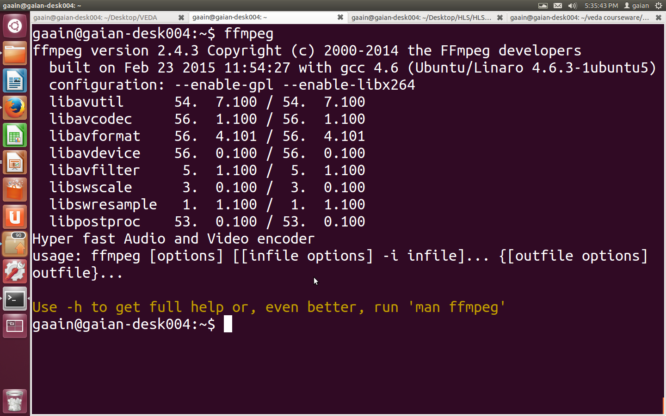
here the installed version is 2.4.3

ffmpeg command to get the information about media file
ffmpeg -i video.avi
this command gives information about bitrate,video codec,audio codec,container ,duration and some more information about media file
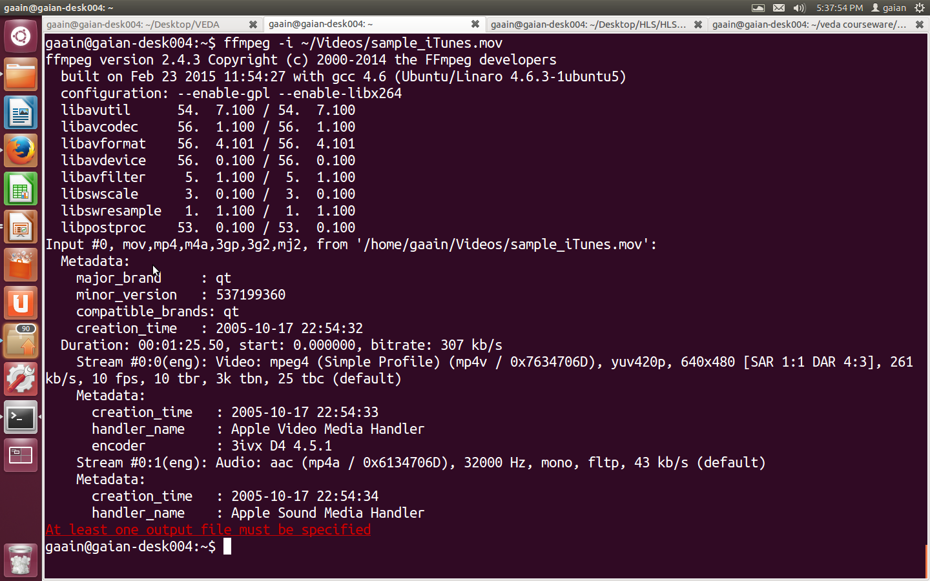

ffmpeg command to convert video into images
ffmpeg -i video.mpg image%d.jpg
this command converts video video.mpg to images (image1.jpg,image2.jpg,image3.jpg,,,,)
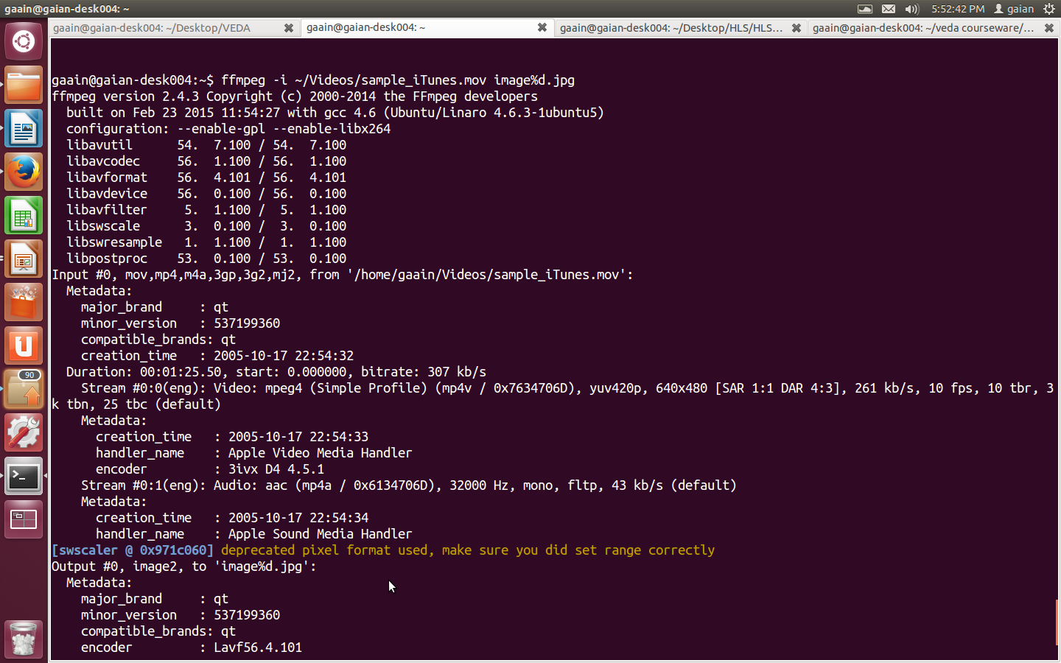
ffmpeg command to extract video from media file
ffmpeg -i yourvideoname.mp4 -an onlyvideo.mp4
ffmpeg command to extract audio from media file
ffmpeg -i yourvideoname.mp4 -vn -ab 128 onlyaudio.mp3
-vn is used to exttract audio and -ab is used to specify audio bitrate in Kbps
ffmpeg command to resize the resolution (Width*Height) values
ffmpeg -i video.mp4 -s 640x480 -c:a copy out.mp4
here video.mp4 is input filename
-s followed by 640x480 specify the final resolution
out.mp4 specify the final out put file name
ffmpeg command to cut the file in to smaller clip
ffmpeg -i ~/chotahall/ABPNEWS4MBPS.ts -ss 00:00:45 -codec copy -t 40 outputclip.ts
ffmpeg command to convert one video format to another format
ffmpeg -i ~/chotahall/ABPNEWS4MBPS.ts -c:v libx264 -strict -2 filename.mp4

ffmpeg command to merge audio and video
ffmpeg -i video.mp4 -i audio.mp3 -c:v copy -c:a aac -strict experimental -shortest output.mp4
-c:v copy make the video codec same as input codec ,-c:a aac makes the output audio codec as aac(advance audio codec) if we want input codec same in output codec specify -c:a copy

ffmpeg command to add subtitles to a movie
ffmpeg -i movie.mp4 -i subtitles.srt -map 0 -map 1 -c copy -c:v libx264 -crf 23 -preset veryfast output.mkv
subtitles.srt contain subtitles of movie

ffmpeg command to rotate video 90° clockwise
ffmpeg -i ~/Videos/10545894_590105417760011_1781322679_n.mp4 -filter:v 'transpose=1' -strict -2 rotated-video.mp4
ffmpeg command to rotate video 180° clockwise
ffmpeg -i ~/Videos/10545894_590105417760011_1781322679_n.mp4 -filter:v 'transpose=2,transpose=2' -strict -2 rotated-video.mp4
ffmpeg command to speed up or slow down the the video
the following command makes the video 2x slower
ffmpeg -i input.mp4 -filter:v "setpts=2*PTS" output.mp4
the following command make the video 4x faster
ffmpeg -i input.mp4 -filter:v "setpts=0.25*PTS" output.mp4
ffmpeg command to speed up or slow down the audio
ffmpeg -i input.mkv -filter:a "atempo=2.0" -vn output.mkv
we can use any value between 0.5 to 2.0 for atempo
if we use atempo value 1.0 or more then the audio plays at faster speeds
if we specifies value lower than 1.0 then the audio playes at slower speeds

