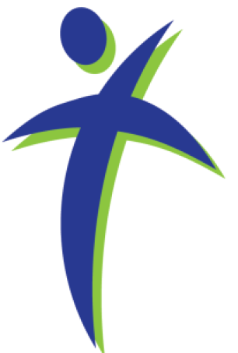
Faith, Hope, and Peace Ministries
432 S Washington St Westmont, IL 60559
630.710.0396 cdc33@att.net

Welcome!
We Worship Every Thursday at 10:30 AM

Devotion for Aug 8-10, 2017

Immediately the father of the child cried out and said, "I believe; help my unbelief!" -Mark 9:24
Emotions are slippery things. We're happy today, we're blue tomorrow. We're bored now, we'll be excited later. I'm feeling overwhelmed now, I'll be on top of the world at some point in the future.
Our attitude toward our faith is the same way, sad to say. There are times when we sit at the edge of our seat when the pastor preaches the Word of God to us - and there are times when we simply can't seem to keep our minds from drifting to other matters.
Martin Luther, the Great German Reformer, recognized this aspect of human nature - but also recognized that approaching the Holy and Almighty God with an apathetic attitude is very harmful to a person. Therefore, he gives the Christian the following advice. This is a paraphrase, from Luther's Small Catechism specifically from "Christian Questions and Their Answers."
When you are feeling far from Jesus and his grace, Luther advises you first to touch your nose. Ask yourself if it made of flesh. See whether or not you're still in your body. If you still have flesh and blood, you're in a dangerous spot. As it says in Galatians 5, "The desires of the flesh are against the Spirit and the desires of the Spirit are against the flesh, for these are opposed to each other - now the works of the flesh are evident - and those who do these things [sinful works of the flesh] will never enter the Kingdom of God." The only thing that can rescue you from your sinful flesh is the Gospel of Jesus Christ.
Second, you should take a look around you. What do you see? People? Buildings? The sky? Are you still in this world? If you are, you're in danger. Remember that in this world, there will be no lack of sin and trouble. Remember the words of Jesus in John 15-16: "If the world hates you, know that it hated me before it hated you...the world hates you...truly, truly, I say to you, you will weep and lament, but the world will rejoice..." The only thing that can overcome a hateful, hostile world is the victory of Jesus Christ our Lord--which he wins anew every time the Gospel is proclaimed.
Finally, if you are still in your flesh and still in this world, you can be certain that you have the devil around to harass and persecute you. He prowls around like a roaring lion, looking for someone to devour, as Peter writes. You cannot stand against the devil, but the Gospel of Jesus Christ prevails against this foe. The devil will let you have no peace, but Jesus is the Prince of Peace who gives you peace through the Gospel.
If you start touching your nose during a sermon, trust me, The Pastor won't mind. The Gospel is living, active, and powerful. The more you recognize the need for it, the more powerful its effect will be for you.
Prayer: Holy Spirit, you direct the eyes of the believer toward Jesus Christ. Help me always to focus on my Lord and Savior that the devil, the world, and my own sinful flesh may be overcome by his love and I may have eternal peace with him; through the same Jesus Christ, my Lord. Amen.
+ + + + + + + + + + +
The weekly worship services conducted by Lutheran Pastors and coordinated through Faith, Hope and Peace Ministries (a 501(c)3 organization as recognized the Internal Revenue Service) are provided at no cost to the attendees or the hosting facilities. Contributions to support this ongoing ministry may be made to "Faith, Hope and Peace Ministries" and sent to: 432 S. Washington Street, Westmont, IL 60559
We are thankful for your support helping continue this meaningful ministry!
Visit our web site www.fhpministries.org

Bringing the Church to the Unwillingly Absent in Residential Care Facilities
www.fhpministries.org

