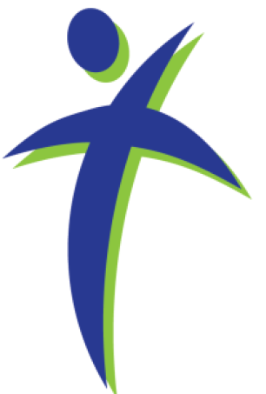
Faith, Hope, and Peace Ministries
432 S Washington St Westmont, IL 60559
630.710.0396 cdc33@att.net

Welcome!
We Worship Every Thursday at 10:30 AM

Devotion for Aug 8-10, 2017

"... the truth will set you free!" (John 8:32)
Jesus was speaking to a group of Jews who had believed in him as Lord and Messiah and he said to them. "If you abide in my word, you are truly my disciples and you will know the truth and the truth will set you free" The word free appears in the Bible 111 times and freedom appears 24 times. It is an idea that we as Americans hold dearly and reverently. One of our East coast states even puts this idea on their state flag. "Live Free or Die."
There has been much discussion in the secular media over something called "Liberation Theology." To be honest it is a coined phrase of recent vintage and one that in current usage lacks a real theological basis. It is much more social Gospel than Saving Gospel. The reason why is, that the whole truth of the Gospel, the Good News of Jesus Christ, is freeing and liberating. Easter is the climax to the season of the church year which emphasizes freedom. Easter is the most liberating experience that any Christian will ever have.
We often ask each other a question after Christmas; one that asks in essence, 'What did you get for Christmas?' But that is not a question that we need to ask after Easter. Not because we didn't get something but that we all got the very same gift. That was forgiveness of sins and the promise of life eternal with Jesus. There is no doubt what you got for Easter—it was freedom. You were liberated!
The whole of Easter reminds us that we are terrible sinners, sentenced to death and eternal pain and suffering as a consequence of our sinners. There is nothing we can do to right our wrongs, earn our way to heaven or do enough good works to counteract all of our sins. We are woefully and dreadfully oppressed by the weight of our sinners. There is no way we can free our selves.
Yet the whole substance of Holy Week, Maundy Thursday, Good Friday and Easter is how God liberates you from the oppression of sin. Through the life, death and resurrection of Jesus Christ, God's Son you have been liberated, freed, released from a sentence of death that was sure and certain.
Our Easter celebration needs to continue on this month and every month of the year. In fact, in the purest Christian understanding each Sunday is a mini-celebration of Easter. For each and every time when we come together to worship we review and revisit the Good News of Easter. We are reminded that we have been liberated, set free from our bondage to sin. No longer are we lost and oppressed but in fact are free!
He Is Risen, He is Risen Indeed, Alleluia—This truth sets you free!
Prayer: Lord God Almighty, I come to you with a grateful heart, because you have so graciously preserved me throughout these days and weeks. In your tender love, watch over me also this day, guard me from sin and temptation. Let not any irritations of this day rob me of the joy of my heart that comes from knowing you and reading your word. Let your divine love enable me to glorify your name with all that I do and say this day. Watch over all people who trust in you and forgive us as we come seeking peace in Jesus Christ our Lord and Savior. Bless me this day and keep me steadfast in faith, through Jesus Christ my Lord. Amen
+ + + + + + + + + + +
The weekly worship services conducted by Lutheran Pastors and coordinated through Faith, Hope and Peace Ministries (a 501(c)3 organization as recognized the Internal Revenue Service) are provided at no cost to the attendees or the hosting facilities. Contributions to support this ongoing ministry may be made to "Faith, Hope and Peace Ministries" and sent to: 432 S. Washington Street, Westmont, IL 60559
We are thankful for your support helping continue this meaningful ministry!
Visit our web site www.fhpministries.org

Bringing the Church to the Unwillingly Absent in Residential Care Facilities
www.fhpministries.org

