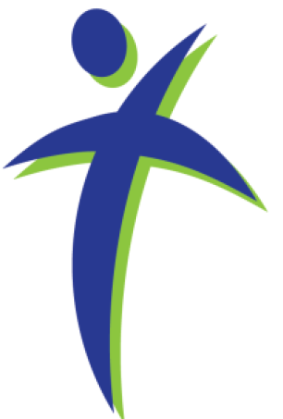
Faith, Hope, and Peace Ministries
432 S Washington St Westmont, IL 60559
630.710.0396 cdc33@att.net

Welcome!
We Worship Every Thursday at 10:30 AM

Devotion for Aug 8-10, 2017

"He is risen! He is risen indeed!" This traditional greeting is used in Lutheran churches on Easter Sunday morning. The words carry a great deal of significance for us and for our salvation. Paul says, "And if Christ has not been raised, our preaching is useless and so is your faith." –1Corinthians 15:14.
I was listening to the radio the other day and heard a Christian speaker say that the resurrection of Jesus Christ is absolutely essential to the claims of Jesus and the truth of our faith. It is the resurrection that gives meaning to the forgiveness earned on the cross on Good Friday. It is the resurrection which promises life eternal in heaven with Jesus. It is the resurrection which gives evidence to the appearance of the Holy Spirit on Pentecost. All of Christianity hinges on this one event.
The speaker went on to say that if the disciples had invented the Christian faith, they would not have selected a bodily and physical resurrection as the lynch pin for their claims of Jesus as Lord. Their claims about the resurrection of the body would be easily proven false if the body or bones of Jesus were discovered somewhere. If the disciples had been peddling a fraud, they would have been much wiser to claim a spiritual resurrection only, which could not be dis-proven by any physical evidence.
It is interesting to note that among the recent attacks on Christianity was one on this key truth of the resurrection. A Hollywood producer, James Cameron, contended that a recently-discovered Jewish ossuary, a burial container, held the bones of Jesus and thus proved that Jesus was buried and never resurrected. Scientists from around the globe found that the evidence was unconvincing and did not refute the disciples’ claim that Christ is risen.
In fact, Paul speaks of the people who saw the resurrected Christ. In 1Corinthians 15, Paul writes "that he was buried, that he was raised on the third day according to the scriptures and that he appeared to Peter and then to the twelve. After that he appeared to five hundred of the brothers at the same time…. Then he appeared to James…. and last of all he appeared to me also, as to one abnormally born." –(15:4-8)
So on Easter Sunday morning and during the weeks after Easter, we will use this traditional greeting to testify to the most significant event in all of human history—the resurrection of Jesus, our Lord and our Savior. "He is risen! He is risen indeed!"
Prayer: O Lord, you have searched me and know me. You know me when I am sitting down and resting and when I am up and about each day. You know when I have sinned and disobeyed your will and word. And you know when I have lifted you up and brought honor and glory to you with my words and actions. Each morning may I begin my day with praise and thanksgiving on my lips. And each evening may I be granted your forgiveness and your abiding presence as I look for restful sleep. Whether I am awake or asleep I ask you to watch over me and care for me, your very own child. Amen.
+ + + + + + + + + + +
The weekly worship services conducted by Lutheran Pastors and coordinated through Faith, Hope and Peace Ministries (a 501(c)3 organization as recognized the Internal Revenue Service) are provided at no cost to the attendees or the hosting facilities. Contributions to support this ongoing ministry may be made to "Faith, Hope and Peace Ministries" and sent to: 432 S. Washington Street, Westmont, IL 60559
We are thankful for your support helping continue this meaningful ministry!
Visit our web site www.fhpministries.org

Bringing the Church to the Unwillingly Absent in Residential Care Facilities
www.fhpministries.org

