Errata
- Recommendation: Use a AA battery
- USB C needs resistors on CC1 and CC2 to negotiate power. Solution: 5.1k each from CC1 and CC2 to ground
- Resistors for each LED need to be increased from 470 to something like 1k
  - Voltage across Green LED resistor at VCC = 5 🡪 2.4V 🡪5.1mA
  - Blue LED 🡪 2.2V 🡪 4.7mA
Vcc | 5 | 2.8
Resistor V_{Red}
Resistor V_{green} | 2.4 | 0.45
Resistor V_{blue} | 2.2 | 0.24
Total I_{Red} (mA) | 272 | 86
Total I_{Green} (mA) | 265 | 53
Total I_{Blue} (mA) | 222 | 29

5V output draws too much power from the coin cell battery, so supply voltage is dropping and VCC cannot be maintained. Fix: Lower Vcc. This can be done by changing R76 to the following:
- 680k: ~5v
- 360k: 2.9V
- 345k: 2.8V
- 330k: 2.7V
- 71k: ~2.77V

Summary of changes to keep battery life reasonable
- R76 🡪 680k, buck71utput it 2.68V instead of 5V
- R99 is 47k instead of 470 (Green)
- R98 is 33k instead of 470 (Red)
- R100 is still 470 ohm (blue LEDs have higher Vf)

Second Revision
- Add a higher ntroller and fill in the rest of the LEDs to make a grid
  - STM32L05x promising
- 24x8
- AAA battery x 2 for combined, ~1AH each for 2AH. 40mA continuous draw = 50 hours
- RGB option
- Possible PWM options
  - PCA9635
  - PCA9685
  - tlc5940 (too expensive)

Font
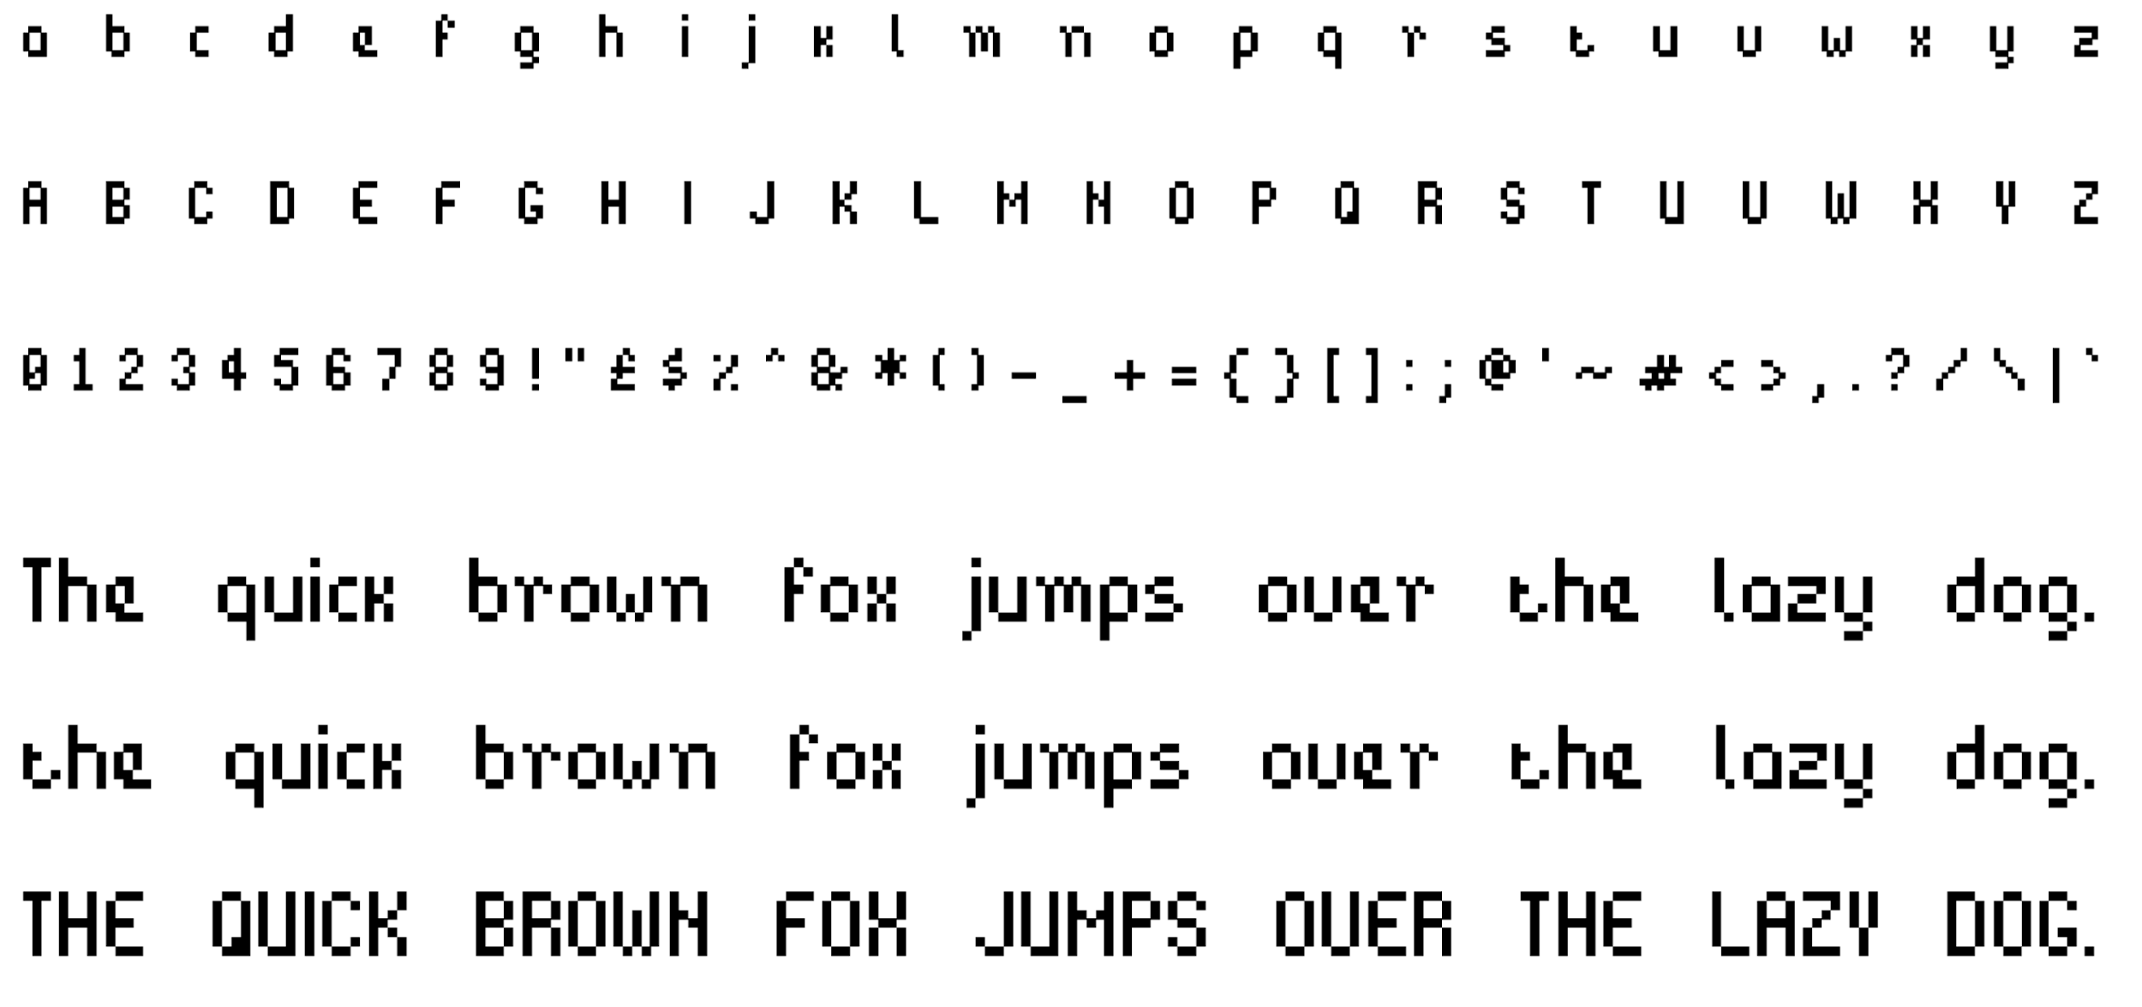
https://imgur.com/a/bitpotion-free-4x7-pixel-font-KjeUx

Development plan
LED array is 19x7
38 blank spots
-->95 LEDs per board
If using 3mm TH LEDs, 4mm per led,
- LED: C22461786 (2.7x2.8mm)
- Boost converter:
  - TPS63002 (C116655),
  - inductor (C9890)
- Flip flop: C6762 / SN74HC74DR
- BJT: C2150 / 300mW.Vce sat = 500mv, 🡪 600mA max
- USB C connector: C165948
- Battery holder: C964806
- 10uf cap: C1713 (0805 X5R 16V)
- 100nF cap: C1591 (0603 50v X7R)
Unit cost > 100:
Lithium ion batteries: 1.48Wh
AA batteries: 2-4Wh
CR2450: 0.59540
Boost: 0.1235

$500 manual assembly fee
- Either LEDs, switch, battery, or USBC
- Not USBC
- Not switch
- Not battery
- It is the batteries

https://www.snapeda.com/parts/TYPE-C-31-M-12/HRO%20Electronics%20Co.,%20Ltd./view-part/

Senior banquet is may 2nd
Order right now, 4/7 in china, PCB gets built on 4/10. PCB is assembled by 4/16, arrives 4/20

Cost of prototype run: base time is 3 days PCB, 5-6 days assembly 🡪 $145 pre shipping.
3-4 days assembly adds $95 for a total of $240
1 week turnaround, i.e. shipping on 4/14, arrives 4/21. Order on 4/21

Full batch run with expedited assembly will cost $500 pre shipping,

Order right now, first PCB is assembled on 4/13. If that PCB works, do a batch

Options:
Get JLC to test a board for us:
- Order 10 prototypes right now, boards done on 4/14. Gets delivered by 22nd-24th
- Order 50 on the 14th, boards done on 26th, ship on 26th, arrive

- Double checked LED footprint
- Double checked stop mask
- Double checked BJT pinout
- Double checked switch

Battery life measurement
- Turned on at 3:19PM with 324k resistor (Vcc = 2.66)
- Lasts about 40 minutes

