Introduction
The Virtual Programming Lab is an online interactive student laboratory environment that is designed to mimic the experiences a student would encounter in a physical campus computer lab, but without the constraint of physical proximity. Students are able to chat and share code as though working over each other's shoulders in a physical lab, and are also able to interact with instructors and tutors as needed. They can run, compile, and view their web, java, and C++ projects in an IDE-like setting, all from within the web browser.

Previous Technologies
Online IDEs and Virtual Programming environments are not new. There are several projects whose purpose is to enable asynchronous or synchronous programming collaboration. Some of these are even oriented towards academic environments. However, no-one has brought the social nature of a student lab to the online sphere. Here, we discuss some of the earlier work in this area.

Online IDEs
IDEOne provides a system for editing and executing code. It doesn't provide file management, it's purpose is to allow small scripts to be entered, executed, and shared online. It does not provide support collaboration or sharing, rather, the results of code copied into the ideone box are meant to be shared through other channels (instant message, facebook, e-mail). It uses editarea for syntax highlighting, the same javascript editor we use in VPL. http://ideone.com/
It has been integrated into Moodle as an automatic grading plugin. https://code.google.com/p/sunner-projects/wiki/OnlineJudgeInstallation
Coderun provides a full IDE with file management, project management, code completion, and compilation. It supports code sharing and collaboration, along with numerous languages. It does not support interactive chat or any instructor/student separation. http://coderun.com/ide/
phpanywhere is a web based php editor featuring most common IDE topics, but it is only able to edit php code. http://phpanywhere.net
Mozzilla Skywriter (previously known as Bespin) is a fully customizable web-based programmer's editor that supports cloud coding and compiling. It supports collaborative editing, extensions, syntax highlighting, testing, and more. It is the most complete cloud-based IDE currently available. https://mozillalabs.com/skywriter/
Kodingen provides an online environment that integrates with editors like Bespin. It provides the backend, cloud storage, databases, and other features, and plugs into the online editors to do the work. It doesn't strictly support collaboration, but multiple users can access individual files and edit them. http://kodingen.com
embide is creating an embeddable ide (currently in beta) that supports version control, user management, syntax and error highlighting, collaboration, chat, and deployment. It is designed for distributed teams of coders, with no support for student-student or student-instructor interactions. http://www.embide.com/

Virtual Programming Labs
University of Las Palmas de Gran Canaria (Spain) has created a Virtual Programming Lab plugin for the Moodle Course Management System. It does not support interactive file sharing or discussion between students, but is designed for independent assignment submission with optional automatic evaluation. http://vpl.dis.ulpgc.es/
Cao, Chan, Cao, and Yeung have written the "Virtual Programming Lab for Online Distance Education” (2002) Lecture Notes in Computer Science. Their lab allows students to log in remotely from home or separate campuses and use lab software directly. It does not support web based editing, collaboration, or communication. http://www.springerlink.com/content/6dk381tqcq58m6nm/
Dincer and Fox published a VPL document in December 1998, “Using Java and Javascript in the Virtual programming laboratory: A web-based parallel programming environment.” It is designed with parallel computing education in mind. It provides a web based interface to server-side editors, file managers, and compilers. It also provides no support for collaboration, chat, or communication. Search Wiley database in AU Library.

Virtual Computing Labs
NCSU provides the Virtual Computing lab, a system for reserving logins onto remote systems. The logins last one hour and can be renewed for up to six hours. This allows users to use specialized software on remote system, but does not provide support for collaboration or marking. http://vcl.ncsu.edu/ It was later released as open source as the Apache VCL. https://cwiki.apache.org/VCL/ The published paper is “Virtual Computing Laboratory (VCL) by Averitt Bugaev, Peeler, Shaffer, Sills, Stein, Thompson, and Vouk, 2007.
IBM has published “A Cloud Computing Solution for Universities: Virtual Computing Lab” by Moothoor and Bhatt, 2009. It is an extension to the NCSU lab to use automatically allocated cloud servers. http://www.ibm.com/developerworks/webservices/library/ws-vcl/
All of these technologies serve different purposes in distributing resources to both career programmers and students, and in allowing both synchronous and asynchronous collaborative development. However, none of them make an effort to simulate the easygoing social aspect common in university computing labs. This in where the VPL comes in.

VPL Technologies
The Virtual Programming Lab backend is primarily implemented in the Python programming language using the popular Django web application framework. Python version 2.7 and Django version 1.2.4 are used. Python was chosen for its versatility and rock hard history. Django is one of the most popular web frameworks in use today, and has a rigorous history of test and documentation driven development. It is well maintained and security releases are issued within hours of major problems being uncovered.
Django provides many useful tools out of the box, including built-in session management and an authentication and authorization system. It provides its own templating language to generate html pages populated with values passed in from the python backend. A robust object relational manager allows a wide variety of database systems to be chosen.
We chose PostgreSQL is used as the database system. PostgreSQL provides excellent support for database tuning. Another important feature not available in other popular database systems (notably, MySQL) is the ability to use transactions for schema-modifying commands. This is important when migrating the database schema. If something goes wrong during a migration, we don't want the database to end up in an inconsistent state.
A Django app known as South is used for database migrations to ensure that development and production systems have the same database schema. South allows the database schema to evolve over time. It is usually able to automatically introspect changes to the ORM schema, and allows the structure of the database to move forward and backward over time. When changes are made in development (e.g. adding a column to a table), South will create a migration script. Later, when the changes are pushed to a production web server, South runs a migration to ensure the production database is up to date. In the rare event of a problem, the migration can be reverted and fixed manually for the production system or systems.
Zc.buildout is used for deployment. It will download and install all dependencies in a reproducible manner, and makes updating disparate systems simpler. Buildout is composed of pluggable recipes that can install and configure virtually any dependency. It is able to compile C libraries (such as psycopg2, the Python postgres connector), download python libraries (such as Django and South), import libraries from various version control systems including Mercurial and Git. It is even able to configure run scripts for Django. It wasn't necessary for the VPL, but it is even possible to develop new recipes to perform complicated deployment tasks.
Our web application is deployed on a traditional Linux server setup, using Apache as a reverse proxy to a WSGI frontend. WSGI is a Python standard for communicating with web frameworks. Apache ties into the Django WSGI connector to execute each incoming HTTP request.
The frontend of the VPL web application is, of course, implemented in standards compliant XHTML (1.0 Transitional), CSS, and javascript. The powerful jQuery library is utilized to make the interactive elements work, including AJAX calls, DOM updates, effects, events, and other manipulation. JQuery has become a de facto standard javascript framework. Its primary features include a powerful CSS inspired element selector, cascaded manipulations, and complete cross-browser compatibility.
The syntax highlighted editor widget is supplied by the popular opensource EditArea widget (http://www.cdolivet.com/index.php?page=editArea). Many projects are using this widget for source highlighting, however it has not been updated recently and is not yet compatible with Internet Explorer 9.
The 960 Grid system CSS framework is used to manage layout. The grid splits the display width into fixed sized blocks and takes the guesswork out of placing HTML block elements on the page. In the VPL, this is used to create a three-column IDE-like system, with project and file management functions on the left, and chat features to the right of the code area. The grid system also allows placement of a context-sensitive menubar above the IDE.

VPL Design
The VPL IDE is comprised of four visual components: classlists, labs, chat, and projects. The backend has seperate modules (known as “apps” in Django parlance) for each of these, as well as a separate vpl_profile app for user profile management, and an encompassing ide app that ties the other apps together. In addition, Django provides a built-in admin module that is used for the administrative functionality (user creation, class management, etc) in the site. The Django auth system is also used directly for logging in both administrative and normal users
The frontend code is divided between a collection of Django templates (mostly static HTML files with directives for including dynamic code in them), a css file for display, and a javascript file containing the client side dynamic code. All javascript is included in a single file for efficiency reasons, as the file only needs to be downloaded once for the entire site.

Frontend Layout
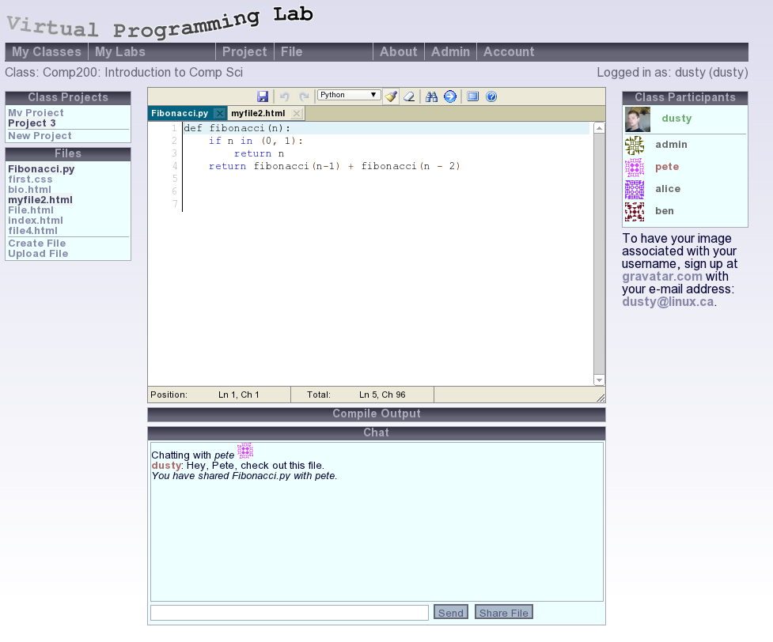
The majority of the user's time is spent at the /ide/ url, with javascript loading the required functions using asynchronous calls when certain events (usually mouse clicks on page elements) are triggered. Several functions will take the user away from this url, usually to perform a basic create, update, or modify REST action using the traditional GET-POST-REDIRECT paradigm.
For example, if the user clicks the “Create Project” link, they will be directed to a page via a GET request to display a form requesting project details. When they next submit the form, a POST request will process the details. If the form is invalid, it will be rerendered with error messages, and the user will be allowed to edit and POST the form a second time. But if it is successful, the project will be created and an HTTP 302 redirect will send the browser back to the main /ide/ url. Other functions that use this paradigm include deleting editing projects, creating, uploading, renaming, or deleting files, and account management.
The javascript in the /ide/ page supports several GET parameters for selecting projects and files for display when the page is loaded. For example, if the user has created a new project, in a lab, the GET querystring “?lab=1&projectlist=2” will be appended to the url. Once the IDE has loaded, javascript will inspect these parameters and ensure that the appropriate lab and project menus are populated.
Most other events on the /ide/ page are loaded via asynchronous requests when events occur. Classes and Labs are treated nearly identically, even though they have different purposes. Classes have specific instructors and are designed to allow students to communicate with the instructor or other students taking that class. They model a tutored lab for a specific class at a specific time. Labs, on the other hand, model a drop-in lab, where students can walk in, develop a project of their choosing (be it a class project, experimenting with textbook examples, or an extracurricular programming exercise of their choosing), and chat with other students in the lab. The different labs in the VPL are organized around programming themes; there is a C++ lab, a Java lab, and a web development lab.
When a class or lab name is clicked in the menu, the student's projects for that class or lab are loaded in the background and displayed in a list on the left-hand side of the screen. When a project is selected from this list, a list of files is similarly loaded, and the project menu is updated to refer to context-sensitive functions that make sense for the currently active project (For example, a Java project can be compiled, and web projects can be viewed in a new browser window). When a file is clicked, its contents are loaded into the code editing area via an asynchronous call, and the file menu is similarly updated. The EditArea automatically takes care of syntax highlighting and tabbing of multiple open files and provides several code editing features such as searching and line numbering.
The chat module is displayed upon the right side of the screen. While it at first appears to be independent of other aspects of the IDE, it actually loads a different list of users depending on which labs or projects they are actively editing files for, and which classlist or lab the user is currently browsing. The chat module uses a polling system to look for new messages; every ten seconds, an ajax call checks to see who is currently logged in, and updates the color of users who have sent the user unread messages. Clicking a username sends another asynchronous request to load the chat log for that particular user. When a chat log is open, it also polls to see new messages between the two users. The chat module also contains functionality for sharing files. Clicking the “Share File” button will share the file currently displayed in the EditArea. A link to the file will then be appended to the chat messages window. If the receiving user clicks this link, the shared file will be displayed in a read-only view in a new window, with line-numbers and appropriate syntax highlighting.
The chat userlist displays a small avatar beside each user to identify them, and displays the user's name in a different color depending on their status. Avatars are supplied by the online service Gravatar.com. If users already have a Gravatar account, their image will be used automatically, so they do not have to upload an image for themselves. Gravatar automatically creates a random graphic for users that do not have accounts.
The current status of each user in the user list is described by the color of their username. Online users are shown in green, while users not currently online are displayed in grey. The instructor for a class is highlighted in red. If any user in the list has sent an unread message to the student, their name is highlighted in blue.

Backend Layout
The backend code follows the Django model, template, view layout for each app. This is very similar to the traditional model, view, controller design pattern, but it can be confusing because Django calls controllers “views”! The templates (views in MVC parlance) are discussed above, we'll go into more detail of the models and views here.
Django has its own object relational manager for mapping models to database tables. It supports inheritance, many to many relationships, and complex querying. Each Django app (classlist, lab, project, vpl_profile) is a django package and has its has it's own collection of ORM database models. These models and apps have relatively simple, concrete relationships in the VPL.

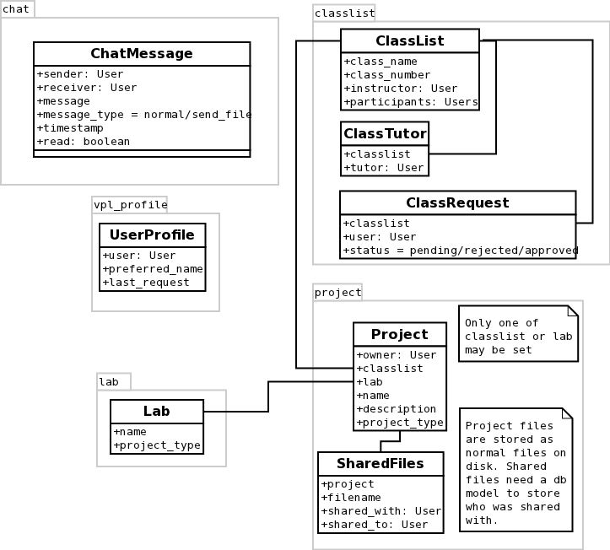
- classlist app:
  - ClassList: Represents a class by name and number. Holds a M2M relationship to participants.
  - ClassTutor: M2M relationship between classes and users that tutor that class
  - ClassRequest: Model users that have requested participation in a particular class, as well as the status of that request.
- lab app:
  - Lab: Represent a lab by name and the type of project (for compiling)
- project app
(Note: The project app is the most complicated app in the VPL. It models both projects and student files, and all the interactions with it. Files are stored on disk and looked up by project id.)
  - Project: Models a project by name with attributes for which lab or class it is associated with, and which user owns it.
  - SharedFiles: Models filenames in projects that have been shared between two users during a sharing session in chat.
- vpl_profile app:
  - UserProfile: Attached to users to model attributes required by the VPL. This is a one-to-one relatioship to the Django auth app User model. It is set up as a separate model so that the auth app can be implemented autonomously from the project-specific profile information. We store the user's nickname and last request time (to calculate if they are logged in or not) in this model.
- chat app:
  - ChatMessage: models a message sent between a specific sender and receiver. Models different types of messages, including normal chat and files sent between users.
In addition to items modeled in the database, files attached to student projects are also modeled. They are stored in the operating system filesystem in a specific folder hierarchy, and the projects app has functions for loading specific files and listings. The VPL does not support folder hierarchies; all files go in one directory for the project. The purpose of storing files in the filesystem is to allow commands that expect files to be run on them. Most notably, compiling a project requires compiling each of the files in the project's folder. Compilers expect filesystem objects, not databases. They also generate new files (i.e. the compiled executable or .class files) that need to be displayed to the student. Thus, the web interface introspects the filesystem to retrieve the available file list, instead of indexing them in the database.
Each app is represented by a separate Python package, which is represented as a folder containing a file named __init__.py. Each package contains python modules for models.py and views.py for the ORM and view code, as well as any support modules for forms or other features. In addition, each app has a separate listing of regular expression based URLS (mostly REST based, with the occasional RPC style action). Each url maps to a view function with parameters captured from the regular expression. Each view is a function that has to return a Django response object. Both normal views and ajax requests are modeled in the views.py module, the format of the data returned (HTML for a normal request, JSON or an HTML snippet for an ajax request) normally depends on the template that was rendered. The normal format of a view is to receive a request, process the url parameters, process any GET or POST parameters, update the database or filesystem, and return an appropriate response.
The non-ajax create, update, and delete views discussed earlier that follow the GET-POST-REDIRECT paradigm use Django forms to process the data. The forms are stored in a forms.py python module for the app. They model an HTML form to the user; specifically, which input fields should be displayed, as well as performing an validation and data conversion to make the transition between human-entered data and machine readable data as simple as possible for both programmer and end user.
A particularly useful class in the Django forms package is the ModelForm, which automatically maps the models discussed above to forms that are prefilled with data from a specific instance of a model. It is also able to save the form to the database after it has been submitted. The views for these forms instantiate a form in the GET request, possibly prepopulated with values to be edited (in update requests). Then when the user submits the data via POST, a form is instantiated with the POST data, and Django validates the data. If the data is not a valid submission, it returns the GET request with error messages, otherwise it returns a redirect to an appropriate location.

User Experience
A typical user experience would be to first request an account on the VPL. Once an administrator has authorized the request, the user account is created and the user can log in. She will be presented with the main IDE screen. Likely, she won't have been assigned to any classes yet, so she'll open a lab of her interest.
A newly created lab has a default project created so the new user can start creating and editing files in that project with a minimum of overhead. To get a feel for things, the user may create a few files in the project. She'll edit the files in the text area, switching between tabs to see different files. Once she has saved the files she can explore the Project menu to figure out how to compile it.
At some point in this process of compiling and editing files for one or more projects in different labs, they'll discover they have a question. They can scroll through the logged in names on the user list for the current lab and click one to open a chat session. The other user may be a friend, classmate, or even a tutor or instructor in one of the classes. She can ask her question in the chat message. When the second party responds, his name will be highlighted in blue, and the message will show up in the chat window. If the user is chatting with multiple users, she can click different blue names to see different responses.
Finding herself unable to explain her problem adequately, she can click the “Share File” button to share the file that is causing her troubles with the currently selected user. This mimics the act of two students debugging the same piece of code in a physical lab setting. The helping user can glance through the code and mention a line number that looks like it needs correction in the chat window. Having fixed the offending line, she can compile and run the file, still maintaining her conversation with the helper.
Once she's been assigned to a specific class, she'll find that when editing a project for that class, she can chat with other members of the same class. Whereas a lab is restricted to currently active user chat, it is actually possible to leave a chat message for a user that is currently offline. More importantly, she can directly question the instructor or a specific tutor for that lab while working on a project that has been assigned for the course.

Administrative Interface
The administrative interface for the VPL allows people with appropriate user privileges to access additional functions. The admin interface is a heavily customized version of the Admin system Django provides. Django's built-in admin allows basic Create/Read/Update/Delete requests as well as filtering and searching for each ORM model that has had an admin feature defined. We use these to manage users and permissions, Labs, Classes, and Student Projects.
Django has a built-in authentication and permission management system. We set up the VPL to have four levels of permissions: students, tutors, instructors, and superusers. Students can only access the main VPL features. Tutors can access the student lists for classes they tutor. Instructors can manage any classes they are an instructor of, and superusers can perform all administrative duties such as creating new classes and assigning instructors to them or approving newly registered students for membership in a given class. If the current user is a tutor, instructor, or superuser, a custom Admin menu will show up in the main VPL menubar. This menu will contain links to the features that user has permission to modify.
The participants section allows the list of registered users to be introspected and manipulated. A list view lists each username along with their name, email, and whether or not they are an instructor or superuser. The list can be searched and filtered. Individual users can be edited by the superuser, if necessary.
The labs section allows labs to be created or edited. In normal usage, this section would not likely be manipulated. Labs normally require code development (to facilitate any custom compilation or viewing commands for the specific type of lab) in the backend before they can be added. The VPL includes three types of labs by default; Java, C++, and Web labs. The former two use javac and g++ as compilers, while the latter allows the created HTML pages to be viewed in a separate window. The admin view allows searching and editing of the labs, but aside from a name and type, neither of which should change, these objects have nothing to edit.
The classes section has the most administrative support. Even though classes and labs behave very similarly from the students' point of view, they are treated quite differently by administrators. The superuser is able to list, filter, add, and edit all possible classlists. Instructors are only able to manipulate those classes that they instruct. The list view for classes simply lists the name and course number. However, the edit view is more robust and allows the instructor or administrator to change the participants list, add or remove tutors, or change the instructor, course number, or name.
A view for approving user participation is custom built, but provides a look and feel that integrates with the Django admin. Students can request membership in any course. The superuser can then choose to approve or deny participation from the approval page. The page simply presents all requests with checkboxes, and those that the admin checks will be approved for access to a given course.

Future Work
The VPL has plenty of room for future development. One useful feature would be to provide template projects or lab assignments that tutors can create for entire classes or for individual student sessions. Such a template might include previously written code with areas that the student has to complete. It could also contain instructions for completing the assignment.
The VPL is designed to model a lab, rather than courses or lectures. It does not include support for lecture notes, assignments, scheduled readings, grading, or related tasks. This is an area where future work could expand the lab. Alternatively, it may be possible to integrate the VPL into Moodle or other course delivery software. In this model, the course would be delivered via Moodle, and assigned lab sessions could be scheduled where the student is expected to perform work in the VPL.
The chat backend for the VPL could be greatly improved by utilizing HTTP push technology, such as comet or websockets, instead of the polling currently implemented. Push technology would mean that chat messages are received as soon as they are sent instead of the up to ten second delay currently experienced.
On the subject of chat, there is also room to expand the chat system into a multi-user system (like a chat room) so that users can interact with multiple participants at one time. This does not model typical lab interaction, though; typically only two or three students are collaborating at any one time. Support could also be added for a broadcast type medium, where an instructor can send chat messages to multiple students at one time. Possibly, individual students could request to pose a question in a “raise your hand” type of atmosphere.
One major problem with the interface is that the Editarea javascript editor that we utilize for code editing is buggy on certain browsers. On the recently released Internet Explorer 9, it doesn't work at all. The system works most effectively on webkit browsers such as Google Chrome and Safari, and behaves acceptably on Firefox. The Editarea is written in Javascript and is open sourced, so we have the ability to improve it if necessary. The original developer seems to have lost interest in the project, but it is actively used in numerous online code editing projects. It is likely that another open source developer will pick up maintenance of the code editor before too long.

