Virtual Programming Lab Manual
The SCIS Virtual Programming Lab is a study tool for programming students to code and interact in an online virtual lab, mimicking the experience of an on-campus lab, with coding tools, chat interation, and project management.

Registering
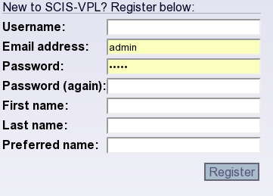
Before you can start using the SCIS-VPL, you need to create a user account. All your classes, projects, and files will be associated with this account. The registration process is simple. Visit the main VPL page at http://vpl.athabascau.ca/ and enter a username, e-mail address, and password. You should also enter your first and last name for display purposes, and can provide a preferred name for chatting if you would like to keep your real name private. The VPL will tell you if the username is already taken, otherwise you will be automatically logged in and ready to go.
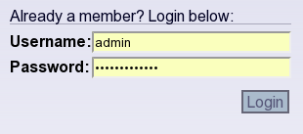
If you are already registered, you can use the login form to access your saved projects and chats. Simply enter the username and password on the VPL front page, and you'll be taken to the IDE.

Labs, Projects, and Files
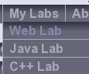
Once you've logged in, you'll be presented with the main IDE screen. To get started programming, choose a lab from the “My Labs” drop-down menu. The three labs have slightly different features; if you choose a web lab, you'll be able to create web pages in html, javascript and css. The Java lab allows you to write java classes and compile them, while the C++ lab alows compilation of C and C++ projects.
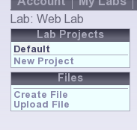
When you select a lab, it displays a list of projects on the left side of screen, along with a link to create a new project. Labs have a project named “Default” created when you first log in, so you can start coding as quickly as possible. Select this project or create a new one to start adding program files.
When a project is selected, the list of files shows up below it. There are no files by default, but you can choose to create an empty file using the “Create File” link, or to upload a file from your computer if you have already started working on one.

Create
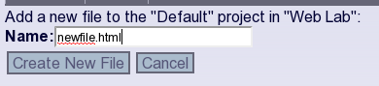
When you click the “Create” link, you simply need to enter a filename for the new file to be edited. Ensure that the link has a valid extension (ex: that it ends with .html, .txt, .java, .css or similar), as the extension is used to help figure out syntax colouring for the file. Click the “Create New File” button and the new empty file will be opened in the IDE and will be listed in the Files box on the left side. Or click the “Cancel” button if you have decided you do not want to create a new file; you will be taken back to your project.

Upload
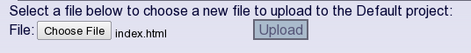
Uploading a file is very similar, except you must select the file from your hard drive. Click the “Choose File” or “Browse” (note, your browser may display the box differently from that displayed) to select a file to upload. Then click the upload button to copy the file into your VPL project folder. The file will be opened in the editor. The upload feature can be useful for putting images in website projects or adding other files that can't be edited in the editor.
If you select to upload a zip file from your harddrive, the files inside the archive will be extracted and added to the project individually.

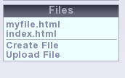
Open
You can also open files that have previously been added to the project by clicking their filename in the box on the left side of the screen. It is possible to have multiple files open for editing at one time. You can switch between them using the Files box, or by using the tabs at the top of the editor window.

Editing
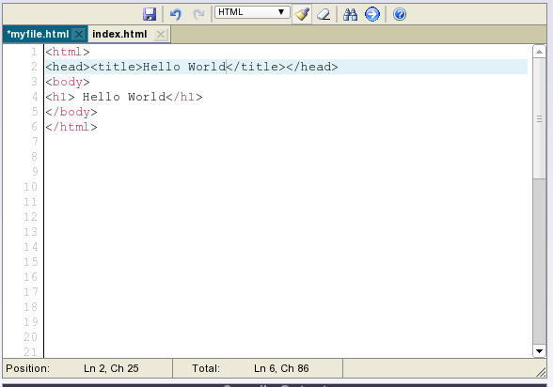
Once you have a file open in the central editarea box, you can interact with it like a normal text editor. If the file type can be identified, the programming lab will provide automatic syntax highlighting. The line currently being edited is highlighted with a blue background color. The linenumbers are identified along the left side of the screen for easy debugging when a compiler provides an error message.
The statusbar along the bottom provides some feedback about the number of lines and characters in the file, as well as the current cursor position within the file.
All open files are displayed on the tab-bar at the top of the edit area, as well as in the files box on the left side. The currently displayed file is highlighted with a navy background. Any files that have been modified since the last time they were saved will be marked with an asterisk (*) before the filename. You can switch between the open files by clicikng on different tabs, and you can close a file by clicking the X icon at the right side of the tab name.
The toolbar provides several useful interactions to aid you in your editing. From left to right, they are:

Save
Click this button to save the currently open file. The contents will be stored to the server, and the modified marker asterisk will be removed from the tab bar.

Undo and Redo
These two buttons can be used to undo or redo editing in the edit area. Use them to go backwards and forward through your history of changes if you want to fix a mistake or look at earlier versions of the code.

Syntax Options
By default, the dropdown will select a proper syntax highlighting language depending on the filename extension. You can choose different highlighting from this dropdown if the highlighting is incorrectly chosen. Most of the time you won't need to touch this.
The Toggle Highlighting button to the right of the dropdown allows you to disable highlighting. You may want to do this if editing a massive file, as highlighting can slow down the editor on very large files.
The Reset Highlighting button next to it is useful if the editor has gotten confused in its highlighting tasks, and needs to be reset.

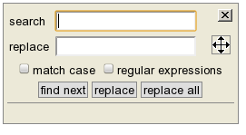
Find and Replace
Clicking the find and replace button brings up a dialog box that allows you to search your code for specific search strings and replace them with other values. Enter a search term in the upper box and a replacement value in the lower box. You can choose to match case, which ensures that only values with the same capitalization are searched for. You can even search by regular expressions, if you know them. Regular expressions are a powerful tool for matching string patterns in a document. They can be quite complex; you can find a tutorial on regular expression matching on any search engine.
The three buttons, Find next, Replace, and Replace All do what you would expect. The find next button simply searches for the next match. The replace button replaces the currently highlighted match with the value in the replace box. The replace all button replaces all matches in the currently open document. The x in the upper right corner allows you to close the search box, and the move symbol is a place you can click to drag the box around, allowing you to see the search terms in the editing area.

Go To Line
The Go To Line button presents a dialog where you can enter a line number you want to edit. This can be very useful if your compiler output provides a line number with an error message and you need to visit that line to fix it.

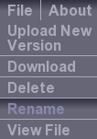
Files
When a file is open for editing in the code area, a File menu will show up on the toolbar with custom actions for manipulating that file. These operations will only apply to the currently open file, and the entire menu is only visible if there is a file currently open.

Upload New Version
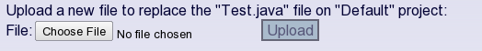
Like the dialog for uploading a new file, this file item allows you to upload a new version of an existing file. The current file will be lost, and the newly uploaded file will replace it, with the same filename. Click the “Choose File” or “Browse” button (depending on your web browser) to select a file from your filesystem. Then click the “Upload” button to transfer the file to the VPL server and replace any current file on the server.

Download
The Download menu item in the file menu is the opposite of the upload version option. It allows you to download the file to your computer for offline editing. This can also be useful for testing compiled binaries on your computer, since they cannot be run on the VPL server for security reasons. The downloaded file will have the same filename that it has in the VPL system.

Delete
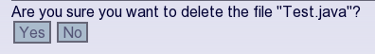
The Delete menu item provides a confirmation dialogue allowing you to permanently delete the file and remove it from the project. Clicking “Yes” will delete the file; clicking “No” will return you to the editor for the file.

Rename
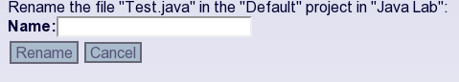
The Rename file menu item allows you to rename the file within the given project. You can use this feature to change the extension, or to change the name of a public java class, for example. Simply type the new name, including extension, into the Name field, and click the “Rename” button. If you decide not to change the name, use the “Cancel” button to return to the editor for the file.

View File
The View File menu item opens a new browser window or tab to display the file. This is most useful in editing web projects; it allows you to see what the html file looks like in a web browser. All files in the project will be properly linked, so if you have any images, css files, compiled java applets, or other html files in the project, you will be able to click through the website you are building to see all the parts in action. It is generally a good idea to use relative links for your linked files in this situation.

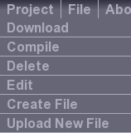
Projects
When a project is selected in the “Lab Projects” on the left side of the screen, several commands for manipulating that project become available in the Projects menu on the menu bar.

Download
The Download Project menu item allows you to download all the files in your project as a single zip file. When you click the link, a screen will appear allowing you to choose a name for the downloaded zipfile. The default name provided will be the name of the project with “.zip” appended as an extension, but you can change this to any filename you like.

Compile
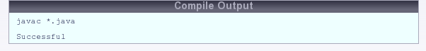
If your project can be compiled using one of the VPL compilers (currently gcc and javac are available), a “Compile” item will be displayed in the menu. Clicking this item will attempt to compile all the files in the project using either the command “javac *.java” or “gcc *.c -o <projectname>”. Web projects can be compiled using the Java compiler, in case you want to include an applet into the web page.
When a project is compiled, the output will be displayed in the “Compile Output” box below the edit area. If there is a compiler error, you will be able to use the error report and line-numbers to correct your program.
When you compile a project, the compiled files (.class files for Java, and an executable for gcc) will show up in your files menu for the project. You can download the files to run them; they can't be run on the VPL server for security reasons. An exception is Java applets; these can be run in the browser if you create an HTML file that links to the applet.

Delete
The delete menu item will delete the project and all files in it. A confirmation dilaogue similar to the one used for deleting files will also be displayed.

Edit
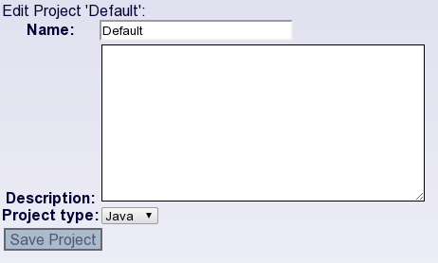
The edit menu item allows you to edit the details of the project. The form is the same as the create project form; you can specify the name of the project, an optional description, and change the type of project, for compiling purposes.

Create and Upload File
The Create File and Upload File project menu items are shortcuts to the commands with the same names in the Files box on the left side of the screen. They allow you to create a new file or upload a new file to the current project, as we discussed earlier.

Classes
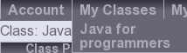
If you are registered in any VPL classes, you will find them in the “Classes” menu on the menu bar. When you are working on a class, you can create, manage, and edit projects and files just as you would for a lab, but they will be associated with the class instead of the project. You can create as many projects as you like for a given class, whether it's just for experimenting with the concepts you are learning in the course, applying the exercises and labs introduced in the textbook, or assignment projects you intend to submit to your instructor for marking.
When a class is selected from the menu, a list of projects for that class will replace the “Lab projects” on the left sidebar, and the name of the class will appear just under the menu bar to remind you which class you are currently working with. You aren't restricted to a specific type of project for a given class; if you are working on a C programming class, there is nothing to stop you from creating a Java project if you desire. You may want to do this in order to compare Java code to C++ code, for example, or you may want to create a web project to display Java applets in browser.

Chat
While the VPL IDE provides a useful set of tools for code editing, project and file management, and compilation, the real heart of the SCIS Virtual Programming Lab is the chat system. It allows you to discuss and share files with other students and your instructor in realtime. This is great for collaborative debugging, problem solving, and development, not to mention moral support! The chat windows are located along the right side of the IDE.

Chat participants
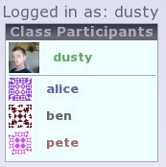
When you have a lab open (as opposed to a class), the user list will display all the logged in users that are also working on that lab. So if you are working on a project in the Java lab, you'll be able to chat with other users who are also working on a Java lab. You can ask questions, socialize, or share code with these users.
If, instead, you currently have a class open, the user list will be titled “Class Participants” and you will see the list of all other users who are members of that class, including instructors and tutors. Users who are not currently online are displayed in the list as well as those who are currently active. It is possible to send messages to offline users for them to see when they next log in.
Your name and an icon representing your persona is displayed at the top of the chat box. Below this, all other users for the current lab or class are displayed.

User statuses
The color of a user's username in the participants list indicates their current status. If a user has sent you a message that you haven't read yet, their username will be blue to indicate new messages. Click on the name to view the messages and respond. In class lists, users who are members of the class, but are not currently logged in will show up in grey. You can send messages to these users, but they won't respond until they are logged in again. Users that are currently logged in, but have not sent you any messages will have green usernames. Red represents the instructor for the course.

Your picture
A small icon will be displayed next to your name, and the name of each other participant in the participants list will also have an icon associated with it. You can set your own icon by signing up for an account at http://gravatar.com/ with the same e-mail address with which you registered for the VPL and uploading a picture there. If you already have an account there, then your gravatar image will be automatically associated with your VPL profile.
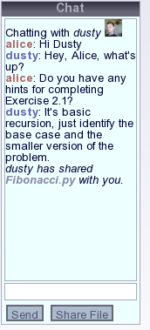
If a user has not set up a gravatar with their e-mail address, a random art image will be used in their place. The color and pattern of this image will be unique for each user.

Chatting
The process of chatting is identical to any other chat program. Clicking a username in the participants list will open the chat window with that user. A text entry box allows you to enter messages, and pressing enter or clicking the “Send” button will send the message to the other user. Incoming messages will automatically show up in the same box. The name of the user who sent the message will be displayed in either red or blue (depending on who sent the message).

Sharing Files
If you are currently editing a file in the editor window, you can share that file with the user you are chatting with by clicking the Share File button. A link to view the file will automatically be sent to the other user's chat window.
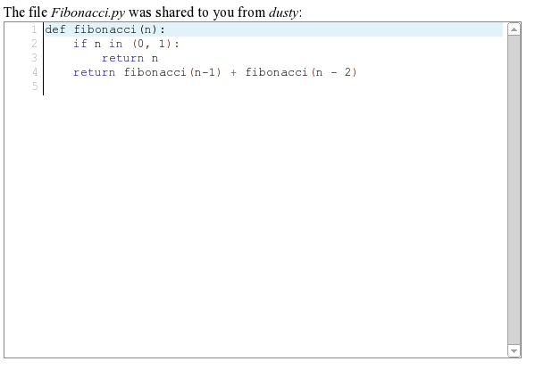
When you receive a shared file, click the link to view the file contents. It will be opened in a non-editable window, you can view, but not edit the file. Line-numbers are displayed beside each line in the file, so that as you scroll through it, you can discuss specific lines with the author of the file. This can speed up communication when identifying bugs or problem areas in the code, or suggesting changes.
If the user who created a file saves the file, the shared version of the file will be updated to reflect those changes when the viewing user refreshes the page.

Admin
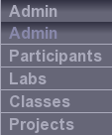
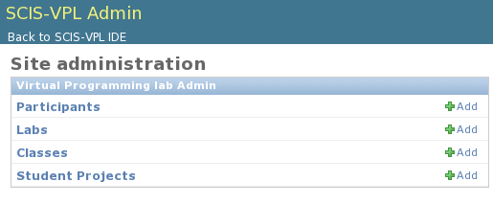
The admin menu is only visible if you have some level of administrative privileges in the VPL. This includes instructors, tutors, and full administrators. The admin views allow you to manage what labs and classes are available, who instructs, tutors, or participants in a specific class, and a view of student projects. These functions are in a separate administrative area, with shortcuts visible in the admin menu. When you are in the administrative area, you can click the “Back to SCIS-VPL” link at the top of the screen to return to the main app.

Managing Labs
Clicking the labs menu item takes you to the labs administrative area. Only full administrators are permitted to edit labs. You can see the list of available labs that show up in the Lab menu. You can add a new lab by clicking the “Add Lab” button, or you can edit an existing lab by clicking it's name in the list. Labs are very simple objects and have only a name and default project type. When a student creates a project in a lab, they can choose which type of project it is (different projects have different compilers and default syntaxes). For their convenience, you can set a default project type in the admin area. They are free to change this type when they create a new project, but it is an added convenience for them in the normal case.

Managing Classes
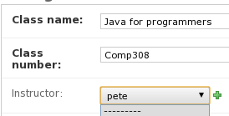
Classes are quite a bit more involved than Labs. In addition to a name, they have a class number, instructor, and tutors. Only administrators and instructors are permitted to modify classes. Further, an instructor is only permitted to modify those classes that they instruct. Other classes are off limits. The class administrative interface is also used to add newly registered students to the course so they can access class-specific materials and interact with other students and the course instructor or tutors.
Like labs, clicking the classes menu item will take you to a view summarizing all the available classes. An Add Class button allows you to create a new one, or you can edit an existing class by clicking it's link in the list. You'll need to do this if you want to add participants or tutors to a class.
Classes have fields for the class name and course number. These are used to identify the classes to students. You can also assign a course instructor to each class. The instructor must already be registerd in the VPL system; then you can select their username from the dropdown list.

Managing Participants
Class participants include all members of the class: students, tutors, and the course instructor. When you save a class, the tutors and instructors are automatically included as participants, so you only really need to worry about adding students in the participants list.
The participants list is set up as a split pane with a list of all VPL system users on the left side, and a list of those users currently participating in the class on the right. You can select students in either box by clicking them; multiple students can be selected by holding down the “Control” key as you click.
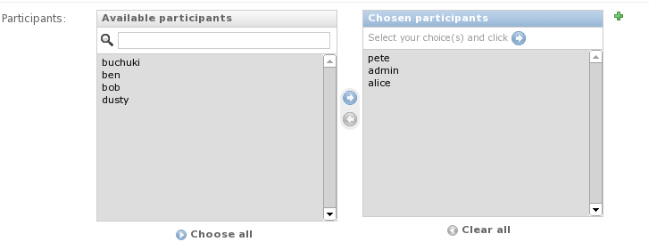
Once you have selected participants, you can use the buttons between the two boxes to move them from the “Available” list to the “Chosen” list, or vice versa. Make sure to click “Save” at the bottom of the page when you are done.

Managing Tutors
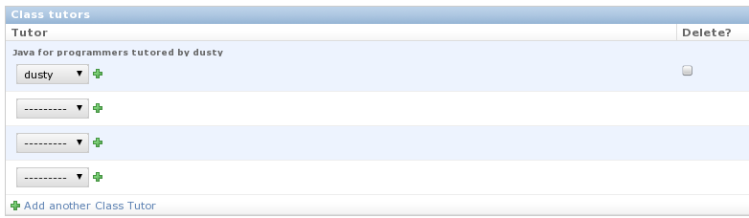
A single class may have multiple tutors. You can select individual tutors from dropdown menus below the participants list. If you run out of menus, simply save the class, and more empty dropdowns will show up. If you no longer want a user to tutor a particular class, check the “Delete” checkbox beside their dropdown box and save the class. This will delete the tutor relationship; the user will still be registered in the system.

Managing Student Projects
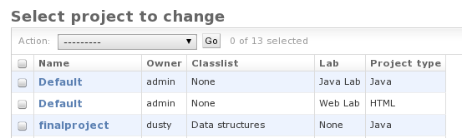
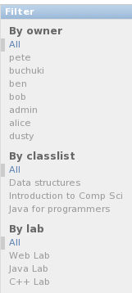
The Student Projects link shows a list of all projects in the system, summarizing their owner, class or lab, and project type. It is possible to edit a student's project from this menu. Currently, you can only manage project details from this menu, it is not possible to manage the files associated with the project on the VPL server. Administrators, instructors, and tutors can all manage student projects. However, instructors and tutors can only manage those projects that are associated with classes that they tutor or instruct.
It is possible to filter projects by the owner's username, the lab projects are associated with, or the class the project is associated with. This can help identify a given project or set of project that needs to be edited in the list. The filters are located on the right side of the screen. There is also a search box at the top of the list that allows you to search the name, classname, lab, and owner.

