An analysis of government responses to the COVID-19 pandemic

Petre Buciu

2020-04-02

# Objectives

In this article we will analyse how different governments around the world have responded to the COVID-19 pandemic - what kind of measures they took, when and how early have they been implemented. It has also been attempted a rough quantification of their impact in limiting the spread of the pandemic. The data used for this analysis comes from two primary sources: the database from the Oxford COVID-19 Government Response Tracker [1] developed by *Blavatnik School of Government* from *University of Oxford* and the famous data repository tracking the COVID-19 pandemic around the world developed and maintained by the *Johns Hopkins University Center for Systems Science and Engineering* [2]. Together they make a comprehensive and consistent source of information across countries and time regarding the spread of pandemic. I shall no longer dwell on the methodologies used to collect the date as they are well explained by the authors in the links I provided.

# About the data

In the data provided by the **OxCGRT** there is publicly available information coded in 11 indicators of government responses - some from the sphere of enforced social distancing (S1-S7) from mild ones like school closings to workplace closings and international travel bans to those pertaining to financial measures (S8-S11). The first category of indicators are coded as ordinal variables with three levels (0 - no closing, 1 - recommended closing or 2 - required closing) and the financial indicators are continuous variables. The first six indicators can also be targeted - applied only in a geographically concentrated area) or general (on the national level). S8 is the value of the fiscal stimulus (tax cuts or spending) in USD, S9 is the value of interest rate (monetary measures), S10 is the alue of new short-term spending on health in USD and S11 is the USD value of investment in vaccine development. This indicators are aggregated, for the general ones a point is added to the final score, which is then normalized on a 0-100 scale and transnformed in a novel index named *stringency index* which is useful for country-to-country comparisons. As of today, there are 77 countries included in their dataset.

The data from the **JHU CSSE** contains total confirmed cases, total deaths and total recovered patients aggregated for every day, country and, where it is the case, province. This data is also included for the corresponding countries in the **OxCGRT** dataset.

# Analysis

Given that the first seven indicators are ordinal variables on the same 0-2 scale, we can sum them up to compute a general metric of social distancing, much like the stringency index. I will call this index *social distancing index* or *SDI*. We are interested in these indicators alone because they are the most effective in slowing the spread. The financial measures are very important, of course, to keep the economy functioning during the crisis but they do not significantly slow the spread in the short-time horizon. On the graph I have also plotted the number of total confirmed cases and total confirmed deaths (in logarithmic scale) for each country at each day. The results can be inspected in the Figure 1.

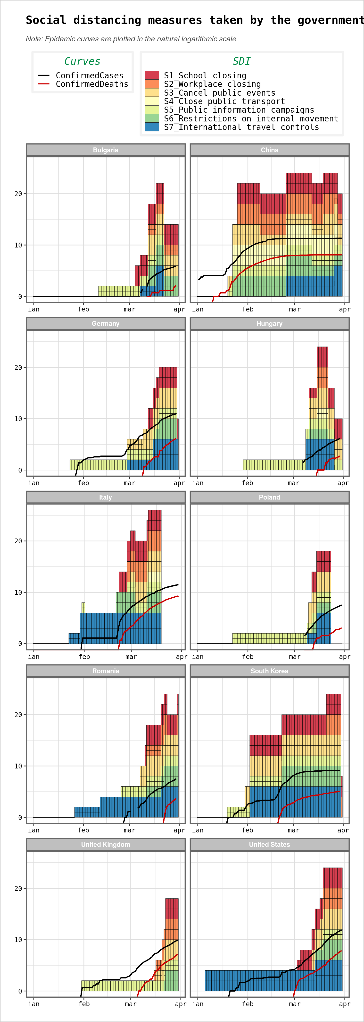

Figure 1. Various measures for different countries

We observe UK and US as the countries which took the least stringent measure - and with significant time delay. The eastern-european countries took measures similar to their western counterparts and around the same time, but with a significant advantage because they had far fewer confirmed cases at the moment of enforcing these measures. We can plot the stringency index against confirmed cases and then confirmed deaths to get a clearer view of this phenomena.

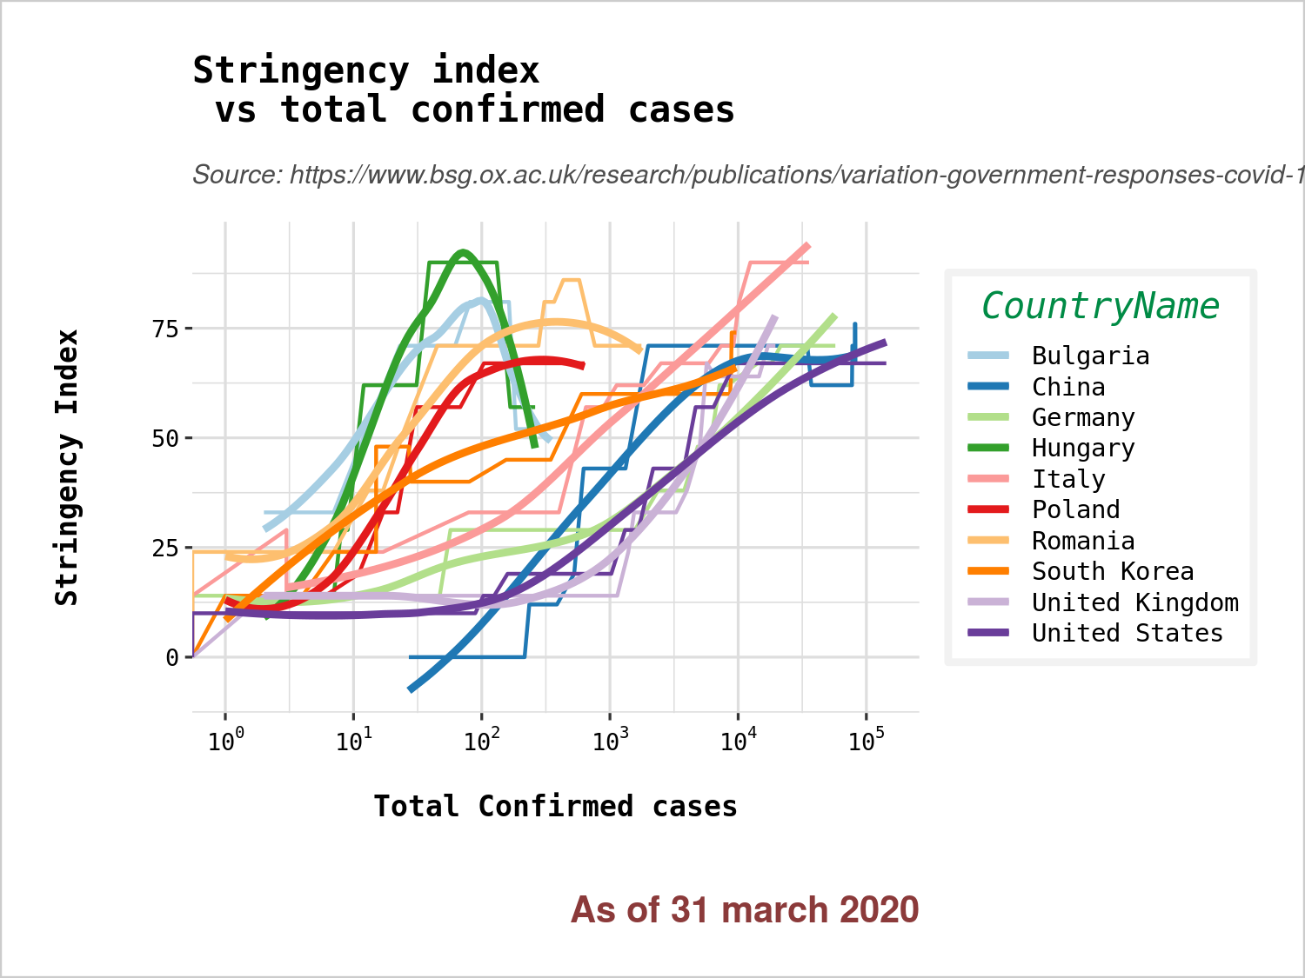

Figure 2. Stringency Index for different countries

The same information displayed versus the confirmed deaths.

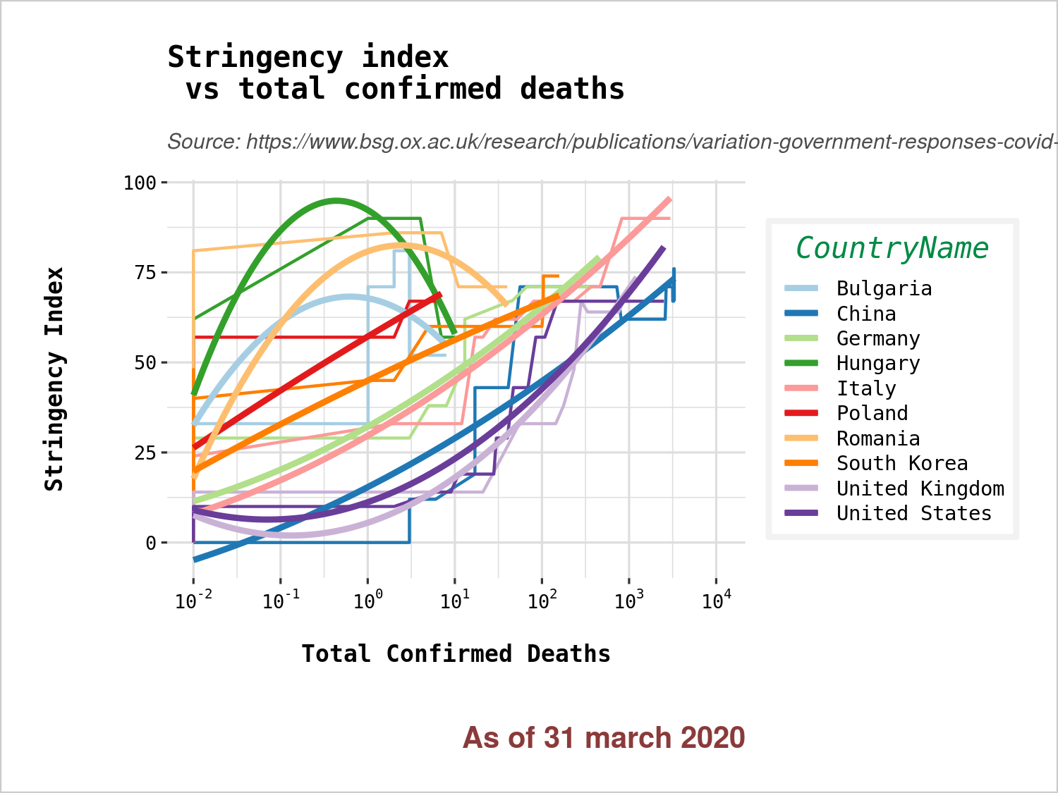

Figure 3. Stringency Index for different countries - with confirmed deaths

We see the same patterns (albeit less clearly) between the late-acting western countries (and mostly of all, UK and US) and early-acting eastern european countries with China being somehow in the first group, South Corea in the second. The smooth curves are LOESS models fitted to the raw stringency index data for a better identification of trends and clusters.

We should take a look at the financial indicators too. We represent them as cumulative sums on logarithmic scale.

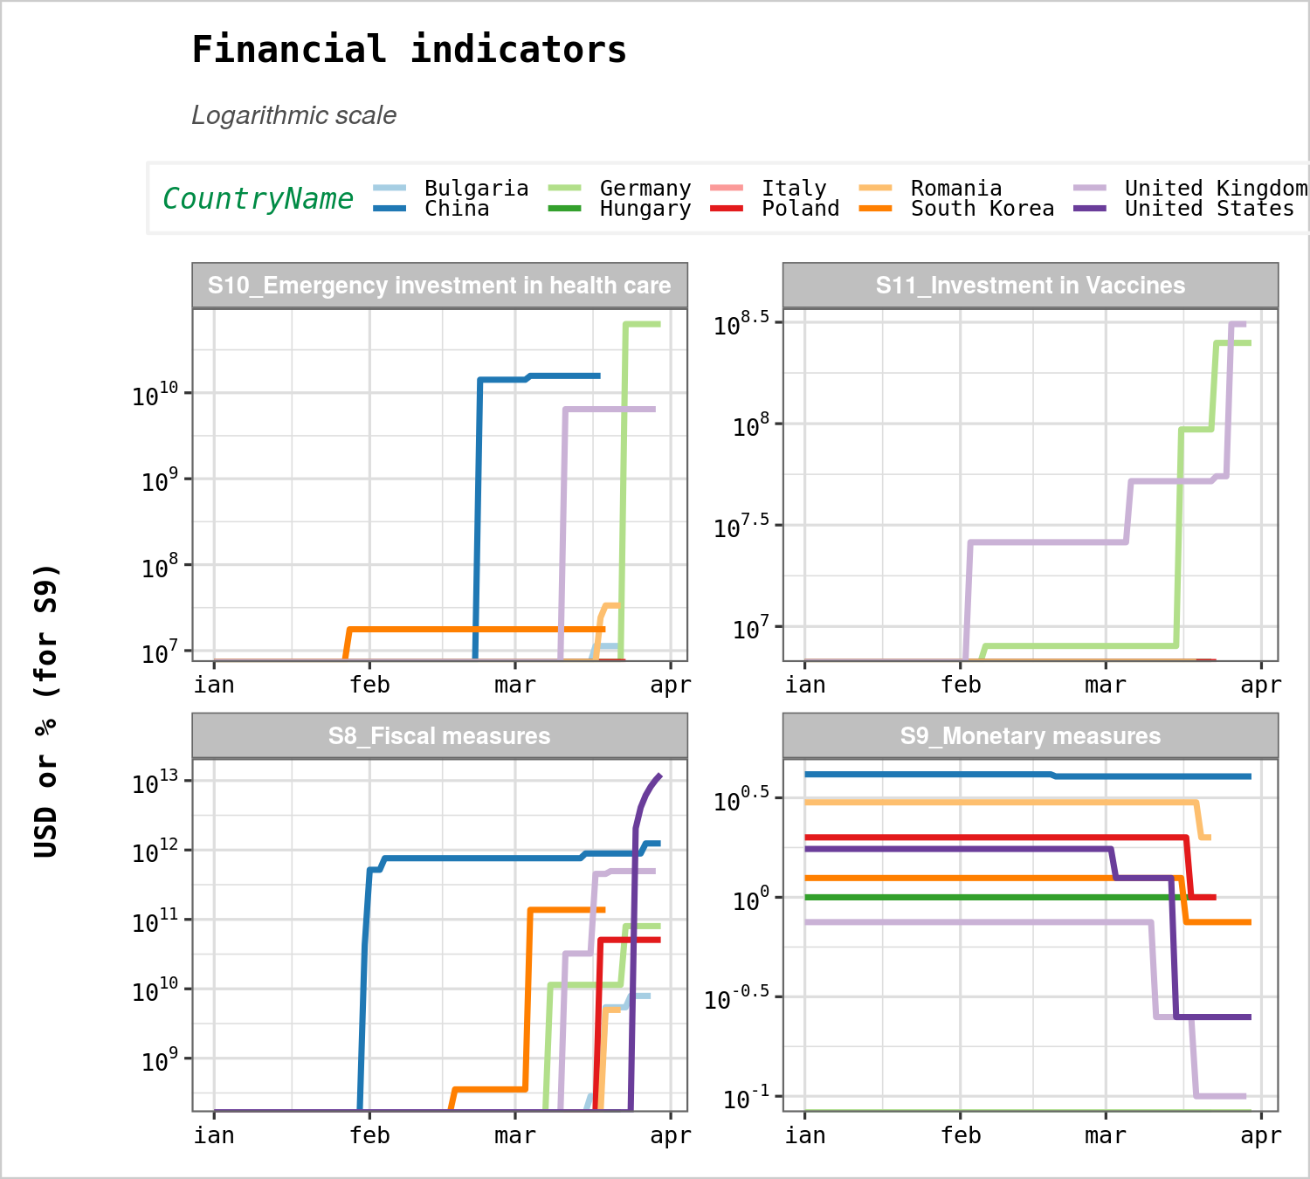

Figure 4. Financial indicators

# Is there a connection between these measures and the rate of growth of confirmed cases afterwards ?

First, we should visualize the epidemic trajectories of the countries in the form of a semi-logarithmic plot. We exclude from the plot the period from the onset to the first 100 confirmed cases as it is significantly noisy. We see in the Figure 4 different trajectories in which eastern european countries have a slower rate of growth compared to their western counterparts and, more extremely, UK and US.

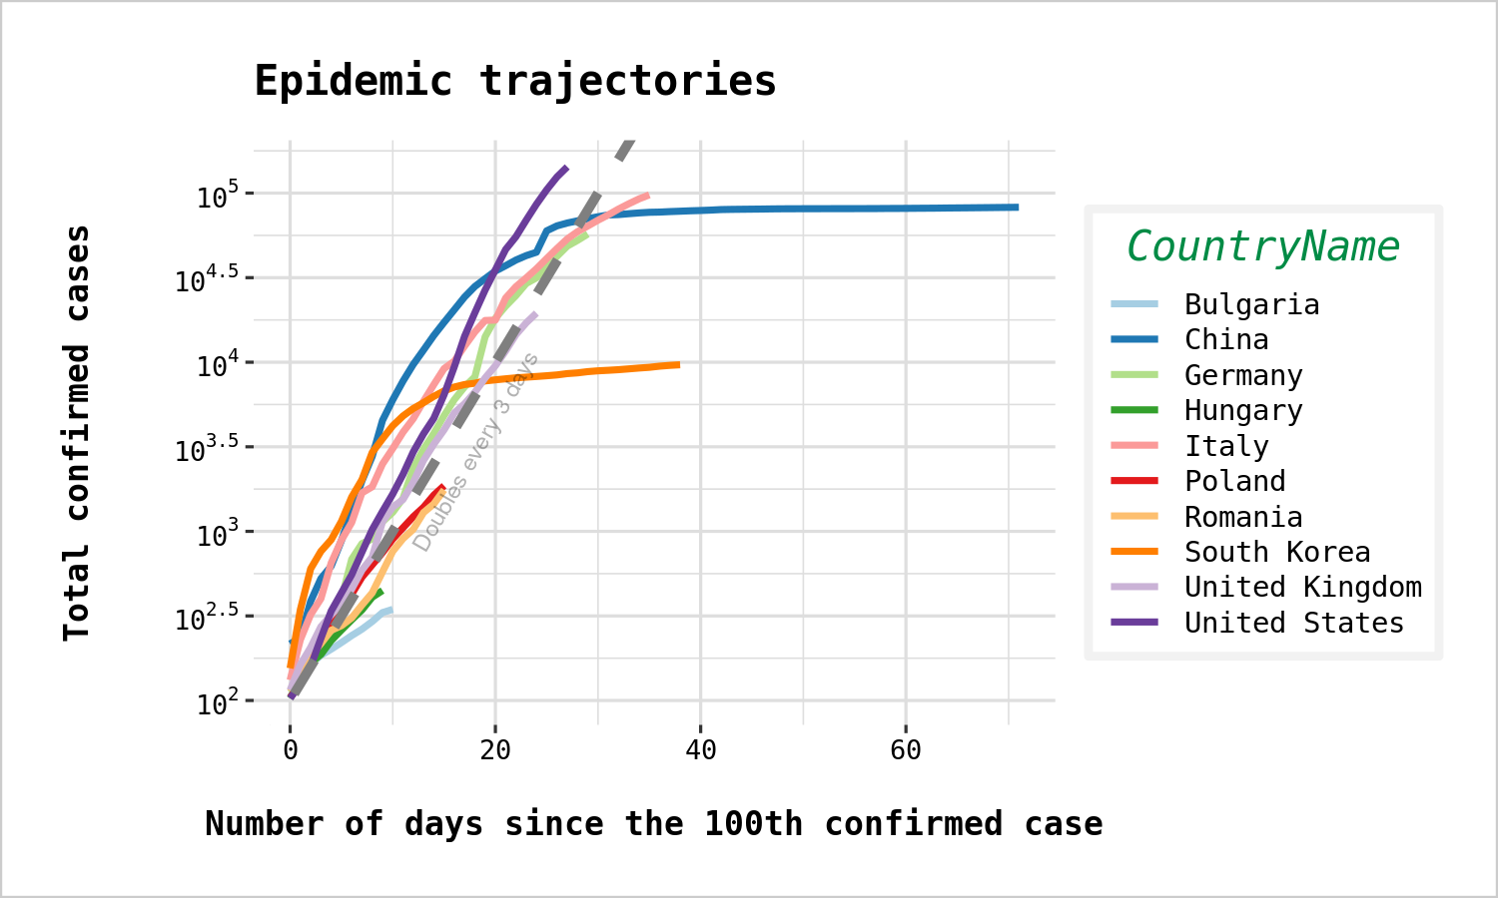

Figure 4. Epidemic trajectories

For a more precise quantification, there is need to compute the rates of growth in all these countries. We use log-linear regressions for modeling the incidence curves. We fit multiple models for each country, one starting every day since 1 march 2020 until 21 march 2020. In this way we can asses how the epidemic curves behaves in time. We define the growth rate as the slope best-fit line of the log-linear model. It is not to be confused with the daily growth of the total confirmed cases. It is a parameter of the exponential curve that best fits the empirical data on daily incidence (new confirmed cases). We can think of it as a *rolling* window method of prediction. We will see how this parameter change in time and draw appropiate conclusions.

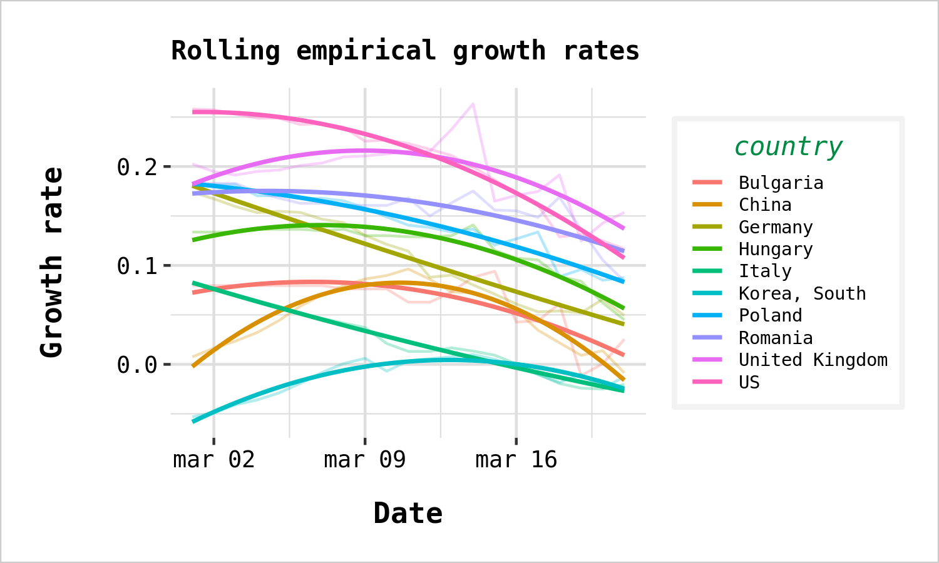

Figure 5. Growth rates

It seems there is no discernible pattern in the data regarding the impact of social distancing measures on the growth rates, as all trends start to point downwards after 15 march. As most quarantine measures were taken in the first part of the month, the effects are to be expected after at least two weeks so we should not read too much in this data. An explanation may be that the social distancing measures took by the governments reflect a wider approval and consent in the large population toward these measures and we can suppose that social distancing measures were already informally respected before it became compulsory to do so. Another possible explaination is that the coronavirus is already widespread in the population, testing being limited almost everywhere and we are actually witnessing a general slowdown which is expected when a large part of the susceptible population is infected. This is a more optimistic scenario as it implies that we grossly overestimated the fatality rate of the coronavirus infection and the end of the pandemic may be near. Based on our data it is impossible to judge in favour of one model rather than the other.

1. **OxCGRT**: <https://www.bsg.ox.ac.uk/research/research-projects/oxford-covid-19-government-response-tracker>
2. **JHU CSSE**: <https://github.com/CSSEGISandData/COVID-19/blob/master/README.md>)