Input-Output Analysis for growth regimes

Petre Buciu

2023-06-21

Table of contents

# 1. Untitled

# 2. Some theory

## 2.1 Production Matrix

We have at our disposal a huge table recording transaction between industries (the sellers on rows, the buyers on columns). This is how input-output data come from OECD and not also from OECD, but also WIOD, etc. The cells of our table represent monetary sums. We calculate the production matrix, $\text{A}$ by using the following matrix formula:

$$\text{A}=\text{Z}{\text{x}}^{−1}$$

Where $\text{Z}$ is the so called transaction table we have been mentioning, $\text{x}$ is a diagonal matrix where each diagonal entry represent the invers of the total production ( $x_{i,i}$).

## 2.2 Leontief inverse matrix

Leontief inverse matrix is ${\left(\text{I}−\text{A}\right)}^{−1}$ being the fundamental tool in input-output analysis. Premultiplying Leontief inverse matrix with $\text{f}$, the final demand, we obtain the a new matrix (or vector, if $\text{f}$ is a vector) where we have the total production each sector must produce to satisfy this final demand. We can also write Leontief’s inverse as an infinite series:

$${\left(\text{I}−\text{A}\right)}^{−1}=\text{I}+\text{A}+{\text{A}}^{2}+...$$

## 2.3 Import content of exports

We can calculate the import content of exports by the following formula:

$$r=\frac{{\text{s}}^{T}\text{M}{\left(\text{I}−\text{A}\right)}^{−1}\text{e}}{{\text{s}}^{T}\text{e}}$$

Where ${\text{s}}^{T}$ is the summation vector transposed , $\text{M}$ is the import coefficient matrix $\text{e}$ is the vector (or matrix if disaggreggated) of exports.

## 2.4 Domestic Trade Value added

Similarly, we can calculate the domestic value added content of trade (or more generaly final demand categories) which we will use in our analysis.

$\text{VA}=\text{v}{\left(\text{I}−\text{A}\right)}^{−1}\text{f}$

Where $\text{VA}$ is the value added matrix which we cam sum over columns to get the total value added, $\text{v}$ is a diagonal matrix with value added coefficients as diagonal entries, and you already know the rest.

## 2.5 Structural decomposition analysis

We will take a different path from [Baccaro et al (2023](https://www.mpifg.de/994292/baccaro-hadziabdic-operationalisierung-von-wachstumsmodellen)) and rather than calculate induced imports by final demand category and subtracting them from the corresponding category responsible for their existence, by will calculate value added generated by exports and decompose this value added on a year-by-year basis into quantities corresponding to changes in technical coefficients, import coefficients and final demand changes. As recommended by Miller and Blair (2009) we use the average of two polar decomposition.

$ΔVa=\frac{1}{2}Δ\text{v}\left({\text{L}}_{1}{\text{f}}_{1}+{\text{L}}_{2}{\text{f}}_{2}\right)+\frac{1}{2}\left({\text{v}}_{1}Δ\text{L}{\text{f}}_{2}+{\text{v}}_{2}Δ\text{L}{\text{f}}_{1}\right)+\frac{1}{2}\left({\text{v}}_{1}{\text{L}}_{1}+{\text{v}}_{2}{\text{L}}_{2}\right)Δ\text{f}$

The difference in the value added generated by final demand categories will be decomposed into three sums, each corresponding to changes in one of its constituent terms.

# 3. Some exploratory analyses

Let us decompose the value added generated by final demand categories for the eastern european countries between 1995 and 2018. Let us see Romania first.

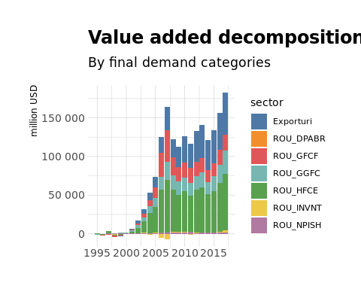

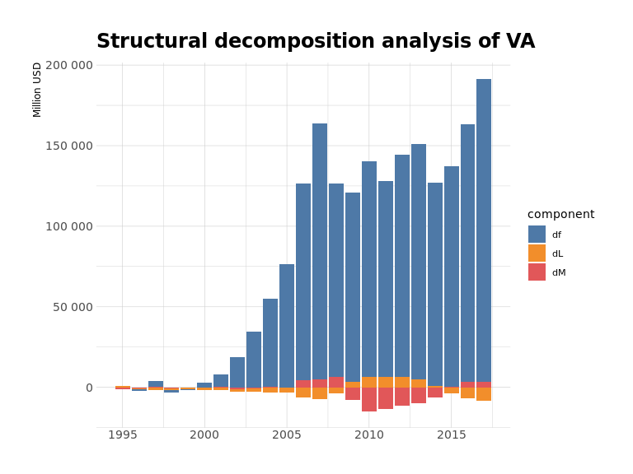

We can see that almost all the value added between 1995 and 2018 is due to final demand growing in this time. Also, exports are more important in the generation of value added since the Great Financial Crisis.

Let us see Eastern Europe relative contribution to value added before and after the financial crisis.

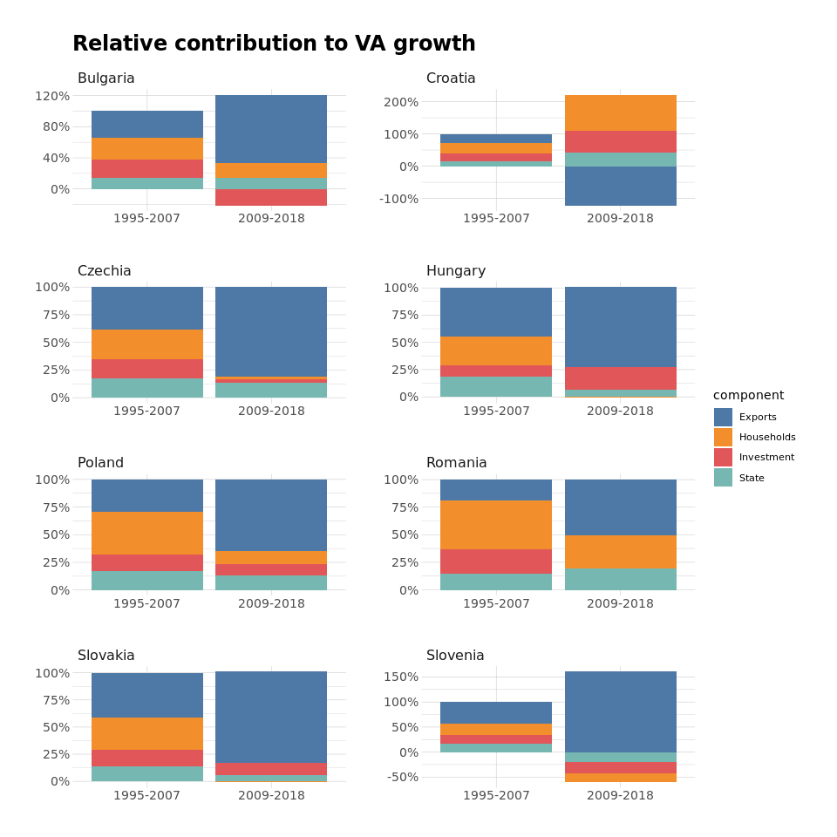

As it was to be expected, our countries are now more export-oriented.

Why does Croatia look that way, also different from your study ?

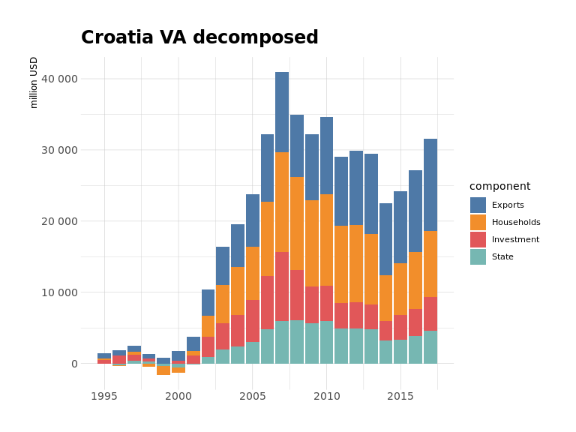

It is hard to see problems with graph so maybe we plot annual changes:

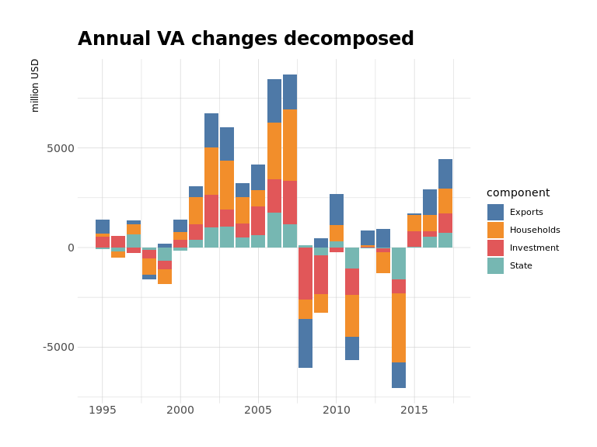

We can see more clearly now that we had negative (absolute) contributions from exports in a few years after the financial crisis and some constant contributions afterwards. They mostly cancel out but they remain positive (actually the only positive component in the 2009-2018 period). So we will use the math module function for the total value added so we can have positive contribution of positive components even when growth is negative.

# 4. Growth Regimes

Let us make a plot similar to yours.

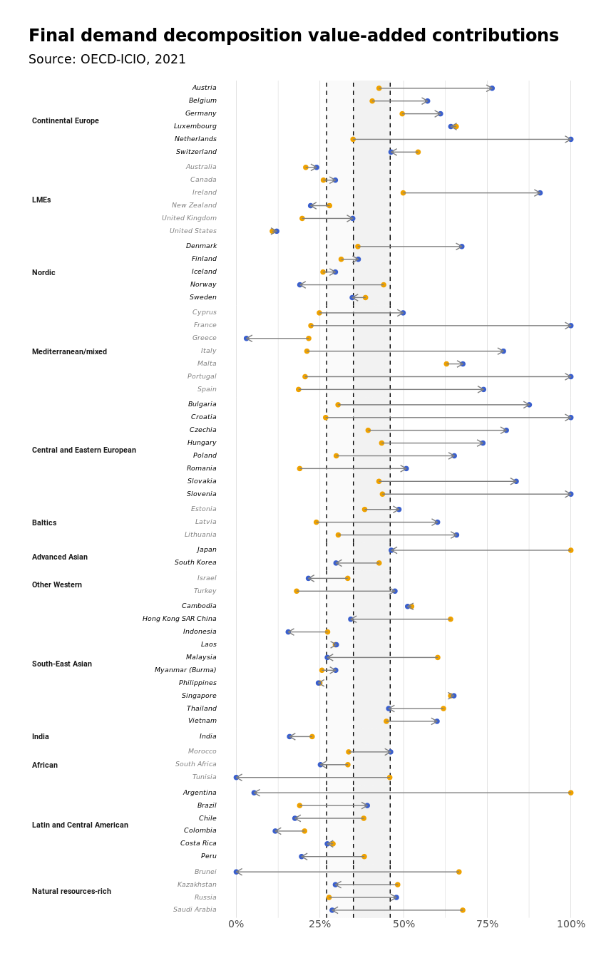

There are some differences between these graphs, but there is an overall agreement as well. Let us now see the growth contribution on the regional level.

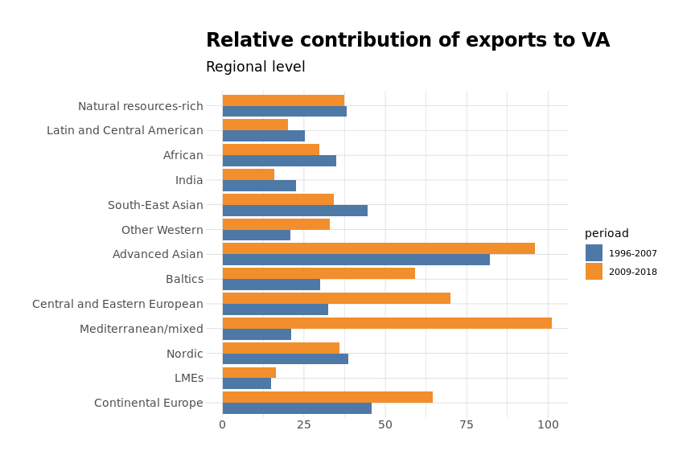

Let us see the export sectors with the greatest change between 1995-2007 and 2009-2018 as contribution to value added in six eastern european countries.

Table 1: Top 10 export sectors by value added generated

Sorted by the largest absolute difference between periods*1*

| sector | 1995-2007 | 2009-2018 | delta |
| --- | --- | --- | --- |
| **Slovakia** | | | |
| Motor vehicles, trailers and semi-trailers | 12.24% | 27.61% | 15.37% |
| Machinery and equipment, nec | 6.75% | 9.33% | 2.57% |
| IT and other information services | 0.86% | 3.02% | 2.16% |
| Professional, scientific and technical activities | 2.80% | 4.66% | 1.86% |
| Wood and products of wood and cork | 1.81% | 0.14% | -1.67% |
| Paper products and printing | 1.99% | 0.32% | -1.68% |
| Telecommunications | 1.62% | -0.17% | -1.79% |
| Coke and refined petroleum products | 1.48% | -0.44% | -1.92% |
| Construction | 9.91% | 5.62% | -4.29% |
| Computer, electronic and optical equipment | 4.99% | 0.14% | -4.85% |
| **Czechia** | | | |
| Motor vehicles, trailers and semi-trailers | 15.48% | 26.42% | 10.93% |
| Administrative and support services | 1.17% | 2.67% | 1.50% |
| Land transport and transport via pipelines | 2.07% | 3.50% | 1.43% |
| IT and other information services | 1.09% | 2.47% | 1.38% |
| Telecommunications | 1.25% | 0.02% | -1.23% |
| Food products, beverages and tobacco | 4.18% | 2.83% | -1.35% |
| Computer, electronic and optical equipment | 4.36% | 2.68% | -1.67% |
| Basic metals | 3.71% | 2.01% | -1.70% |
| Electricity, gas, steam and air conditioning supply | 2.51% | -0.28% | -2.79% |
| Construction | 10.20% | 6.32% | -3.88% |
| **Romania** | | | |
| Motor vehicles, trailers and semi-trailers | 7.01% | 16.86% | 9.85% |
| Food products, beverages and tobacco | 4.83% | 8.65% | 3.82% |
| Professional, scientific and technical activities | 3.32% | 6.24% | 2.92% |
| IT and other information services | 1.53% | 4.10% | 2.57% |
| Machinery and equipment, nec | 4.07% | 5.36% | 1.29% |
| Financial and insurance activities | 2.77% | 1.55% | -1.22% |
| Computer, electronic and optical equipment | 3.19% | 1.88% | -1.32% |
| Textiles, textile products, leather and footwear | 3.21% | 1.21% | -2.01% |
| Basic metals | 3.41% | 1.26% | -2.15% |
| Construction | 8.52% | 6.17% | -2.35% |
| **Hungary** | | | |
| Motor vehicles, trailers and semi-trailers | 12.05% | 19.35% | 7.30% |
| IT and other information services | 1.50% | 4.27% | 2.76% |
| Administrative and support services | 1.64% | 3.28% | 1.64% |
| Rubber and plastics products | 2.19% | 3.42% | 1.23% |
| Machinery and equipment, nec | 5.94% | 4.82% | -1.12% |
| Public administration and defence; compulsory social security | 1.92% | 0.70% | -1.22% |
| Food products, beverages and tobacco | 6.18% | 4.22% | -1.96% |
| Construction | 8.33% | 6.23% | -2.10% |
| Telecommunications | 1.89% | -0.72% | -2.61% |
| Computer, electronic and optical equipment | 5.93% | -0.75% | -6.68% |
| **Bulgaria** | | | |
| Food products, beverages and tobacco | 8.44% | 12.86% | 4.43% |
| Motor vehicles, trailers and semi-trailers | 3.43% | 6.93% | 3.49% |
| Electrical equipment | 2.41% | 4.78% | 2.37% |
| Fabricated metal products | 4.62% | 3.26% | -1.37% |
| Warehousing and support activities for transportation | 2.09% | 0.62% | -1.48% |
| Financial and insurance activities | 2.47% | 0.67% | -1.80% |
| Water transport | 1.80% | -0.01% | -1.80% |
| Telecommunications | 2.03% | 0.03% | -1.99% |
| Construction | 10.47% | 8.20% | -2.27% |
| Wholesale and retail trade; repair of motor vehicles | 7.26% | 3.83% | -3.43% |
| **Poland** | | | |
| IT and other information services | 1.08% | 3.04% | 1.96% |
| Motor vehicles, trailers and semi-trailers | 9.84% | 11.29% | 1.45% |
| Human health and social work activities | 2.35% | 3.71% | 1.37% |
| Accommodation and food service activities | 1.67% | 2.90% | 1.22% |
| Administrative and support services | 1.70% | 2.76% | 1.06% |
| Electricity, gas, steam and air conditioning supply | 1.80% | 1.00% | -0.80% |
| Wholesale and retail trade; repair of motor vehicles | 8.04% | 7.14% | -0.90% |
| Basic metals | 4.43% | 3.18% | -1.25% |
| Construction | 9.40% | 7.82% | -1.58% |
| Computer, electronic and optical equipment | 3.22% | 0.99% | -2.23% |
| *1*Relative contribution to total VA generated by exports | | | |

# References