**HC-SR04 Ultrasonic Ranging Module**

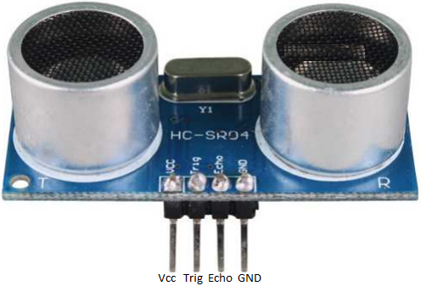

**Operation**

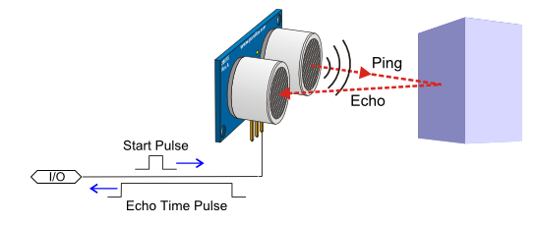The HC-SR04 works using sonar. A pulse of sound (in this case an ultrasonic 40kHz wave) referred to as the ‘ping’ is emitted eight times in a space of 10us. The HC-SR04 then waits listening for the ‘echo’ of the sound which is reflected from a hard surface.

Having received an echo the HC-SR04 then reports back to the microcontroller the time between the ping being sent and the echo received.

**Calculation**

The HC-SR04 will tell you the **time (T)** taken in **MicroSeconds (*10-6 Seconds)**.

The **speed** of sound in air is known to be **340 m/s.**

*Speed = Distance / Time : Speed in ‘m/s’, Distance in ‘m’ and Time in* ***‘s’***

**Task:** *Derive a simple equation to convert the time in microseconds to the distance in metres. Remember that the time is in Microseconds.*

Therefore: **Distance =** Metres

**Implementation**

The HC-SR04 has four pins to be connected.

**Vcc : Connect to +5V rail**

**GND : Connect to GND rail**

**Trig : Connect to a digital pin. Raise high for 10 us to ‘ping’. [Input to Sensor]**

**Echo : Connect to a digital pin. Goes high while waiting for an echo. [Sensor Output]**

**Timing / Pin Operation**

Microcontroller : Raises Trig Pin high

~ Wait 10 us ~

Microcontroller : Pulls Trig Pin Low

HC-SR04 : Raises Echo Pin High

~ Wait for Echo ~

HC-SR04: Pulls Echo Pin Low

The **Time** is the length of time the Echo pin is held high. The HC-SR04 program library for the Arduino IDE will measure this and return the time in microseconds for use in the program.