Antonio Pedrozo

CRN #
84113

IT025: Project #6

12/4/16

Fall 2016

Table of Contents
Table of Contents 2
Executive Summary 3
Information Systems Development 4
Quality Triangle 5
Compiled vs. Interpreted Programming 6
Responsive Design 6
Python Programming 7
Object Oriented Programming vs. Structured Programming 9
Location Object 10
CPSR 10
CERT Organization 11
Conclusion 11
Bibliography 13

Executive Summary
In this project, I will providing an overview of different aspects of information systems and their development. We will look at different types of system development methodologies like SDLC, RAD, Agile, and Lean systems and explain the differences. I will select a methodology that I would choose to create project. This will be partially based on the Quality Triangle. I will explain the triangle and why it is important how it factored in my methodology decision.
We will be explaining the differences between compiled and interpreted programming languages and giving examples. We will also look at programming languages and categorizing them on generation, whether they are compiled/interpreted, and procedural/object oriented.
Responsive Design is also something that has affected the marketability and usability of websites. We will be defining that term and also looking at three websites that have done responsive design correctly.
We will look at the Python program and analyze the step by step process of the syntax tutorial and how the experience was with the final tip calculator example. We will also look at the differences between object oriented and structured programming and give examples.
Out of the browser object choices we looked at the location object and had a brief review regarding the object along with its properties and methods.
Finally we looked at projects and initiatives that have been undertaken by CPSR and the CERT organization and how they are affected by information technology.

Information Systems Development
The first development methodology that we will look at is the Systems-Development Life Cycle. The SDLC is also known as a waterfall methodology because each step in the process is separate. This process starts off with analysis regarding that solutions to the problem(s) might be and what can be implemented. The rest of the steps are system analysis, system design, programming, testing implementation, and maintenance. It is a very rigid system and needs to be done step by step. It could take years to implement a new system with this program but it is beneficial for large, expensive and company-wide changes.
Rapid Application Development on the other hand is a methodology that concentrates on building a software model fast. One feedback from users is received then we can update the working model. This methodology and implementation is best when we have smaller projects that aren’t as expensive and need to be developed quickly.
Agile methodologies is similar to Rapid application development in that we are on a shorter timetable. A big difference is that small improvements are implemented that are focused on improving quality. With Agile methodologies small groups of teams get together consistently regarding the steady development of the program. It is less frustrating that what SDLC could be because there are fewer people involved in the process and the changes being implemented are suggested by few and can be implemented in quick time while trying not to sacrifice a quality product for speed.
The last is the lean methodology that is different from the rest of the methodologies because it is the only one that doesn’t have a full set of requirements determined prior to starting the project. Each iteration is developed after starting with a Minimum viable product (MVP) and then shown to users for review. During the review they determine if the product has viability to go further or if they need to start over again with a new MVP. This process keeps going until the final product is complete so it is very detailed oriented like the agile method but also someone rapid like the RAD. Unlike the SDLC they can usually see the problems earlier in the development process and lower the amount of time and money invested in the project.
If I had to choose one to go with I would take the Agile method because it has a very interactive schedule with other members on the team so that there are fewer surprises and miscommunications that may arise from the SDLC method but it is not focused on getting the product out faster, it is also focused on quality and taking it step by step and reaching the goal. It is also not completely as focused on impressing management as the lean methodology is. If management is not interested in the product early on, they might pull funding for it when it could develop itself into a quality product early on without constant change.

Quality Triangle

The Quality triangle is relevant to these methodologies as it states that at least one important factor of the following needs to be sacrificed in the development process: time, quality, and cost. We cannot have a process to develop a product in a timely manner that is high quality and at a low cost so we need to complete the best alternative and take two out of three. As mentioned before, I would prefer to take the agile method because quality is important and so is time in the process. Cost is sacrificed because quality seems to be the main focus and staying on a schedule and keeping communication to make sure that a quality product is being produced in a timely manner are the main focuses. Naturally this will be a little more expensive.

Compiled vs. Interpreted Programming

A compiled program is one where once the code has been compiled this signals a set of instructions to be completed by the object machine. An advantage of using this type of programing method, of which C++ is an example of, can include faster processing times. An interpreted language like HTML, are programs that require a run-time program to be installed prior to interpret the program code line by line. They are easier to work with but they are slower since there are more moving parts.
Three examples that we will look at are C#, MATLAB, and Pascal. We will categorize them by their generation in the programming spectrum, whether they are compiled or interpreted programs, and whether they are procedural or object-oriented programs. C# is a 3rd generation programming language that can be both object-oriented and procedural and is also a compiled program (Microsoft, 2014). MATLAB is a 4th generation programming language that is also object-oriented (Stanford, 2014) and an interpreted program. The final program is Pascal which is a 3rd generation programming language that can be both compiled and interpreted while being a procedural programming language(The University of Rhode Island).

Responsive Design

Sometimes when browsing a website on a phone it is a completely different experience than when on a desktop or laptop. It can be a hassle and a lot of companies are trying to make their websites for friendly for those who like to browse or purchase on their hand held devices. A framework used to make the experience more functional is called responsive design. With a responsive website the images or text will automatically resize themselves to allow better customer usability. One company that has done responsive design well is Disney. The experience on laptops is similar to experiences on mobile devices and they even have an Apple Watch application for their Pixar website (Creative Bloq, 2015).
The Boston Globe was one of the first websites to adopt responsive design so that all of their readers could have access to their stories and news using many different devices without having to struggle through fumbling around the website on a device that wasn’t compatible before switching over to responsive design (Filament Group, 2011).
The World Wildlife Fund (WWF) is also an organization that has used responsive design for its internet patrons. On their website their CEO and President, Carter S. Roberts, explains that the new design allows for users to access the website with any device, not lose the intuitive navigation of the site while also providing information on the species and places that the WWF advocates for.

Python Programming
Within the python tutorial, we started by learning some basic syntax and learning how to store values into variables. We learned we have the ability to set variables and assign them as integers, decimal numbers, and Boolean values (e.g. True or False). We also learned how to command python to print our outputs and also that syntax errors occur sometimes. I assigned ‘Spam = true’ and ‘Eggs = false’ but since the Boolean values are case sensitive, running the code gave us errors. The program tutorial also showed us how to enter in comments that we don’t want to be part of the code but could be used as a tutorial or a note. Entering in the ‘#’ character prior to text will designate that line as a comment. To do multiple lines as commentary, adding three double quotes before and after the comments will keep that part of the program from trying to compile. Similar to other programs, the basic mathematical operations can be used by coding with ‘+’, ‘-‘, ‘*’, and ‘/’ for addition, subtraction, multiplication, and division respectively. In addition, using exponential calculations is a bit different. Normally ‘^’ would be used for a lot of programs but 10 to the power of 2 is coded by typing ’10 ** 2’.
After learning how to assign basic values, use mathematical calculations and avoid syntax errors, we were able to put this into practice with the ‘monty python’ example. We assigned ‘python’ to be the number 1.234 and ‘monty python’ to be ‘python **2’, which is python squared. This gave us a good tutorial for the calculations for a dinner bill in the tutorial section of the curriculum. Reassigning values to the meal and total variables and taking to account the meal, tax, & tip portion of the dinner was made easy with the lesson as seen with the screenshot below of the final code. 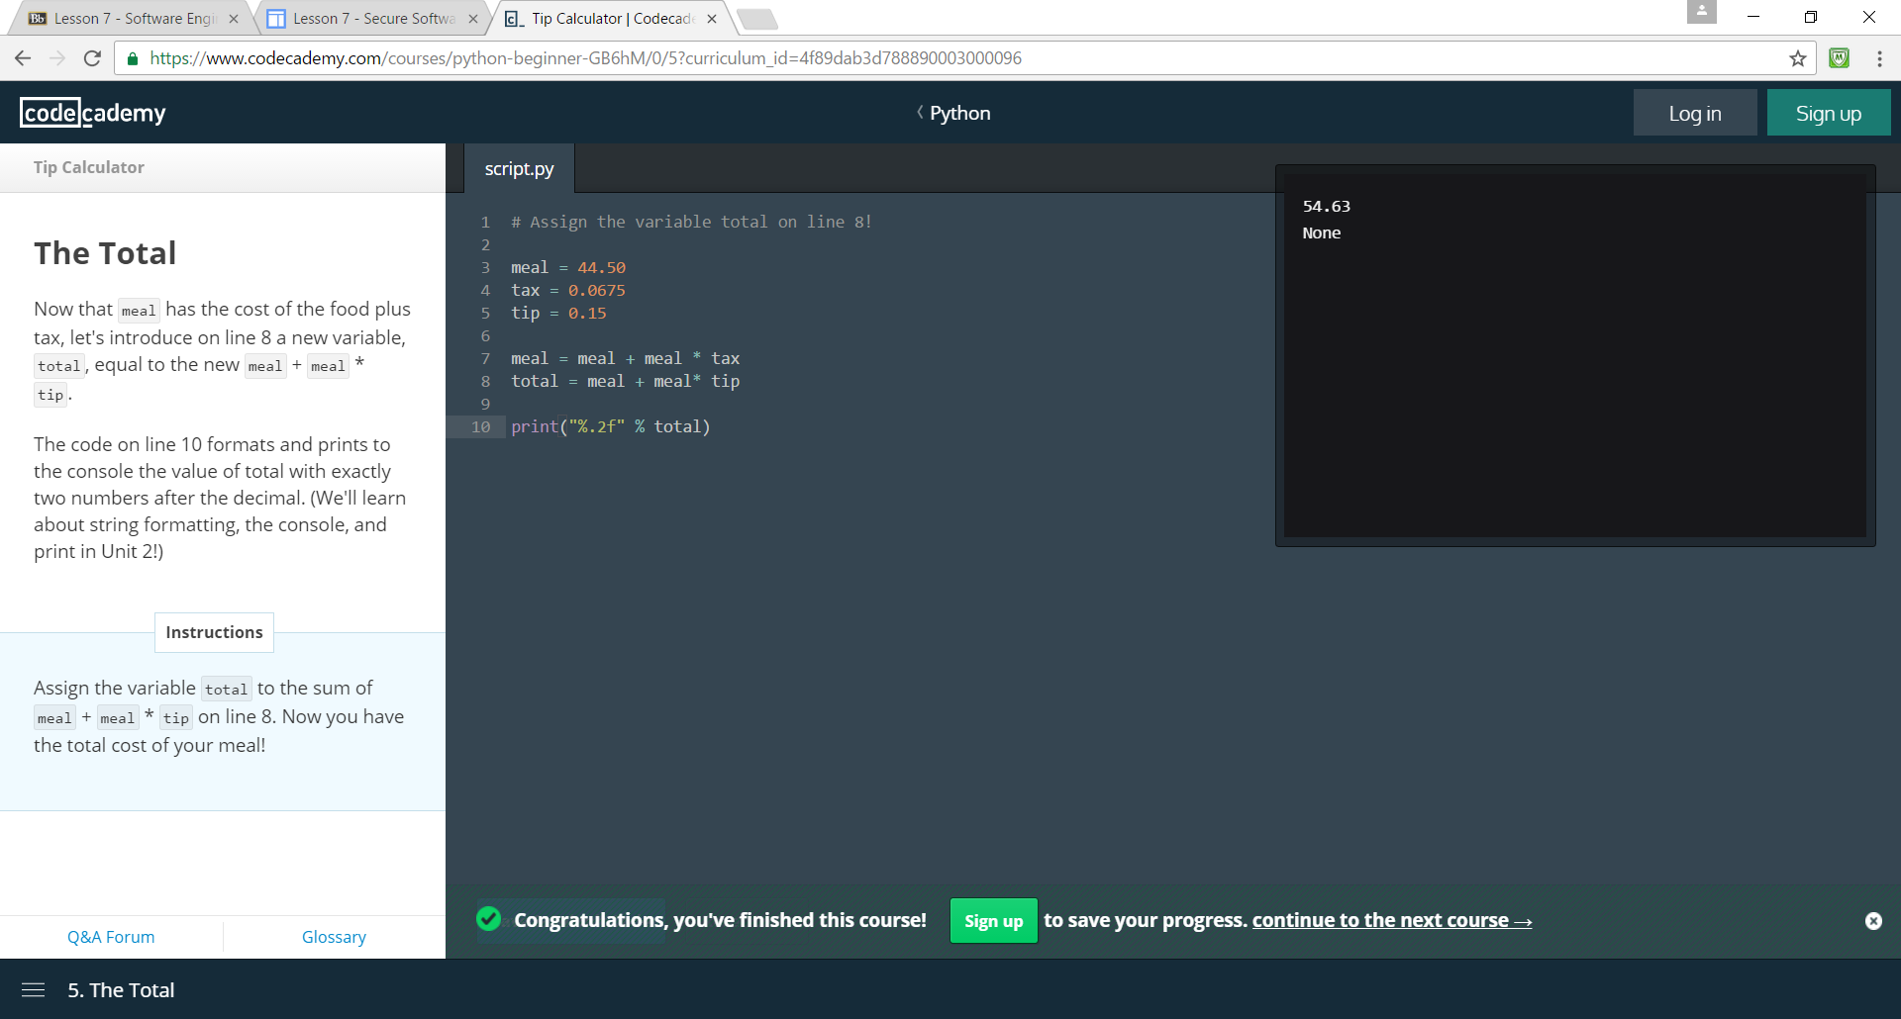

Object Oriented Programming vs. Structured Programming
Structured programming is a type of programming that is procedural in its nature. The way the code runs it is telling the computer how to act in a step by step manner. Object oriented programming allows for reusability of code by focusing on creating objects instead of following procedures. The objects would then have methods that would allow the user to manipulate information. For example, a human being is an object of the class of Mammals. If we were to create code for a video game program to allow the programmer to make the human walk In the game then that would be to create a walking method. If we wanted to add a dolphin into the game then in a procedural programming environment we would need to double the amount of code. With object oriented programming we can reuse code when possible. We already had created the class of mammals. A dolphin is a mammal just like a human so we can reuse the class: mammal and create a new object within that class that can handle its own methods like swimming instead of walking. For creating a video game, object oriented programming is the best option since reusing code would save time and effort when trying to create different classes, objects and methods. Almost all games today take code from other games. Structured programming is much better when dealing with smaller projects where spending time on creating reusable code is not beneficial in saving time. Procedural programming could be used to create programs like video games but it wouldn’t be the most efficient way, just like spending time creating classes, objects, and methods wouldn’t be the most efficient way to create a simple tip calculator.

Location Object
We will look at the example of the location object which covers information regarding the current URL. Some of the properties include the hostname property which sets and/or returns the hostname. In our case it would return www.w3schools.com. Another property used in the location object is the search property. This property sets and/or returns the query string part of a URL. The query string portion of the URL is the part that populates in the address bar when a user requests certain information from the website. For example, On the Cleveland Library Website, the search URL is https://search.clevnet.org/client/en_US/cpl-main/search/results?qu=. If we searched for ‘Ernest Hemingway’ the added portion to the URL, which is Ernest+Hemingway&te=, would be the query string portion. The methods for the location object are assign(), reload(), and replace. The assign() method allows the user to load new documents. Reload() reloads a current document. It does the same thing as the reload button in the browser. Replace() replaces a current document and prevents us from access the previous document since we are not able to use the back.

CPSR

The Computer Professionals for Social Responsibility has been involved in a lot of goodwill projects and one that I find interesting is the Election Verification Project. Protecting the validity and legitimacy of the election process is critical to continue the functionality of a representative republic like the United States. The CPSR has worked with organizations like the Verified Voting Foundation to make sure that voters feel that their vote counts and are not kept away from the voting booths because of a concern regarding the legitimacy of the system(s).
Technical groups and voting rights groups joined together in the Election Verification Project to work in the field to inform people regarding election day problems, to get journalists to interview people who have had voting issues, and to use data for election day analysis. These types of organizations could help support voting validity and expose any corruption or illegal practices.

CERT Organization

One initiative that has been undertaken by the Computer Professionals for Social Responsibility (CERT) organization is the DidFail project. DidFail stands for Droid Intent Data Flow Analysis for Information Leaks and it uses static analysis to find possible leaks of sensitive data within a set of Android applications. It has the ability track information coming from within and from other devices. CERT looks at the data flow that has been enabled individually and then monitors the potentially problematic data that the applications on the device has as a whole.

Conclusion
Within this project we were able to explain the differences between SDLC, RAD, Agile, And Lean methodologies but also see the validity of using each method based on what a company values. That is where the Quality Triangle comes into play. If we look at what a company values the least (cost, time, or quality) then we can decide what method would probably be best.
We looked at the different type of programming languages and how they aren’t all the same. Some are compiled while some are interpreted and deciding which to use depends on what someone is trying to accomplish. We gave some examples like Pascal and C# and how they measured up when it comes to their programming generation, and whether they were compiled/interpreted programming and procedural/object-oriented programming.
Responsive Design is important in the 21st century to market your website because since the smartphone came into existence the users who have a mobile device as a primary internet connectivity tool has grown rapidly. We looked at companies like the Boston Globe and Disney that have been able to stay ahead of the curb and made the experience on handheld devices as intuitive as laptops or desktop devices.
We went through a syntax tutorial of the Python programming language and it was very intuitive in its nature. Assigning values and using mathematical commands were simple enough through the process and prepared us well for the applied example of the tip calculation at the end.
We looked at the difference between object oriented and structured programming and gave examples of each type to show why someone would prefer one to another depending on what some user is trying to accomplish.
Finally, we looked at projects and initiatives that were undertaken by the CPSR and the CERT organization and how they related to information technology. The project involving the CPSR helped to create a better communication and security when it comes to supporting the voting system and its legitimacy and the CERT organization endeavor and how it uses the DidFail project to monitor potentially harmful data flow.

Bibliography
"Object-Oriented Programming." MATLAB Primer, Eighth Edition (2010): 201. Stanford.Edu. Web.
http://stanford.edu/~mzahr/extras/cme292/spring2014/lec/lec05.pdf
"Problems and Innovations." Problems and Innovations. Microsoft, n.d. Web. 04 Dec. 2016.
https://msdn.microsoft.com/en-us/library/ms954817.aspx
Https://www.facebook.com/CreativeBloQ. "Design Team Creates Incredible Pixar Website Concept." Creative Bloq. Creative Bloq ART AND DESIGN INSPIRATION, 05 Mar. 2015. Web. 04 Dec. 2016.
http://www.creativebloq.com/web-design/pixar-website-concept-31514388
"Welcome to the New Worldwildlife.org." WWF. World Wildlife Fund, n.d. Web. 04 Dec. 2016.
http://www.worldwildlife.org/pages/welcome-to-the-new-worldwildlife-org

