Stata Markstat Example of PDF

Jason Thomas

4 Sep 2019

## Introduction

Let us read the fuel efficiency data that is shipped with Stata

. sysuse auto, clear  
(1978 Automobile Data)

## **Results**

To study how fuel efficiency depends on weight it is useful to transform the dependent variable from “miles per gallon” to “gallons per 100 miles”

. gen gphm = 100/mpg

We then obtain a more linear relationship

. twoway scatter gphm weight || lfit gphm weight ///  
> , ytitle(Gallons per Mile) legend(off)  
  
. graph export auto.png, width(500) replace  
(file auto.png written in PNG format)

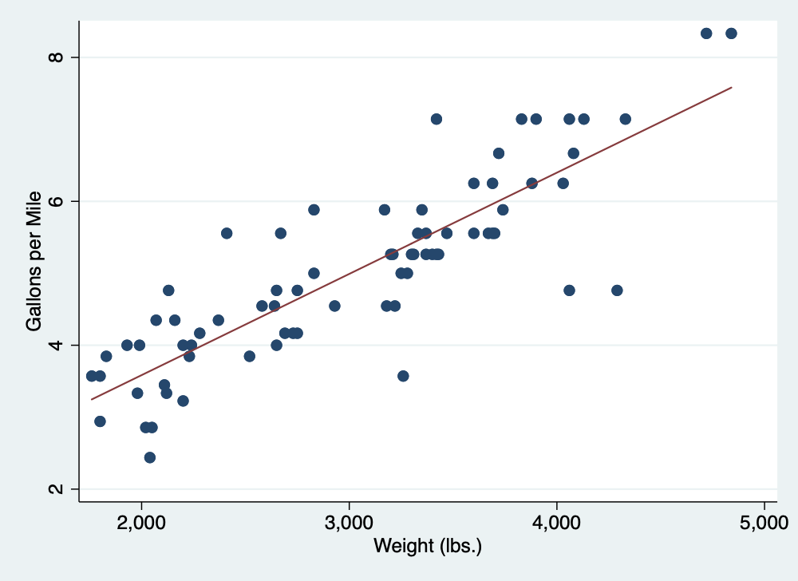

Fuel Efficiency

That’s all for now!