Business plan

**Group members:**

***Name:*** Oussama LGHACHI

***Project:*** Android application for diet programs and food ingredients calculations

***Application name:*** Easy-FIT

***Group:*** Group 8.1

1. **Industry/branch description**

* ***Project goals:***
* The user is able to see a full list of available training coaches on the application and how to contact them.
* The user is able to use the application to calculate his meal’s calories, ingredients…etc. just from giving the weight of a selected type of food
* The application is able to predict the changes and future developments that would happen to a user body according to the given information
* ***Competitors and corresponding applications:***
* Getting fit and staying in shape is a very common and famous issue in everyday life of any person, that is why there are hundreds of applications in **Samsung PlayStore** that try to tend to this need and take advantage of the opportunity.

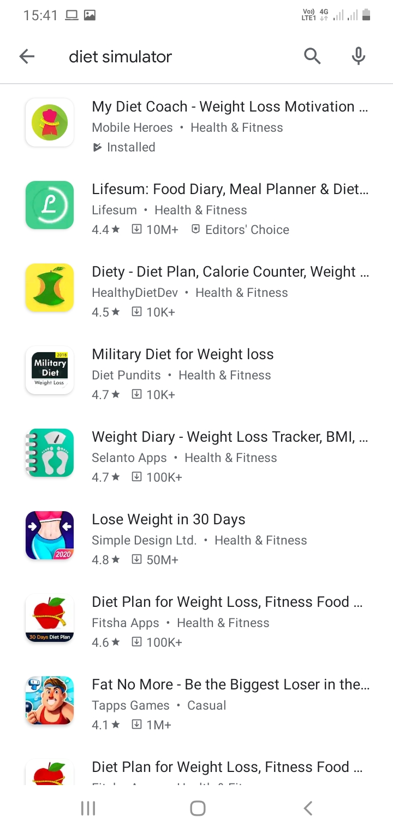

**(source: Samsung PlayStore, Date 31/03/2020)**

* However, it’s not very hard to notice that most of these applications get repetitive quickly and how they are quite lacking when it comes to having multiple functions for the user.

Most of them have very positive feedback but they also have negative ones from users who are bored with the application limitations:

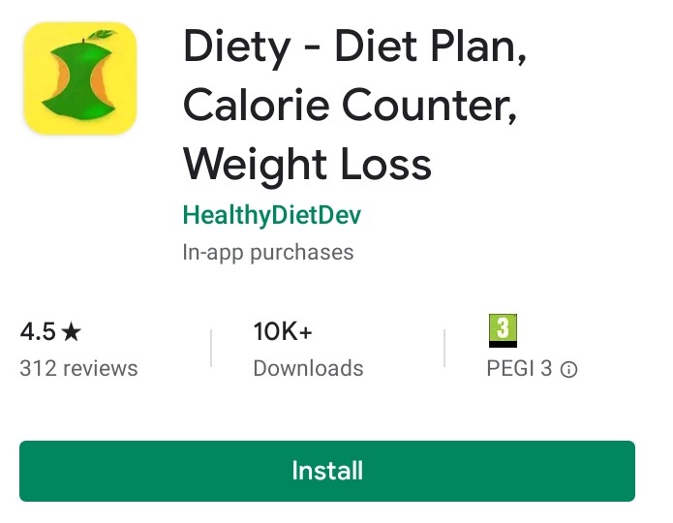

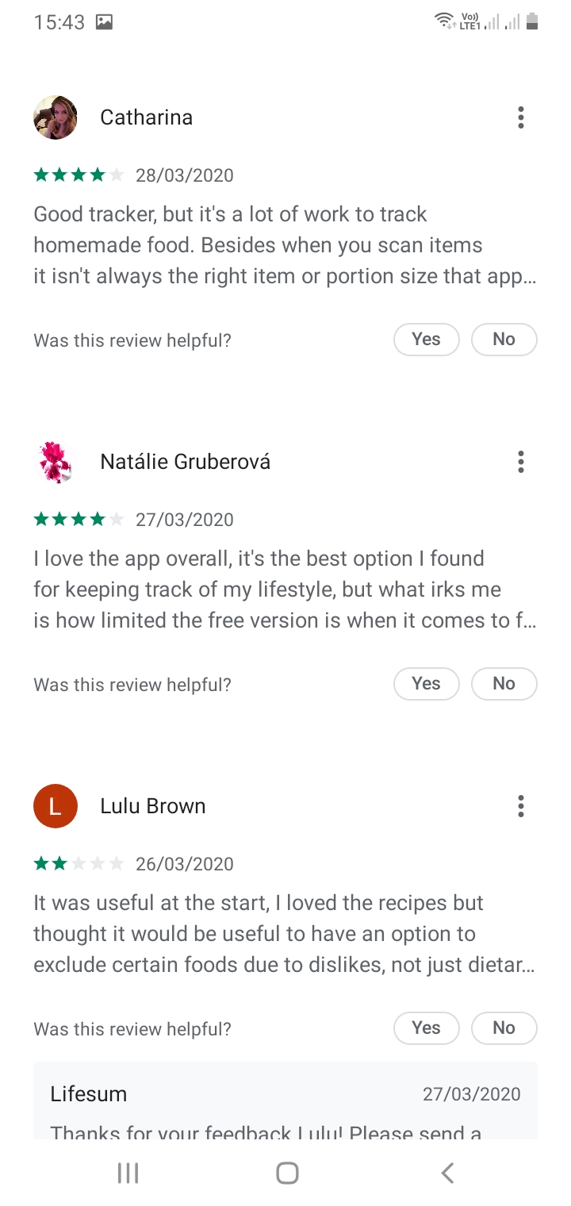

**(source: Samsung PlayStore, Date 31/03/2020)**

* That is why it is worth creating a new application that would gather all the functions requested by the users from different feedbacks on competitors application.

An application that woudn’t focus on fake looks to attract the user but rather one that will help them solve their problems and keep them in shape.

1. **BUSINESS MODEL**

* ***Example of how the application runs:***
* When the user loads the application :

1. He will first get to fill a form with information about his past (diets, sports, meals, sickness….etc ).
2. The application then collects all of that data and process it
3. After the process is over the costumer will set in the application what his goals are and what kind of program he chosed to follow
4. Finally the system will take all the collected data and information and give the user a prediction of the changes he is expected to have after finnishing the selected program
5. The user will also have the option to check components and types of food.
6. The application can also tell the user how much proteins are in a selected food just by weight.

* ***Business model:***

|  |  |
| --- | --- |
| **Needs/advantage for the customer**   * The need reliable and easy to reach and use mobile application for fitness advices and diet programs. * Easy and handy way of calculating how many calories are in a certain meal without equipement * The abilityto see how a certain sport and diet program can affect a person body to adabt before hand. * Diet and gym programs for all kinds of people with special conditions, allergies, vegan....etc. | **Image (Company image)**   * Friendly and usable by all kinds of people.      * Reliable and abble to produce results rather than just fake ads. * Company that scouts the user needs and tries to accomodate all of them as much as possible |
| **Customers/customer groups**   * People with special need and exceptional diets (vegan, allergies...etc.).      * Coaches who wants to advertise their services * People who are regulars to body workout and fitness * People who are looking for information about different types of food and how much calories and ingredients are in their chosen meals | **Products/Services**   * List of coaches available for hire.      * Information about many types of food and diets * How to easely and quickly calculate food ingredients and calories using the application. * Suggested diets and program depending on each user history and information. * The ability to see future expected changes and developements to a user body according to his/her diet and practiced sport. |

|  |  |  |
| --- | --- | --- |
| **Mode of operation**  Location: Finland, available in Samsung Play Store 24/7   * Easy-FIT scouts all the competitor’s users’ negative feedback and tries to implement function that would satisfy those needs, to have an advantage in the market. * EASY-FIT has partnership with many coaches that help the application grow, attract more costumers and advertise it more. * EASY-FIT is an online application available on Samsung Play Store, that is easy to download and very user friendly. * EASY-FIT marketing mainly focuses on internet advertisement and distributed business cards of its coaches all around gym in the country. * EASY-FIT has rented its own host server and development team that make sure the application runs smoothly and any reported problems are fixed as efficiently and soon as possible. * EASY-FIT outsources the coaches help but owns an expert team that make sure all its program and diets are up to date. * EASY-FIT exists to help those with special need and rare conditions to also get fit, while providing the regular costumer with all the information he would need. | | |
| **Resources** | | |
| **Physical**   * Tech devolepement team (6), coaches(20),costumer services(2), Payment is on average 1000e to 1500e. Administration(3) Payment on average is 2500 * Administrators can request special services like maintenance or any other need for other expertise if deemed necessary. * Materials that are needed for the working team is all bought by EASY-FIT. * One hundred thousand euros is triple of the starting amount needed for the company to function * For all employees except the owners the monthly payment is guaranteed whether the company gets revenue or not. |  | **Intellectual**   * knowledge of this field * work experience * professional team and technicians that can help solve any issue faced in the field |

# **3.Market segmentation**

* ***Customers:***

Segmentation is the division of unintegrated markets into separate groups of buyers which the company chooses its target group from and for which it builds a marketing program matching the needs and courses of action for the group.

Define the main segments of customers. What kind of customers are being focused on and why? Define the main customer group as precisely as possible.

* ***Q1: What is appreciated by the customer group?***
* The customer needs and negative feedbacks are both treated by professionals who make the application to accommodate the user.
* ***Q2: Who and where are the customers of the enterprise located?***
* The enterprise customers are located in Finland.
* *The Company focuses on:*

1. People with special needs, rare conditions, exceptional diets, vegans…. etc.
2. Costumers who are searching for an easy and reliable application that can give them all the information they need in their diets and programs
3. Users who are regular gym trainers, fitness models and normal everyday life people who are trying to stay fit
4. Coaches who are looking for a platform to advertise their services.

* ***Q3: The number of potential customers and how many could be acquired?***
* Figures and studies show that in after 2014, all reported dietary restrictions on meat consumption increased. As shown in the figure below:

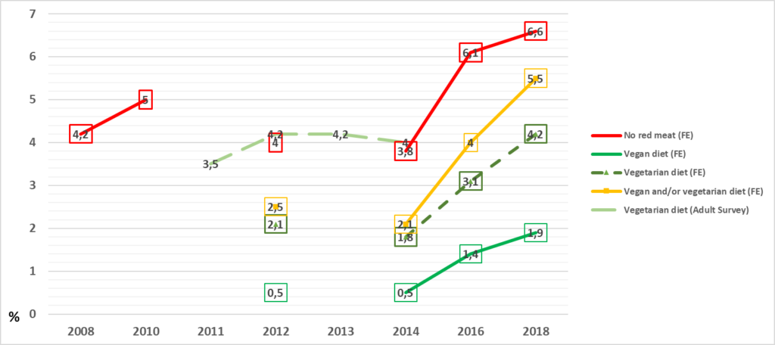

**(link:** <https://www.versuslehti.fi/kriittinen-tila/what-do-surveys-reveal-about-the-popularity-of-vegetarian-diets-in-finland/> **)**

* *Vegetarians in the Health Behavior and Health among the Finnish Adult Population Survey (Adult Survey) (Helakorpi et al. 2012, Helldán et al. 2013a, 2013b, Helldán & Helakorpi 2015) and vegetarians, vegans and respondents who do not eat red meat in the Finland Eats survey (FE), from 2008 to 2018, among aged 15-64 years, percentage of respondents*
* ***Q4: Most important potential customer groups.***
* People with special needs, exceptional diets, rare programs
* ***Q5: How are the customers reached?***

1. The Costumer is reached with advertisement made in gyms all around the country.
2. Google ads in online applications and online activities
3. Business cards distributed around cities

¨

* ***Q6: The customer’s median buy?***
* The application is free of charge
* ***Q7: What are the customer needs that are satisfied?***

1. The need reliable and easy to reach and use mobile application for fitness advices and diet programs.
2. Easy and handy way of calculating how many calories are in a certain meal without equipement
3. The abilityto see how a certain sport and diet program can affect a person body to adabt before hand.
4. Diet and gym programs for all kinds of people with special conditions, allergies, vegan....etc.

* ***Q11: What do the customers consider important factors in the operations of the enterprise and its products?***
* The important factor that the costumer consider when using the application is the fast the application is reliable to produce results, the application treats all the needs and negative feedbacks collected from other competitors and improve on them to satisfy the costumer and its an easy to access application and free of charge.
* ***Q12: What sort of customers bring in the best margin and who are the futile (but compulsory) customers?***
* The costumers who will bring the biggest margin are those with special need for rare diets and programs.
* The compulsory costumers are the ones who are regular people who need an easy to access way to calculate ingredients in their meals and general information about their health and sports.

Segment 1

|  |  |
| --- | --- |
| Description of the target group:  ***People with rare diets*** | **Geographic: Finland** |
| **Demographic: Both gender**  **Age : 15-45**  **Regular income, any background** |
| **Psychographic: tend to look for healthy but strict rare diets to stay fit.** |
| **Behauvioral mostly obssed with staying healthy and picky with their diets** |
| The needs of the target group: | **Rare diets to accommodate their needs** |
| The amount/size of the target group: | **About 20 percent of the population** |

Segment 2

|  |  |
| --- | --- |
| Description of the target group:  **Coaches** | **Geographic: Finland** |
| **Demographic: both genders**  **Age: all ages**  **Expertise in the field** |
| **Psychographic: strong intelect and ability to teach** |
| **Behauvioral: always looking to make a living with their expertise and knowlesge** |
| The needs of the target group: | **Need for a platform to advertise their services** |
| The amount/size of the target group: | **About 10 percent of the population** |

Segment 3

|  |  |
| --- | --- |
| Description of the target group:  **Regular people** | **Geographic: Finland** |
| **Demographic: Both genders**  **Age: all ages**  **Sportive people** |
| **Psychographic: love fitness and sports** |
| **Behauvioral: always staying fit and looking for healthier life style** |
| The needs of the target group: | **Reliable easy to use application with trusted results** |
| The amount/size of the target group: | **About 50 percent of the population** |

# **4.Describe your earning models. Where you´ll get your revenue?**

* The owner has taken a 50000-euro loan to kickstart the company for the first few weeks
* The secondary revenue will come from coach’s advertisement, every costumer who hire a coach through the application platform will give the application 20% of the deal that was made.
* The final source of revenue would come from google ads implemented on the application
* The prices of most the coaches available in the application is at least 250e for 12 weeks or higher. Since the company takes 20% of the deal, about 50e revenue will be added to the company finances with every deal made.
* In case the company faces very slow start or slow month then the company will rely on its loan money and google ads to keep the wheel turning until more deals have been made.

# **5. The Marketing Plan (Part 3)**

**4 P’s**

**What is or are the main products and/or services which you are offering to your customers?**

* Easily accessible application for healthy advice and diets.
* Diets for rare condition people and special programs
* List of available coaches to hire
* Easy way to calculate ingredients in meals with weight
* Ability to track improvement and change in a user body according to given program and sport

**What is the basis of the competitive advantage of the product or service?**

* Competitors have a hard time meeting what EASY-FIT is offering with its free of charge services and ability to gather negative feedback and work on them to satisfy the costumer

**Which problem of the customer does it solve?**

The costumers need a reliable application that would target the exact negative points the costumers have.

**What is the life cycle of the product?**

Service aims to have a long-life cycle.

**Additional or by-products?**

24/7 costumer service that collect feedback from costumers

|  |  |  |  |
| --- | --- | --- | --- |
| **SEGMENTS:** | | | |
| **Special need people** | **coaches** | **Regular fitness people** |  |
| **PRODUCT:** | | | |
| **Rare diets, and special program according to their requests** | **Platform to advertise their services** | **Easy to use platform to get all information needed for daily programs and different sport**  **Prediction of changes to come to the user body according to chosen program** |  |
| **PRICE:** | | | |
| **Free of charge** | **20% of deals made in the platform** | **Free of charge** |  |
| **PLACE:** | | | |
| **Finland** | **Finland** | **Finland** |  |
| **PROMOTION:** | | | |
| **Social media and business cards in gyms around the country** | **Social media and business cards in gyms around the country** | **Social media and business cards in gyms around the country** |  |

# **Core Strategy Tools:**

# ***The Competitive Analysis***

* ***Who are my current competitors? What is their market share? How successful are they?***
* Getting fit and staying in shape is a very common and famous issue in everyday life of any person, that is why there are hundreds of applications in **Samsung PlayStore** that try to tend to this need and take advantage of the opportunity.



* ***What are their strengths? Price, service, convenience, extensive inventory are all areas where you may be vulnerable.***

1. The biggest advantagemy competitors have is that they have already established a big database of cotumers and they are very hard to take over.
2. The competitors’ applications are very user friendly and looks way better

* ***What are their weaknesses? Weaknesses are opportunities you should plan to take advantage of.***

1. it’s not very hard to notice that most of these applications get repetitive quickly and how they are quite lacking when it comes to having multiple functions for the user.

Most of them have very positive feedback but they also have negative ones from users who are bored with the application limitations:

1. That is why it is worth creating a new application that would gather all the functions requested by the users from different feedbacks on competitor’s application.

An application that wouldn’t focus on fake looks to attract the user but rather one that will help them solve their problems and keep them in shape.

1. Most of the application are not free of charge and need payment to get the reliable features
2. Most of the applications have many ads and bugs that take long time to fix due to bad costumer service.

|  |  |  |  |  |
| --- | --- | --- | --- | --- |
| Current competitiors:  3-5 worst competitors | Competitor´s strenghts | Competitor´s weaknesses | Your notes | |
|  | **All the competitors have the same strenghs and advantages:**   * **Big Costumers base**      * **Very friendly interface** * **Good costumer services** * **Minor bugs and problems faced in application** | **All the competitors have the share weaknesses and disatvantages**   * **Very limited functions**      * **Expensive subscription that limit user usage of the application** * **Rarely fixes bugs and negative feedbacks given by the users** * **Very repetitive and about the same** | | **As a newly created company we must focus on the negative feedback given to these competitors and try to improve on them to have a chance at competing with them at close level**  **We should distant ourselves from all function offered by these products to be able to standout and have our own way of attracting clients to our services** |
| (Potential competitors:) | Competitor´s strenghts | Competitor´s weaknesses | Your notes | |
| **For the moment potential competitors have small effect as the market is already crouded and hard to predict.** |  |  |  | |
| * **How will your company be different from the competition? What competitor weaknesses can you exploit? What competitor strengths will you need to overcome to be successful?** * Our application will be different because it attacks all the negative feedback given by the costumer like repetitive functions, limited edition and free of charger * Also, good customer service that will fix bugs and problems reported by the costumer as soon as possible * **Which companies/products succeed well in the markets? Why? & Which of your competitors are growing and developing the fastest?** * Companies that succeed in the market are the ones with cheaper subscription, friendlier user interface and reliable to produce result * And good costumer support for the application * **How is the international competition going to move ahead in your field?** * There are already many companies around the world that try to target this market because fitness and staying healthy is a very common need * **What marketing strategies do they use? Look at their advertising, public relations, etc.** * All the competitors have the same strengths and advantages: they target bigger audience by advertising their application frequently online. They also have very friendly user interface with help user stick around for longer times * **How can you take market share away from their business?** * We can take market share away from the competitors by:  1. As a newly created company we must focus on the negative feedback given to these competitors and try to improve on them to have a chance at competing with them at close level 2. We should distant ourselves from all function offered by these products to be able to stand out and have our own way of attracting clients to our services  * **How will they respond when you enter the market?** * They will probably try to gather information from what we have worked on and try to improve on it to keep their customers happy. * **What market do current competitors target? Do they focus on a specific customer type, on serving the mass market, or on a particular niche?** * Most of the competitors don’t have specific costumer but rather target the mass market as a whole. * **Are competing businesses growing or scaling back their operations? Why? What does that mean for your business? & What will you do if competitors drop out of the marketplace? What will you do to take advantage of the opportunity?** * Most competitors are mainly staying the same and haven’t improved on their services at all. This is good news for our company since users are tired and need new functions and services that would satisfy their need and stay up to date with them. * **What will you do if new competitors enter the marketplace? How will you react to and overcome new challenges?** * To overcome new challengers and stay on top we must always keep track of the user’s feedback and use it to improve the application and satisfy their needs. * We also tend to rare and special conditions people which will give us a decisive advantage. | | | | |

# **SWOT Analysis Worksheet**

|  |  |
| --- | --- |
| **Strengths**  What do you do well?  What unique resources can you draw on?  What do others see as your strengths? | **Weaknesses**  What could you improve?  Where do you have fewer resources than others?  What are others likely to see as weaknesses? |
| * Our company does to the best of abilities is gather information and negative feedbacks from other competitors and improve on them and satisfy those needs * The unique resources that our company has are the experts that develop the application and knowledge about negative feedback to improve on gathered from competitors’ negative points. And the ability to check feedback and work them really fast and quickly while fixing all bugs that were reported. * Our strengths seen by others is that the company is brand new and have a lot of strength and will to work the hardest to become the best in the field | * The user interface could use some work and improvements to attract users even more * The designer’s team is lacking compared to other competitors * The company is brand new other competitors have big control on the users and have already established themselves as the best in the field. Which will make them hard to overcome. |
| **Opportunities**  What opportunities are open to you?  What trends could you take advantage of?  How can you turn your strengths into opportunities? | **Threats**  What threats could harm you?  What is your competition doing?  What threats do your weaknesses expose you to? |
| * The special need people, rare types of diets are an untapped market which gives the company great potential to blossom      * Everyday people who wants to be healthy using restrictive diets like vegans for examples grow by the day which helps the company grow in the future. * The ability to treat reported bugs and negative feedback as fast as possible make the company loves by the user and help it improve faster than other competitors. | * The big companies who have already established themselves might take from our company and add our features which will be a big problem for us.      * Currently our competition is stable and very repetitive when it comes to functions. Mainly focusing on income rather than pleasing the users. * Companies with highly trained and payed designers will easily interest the users and take them away from us with their friendly user interface. |

# **PESTEL**

|  |  |  |  |
| --- | --- | --- | --- |
|  | **Factor** | **Opportunity** | **Threath** |
| **Political** | The goverment in Finland help new companies with funds and support | This will help the company stabilize more quickly and have a safety net in case things go wrong | Most of the new competitors will have a solid chance to overwhelm us |
| **Economic** | Oulu is one of the biggest northen cities in Finland | Population increase in the future which will bring benifit to the company | Chance for more rivaling companies to appear |
| **Social** | Very high mentality to stay in shape and healthy | The demand for the app will be higher  People are always competing to have the best body shape | Application can lose a lot of support if there is many negative feedback and small room for improvement |
| **Technological** | People have access to high end phones and devices with the latest technologies for cheap prices | This increasece the ability of the users to download and use the app | The application will need frequent updates and compatibility with different types of devices and manufacturers |
| **Environmental** | 9 months long winter and very cold conditions outside | People will be more forced to go to gyms to fill time and stay healthy | The application will have to adabt to the conditions and provide diets that will satisfy the costumers |
| **Legal** | Finnish goverment closely monitors all companies for breaking any of the rules | This will make the users feel safe and be more open to try our services | The application will have a lot of limitation which might affect the overall product |

# **Choosing the Right Generic Strategy**

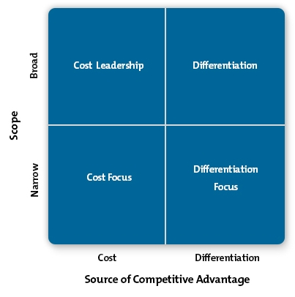

* ***Which strategy do you choose and why?***
* ***EASY-FIT include various strateties from the figure above:***

1. The company is competing to become the cost leader, because most of the competitors have implemented an obligatory subscription to use the main function of their application. Easy-FIT earns the advantage because it is free for use for the full functions with no limitations, this makes it number one choice for many users rather than having to pay they can simply download our free application and benifit all the same.
2. The second strategy is Differentiation, in this part the company has focused most of its resources into developing on all the negative points and limitations mentioned by the people on the competitors. For example, the lack of diets that would suit people with special needs or certain sicknesses and allergies. In addition to that EASY-FIT collects data from the user and update the services based on them in a very short time compared to the competitors.
3. As for the narrow scope, the company is branding itself as a savior for all the users who can’t find a suitable service because of their conditions or allergies. This makes EASY-FIT stand out even more from the competitors and makes it a valuable alternative for the costumers.

# **Competitive advantage**

# ***USP Analysis Worksheet***

**After downloading various competitors applications from the Play Store and testing them, in addition to reading feedbacks from the users on these applications. The general factors and conditions that our competitors are focusing on are:**

1. Friendly and good looking interface.
2. Variety of diet programs
3. Number of functions available for the costumer
4. Extra features to keep the costumer around
5. Pricing and subscription plans
6. Frequents updates and bug fixes

**The companies that were chosen for the analysis are the same used previously on the business plan for the competitive analysis**:

1. *My diet coach, weight loss motivation ( number one in the market )*
2. *Diety, diet plan , calory count, weight loss*
3. *Lifesum, food diary, meal planner and diet tracker*

|  |  |  |  |  |
| --- | --- | --- | --- | --- |
| Criterion | EASY-FIT | My diet coach | Diety | Lifesum |
| Interface | 6 | 10 | 6 | 5 |
| Diet programs | 9 | 7 | 6 | 5 |
| services | 8 | 7 | 5 | 5 |
| price | 10 | 4 | 6 | 5 |
| maintainance | 9 | 7 | 5 | 5 |
| Extra | 7 | 9 | 7 | 5 |

|  |
| --- |
| USP Statement |
| * Compared to most of the competitors the strong advatanges that our application has are the ability to treat different types of people with suitable diets including allergies. Vegan, sickness, special need....etc. * In addition, EASY-FIT is always closely monitoring negative feedbacks given to the competitors and improve based on those opinions to attract users attention more and stand out from other applications. * There is also a 24/7 tech team that will be in charge of fixing any bugs reported by the costumers and keep the application always updated with the latest technologies. * Therefore, this will prove to be a decicive factor for getting the company bigger and have a solid start and chance against the opposition. * However, this also means that the competition will try to undermine these efforts by doing the same updates and adding the same improvements our company has. * For that reason, EASY-FIT will stay always free of charge to make it harder for the opposition to keep up with the expenses of the updates and will as soon as possible expand its functionalitites to reach an international audience and new ideas will be implemented for different sports. |