Novel Human-Computer Interaction

Author
Andrew McGlynn

Supervisor
Paul Dunne, Galway-Mayo Institute of Technology

Course
Bachelor of Engineering (Honours) in Digital and Software Systems Engineering

April 2010

Submitted in part requirement for final year project to
Galway Mayo Institute of Technology

Abstract

People normally interact with computers using a mouse and a keyboard. A number of innovative Human-Computer Interaction mechanisms have been developed and are described in this document.
The human-computer interaction mechanisms include:
- Gesture recognition,
- Face recognition
- Motion detection.
The hardware used to in this project to develop such interaction include:
- Sun SPOTs
- Nintendo Wii Remote
- Webcam

Table of Contents
Contents
Abstract 2
Table of Contents 3
List of Figures 5
Acknowledgements 6
Introduction 7
Human-Computer Interaction 8
Objectives 9
Background 10
Motion Detection 10
Gesture Recognition 11
Face and Head Tracking 12
Hardware 13
Sun SPOT 13
eSPOT 13
Basestation 22
Sun SPOT gloves 24
Nintendo Wii Remote 26
WiiRemoteJ 27
Connecting to the Wii Remote 27
Wii Remote Hardware Interaction 28
Bluetooth 31
Infrared Light-Brush 32
Camera 33
Software 34
Java 34
Ant 34
Processing 34
Applications 35
Photo Viewer 36
Sun SPOT Communication 41
3D Model Viewer 49
3D Environment 51
Webcam Video Capturing 52
Face Detection 52
3D Camera Control 54
Drawing Application 56
Wii IR Light Detection 57
Conclusion 59
Appendices 60
Sun SPOT SDK Installation 60
Installing Ant 60
Building Sun SPOT applications 61
Starting a Host Application 62
Starting an eSPOT Application 62
Sun SPOT Programming with Netbeans 63
Creating Sun SPOT programs 63
Downloading Projects to Sun SPOTs 64
Running a Host Application 65
Including External Jar Files 66
Including External Files to Sun SPOT project 68
Sun SPOT problems 68
Setting up PFaceDetect 70
Setting up JMyron 70
References 71
Bibliography 71

List of Figures

Figure 1: Sun SPOT Boards 13
Figure 2: Sun SPOT Sensor Board 16
Figure 3: Accelerometer X, Y and Z axes 18
Figure 4: SPOT Base view 20
Figure 5: Sun SPOT Gloves 24
Figure 6: Sun SPOT Glove Circuit Diagram 24
Figure 7: Nintendo Wii Remote 26
Figure 8: Conventional Wii Use 32
Figure 9: IR Light-Brush Use 32
Figure 10: Light-Brush Circuit Diagram 33
Figure 11: Photo Viewer Application 36
Figure 12: Login Screen 37
Figure 13: OSI Reference Model 42
Figure 14: Default Cursor Image 45
Figure 15: Moving a Cursor 46
Figure 16: 3D Model Viewer 49
Figure 17: 3D Environment 51
Figure 18: Camera Orientation 54
Figure 19: Drawing Application GUI 56

Acknowledgements

I would like to thank my parents and family for their help and moral support through my college years. I would like to thank my girlfriend Mary for her help and endless support. I would also like to express my sincerest gratitude to my supervisor, Mr. Paul Dunne, whose help and guidance made this project possible. I would also like to thank my colleagues and lecturers in college for their help throughout my college years.
Introduction

Computer interaction is an exciting area of technology that is constantly being explored. Voice recognition, motion tracking and touch screens are modern, novel, computer interaction mechanisms.

One of the most popular computer interaction hardware components is the mouse. Apple created a personal computer in 1984 named Macintosh. Macintosh displayed a graphical user interface (GUI) and let users to ‘navigate’ around the GUI and perform different tasks with the use of the mouse. This allowed computer users to leave the command line interface. This revolutionary computer made the mouse a huge success and changed the way we interact with computers.

Computer hardware is becoming more and more powerful, new technologies are constantly being introduced. Using these new technologies with computers can lead to very exciting new forms of interaction. The mouse is still used even after 26 years; it is a simple device but is not very ‘human’. This project is a study of different forms of human-computer interaction using such technologies.

Human-Computer Interaction

Human-computer interaction (HCI) is the design, implementation and understanding of how humans interact with computers. Humans interact with computers through interfaces, the most commonly used interfaces are the keyboard and mouse. Other interfaces such as drawing pads and joy sticks are available but not as common in use. Humans need to be trained to use a computer and its interfaces. The aim of HCI is to make more innovative interfaces to make computing easier for humans. Interfaces such as multi-user touch screen displays are a big step in HCI; users can touch and interact with the objects on the screen just like they can with real everyday objects.

Objectives

The objective of this project is to explore and develop novel ways of interacting with a computer using modern technologies. These include:

- Recognising hand gestures and manipulating images with Sun SPOTs.
- Recognising body motion and reacting to movements using the Nintendo Wii Remote.
- Exploring Virtual Environments with a standard webcam and face detection.

Background

Motion Detection

Motion detection is a mechanism where a computer is able to detect that something has moved. This can range from cameras detecting movement to using simple electronic transducers to detect motion. The main area for motion detection includes security systems and energy saving systems.

Motion detection is used in modern consumer electronics; many mobile devices have built in accelerometers to detect the motion of the user. Gaming consoles like the Nintendo Wii have sensors that can detect motion from the user.

Motion detection also has applications in filmmaking and computer animation. The motion of a person is captured by attaching small light emitting diodes (LEDs) or reflective dots to the body. Optical trackers then detect and track the movement and send the data to a computer. The computer then maps these motions to the animation to give a more realistic movement.

Gesture Recognition

Gesture recognition is a HCI mechanism which involves a computer interpreting body gestures. This was used in Virtual Reality (VR) programs in the 80’s and 90’s. These VR programs used sensors that needed to be plugged into a computer for it to function. VR read in data from a glove interface and let the user manipulate the virtual environment by performing gestures with the glove.

Other glove based interfaces include Charade which was released in 1993. Charade is a gesture recognition interface used for computer aided presentations. It consists of a data glove connected to a Macintosh computer. Charade allows the user to issue one-handed gesture commands to control the presentation.

Computer vision techniques can also be used for gesture recognition. This is currently being investigated by Microsoft and the Xbox. This type of technique is more natural since the use of hardware such as glove interfaces are not required. Computer vision techniques do not provide the same amount of accuracy as glove based interfaces.

The introduction of wireless technology, high speed computing and more advanced hardware creates a new wide range of possibilities in developing gesture recognition systems. Microsoft is releasing a gesture recognition interface for their Xbox 360 gaming console, this interface is named “Project Natal” and is scheduled to be released in December 2010 [1]. It will allow the user to interact with the console by performing bodily gestures. Gestures are detected by this interface by using sensing cameras.
Face and Head Tracking

Head tracking was extensively investigated in the early nineties. Virtual Reality programs tracked a head’s position to suit the perspective view which the user should see within the virtual environment. Head and face tracking were developed greatly in the past 15 years with recent commercial applications such as VR based simulators, CAD design and telesurgery. This gives the user the advantage of controlling their point of view with natural movements of their head.

Some of the devices used for head tracking in the early nineties were optoelectronic sensors, acoustic sensors and magnetic sensors. Modern techniques of head and face tracking include computer vision and infrared (IR) light tracking.

There has been previous work done by a student in this institution in regards to face tracking; David Maher developed programs that used the Nintendo Wii Remote and an infrared headset that would track a face. This work is similar to the work done by Johnny Lee [2] who developed HCI programs which used the Nintendo Wii Remote and Infrared glasses to track head movements.
Hardware

Sun SPOT

The Sun Small Programmable Object Technology (SPOT) is a wireless, battery powered embedded development platform created by Sun Labs of Sun Microsystems. Sun SPOTs were developed as a way to encourage new design applications. These contain hardware to interface with the outside world. These devices are programmed in Java and are only sold in development kits. Each Development Kit contains a basestation and two eSPOTs. Sun SPOTs have their own software development kit (SDK). This contains a full application programming interface (API) for developing applications for deployment on eSPOTs and for desktop host applications. Both basestation and eSPOT use the Java Micro Edition (JME) CLDC 1.0 libraries.

eSPOT

The eSPOT or “free range Sun SPOT” is a Sun SPOT that can interact and detect information from the physical environment around it. It consists of different stackable printed circuit boards (PCBs). These boards include a main processor board, a sensor board and a rechargeable battery.

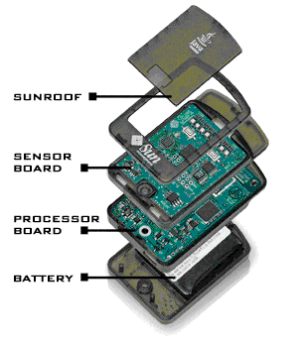
Figure 1: Sun SPOT Boards

Processor Board

The processor board contains the main processor that runs the Java virtual machine (VM) “Squawk”. There is no operating system on the board. The VM runs directly from the flash memory. The main processor is the 32 bit Atmel AT91RM9200. The processor board contains 512 kilobytes (KB) of random access memory (RAM) and 4 megabytes (MB) of flash read-only memory (ROM). The omnidirectional wireless antenna is also integrated into the processor board.

eSPOT Programming

An eSPOT application uses the JME MIDlet standard so all eSPOT applications need to implement the methods startApp(), pauseApp() and destroyApp(). The application starts with the startApp() method. The pauseApp() method is never called by the VM so this method should be left blank. The destroyApp() method should be used to clean up resources such as streams.

Sensor Board

The sensor board, also known as the eDemo board is the top board of the SPOT. It contains several peripherals which can be programmed. They include a 3-axis accelerometer, a temperature sensor, a light sensor, two push button switches eight tri colour LEDs, six analog pads, five digital input/output (IO) pads.

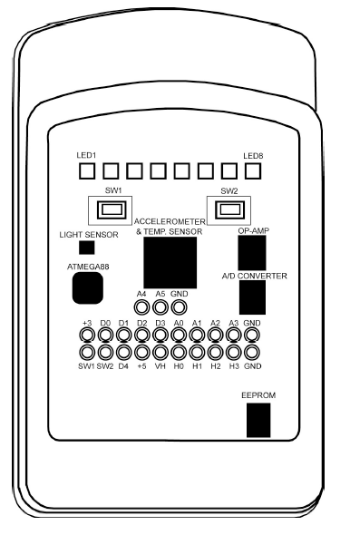
Figure 2: Sun SPOT Sensor Board

Accessing any of these peripherals involves requesting them from the EDemoBoard object, instantiating the EDemoBoard object is done by calling the static getInstance() method.

EDemoBoard demoboard = EDemoBoard.getInstance();

Once the EDemoBoard object is created, it can then be used to access any of the peripherals on the board.

Push Button Switch

There are two push button switches on the SPOT (SW1 and SW2). Accessing these switches is done by using the ISwitch class. The logic level of these switches can be monitored by the isOpen() and isClosed() methods.

ISwitch[] switches = EDemoBoard.getInstance().getSwitches();

if(switches[i].isOpen()){

}

Digital Input Output Lines

There are five general purpose digital IO lines (D0 –D4) available for use on the sensor board. These lines can be configured as either input or output. These lines can source 16mA of current and sink 24mA of current. Accessing these IO lines requires the IIOPin class. The EDemoBoard class’s getIOPins() method is the way of getting a reference to these IO lines.

IIOPin[] pins = EDemoBoard.getInstance().getIOPins();

Configuring the IIOPin as output requires the setAsOutput() method. The IIOPin is configured by default as input.

pins[2].setAsOutput(true); //set as output
pins[0].setAsOutput(false); //set as input

Once the IIOPins are configured, they can be used in the application. When in input mode, the methods isLow() and isHigh() are used to read the logic level of the IIOPin.

//check if the pin is low
if(pins[0].isLow()) {

}

//check if the pin is high
if(pins[1].isHigh()) {

}

When the IIOPin is configured as output, the methods setHigh() and setLow() can be used to control the logic levels of the IIPins.

pins[0].setHigh();
pins[0].setLow();
There are four high current driver pins (H0, H3) which can be used if the D0 to D3 do not provide enough current but battery life will decrease more with the use of these pins.

Accelerometer

The accelerometer on the EDemoBoard is the LIS3L02AQ low power, three axis accelerometer. It can be used to measure the motion of the SPOT. It can also measure the SPOT’s orientation with respect to gravity. The accelerometer consists of a Micro-Electro-Mechanical System (MEMS) sensor element which is then read by the EDemoBoard’s analog-to-digital converter (ADC).

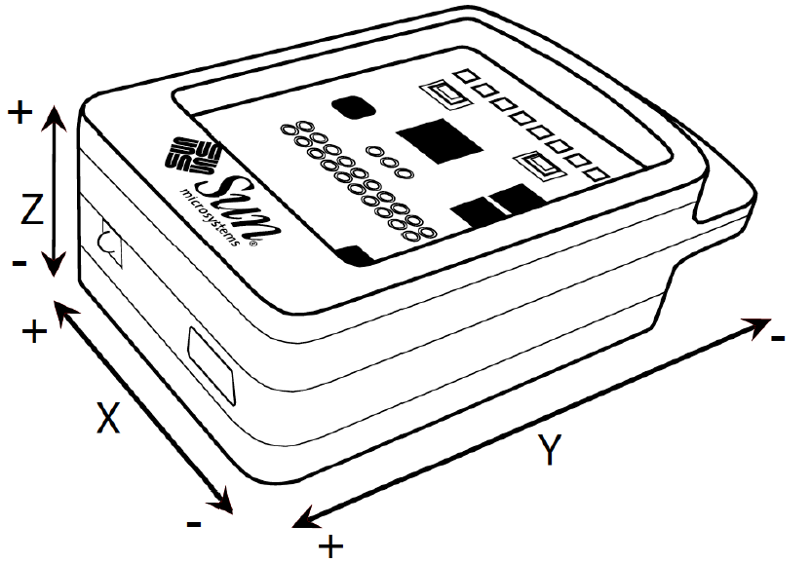
Figure 3: Accelerometer X, Y and Z axes

The LIS3L02AQAccelerometer API allows access to the accelerometer from the application program. The LIS3L02AQAccelerometer object must be instantiated to use the API.

LIS3L02AQAccelerometer accelerometer =
(LIS3L02AQAccelerometer)EDemoBoard.getInstance().getAccelerometer();

Once the accelerometer is instantiated, it can be set in two modes, the 2G scale mode or the 6G scale mode. In the 2G scale mode, the accelerometer can be set to measure accelerations over a scale of ±2g and ±6g in 6G scale mode. The setScale() method is used to set the mode of the accelerometer.

accelerometer.setScale(LIS3L02AQAccelerometer.SCALE_2G);

The accelerometer is now set up to read from the application. There are different ways of reading the data. The methods getRawX(), getRawY() and getRawZ() return the raw voltage values read each axis from the accelerometer.

int rawX = accelerometer.getRawX();
int rawY = accelerometer.getRawY();
int rawZ = accelerometer.getRawZ();

The getAccelX(), getAccelY() and getAccelZ() methods are used to get the value of the accelerometer in G’s.

double xaccelReading = accelerometer.getAccelX();
double yaccelReading = accelerometer.getAccelY();
double zaccelReading = accelerometer.getAccelZ();

The getTiltX(), getTiltY() and getTiltZ() methods are used to get the tilt or inclination of the SPOT. This is done by measuring the force of gravity acting on the accelerometer. These methods are only correct if the SPOT is at rest. These methods return doubles which are the tilt of the SPOT in radians, these values range from (–π/2 to +π/2).

double xTilt = accelerometer.getTiltX();
double yTilt = accelerometer.getTiltY();
double zTilt = accelerometer.getTiltZ();

Sampling the accelerometer is a process that takes time due to the ADC having to convert the raw voltage into a digital number. A sufficient delay must be used between sampling. Sampling rates of 10 – 20 Hz should be sufficient sampling rates.

Battery

The battery in the SPOT is a rechargeable 3.6v lithium-ion battery. The battery is be recharged by the USB connector on the base of the SPOT. Battery life can support up to 7 hours of operation. SPOT battery life can be saved by switching the SPOT into a low power sleep and switching the radio off when not in use. This is done by the Utils.sleep() method.

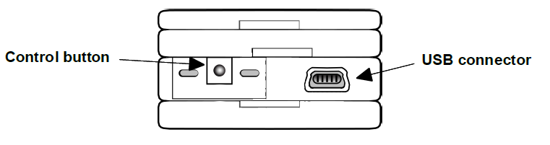
Figure 4: SPOT Base view

Radio

Sun SPOTs communicate wirelessly through an 11 channel 2.4GHz – 2.4835GHz radio, it is IEEE 802.15.4 compliant. The radio can be configured in different modes. The SPOT can be set up with a point to point connection. This mode provides a reliable means of sending data which is similar to TCP. Another mode of operation is broadcasting; this is unreliable and is similar to UDP. Server mode sets up the SPOT to receive all radiograms sent to a given port.

Broadcasting Data

In broadcast mode the SPOT broadcasts on a specific port. The wireless data can be received by all listeners on that port. Broadcasting data involves setting up the RadiogramConnection object in broadcast mode.

RadiogramConnection rCon =
(RadiogramConnection) Connector.open("radiogram://broadcast:" + port);

Broadcasting data is done through the use of Datagrams. All data to be broadcast has to be encapsulated in the Datagram object. Creating a Datagram object is done by the newDatagram() method of the connector, this accepts the datagram size.

Datagram dg = rCon.newDatagram(rCon.getMaximumLength());

There are a variety of methods to fill up the Datagram with data. They include write methods similar to DataInputStream and DataOutputStream. Note that the amount of the data in a Datagram is limited by the Datagram’s length. There are multiple methods such as writeByte(),writeChar(), writeInt() etc.
dg.writeByte(data);

To broadcast the datagram, the connector object’s send method is used. It accepts the Datagram to be sent.
rCon.send(dg);

When in broadcast mode, the connector is setup to have simplex communication. The connector cannot receive Datagrams when it is set in broadcast mode.

Basestation

The purpose of the basestation is to act as a gateway between a host application running on a workstation and the eSPOTs. The host application runs a Java Standard Edition (JSE) program. The communication between the basestation and workstation is done via USB and the communication between the basestation and the eSPOTs is done via 802.15.4 radio. The basestation contains a USB connection to interface with the workstation and an IEEE 802.25.4 radio transceiver and antenna. The basestation is supplied power from the USB connection. It does not have a battery so it must be always connected via USB to supply power to it. The basestation contains only the main SPOT board; it does not contain the sensor board or the battery. Any SPOT can be used as a basestation as long as it is configured correctly.

Using the basestation

The basestation is used to connect the wireless SPOTs to a Java host computer application. The RadiogramConnector can be set up in server mode to receive data. In this mode any radiogram sent on a specific port will be received.

RadiogramConnection rCon =
(RadiogramConnection) Connector.open("radiogram://:" + port);

A Radiogram object is needed to receive incoming data. It needs to be set up with a large buffer to ensure no loss of data.

Radiogram rg =
(Radiogram)rCon.newDatagram(BufferSize);

Receiving data is done by the RadiogramConnection object’s receive() method. This method accepts the Radiogram object to store the data in.

rCon.receive(rg);

Once the Radiogram is received, its data can be received by the read methods.

byte inputType = dg.readByte();

Once the data is read from the Radiogram, the data is then removed. The readUTF() method will read the entire Radiogram’s contents.

Sun SPOT gloves

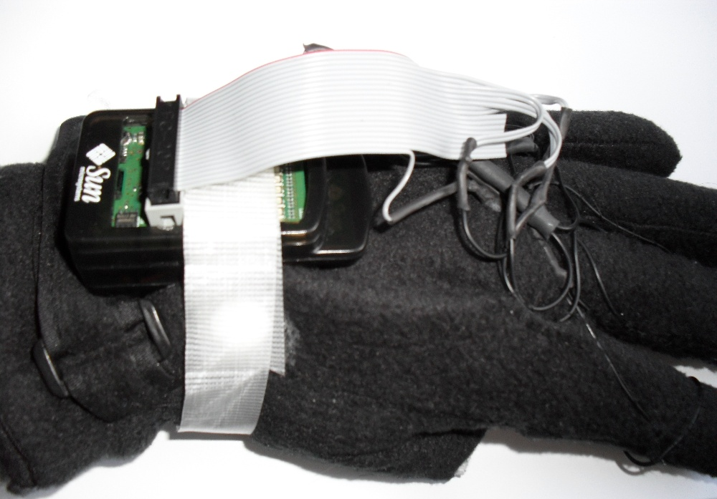
Figure 5: Sun SPOT Gloves

To implement gesture recognition a pair of Sun SPOT gloves were created. The Sun SPOT gloves consist of a Sun SPOT and 4 pushbutton switches. A Sun SPOT is used to detect how the hand is posed (hand orientation). The user can make gestures by pressing their thumb against their finger tips.
These gestures are detected by push button switches positioned on the tip of each finger of each glove. The switches are then inputted to the digital IO pins D0 – D3 on the Sun SPOT.
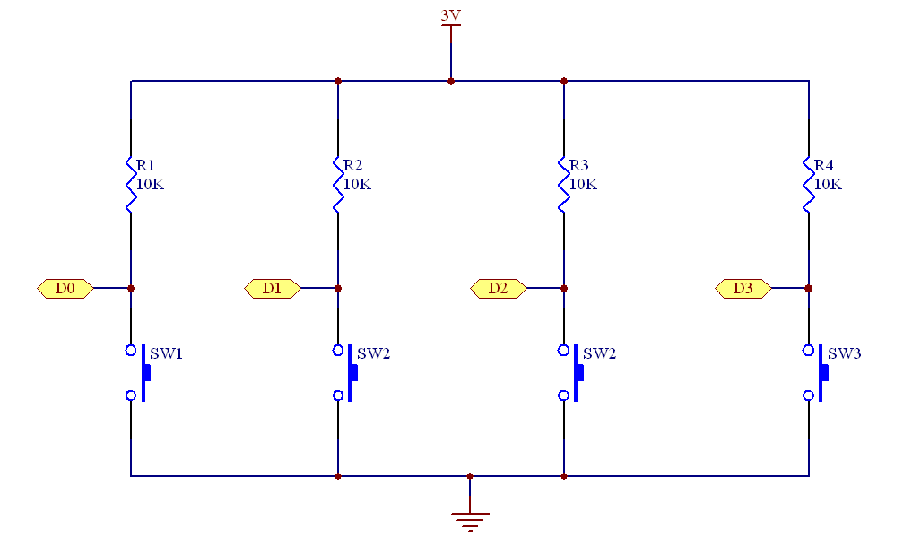
Figure 6: Sun SPOT Glove Circuit Diagram

The eSPOTs on the Sun SPOT gloves are programmed with a program that samples data from different sensors and transmits the sampled data. The Sun SPOT runs a program which consists of a continuous loop. The program samples the accelerometer and reads the values for the x, y and z axes.
public LIS3L02AQAccelerometer accelerometer =
(LIS3L02AQAccelerometer)EDemoBoard.getInstance().getAccelerometer();
double xaccelReading = accelerometer.getAccelX();
double yaccelReading = accelerometer.getAccelY();
double zaccelReading = accelerometer.getAccelZ();

When the accelerometer readings are finished getting sampled the readings are broadcast wirelessly.
dg.reset(); //clear the datagram
dg.writeByte(ACCEL_ALL); //add the header information to the datagram
dg.writeDouble(xaccelReading);//add the x-acceleration to the datagram
dg.writeDouble(yaccelReading);//add the y-acceleration to the datagram
dg.writeDouble(zaccelReading);//add the z-acceleration to the datagram
rCon.send(dg); //send the datagram wirelessly

The values on the digital IO pins are then sampled, if there is a change in state in any of the IO pins from the previous loop, the pin number and the pin state is broadcast.
//loop through digital IO pins D0 to D3
for(int i = 0; i < pins.length-1; i++){
//read the pin state
if(pins[i].isLow()) ioPinState[i] = false;
else ioPinState[i] = true;
//detect a pin state change and broadcast the pin and state
if(ioPinState[i] != oldIoPinState[i]){
// broadcast the pin and state
}
//update old state
oldIoPinState[i] = ioPinState[i];
}

The program then sleeps for a 100 milliseconds to conserve battery and allows the receiver enough time to process the received datagram.
Utils.sleep(SAMPLE_PERIOD);

Nintendo Wii Remote

The Nintendo Wii Remote is a human interface device (HID) designed as the main input to the Nintendo Wii console. It communicates wirelessly to the host console via the Bluetooth Logical Link Control and Adaptation Protocol (L2CAP) protocol. This device requires a DC voltage of 3.3V to drive it and draws 35mA of current.
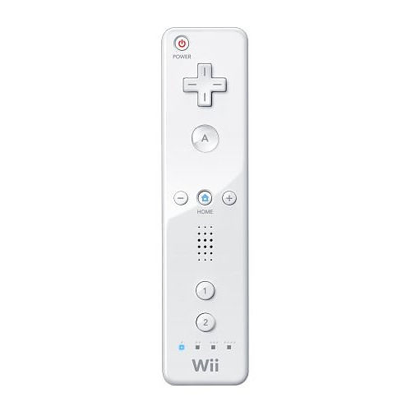
Figure 7: Nintendo Wii Remote

It contains the following hardware features:
- BCM2042 Bluetooth chip (Contains full Bluetooth stack, 8051, RAM and ROM)
- ADXL330 3-axis accelerometer
- 16kB EEPROM chip
- 12 push button switches
- 4 surface mounted blue LEDs
- Small DC motor to control Rumble Feature
- Piezo-Electric Speaker
- 6-pin expansion connector
- 11 buttons
- PixArt optical sensor.

WiiRemoteJ

This project uses a Java library to interface the Wii Remote to a computer. WiiRemoteJ is a library developed by Michael Diamond; it allows the Nintendo Wii Remote to connect to a computer’s Java program via Bluetooth [3]. WiiRemoteJ provides the functionality to allow a computer to connect to the Wii Remote, read and control the hardware. This library has a full API available to interface to the Wii Remote.

Connecting to the Wii Remote

To connect to the Wii Remote, it must be put into discoverable mode. To put the Wii Remote into discoverable mode, press buttons ‘1’ and ‘2’ simultaneously. When in discoverable mode the LEDs positioned under button ‘2’ of the Wii Remote will blink. While this is happening, the Wii Remote can be queried by another Bluetooth host. The Wii Remote will stay in this mode for 20 seconds. Within the 20 seconds the host Bluetooth device can connect to the Wii Remote using standard Bluetooth pairing. If the Wii Remote is not paired with a Bluetooth device in 20 seconds, it will turn itself off.
Connecting to the Wii Remote from a WiiRemoteJ program involves using the findRemote() method, this method searches for a WiiRemote and pairs it via Bluetooth.

WiiRemote wii = WiiRemoteJ.findRemote();

Connecting to a specific Wii Remote can be done by using the connectToRemote() method and specifying its Bluetooth address.

WiiRemote wii = WiiRemoteJ.connectToRemote("001FC51E7306");

Once a reference is made to the Wii Remote, the WiiRemote object can then interact with the hardware.

Wii Remote Hardware Interaction

LED Control

The four blue LEDs can be controlled by the setLEDIlluminated() method. This method accepts the LED number (0 – 3) and a Boolean stating the state of the LED.

wii.setLEDIlluminated(1, true); //set LED 0 on.

Speaker Control

The speaker on board the Wii Remote can be used to play sound files. The file needs to be streamed directly from the host computer. For best results, use only short sound files with low sampling rates. The sound file must be converted to an AudioInputStream, once the AudioInputStream is set up it needs to be converted to a PrebufferedSound, this can be done by the WiiRemote.bufferSound() method. The PrebufferedSound can then be played on the Wii Remote by the playPrebufferedSound() method.

AudioInputStream audio = AudioSystem.getAudioInputStream(new File(filePath));
PrebufferedSound prebuf= WiiRemote.bufferSound(audio);
wii.setSpeakerEnabled(true);
wii.playPrebufferedSound(prebuf, WiiRemote.SF_PCM8S);

Wii Rumble Control

The DC motor contained inside the Wii Remote can be used to control the rumble feature. This can be done by the startVibrating() method, it will start vibrating until the stopVibrating() method is called. The rumble feature can also be enabled on for a set time duration. This can be done by the vibrateFor() method.

wii.startVibrating(); //start vibrating
wii.startVibrating(); //stop vibrating
wii.vibrateFor(1000); //vibrate for 1 second

Wii Remote Events

WiiRemoteJ provides an event driven framework. Software events are generated by buttons being pressed, a change in the accelerometer readings, a change in infrared light position and changes in the battery level.

Wii Battery Level

The battery level of the Wii Remote can be accessed by implementing the WiiRemoteListener class. The statusReported() method can be used to obtain the battery level. This is done by the getBatteryLevel() of the WRStatusEvent object.

@Override
public void statusReported(WRStatusEvent evt) {
double batteryLevel = evt.getBatteryLevel()*100; // values between 0-100
}

Accelerometer Events

The Wii Remote generates an accelerometer event when there is a change in the accelerometer. Receiving accelerometer events is done by the accelerationInputReceived() method. Getting the x, y and z accelerometer readings is done by the getXAcceleration(), getYAcceleration() and getZAcceleration() methods.

@Override
public void accelerationInputReceived(WRAccelerationEvent evt) {
double xAccel = evt.getXAcceleration();
double yAccel = evt.getYAcceleration();
double zAccel = evt.getZAcceleration();
}

The accelerometer will not generate events until the accelerometer is enabled. This is done by the setAccelerometerEnabled() method.
wii.setAccelerometerEnabled(true);

Infrared Events

Infrared events are generated by the Wii Remote reading a change in the infrared light. Receiving infrared events is done by the IRInputReceived() method.
@Override
public void IRInputReceived(WRIREvent evt){
IRLight[] lightArray = evt.getIRLights();

double x = lightArray[0].getX();
double y = lightArray[0].getY();
}

The IR reception has to be enabled and set up before any events will be generated. There are three modes of operation, they include basic, extended and full. Basic mode contains only IR light position information, extended mode contains IR light position and size information, full mode contains IR light position, size, intensity information and the bounding box. Enabling the IR light sensor done by the setIRSensorEnabled() method.
wii.setIRSensorEnabled(true, WRIREvent.FULL);

Button Events

Button events are generated when any button on the Wii Remote is pressed. Receiving button events is done by the buttonInputReceived() method.
@Override
public void buttonInputReceived(WRButtonEvent evt) {
//check if left button is pressed
if(evt.isPressed(WRButtonEvent.LEFT)){

}
}

Bluetooth

The Wii Remote can connect to the computer using Bluetooth. BlueCove is a free Java library which allows standard Bluetooth pairing between a computer and a Bluetooth device. It provides an implementation of JSR-82 to connect to the Bluetooth device. BlueCove interfaces with the Bluetooth stack on a computer. It needs the WIDCOMM or BlueSoleil drivers to connect to the Bluetooth device. WiiRemoteJ is not compatible with BlueSoleil drivers. The computer must be Bluetooth enabled to use BlueCove. If the computer is not Bluetooth enabled, external hardware such as a Bluetooth USB adapter will be required.

Infrared Light-Brush

The infrared light-brush is used as a light source for the Wii Remote. The conventional way to use the Wii is for the user to hold the Wii Remote and to have the light source in a static position, usually positioned on top or below of the television screen. Usually the light source is the Wii Sensor Bar; the Sensor Bar despite the name is not used for sensing but contains 10 infrared LEDs and illuminates the LEDs when it is powered on.
Screen
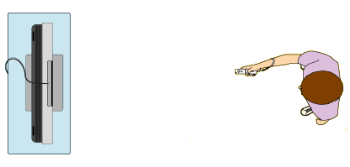
Wii Remote
Sensor Bar
Figure 8: Conventional Wii Use

The light-brush is used in a different way; the Wii Remote is to be static near the display screen and the user holds the light-brush.
Wii Remote

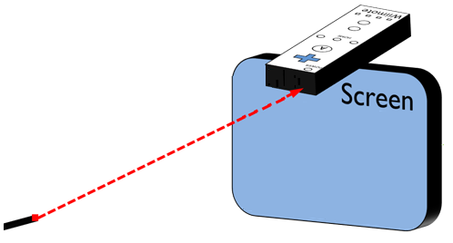
Infrared Light
Infrared Light-Brush
Figure 9: IR Light-Brush Use

The light-brush contains 10 infrared LEDs and runs off a 9 volt battery.

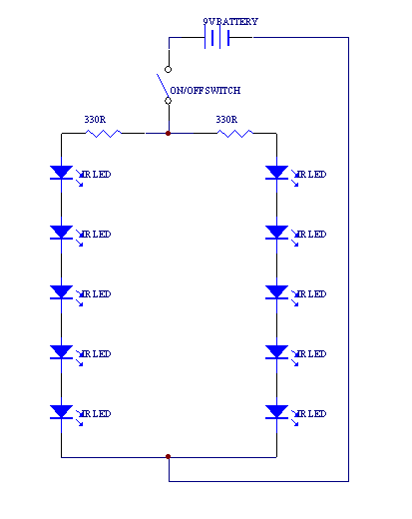
Figure 10: Light-Brush Circuit Diagram

Camera

The specific camera used to test this project was the Alba M6638U 10MP webcam. Any standard webcam will work as long as the manufacturer’s drivers are installed on the operating system, many of the available new webcam devices allows “plug and play”, these devices do not require the installation of drivers.

Software

Java

Java was developed by James Gosling at Sun Microsystems and was released in 1995 [4]. Java is an object orientated language which runs in a Java Virtual Machine (JVM). Java code is compiled into byte code that can be run on any JVM independent to the computer architecture. This project is all Java based.

Ant

Ant is a Java build tool [5], it can be used to compile and run Java projects as well as creating automated build tasks. Ant is used in this project to compile, deploy and run Sun SPOT projects.

Processing

Processing is a Java library which allows the fast creation of graphical programs [6]. A Processing program extends a Java applet and it consists of two methods that need to be overridden: setup() and draw(). The setup method is used as initialisation; the draw method is used as the main loop of the program, methods like line(), ellipse() and rect() are used to draw on the applet and should be called within the draw() method. Processing performs tasks like enabling double buffering and getting any hardware support i.e. graphics card support.
Processing has its own IDE available but it can be integrated with standard Java programs by importing the Processing core.jar library.

Applications

The project is broken up into three main applications. Each of the applications explores and studies a different HCI mechanism.

The Photo Viewer/3D Model Viewer application uses gesture recognition with the use of the Sun SPOT gloves, this application detects gestures such as a user pressing their fingertips and the user tilting their hands. The user can then perform tasks in the application by performing gestures.

The 3D environment application uses the computer vision HCI mechanism. In this application a webcam streams a video feed into the program, then the program detects a face in the video stream and changes the view of the 3D environment. The user can manipulate their view of the 3D environment by just moving their head.

The Drawing Application uses motion detection as a technique of HCI. The user holds the light-brush; the Wii Remote detects the motion of the user by reading the infrared light from the light-brush.

Photo Viewer

Photo Viewer allows the user to manipulate photos with the use of hand gestures. The user has a cursor for the left hand and a cursor for the right hand. Both hands work independently of each other. The user’s hand gestures are recognised by the Sun SPOT gloves. Photo properties such as the x-y position, rotation and the size of a photo may be modified with the use of the Sun SPOT glove and different hand gestures. By performing different gestures with the Sun SPOT gloves, different tasks can be achieved.

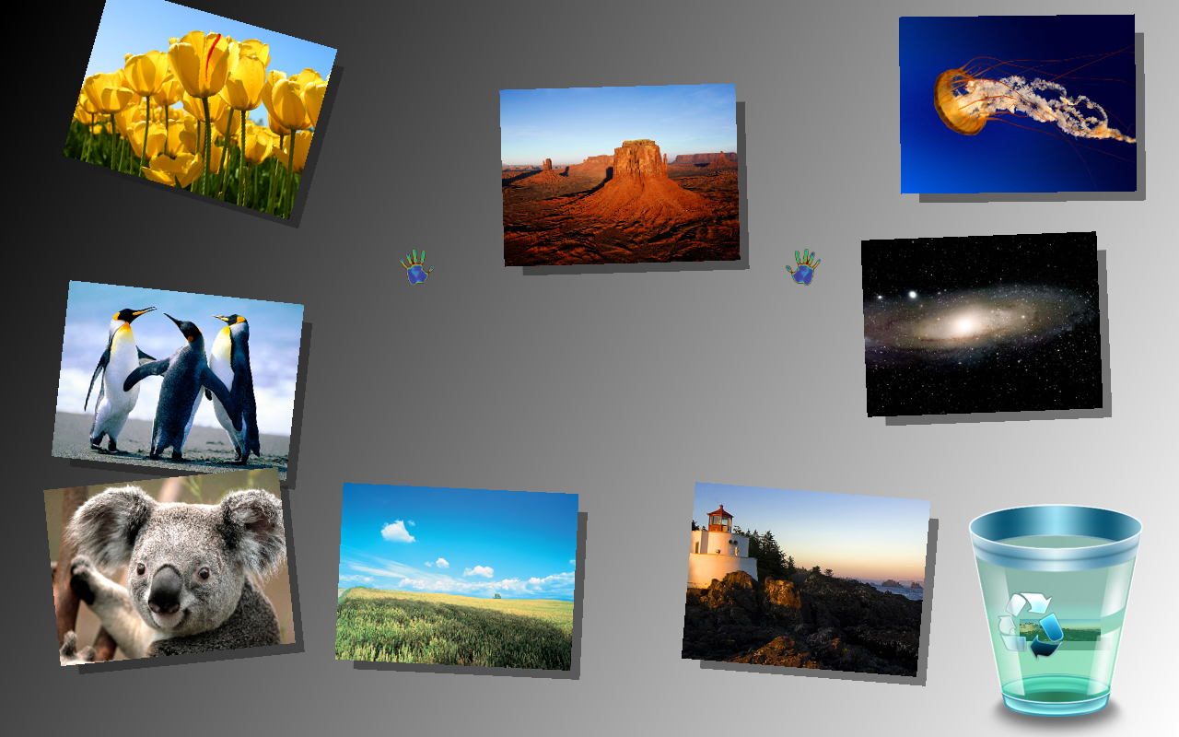
Figure 11: Photo Viewer Application

Login

A login screen is used in this program to allow only registered users to use the Photo Viewer and 3D Model Viewer applications. It connects to a database and confirms that the entered information is valid information. The database stores usernames and their associated passwords.

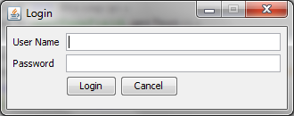
Figure 12: Login Screen

Database

A table is used to store usernames and passwords in a MySQL database [7]. The table is called “users”, inserting new users into the database involves the following SQL code. It will insert a user with name “user” and password called “password”.

insert into users (username, password) values ('user', 'password')

Connecting to a database from a Java program involves the use of the Java Database Connector (JDBC). The JDBC API provides classes and methods to allow the application programmer to perform different tasks with a database. The JDBC allows inserting data, removing data and updating data. Connecting to the database is done through the Connection class.
Class.forName( "com.mysql.jdbc.Driver" ).newInstance();
Connection connection = DriverManager.getConnection(
"jdbc:mysql://localhost:3306/login?user=root" ,"root","");

Once connected to the database data can be accessed. This is done in JDBC by the use of prepared statements. The PreparedStatement class stores an SQL command in the form of a String.

PreparedStatement sqlFindPassword = connection.prepareStatement( "SELECT password FROM users WHERE username = ?" );

Inserting data into the prepared statement is done through the set methods of the PreparedStatement object. Inserting a string into the prepared statement is done by the setString() method.

sqlFindPassword.setString( 1, "test" );

The prepared statement can then query the database by the executeQuery() method. This method returns a ResultSet method containing the information retrieved from the database.

ResultSet rs = sqlFindPassword.executeQuery();

Information can then be accessed from the ResultSet by the get methods. Retrieving a string is done by the getString() method. The next method is used to traverse through the ResultSet.
rs.next();
String storedPassword = rs.getString(1);

The information can then be used in the program as normal variables.

Displaying the User Interface

The Photo Application GUI is displayed in a JFrame. The JFrame is set up in full screen exclusive mode. This mode provides high-performance when displaying graphics in an application.

JFrame frame = new JFrame();
GraphicsEnvironment ge = GraphicsEnvironment.getLocalGraphicsEnvironment();
GraphicsDevice graphicsDevice = ge.getDefaultScreenDevice();
graphicsDevice.setFullScreenWindow(frame);
frame.validate();

BufferStrategy is used to display the user interface. A BufferStrategy object can be created by the createBufferStrategy() method of the JFrame, it accepts the number of buffers to have, in this case double buffering is sufficient. Buffering is needed to reduce on-screen flicker.

frame.createBufferStrategy(2); //create a double buffered strategy
BufferStrategy strategy = frame.getBufferStrategy();

Everything in the user interface is painted by using the BufferStartegy’s Graphics object. Obtaining the Graphics object is done through the getDrawGraphics() method.

Graphics2D g = (Graphics2D)strategy.getDrawGraphics();

The BufferStrategy object has a variety of draw methods. Drawing an image involves using the drawImage() method. This accepts a BufferedImage and the AffineTransform being applied to the image and the ImageObserver.

g.drawImage(image, at, null);

Once everything is painted, the BufferStrategy can then display it to the screen by using the show() method.
strategy.show();

The main loop of the program involves in just the drawing of the background, photos, recycling bin, and cursors. The rest of the program is event driven.

Sun SPOT Communication

There are three Sun SPOTs used in the Photo Viewer application and the 3D Model Viewer application, one basestation and two eSPOTs. The eSPOTs broadcast their accelerometer readings and switch states through a radiogram. Radiograms are read from the basestation, the basestation acts as a gateway node to the computer. It receives radiograms and passes them into the Photo Viewer application. The eSPOTs are set up in broadcast mode and the basestation is set up in server mode. The communication in this program is similar to UDP and uses a simplex communication method, no information is sent from the basestation to the eSPOTs. The two eSPOTs broadcast their information without making a TCP like connection to the basestation.

Differentiating datagrams from the two Sun SPOTs was done by each Sun SPOT communicating to a different port. Sun SPOTs can communicate on a common port but this needs a facility to check address headers of the incoming datagrams. Although this technique is easy to implement, a cleaner solution of communicating to different ports gets rid of the added address checking complexity.

Ensuring effective communication requires a common communication protocol between devices. By referencing the OSI Reference model, an application layer protocol needs to be in place for successful communication. The Sun SPOT API performs lower layers of the OSI reference model. An application layer protocol needed to be developed for this application.
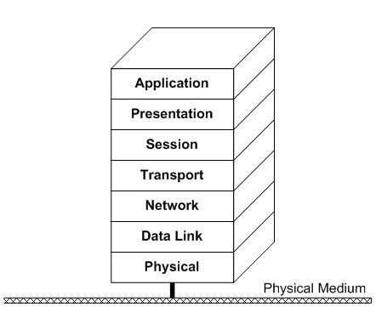
Figure 13: OSI Reference Model

The application layer protocol developed, it specifies that the information being communicated must have a header tag in the datagram before the value of a sensor reading. The header information is stored as one byte. The value of the byte will specify what sensor reading is to follow and what data-type is stored. An example would be sending an x-axis accelerometer reading, this would require the following code.

xaccelReading = accelerometer.getAccelX(); //read the accelerometer value
dg.writeByte(X_ACCEL); //write the header tag
dg.writeDouble(xaccelReading); //write the reading into the datagram
rCon.send(dg); //broadcast the datagram

Reading the sensor value would involve the following code.

byte inputType = dg.readByte(); //read the header

switch(inputType){
case X_ACCEL:
xaccel = dg.readDouble();
break;
}

Receiving Sun SPOT data

A Sun SPOT data receiving framework was developed for use in the project. This receives Radiograms and generates different events depending on the Radiogram’s contents, the SunSpotReceiver class was created to handle this task, it extends the Java Thread class. This thread listens to incoming radiograms on a specific port. To receive Radiograms from the Sun SPOT the SunSpotReceiver must specify what port it is listening to. The thread must then be started to commence listening on the specified port.

SunSpotReceiver rightReceiver = new SunSpotReceiver(RIGHT_COMM_PORT);
rightReceiver.start();

The SunSpotListener interface was created to allow an application to receive Sun SPOT events whenever valid information is received over the specified port. The SunSpotListener interface specifies a list of methods which must be implemented. They include:

public void tiltInputReceived(SunSpotTiltEvent ev);

public void digitalPinInputChange(SunSpotDigitalIOEvent ev);

public void pushButtonSwitchChange(SunSpotSwitchEvent ev);

The SunSpotReceiver class parses the received datagram and generates a different SunSpotEvent depending on what the information that was received in the datagram. Receiving events from an application require adding a class that implements the SunSpotListener interface to the addSunSpotListener() method of the SunSpotReceiver class.

rightReceiver.addSunSpotListener(new SunSpotListener() {

public void tiltInputReceived(SunSpotTiltEvent ev) {
//perform a task with the tilt event
}

public void digitalPinInputChange(SunSpotDigitalIOEvent ev) {
//perform a task with the digital IO event
}

public void pushButtonSwitchChange(SunSpotSwitchEvent ev) {
//perform a task with the switch event
}
});

Sun SPOT event classes were created as a way of passing the received information from the SunSpotReceiver to the main application. Three different types of Sun SPOT events were created, one for tilt input, digital IO input and one for switch input.

Photo Class

The Photo class is used to store the displayable image and its attributes such as size, position and photo rotation. There are several photos displayed on the main GUI. The user may interact with any of the photos with the Sun SPOT cursors.

Sun SPOT Cursors

In the photo viewer application there are two cursors, one per glove. The class, SunSpotCursor was created to handle tasks to be performed by a cursor. Two instances of this class were created. Each cursor has a display image associated with it at all times. There are different modes for the Sun SPOT cursor to be in, they include idle, resize, rotate and move. Depending on the mode that the cursor is in, the display image is changed. Moving a cursor requires the user to tilt their hand in different directions.

Figure 14: Default Cursor Image

Moving a Cursor

Moving a cursor requires changing the orientation of the eSPOT on the Sun SPOT glove. Figure 15 shows different orientations of the eSPOT. The orientation of figure 15 (a) will move the cursor left, figure 15 (b) will move the cursor up in the y-axis, figure 15 (c) will move the cursor down the y-axis and figure 15 (d) will move the cursor right.

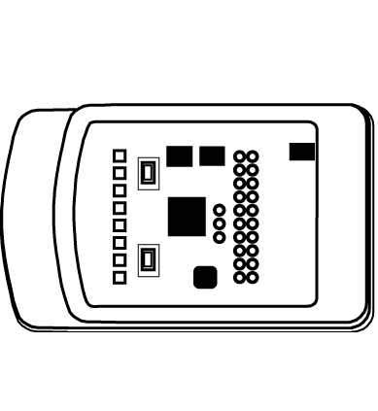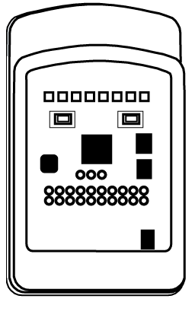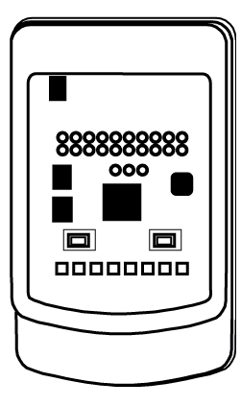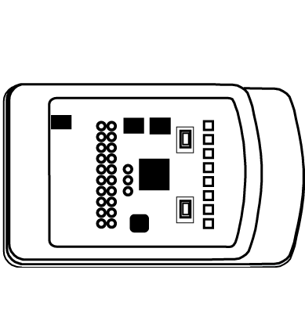
(a)
(b)
(c)
(d)
Figure 15: Moving a Cursor

Moving a Photo

To select and move a photo, the cursor must be positioned over a photo and the user must press their thumb against the button on their index finger. This will set the cursor into the move mode. Once in this mode the photo will be selected and it will move with the cursor. This is done by getting the x-y position of the cursor and applying it to the photo.

Rotating a Photo

Rotating a photo involves pressing and holding the button on the middle finger of the Sun SPOT glove. When this is pressed, the orientation of the user’s hand in the x-axis is used to rotate the photo. The cursor is set into rotate mode, when it is in this mode the cursor won’t move. The current rotation of the photo is obtained and the x-axis accelerometer readings are added to the rotation of the photo.

Photo p = cursor.getSelectedPhoto();
p.setTheta(p.getTheta()+(ROTATE_SENSITIVITY*xaccel));

Drawing a rotated image is done by applying an AffineTransform to a BufferedImage. The image is rotated around its centre point. This is done by the following code:

AffineTransform at = AffineTransform.getTranslateInstance(x, y);
double x1 = image.getWidth()/2;
double y1 = image.getHeight()/2;
at.rotate(theta, x1, y1);

Resizing a Photo

Resizing a photo requires the buttons on both ring fingers of the Sun SPOT gloves to be pressed and held down. The cursors are then set to rotate mode, in this mode the size of the photo can then be enlarged by dragging the cursors away from each other, the photo’s size can then be reduced by dragging the cursors towards each other. Resizing a BufferedImage is done by the code shown below. It creates a new BufferedImage with the required size and draws a scaled version of the original image on it.

BufferedImage scaledImage = new BufferedImage(width, height, BufferedImage.TYPE_INT_ARGB);
Graphics2D graphics2D = scaledImage.createGraphics();
graphics2D.setRenderingHint(RenderingHints.KEY_INTERPOLATION, RenderingHints.VALUE_INTERPOLATION_BILINEAR);
graphics2D.drawImage(image, 0, 0, width, height, null);

Recycling Bin

A recycling bin is available to be used in this program, this allows users of the program to graphically clear a cluttered screen. The user may do this task by pressing their thumb against the button positioned on the little finger of the Sun SPOT glove. When the cursor for the corresponding glove is over a photo, the photo will be deleted. If the cursor is not over a photo, nothing will happen. When a photo is selected to be deleted, it is removed from the ArrayList containing all the active photos and is positioned into the recycling bin queue. The recycling bin queue contains ArrayList of photos. Moving a photo into the recycling bin queue is done by the setMarkedForRemoval() method.

cursor.getSelectedPhoto().setMarkedForRemoval(true);

A Swing timer is used to process the recycling bin queue. Each photo in the queue is moved to the recycling bin image on the screen. When the image is positioned near the recycling bin image, it starts to animate both in rotation and in size. Once a photo has reached the required size and rotation, it is drawn behind the recycling bin image to show it is in the bin. Once it is in a fixed location it is removed from the recycling bin queue.

Timer timer = new Timer(5, new ActionListener() {
public void actionPerformed(ActionEvent e) {

for(Photo p:markedPhotos){
//animate photos in the queue
}
}
});

3D Model Viewer

The 3D Model Viewer demonstrates how different programs could be implemented by using gesture recognition. This program provides the functionality of letting the user control position, tilt, zoom and other 3D engine functionality of a 3D object. The Sun SPOT gloves are used to enable the user to control the x-y position of the object on the screen by the tilt of their left hand. The tilt of their right hand controls the rotation of the 3D object. The push button on each finger has its own individual function.

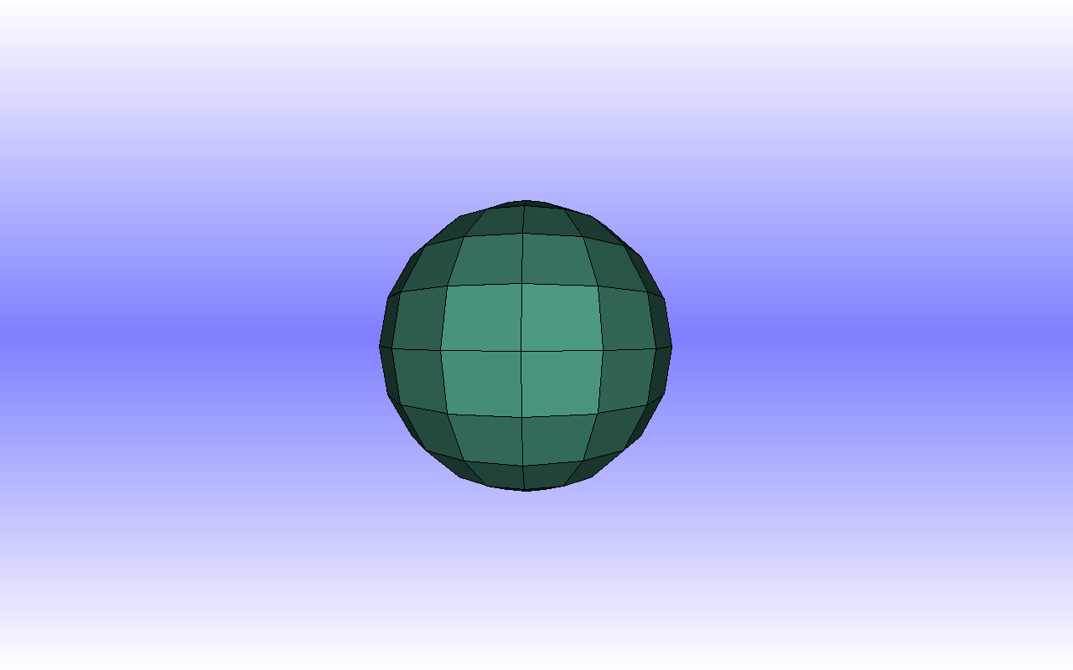
Figure 16: 3D Model Viewer

The 3D engine used in to display the 3D model viewer is the one created by David Maher. This program consists of different SunSpotListeners and a main display loop. The main display loop of the program is done similar to the photo viewer application. Manipulating the 3D engine is done by the SunSpotReceiver methods:

public void tiltInputReceived(SunSpotTiltEvent ev);

public void digitalPinInputChange(SunSpotDigitalIOEvent ev);

public void pushButtonSwitchChange(SunSpotSwitchEvent ev);

3D Environment

The three dimensional (3D) environment is an application that demonstrates the use of face detection in an application. A face is tracked from reading a video feed from a webcam. The view displayed of the 3D environment on the screen changes depending on the user’s distance from the screen and x-y position. This gives the impression that there is depth to the screen instead of being a flat surface. Various 3D objects are scattered through the 3D environment to add realism and provide a better perception of depth. Objects in the 3D environment may be viewed from different angles and it is possible to even look behind certain 3D objects depending on where the user is standing in relationship to the webcam.

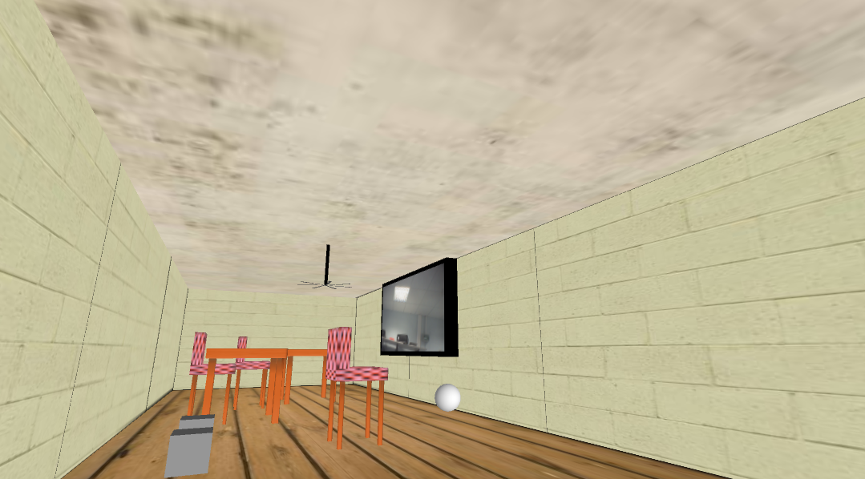
Figure 17: 3D Environment

Webcam Video Capturing

Processing has a library available to capture input from a webcam. This library requires the programs QuickTime and WinVDig to function correctly. The webcam video feed is obtained in this program by using the JMyron library [8]. The JMyron library does not rely on any of these programs to function. Capturing video involves the following steps:

JMyron m = new JMyron();
//start the webcam
m.start(CAMERA_WIDTH,CAMERA_HEIGHT);
//get the current video image
m.update();
//copy the contents of the webcam image into a PImage
arraycopy(m.cameraImage(),img.pixels);
//update the pixel changes to the PImage
img.updatePixels();

After copying the video feed to a PImage, the PImage can then be used throughout the Processing program. The PImage is used in this application to detect a face.

Face Detection

Face detection was implemented by using the PFaceDetect[9] library. The library is built on top of Intel’s OpenCV[10] library. PFaceDetect currently only works with OpenCV V1.0. A Haar cascade classifier file is needed for the library to operate. The Haar classifier file trains the computer to recognise an object, in this case a face. The library extracts face like regions from an image and passes rectangular coordinates for the Processing program to deal with. To tracking faces in a Processing application, create a PFaceDetect object.

PFaceDetect face = new PFaceDetect( this, CAMERA_WIDTH ,CAMERA_HEIGHT,
"haarcascade_frontalface_default.xml" );

The arguments passed to the constructor are the PApplet, the width of the image being tracked, the height of the image being tracked and the Haar cascade classifier xml file. Any external files must be placed in a directory called ‘data’ included in the Processing sketch folder. The PFaceDetect object can then track faces. To track a face, use the findFaces() method of the PFaceDetect object. The method findFaces() gets passed a PImage to track the faces in.

face.findFaces( img );

Obtaining the detected face information is performed by the getFaces() method from the PFaceDetect object. A two dimensional integer array is passed back containing rectangular information about the tracked faces. The first array is all the faces detected in the image. The second array is the information about that face.
int [][] res = face.getFaces();

for (int i=0;i<res.length;i++) {
int x = res[i][0];
int y = res[i][1];
int width = res[i][2];
int height = res[i][3];
}

The 3D Environment program only uses one face for tracking. It calculates which face is closest to the webcam. This is done by calculating the area of each face and comparing them. The face being tracked is the one with the largest area.
int area = w * h;

if(area > largest){
area = largest;
trackeFaceNum = i;
}

After getting the position of the tracked face, the 3D camera’s view can then be changed.
3D Camera Control

The Processing library contains a 3D camera method which controls the view of a Processing application. The OCD 3D camera library[11] is used to control the view of the 3D environment in this project. OCD provides intuitive camera control by using straightforward commands. Multiple cameras can be added to a Processing program with this library, this gives the facility to switch views between different cameras. Setting up a camera from the OCD library requires the use of the Camera constructor. The Camera constructor gets passed the PApplet and the x, y and z coordinates of the camera position.

Camera camera1 = new Camera( this, x, y, z );

The camera’s view can get sent to the viewport by using the feed method. This was used in this application to constantly update a view in a 3D room. It was done by updating it in the draw method of the PApplet.
void draw(){
camera1.feed();
}

The Camera’s view can be expressed by its position and orientation. The position is expressed by the x, y, and z position. The orientation can be expressed by the yaw, pitch and roll. Changing any of these properties will result in changing the view of the camera.
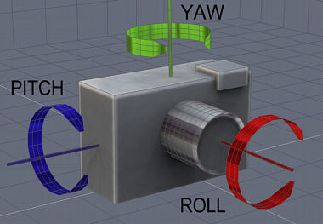
Figure 18: Camera Orientation
The camera can change its position by using the truck, boom and dolly methods. These methods move the camera relative to its current position. The tumble method changes the yaw and pitch of the camera relative to its current orientation, this method accepts radians and not degrees.

A face class was created which stores information such as x, y, z, width and height. Two instances of this class were created to store information being received from the face detection, one for the current frame and one for the previous frame. The distance between the two frames gives suitable coordinates for the tumble method, these values then need to be scaled to suit this application.

int viewX = (previousFace.getX() - trackedFace.getX())/2;
int viewY = (previousFace.getY() - trackedFace.getY())/4;
camera1.tumble(radians(viewX), -radians(viewY));

The area of the tracked face gives an estimate of how far the face is from the camera. The area of a tracked face increases as a face moves towards the webcam. The 3D camera gets moved in or out depending on how close the face is to the webcam. The 3D camera’s dolly method is used to move the camera in and out of the 3D Environment. It is moved relative to the previous z coordinate of the camera. Obtaining the camera’s current position is done by the position method. It returns a 3 element array containing the x, y and z coordinates of the camera, the z position is then subtracted by the tracked face’s distance from the webcam. The distance from the tracked face and the webcam is multiplied by a scale factor to give a more noticeable change in view in the 3D room.

float[] position = camera1.position();
camera1.dolly( -position[2]-4*trackedFace.getDistanceFromCamera() );

Drawing Application

The Drawing Application is a drawing program made for children. Input to the program can be performed by using a mouse or the light-brush. The user holds the light-brush and can “paint” on the screen by moving the light-brush. The Nintendo Wii Remote communicates to the computer via Bluetooth. The Wii Remote reads the infrared light from the light-brush and inputs the readings to the program. The GUI for the drawing application consists of different toolbars and a drawing area. The toolbar located at the left hand side of the GUI is where the user can select the drawing tools. Along the top of the GUI is a scrollbar used to control the size of the drawing tool. The toolbar located at the right of the GUI allows the user to specify what shape their drawing tool may be. Located at the bottom of the GUI is a colour bar which lets the user pick the colour of their drawing tool. In the centre of the GUI there is a large space for the user to create their own pictures using the drawing tools provided.

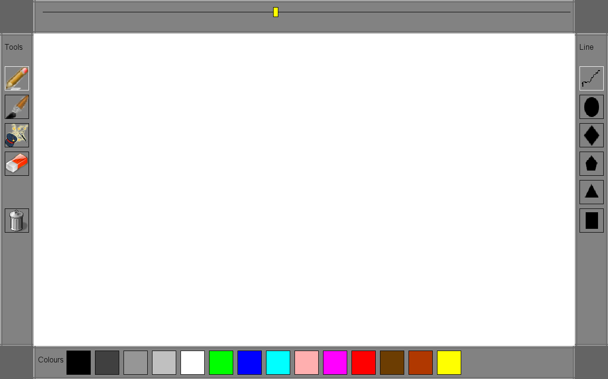
Figure 19: Drawing Application GUI
This part of the project was made by creating a Java application and embedding the PApplet class from the Processing library into a JFrame. The init method of the PApplet must then be called for the PApplet to start executing correctly.

DrawingApplication app = new DrawingApplication(this); //extends PApplet
frame.add(app); //add the applet to a JFrame
app.init(); //start the Processing program

Wii IR Light Detection

The infrared light detected from the light-brush by the Wii Remote is converted to suit the dimensions of the screen.

int x = screen.width - (int)(screen.width*lightArray[0].getX());
int y = screen.height - (int)(screen.height*lightArray[0].getY());

The infrared light then moves the mouse pointer position on the screen. The Robot class is used to move the pointer around the screen. When a Wii IR event is received, it gets a light point. Only one IR light gets tracked in this application. When an IR event is received it is inverted for the screen.

Robot robot = new Robot();
robot.mouseMove( x, y );

This application uses only user motion as input to the program, there is no mouse press or key press recognition. GUI frameworks such as Java’s Swing Framework cannot be used because of this fact. For this application custom made GUI components needed to be created that would select or change depending on the motion of the user. Toolbars, buttons, labels and scrollbars are GUI components created for use in this program.

The Component interface was created for all the GUI components to implement. An ArrayList was set up to hold all the toolbars. Each toolbar object has an ArrayList which contains all the components within it. This interface specifies a display method. Updating the GUI is done by looping through all the toolbars and the canvas in the GUI and displaying them with their display() method. Each toolbar paints itself and requests each component inside it to display. Interaction between the user and each component is also done with this method.

for(Component c: toolbars){
c.display();
}

The canvas has an associated Shape object. If the mouse is in the bounds of the canvas, the shape will be drawn. Drawing on the canvas is done by the following code:

shape.setColour(paintColour);
shape.setX(cx);
shape.setY(cy);
shape.setWidth(scroller.getSliderValue(););
shape.setHeight(scroller.getSliderValue(););
shape.display();
Conclusion

The glove interface requires training to use and it is not that intuitive. The user has to remember all the gestures and their associated functionality. It is straightforward using one glove but it can get quite difficult to control with two gloves. It is easy to concentrate on what a single glove is doing but the other glove could be drifting of the screen, this can be quite frustrating for the user.

The Wii Remote and the light-brush can track motion quite well, this interface is very intuitive and requires little training and practice to use. The fact that the user just has to hold one piece of hardware makes it more user-friendly.

The 3D environment application uses a simple face detection method, more sophisticated face detection mechanisms could be added to make the application more responsive. Face API is commercial software used to detect faces and does not use OpenCV. The 3D environment application could be worked on with this software to achieve better results. The Face API software detects faces at different angles and detects face details such as the eyes, nose and lips so more intricate tracking would be possible.

In conclusion, mechanisms like computer vision and motion detection are the most effective, glove based interfaces are quite complicated and are not as intuitive to use.
Appendices

Sun SPOT SDK Installation

Installing the Software SDK for the Sun SPOT development platform can be done in two ways, installing from the included CD or downloading and installing the latest version from www.sunspotworld.com. Installation from the included CD from the development kit would not be recommended since there has been improvements made to the Sun SPOT software. The SDK is currently at version 5.0. The Sun SPOT manager [12] should be installed from the Sun SPOT website. The software installation guide can be found at the getting started section of the Sun SPOT website [13].

Installing Ant

The Sun SPOT SDK requires Ant to be installed on the host computer to compile, deploy and run SPOT projects. This section provides the steps for installing and setting up Ant from the Apache Ant website, the Sun SPOT Manager will only perform the first two steps of this installation, the environment variables must be set up manually.
- Download the newest version of Ant from http://ant.apache.org/.
- Unzip the downloaded file. It will contain a directory; this directory will have a Linux like directory structure containing directories like bin, docs, lib and etc.
- The operating system’s environment variables need to be created and set up. The environment variables used and their values are shown below.
ANT_HOME – The directory where Ant was unzipped
JAVA_HOME – The location where the JDK is installed
PATH – This must be modified to include %ANT_HOME%\bin

Building Sun SPOT applications

This section explains how to create and run a Sun SPOT application through the command line interface.
- Create a directory for the project.
- Now create an ant script. The name for this file is usually ‘build.xml’, an example build.xml file is shown below.
<?xml version="1.0" encoding="UTF-8"?>
<project name="TestExample" default="help" basedir=".">
<property name="user.properties.file" value="build.properties"/>
<property file="${user.home}/.sunspot.properties"/>
<import file="${sunspot.home}/build.xml"/>
<target name="just-deploy" depends="init,-check-for-manifest,-do-find-spots,-pre-deploy,-do-deploy,-post-deploy"/>
</project>

Sample build.xml file

- A file named build.properties needs to be present. This file contains information such as class path information and which file is the main class. This file can be empty if the project is used for an eSPOT application. An example build.properties file for a Sun SPOT host application is listed below.

#this is an example build.properties file.
#The main class is MyTestClass.java, located in the src directory
main.class=MyTestClass
#Any passed arguments can be specified here
main.args=
#any libraries can be specified here
user.classpath=

Sample build.properties file

- The build.xml and build.properties files need to be placed in the root of the project directory.
- Create two sub directories in the root directory, one named src and one named resources. The src directory is where all the Java source code needs to be present. The directory structure should look like the one displayed below.
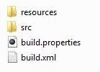
- In the resources directory create a sub directory named META-INF. A manifest file manifest.mf needs to be present in the resources/META-INF directory. The manifest.mf file is only needed for an eSPOT application. An example manifest file is shown below.
MIDlet-Name: TestExample
MIDlet-Version: 1.0.0
MIDlet-Vendor: Sun Microsystems Inc
MIDlet-1: , , packageName.MIDletName
MicroEdition-Profile: IMP-1.0
MicroEdition-Configuration: CLDC-1.1
Sample Manifest.mf file

- Open the command line. Navigate to the root directory of the project.

Starting a Host Application

- Compiling a host application is done by the command ant host-compile.
- Connect the basestation to the computer via the USB cable.
- Make sure it is in basestation mode by using the command ant startbasestation.
- Running a host application is done by the command ant host-run.

Starting an eSPOT Application

- Compile an eSPOT application by using the command ant jar-app.
- Connect the Sun SPOT to the computer via USB.
- Deploy the application to the SPOT by the command ant jar-deploy
- The application is now on the SPOT if the build process is successful.
- Run the application by the command ant run
- The application can be run when the SPOT is reset.

Sun SPOT Programming with Netbeans

Developing a Sun SPOT to PC program requires two Netbeans projects, one for the eSPOT
and one for the computer to receive and send data through the basestation.

Creating Sun SPOT programs

- From the Toolbar Click on File – New Project

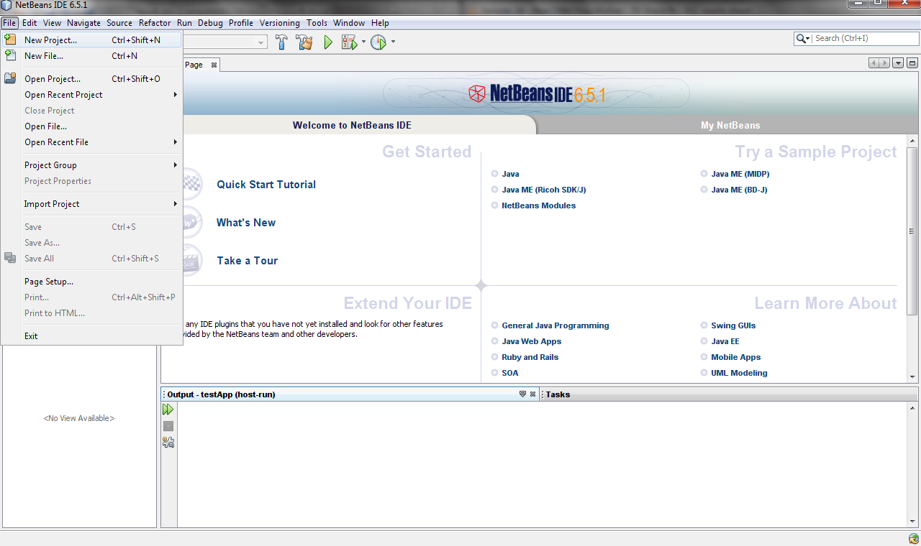

- Choose either Sun SPOT Application (eSPOT program) or Sun SPOT Host Application (Computer / basestation program) and click Next.
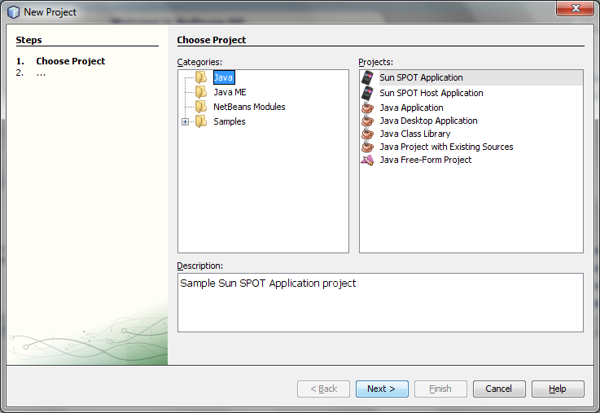
- Choose a Project name, location and package details then click finish. Netbeans will then create all configuration files for the Sun SPOT. The source code for the project can now be written.

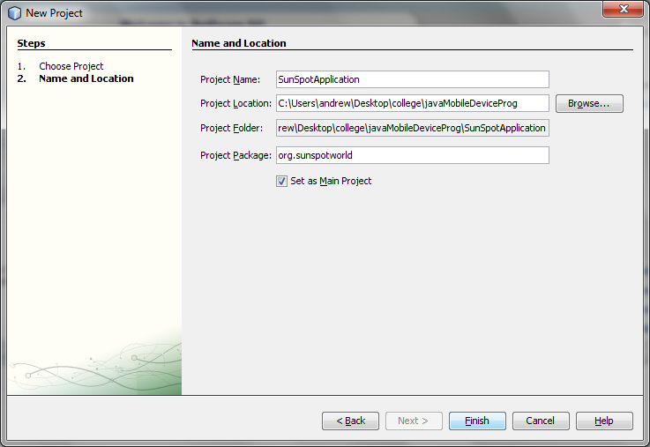

Downloading Projects to Sun SPOTs

- In a Sun SPOT Application Right click on the project, a menu will appear. Click on “Build Project + Deploy to Sun SPOT”. In the console window it may show a message saying to reset the Sun SPOT. If it does, press the control button. The project will then finish downloading to the Sun SPOT. The program can be run by resetting the Sun SPOT (pressing the control button). The program can also right clicking on the project and clicking on Run. This method can be useful in debugging, it is possible to use the console window to display information by using the System.out print stream.

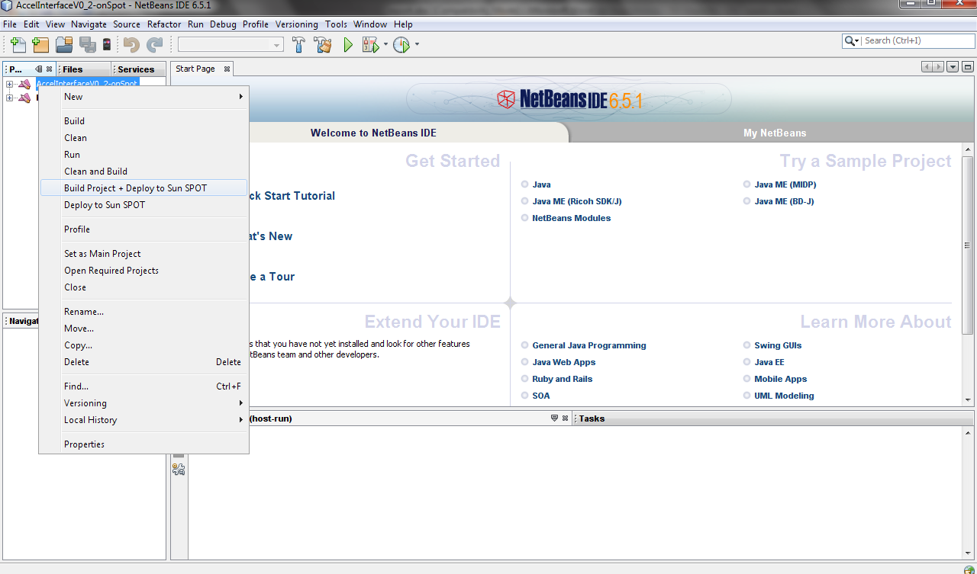

Running a Host Application

- Right Click on the host application project. Click on ‘Clean and Build’. This compiles the source code and performs an Ant build to the project, this is similar to performing ant jar-app from the command line.

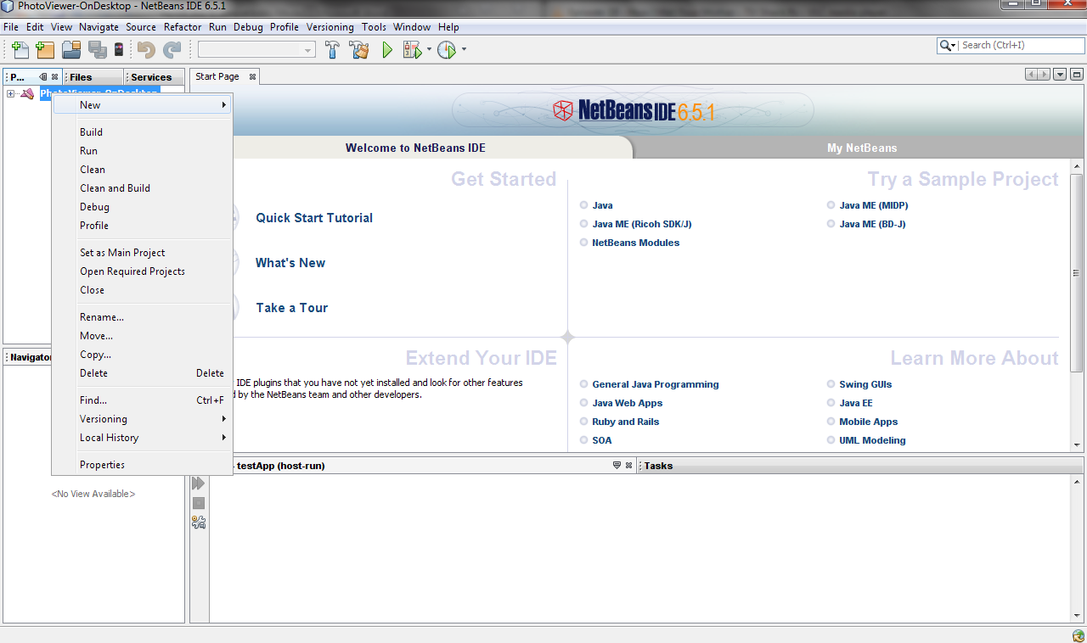

- Right Click on the project name and click ‘Run’. The application requires the basestation to be plugged via USB or it will display a build error message saying:

No Sun SPOT devices found. Connect a device
and retry or, if you know that one is already
connected, specify its port using the "port"
property (either in a properties file or using
-Dport=XXX at the commandline). This will force
the build scripts to use that port.
BUILD FAILED (total time: 0 seconds)

This message will be displayed if an eSPOT is connected instead of the basestation. If the
basestation is not set in basestation mode will result in showing the same error message.
Setting the basestation in basestation mode is done through the ant startbasestation
command.

Including External Jar Files

This project used libraries such as the MySQL connector library. Importing libraries in Sun
SPOT applications is performed differently to Netbeans desktop applications. Including
External Jar Libraries to a sunspot desktop application involves the following steps:

- Right-Click on the project name

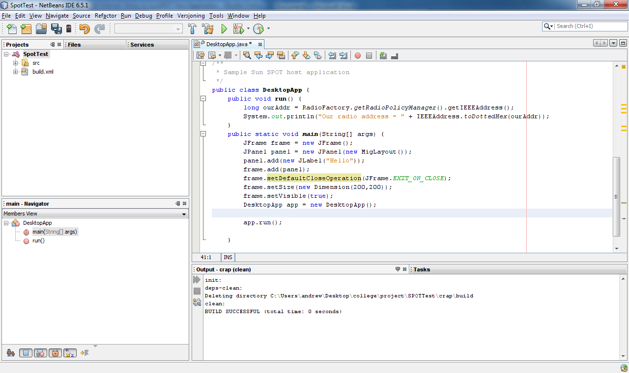

- Click on ‘properties’ from the drop down menu. A menu will open.

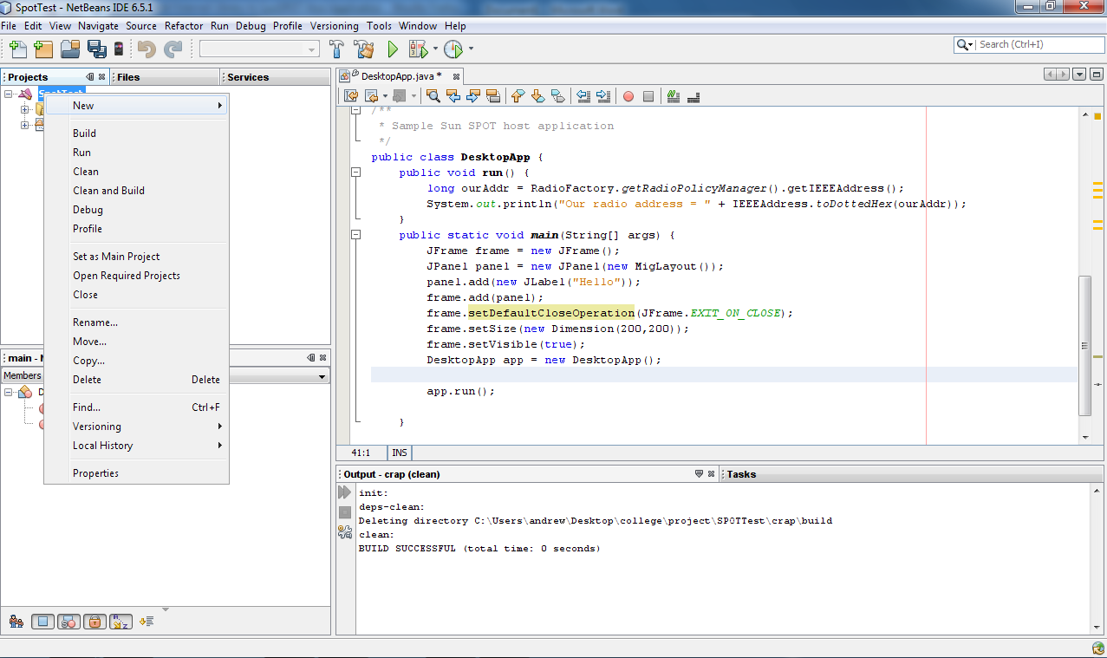

- Click on ‘Java Sources Classpath’

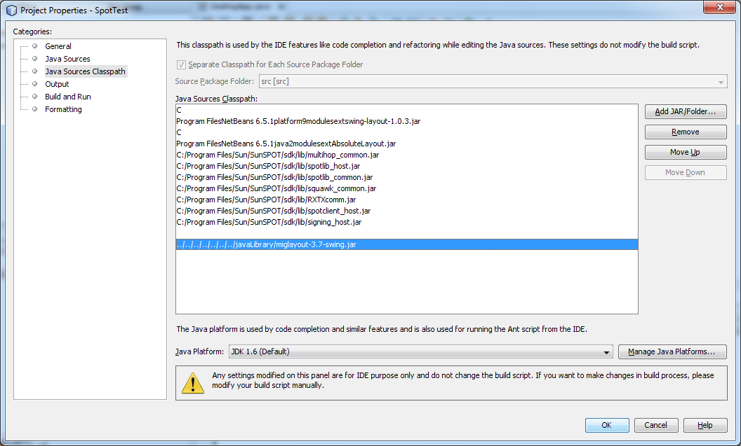

- Click on ‘Add Jar/Folder...’ Browse for the .jar file. The classes can now be added without giving compile errors.

- The classpath has to now be edited in the ‘build.properties’ file located at the sunspot host application root folder. Insert the path of the jar file to be included in the properties file by appending the full path in the user.classpath section of the properties file. Use a colon to separate jar files and use forward slashes between the directories e.g. C:/libraryLocation/yourLibraryHere.jar:
The modified build.properties file should look like:

main.class=org.sunspotworld.DesktopApp
main.args=
user.classpath=C:\Program Files\NetBeans 6.5.1\platform9\modules\ext\swing-layout-1.0.3.jar:C:\Program Files\NetBeans 6.5.1\java2\modules\ext\AbsoluteLayout.jar:C:/libraryLocation/yourLibraryHere.jar

The project can now run with the user libraries added.

Including External Files to Sun SPOT project

This project uses external files such as .png, .jpg and .wav files. The project is built by an Ant
script but the script by default will only include Java files. All external files used in a project
need to be included when the project is getting built. To include external files, the file types
need to be included need to be specified in the build.xml file. Insert the following code into
the build.xml file to include .png, .jpg, .wav files to the project.

<target name="-post-host-compile">
<copy todir="${build.dir}">
<fileset dir="${src.dir}">
<include name="**/*.jpg"/>
<include name="**/*.png"/>
<include name="**/*.wav"/>
</fileset>
</copy>
</target>

Sun SPOT problems

There were multiple problems involved with the Sun SPOTs in this project. A list of problems and their solutions which occurred when developing this project are listed here. All of the problems will stop the build process and will display an error message.

Problem 1:
[java] ERROR: received bad value from the Atmega microcontroller

This is a problem where the firmware on the demoboard of the Sun SPOT is corrupted. If this error appears, use the ant upgrade to upgrade the firmware on the SPOT. If the upgrade process does not work, download the demosensorboardfirmware-blue.jar file from
https://www.sunspotworld.com/downloads.html.
Rename the file to demosensorboardfirmware.jar. Replace the old version of demosensorboardfirmware.jar in the SDK_HOME/upgrade directory with the downloaded one. Upgrade the Sun Spot with the ant upgrade command. This should fix the problem.

Problem 2:

init:
Please wait while connected Sun SPOTs are examined...
No suitable SPOT is available
Java Result: -1
C:\Program Files\Sun\SunSPOT\sdk\ant\find-spots.xml:298: Spotselector failed or was cancelled
BUILD FAILED (total time: 2 seconds)

This error message is displayed when a basestation is plugged in via USB when the eSPOT should be plugged in or vice versa. To correct this problem, simply plug in the correct SPOT and re-run the build.

This problem appears also when the basestation is not in basestation mode. Use the command ant startbasestation.

Problem 3:

The eSPOT would not download any code, the LED positioned beside the control button keeps flashing.

To solve this problem, upgrade the software on the SPOT by using the ant upgrade command, the build processes will sort out this problem.

Setting up PFaceDetect

To use the PFaceDetect library in a Processing program the following steps must be taken.
- Download PFaceDetect
- Download and install OpenCV V1.0 or obtain the OpenCV files cv100.dll, cxcore100.dll, libguide40.dll.
- Copy the cv100.dll, cxcore100.dll, libguide40.dll files into the Processing root directory.
- Insert PFaceDetect into the \libraries directory
The PFaceDetect library can then be used in a Processing programs.

Setting up JMyron

JMyron is a video capture method that can be used instead of the Processing video library. The Processing video library needs WinVDig and Quicktime to be installed on the computer to capture video, JMyron does not need these libraries.

- Dowload JMyron from http://webcamxtra.sourceforge.net/index.shtml
- Unzip the zip file
- Insert the unzipped contents into the processing libraries directory.
- Add the filesmyron_ezcam.dll and DSVL.dll to the processing root directory.

References

- http://en.wikipedia.org/wiki/Project_Natal
- http://johnnylee.net/projects/wii/
- http://www.world-of-cha0s.hostrocket.com/WiiRemoteJ/
- http://java.sun.com/
- http://ant.apache.org/
- http://processing.org/
- http://mysql.com/
- http://webcamxtra.sourceforge.net/index.shtml
- http://www.bryanchung.net/?page_id=251
- http://opencv.willowgarage.com/wiki/
- http://www.gdsstudios.com/processing/libraries/ocd/
- https://www.sunspotworld.com/SPOTManager/index.html
- https://www.sunspotworld.com/GettingStarted/index.html

Bibliography

- Learning Processing A Beginner's Guide to Programming Images by Daniel Shiffman
- Processing A Programming Handbook for Visual Designers and Artists by Ben Fry and Casey Reas
- Visual Interpretation of Hand Gestures for Human-Computer Interaction: A Review by Vladimir I. Pavlovié, Rajeev Sharmam and Thomas S. Huang
- Head Tracking based on accelerometer sensors by Carlo Alberto Avizzano
- Human Computer Interaction by Alan Dix, Janet Finlay, Gregory D. Abowd

