HCI for Dementia Sufferers: Developing a Large Multitouch System for Recreational Activities

Andrew McGlynn *, Paul Dunne *, Shaun O’Keeffe ^,

*Galway-Mayo Institute of Technology, ^ NUI Galway

Address for correspondence: G00173551@gmit.ie

**ABSTRACT**

This paper outlines the development of a multitouch system for dementia sufferers which includes usage logging capabilities for further analysis. Dementia is a growing problem worldwide. Very few recreational technologies are being produced for dementia sufferers. Dementia inhibits a person's ability to learn new skills and using a standard computer is almost impossible due to the high level of training involved. Popularisation of direct input devices such as touch-screens can make interactions with a computer quite intuitive. This paper discusses the design of a Frustrated Total Internal Reflection (FTIR) multitouch screen with software applications suitable for dementia. Testing and evaluation techniques are also described.

**Keywords**

User Interface, dementia, elderly people, older adults, multitouch, FTIR.

# INTRODUCTION

Dementia is caused by complex disorders in the brain. It is not a disease but a syndrome, an umbrella term that categorises various cognitive impairments that can effect a person's cognitive functioning [1]. Dementia affects the patient's memory, thinking, behaviour, mood, social and daily functioning. Dementia is likely to occur to people aged 65 and over [2]. One third of people aged 80 and over, develop the illness [1].

There are many different forms of dementia, including, vascular dementia, Parkinson's disease, and Frontotemperal dementia. The leading form of dementia is Alzheimer's disease. The Alzheimer Society of Ireland highlight that there are currently almost 50,000 people in Ireland who are diagnosed with dementia. This figure is expected to increase to 104,000 people by 2036 [3]. The World Alzheimer Report estimate that there will be 115.4 million people suffering from Alzheimer's disease worldwide by the year 2050 [4].

There is currently no cure or reversal for dementia, however, research has shown that participation in creative activities can improve quality of life [5]. Dementia patients who are also diagnosed with depression have a 90% increase in positive mood when engaging with activities [6]. However activities for people with dementia are limited especially in a hospital/nursing home setting. This can cause agitation or depression with the dementia sufferers.

Learning how to use a computer can be a daunting task for anyone who has never used one. Many hours of practice go into learning how to use a computer. Currently, on average, older people have significantly less computer experience [7]. Learning new skills is difficult for people suffering with dementia [8]. The common computer interface uses indirect input devices such as a keyboard and a mouse. These devices are abstract and can cause problems for older adults [9].

## Technology for people with dementia

There are various new technologies created for people suffering with dementia, most of these technologies are for analysis e.g. fall detection. There are only a few examples of recreational/leisure technologies being developed for dementia sufferers. It is these technologies that can improve the quality of life by participation in activities. Current recreational technologies developed for people with dementia include CIRCA, ExPress Play and ePAD.

CIRCA (Computer Interactive Reminiscence and Conversational Aid) [8] is a multimedia system created by a team with expert knowledge in different disciplines ranging from psychology to software engineering. The system was developed for the purpose of enabling people with cognitive disabilities to reminisce through the means of generic, nostalgic photographs, video clips and music. This system used a touch screen interface. The system was quite successful, the users of the system reminisced and they recalled memories which were not discussed before.

ExPress Play [6] is a musical, touch-based system which allows even non musically trained people with dementia to express themselves creatively through the use of this system. The evaluation of this system established that people with dementia were able to be actively creative while using the system and it provided a positive experience while using the system.

The ePAD (Engaging Platform for Art Development) [10] allows people suffering from dementia to engage in artistic activities. The system uses artificial intelligence to understand what the user is doing at a particular time. If the user gets distracted, the system can then prompt the user with the necessary steps to complete the current task.

# MULTITOUCH TECHNOLOGY

Multitouch research has progressed significantly in the past few years. Many modern consumer electronic devices are currently incorporating multitouch technology, in particular, mobile phones. Apple uses multitouch technology in their iPhone and iPad. This type of technology is being recognized as a natural user interface (NUI) due to its intuitive tactile nature. The main advantages of using a multitouch display is the direct manipulation experience, there is no use of indirect input devices.

Tabletop multitouch devices such as Microsoft Surface [11] allow users to interact on a large multitouch screen. Other benefits of using this type of system are the option of allowing more than one user to access the display while working independently.

There are different types of multitouch sensing technologies. Smaller devices such as mobile phones use a different sensing technology to large tabletop devices. The more common types of multitouch sensing include resistive, capacitive and camera-based techniques. Many modern consumer electronic devices such as the iPhone and iPad use the capacitive sensing technique. Systems like the Microsoft Surface use a camera based approach coupled with infrared optics to detect touch events.

Considerable development has gone into the area of camera-based multitouch technology. There are several types of camera-based sensing techniques, these include: Diffuse Illumination (DI), Laser Light Plane (LLP), Diffuse Surface Illumination (DSI) and Frustrated Total Internal Reflection (FTIR). All of these technologies use infrared (IR) optics and cameras to sense touch events.

It was decided that a camera-based multitouch tabletop system will be developed for this research. Commercial tabletops such as the Microsoft Surface were considered as a potential test system for this project. The Microsoft Surface table is too expensive for projects with a limited budget. Custom-made multitouch screens can be developed for a fraction of the price of the commercial equivalent. As commercial systems are further developed, their retail price could drop dramatically; if this is the case, the feasibility of developing a multitouch screen from scratch could be questioned.

## FTIR

Han introduced the frustrated total internal reflection (FTIR) sensing technique for multitouch technology [12]. This technique is based on the principles of total internal reflection (TIR). When infrared light passes from polycarbonate to air, depending on the angle of the light, the light will either get reflected or refracted. The phenomenon of light getting reflected is known as total internal reflection. This phenomenon is demonstrated in Figure 1.

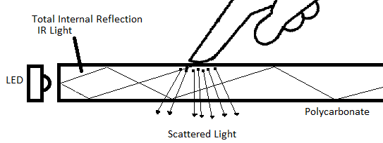

Figure 1: FTIR Explanation

For total internal reflection to occur within the polycarbonate, many infrared light emitting diodes (IR LEDs) are placed along the edges of the polycarbonate until it is flooded with infrared light.

When the fingertips touch the surface of the polycarbonate, the infrared light gets disturbed from the regular path of the total internal reflection. The infrared light therefore gets scattered along the surface of the polycarbonate where the finger press has occurred, resulting in a 'blob' of infrared light. This is illustrated in Figure 1. The blobs of infrared light can then be detected by an infrared sensitive camera positioned below the polycarbonate; this is shown in Figure 3. Figure 2 shows this effect on the author's first FTIR prototype screen.

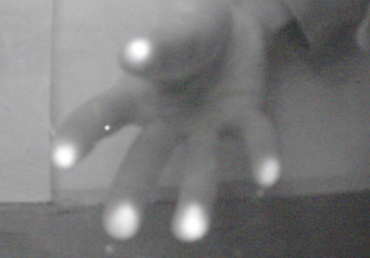

Figure 2: FTIR Effect

Visual feedback to the user of the system can be done by using a digital projector and projection material. A typical FTIR setup with projection is shown in Figure 3.

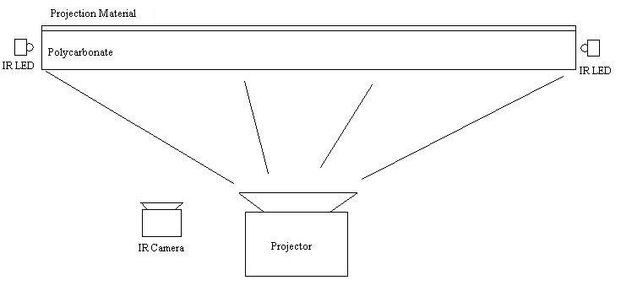

Figure 3: FTIR Multitouch Screen Setup

## Multitouch Software

The software for a tabletop multitouch system consists of various layers. This creates an independent structure where layers are interchangeable software packages and are technology independent. The layers of a typical multitouch system include the operating system, tracking software, communication protocol and a multitouch framework or toolkit.

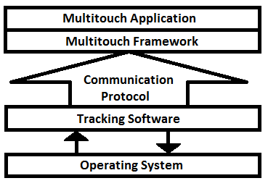

Figure 4: Software Layers

Multitouch tracking software detects blobs of infrared light originating at the touch screen. The tracking software performs many types of image filtering and produces touch events based on the input from the touch screen. The touch events get sent via a communication protocol to a multitouch framework. CCV [13] is an example of open source tracking software.

There are many multitouch frameworks available, indeed most programming languages have a multitouch framework. Two popular multitouch frameworks are "Multitouch for Java" (MT4J) [14] and PyMT [15] for the Python language. These frameworks provide various tools to make visual multitouch applications.

A communication protocol transfers information from tracking software to a multitouch framework. TUIO [16] is a popular communication protocol. TUIO is a simple UDP-based protocol that was developed for tracking tangible objects. TUIO has become the de facto standard for multitouch systems. It is a protocol for sending tracking information from the tracking software to the multitouch framework. In most cases the tracking information is sent to, and from, programs on the local machine.

# PROPOSED SYSTEM

A multitouch-based system for engaging dementia sufferers in recreational activities is proposed. Various multitouch recreational activity applications will be developed for this system. These include a reminiscence therapy application and an artistic therapy application. The system will use the FTIR multitouch sensing principles and will collect usage data while in operation.

The tabletop form factor was chosen as the most suitable design for this research. It was believed that multitouch tablets could be suitable but could cause problems for those with fine motor control problems due to the size of the screens. It is asserted that the large screen from a tabletop system will reduce the need for any fine movements; the size of the screen will also be beneficial to those with poor vision. The touch surface of the screen will be tilted at an angle towards the user to prevent the strain on the user's neck when viewing the screen.

## System Hardware

The hardware for the system consists of a polycarbonate sheet, IR LEDs, digital projector, projection material, infrared sensitive camera, standard webcam and a boxed frame. The boxed frame is used to support the screen and to abstract all the hardware components from the user. This is shown in Figure 5.

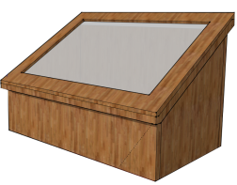

Figure 5: Proposed Multitouch Frame

## System Software

An integrated webcam will be used to take a photo of the system user for session metrics. Session tracking usually involves a user logging in and logging out. The effects of dementia will make this login/logout task quite difficult. The use of automatic data logging and the use of the webcam to capture an image of the user will solve this problem. Touching the screen will trigger an event which will begin the session. An image of the user will be taken at the start of each session. Touch events keep the session active, all touch event data will be stored from the session. If there is no touch activity, a timeout will occur and the session will end and the system will then become idle. It will stay in this state waiting for another session to initiate. The system will also incorporate a database for data logging. The logged data will be used to measure how long the dementia sufferer used the system from week to week and their frequency of using the system. This database is expected to be remotely analysed for evaluation.

Ethical approval and consent is required for people who participate in research [17]. The participants in this research will not be able to give their own informed consent due to the symptoms of dementia. In this case, the next of kin will be contacted as well as obtaining consent from the person with dementia. There are certain elements about the test system which are unethical; this includes the collection and storage of images of the user and logging their interactions. Ethical approval and consent must be acquired before the participants may be involved in this research.

## Applications

The system will have various applications specifically created for the needs of people with dementia. All of the applications which will be developed will respond to simple intuitive gestures performed on the touch surface. These gestures will consist of drag and tap events. Complex and abstract gestures will not be implemented in these applications since they might be too difficult for the dementia sufferer to remember and perform. Text displayed on the screen will be large for those with poor vision. The background of the applications will be neutral, this will allow maximum contrast between the background and the foreground; this is expected to keep the user's attention on only the interactive components in the foreground.

The first application will be an artistic therapy application; this will assess if dementia sufferers can be assisted in creativity by using a multitouch computer system. The artistic therapy application will present a creative activity for the dementia sufferer; this will allow them to paint and draw virtual pictures by using simple multitouch gestures.

A multimedia reminiscence therapy application will be created; this will test if reminiscing while using the system will improve social interactions between dementia sufferers and their families or carers. The reminiscence stimuli which will be used in this application will consist of images, video clips, songs and newspaper articles. The theme of the reminiscence material will be of Ireland between the 1930s - 1970s. All the media used in the application will be placed throughout the user interface similar to real photos scattered over a real table. The dementia sufferer may then manipulate the piece of media by using multitouch gestures. Since dementia affects short term memory, long videos would not be suitable in the application; due to this fact, the length of all videos will be kept under three minutes. All stimulus will be large for those with poor vision and fine motor control problems.

# TESTING AND EVALUATION

Research by Riley [6] suggests that using multiple phases of testing with different groups of people with different cognitive abilities is a suitable approach when developing a system for people with dementia.

The proposed system will involve different phases of usability testing. The initial testing of the system will be done with informal evaluation methodologies such as the heuristic evaluation [18] and/or the cognitive walkthrough [19]. Both of these evaluation techniques can be used throughout the entire design process.

The heuristic evaluation involves the evaluation of the interface by assessing the interface for design problems and to mark the severity of the problem.

The cognitive walkthrough requires an evaluator to evaluate a system by performing tasks and recording what steps are needed to complete the tasks. This will be a crucial evaluation technique for this project since dementia sufferers need a simple interface.

A phase of system testing and evaluation will involve the system being placed in a populated area where it can collect data from many different people. Here the software will get a rigorous testing from regular interaction from many different people. The people using the system will in this phase will have full cognitive functioning.

The last testing phase will involve testing the system by the actual end users. This phase will require between 5 - 20 people suffering with mild or moderate cases of dementia to interact with the system. The dementia sufferer is expected to use the system while being supervised by a care-giver. At the end of each interaction session, the dementia sufferer will be asked to complete a short questionnaire. The questionnaire will consist of approximately 5 open ended questions and 5 close ended questions. Open ended questions that will be asked will include what they liked/disliked about the system. Close ended questions will ask their opinion on using the system, including if they enjoyed the application/activity and would they like to use the application again. The care-giver will be asked to give a short report about the session. This report will contain information such as reporting any changes in the dementia sufferer's mood, the dementia sufferer's engagement with the system and any difficulties faced when using the system.

# CONCLUSION/DISCUSSION

This project will build a large prototype multitouch FTIR system. The assertion is that a computer system with a multitouch user interface will aid dementia sufferers in the creative process and improve their quality of life, social skills, mood and potentially memory. Medium-sized single touch interfaces being used with recreational activities have proven to improve the quality of life of dementia sufferers [6, 8, 10]. This research will investigate if a large multitouch system would be more intuitive to use and provide a more immersive experience.

# REFERENCES

1. A. Singh-Manoux and M. Kivimäki, "The importance of cognitive ageing for understanding dementia," AGE, vol. 32, pp. 509-512, 2010.
2. M. Mulvenna, S. Martin, S. S, venstedt, J. Bengtsson, F. Meiland, R. M. Dr, es, M. Hettinga, F. Moelaert, and D. Craig, "Designing & evaluating a cognitive prosthetic for people with mild dementia," presented at the Proceedings of the 28th Annual European Conference on Cognitive Ergonomics, Delft, Netherlands, 2010.
3. The Alzheimer Society of Ireland. Last accessed: (27/01/2011). Irish Statistics. Available: http://www.alzheimer.ie/eng/Media-Centre/Facts-About-Dementia/Irish-Statistics.
4. Alzheimer's Disease International. Last accessed: (27/01/2011). World Alzheimer Report 2010. Available: http://www.alz.co.uk/research/files/WorldAlzheimerReport2010.pdf.
5. J. Hoey, K. Zutis, V. Leuty, and A. Mihailidis, "A tool to promote prolonged engagement in art therapy: design and development from arts therapist requirements," presented at the Proceedings of the 12th international ACM SIGACCESS conference on Computers and accessibility, Orlando, Florida, USA, 2010.
6. P. Riley, N. Alm, and A. Newell, "An interactive tool to promote musical creativity in people with dementia," Computers in Human Behavior, vol. 25, pp. 599-608, 2009.
7. C. B. Peterson, A. Mitseva, A. Mihovska, N. R. Prasad, and R. Prasad, "The phenomenological experience of dementia and user interface development," in Applied Sciences in Biomedical and Communication Technologies, 2009. ISABEL 2009. 2nd International Symposium on, 2009, pp. 1-5.
8. N. Alm, R. Dye, G. Gowans, J. Campbell, A. Astell, and M. Ellis, "A Communication Support System for Older People with Dementia," Computer, vol. 40, pp. 35-41, 2007.
9. N. Hollinworth, "Improving computer interaction for older adults," SIGACCESS Access. Comput., pp. 11-17, 2009.
10. S. Blunsden, B. Richards, J. Boger, A. Mihailidis, T. Bartindale, D. Jackson, P. Olivier, and J. Hoey, "Design and prototype of a device to engage cognitively disabled older adults in visual artwork," presented at the Proceedings of the 2nd International Conference on Pervasive Technologies Related to Assistive Environments, Corfu, Greece, 2009.
11. Microsoft Corporation. Last accessed: (16/03/2011). Microsoft Surface. Available: http://www.microsoft.com/surface/
12. J. Y. Han, "Low-cost multi-touch sensing through frustrated total internal reflection," presented at the Proceedings of the 18th annual ACM symposium on User interface software and technology, Seattle, WA, USA, 2005.
13. NUIGroup. Last accessed: (04/03/2011). Community Core Vision. Available: http://ccv.nuigroup.com/
14. C. Ruff. Last accessed: (16/03/2011). MT4J. Available: http://mt4j.org
15. PyMT. Last accessed: (22/03/2011). PyMT. Available: http://pymt.eu/
16. TUIO. Last accessed: (04/03/2011). TUIO protocol. Available: http://www.tuio.org/
17. Alzheimer's Association. (1997, Ethical Issues in Dementia Research (with special emphasis on “informed consent”). Available: http://www.alz.org/national/documents/statements_ethicalissues.pdf
18. J. Nielsen and R. Molich, "Heuristic evaluation of user interfaces," presented at the Proceedings of the SIGCHI conference on Human factors in computing systems: Empowering people, Seattle, Washington, United States, 1990.
19. P. G. Polson, C. Lewis, J. Rieman, and C. Wharton, "Cognitive walkthroughs: a method for theory-based evaluation of user interfaces," International Journal of Man-Machine Studies, vol. 36, pp. 741-773, 1992.