My first graph in R (Markdown)

## R Markdown

This is an R Markdown document. Markdown is a simple formatting syntax for authoring HTML, PDF, and MS Word documents. For more details on using R Markdown see <http://rmarkdown.rstudio.com>. A document will be generated that includes both content as well as the output of any embedded R code chunks within the document. You can embed an R code chunk like this:

print('Hello World')

## [1] "Hello World"

## Some data

R knows a lot of distributions, now let us generate some random midterm scores!

scores <- rnorm(100, 50, 15)

## Including Plots

An R Markdown document is very handy if it comes to standard document formats, lets say you want to publish midterm results (very similar structure but different data). First we draw a histogram of the scores:

hist(scores)

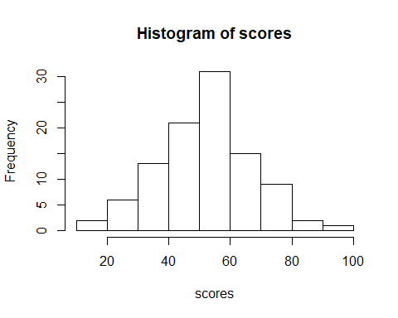

Well, the code is fairly simple, but we want to be stylish.

hist(scores,  
 main = "First midterm results",  
 ylab = "",   
 xlab = "points",   
 col = "cornflowerblue")  
abline(v = mean(scores),  
 col = "red",  
 lwd = 2)  
text(x = mean(scores), y = 5,   
 labels = round(mean(scores), 2),  
 col = "red")

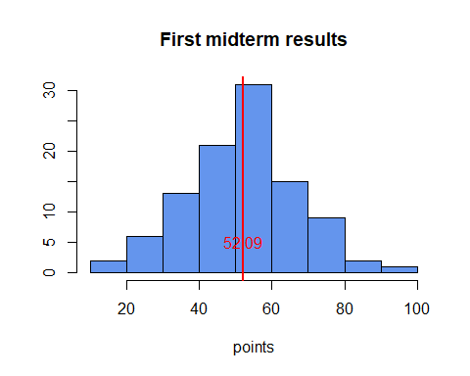

Somewhat nicer! The aim however was only to introduce you to graphs and Rmd files. You can also hide the code just like here to present top three scores:

80.32 81.86 95.73

Congratulations, now you know how to create a histogram and a document you can use multiple times!