Renze Chen: More Than A Web Developer

Yuqing Lin

Binghamton University

Renze Chen: More Than A Web Developer

With 175 billion mobile apps being download during 2017 worldwide (Perez, S., & Perez, S, 2017), applications have become essential to our lives. Although applications have various types, apps usually require a specific platform. Cross-platform applications are a trend but take a longer of development which causes a waste of resources and less efficient in productivity. With cloud computing and cross-platform technology involved, web applications are a good solution. The blueprint seems attractive; however, cloud computing technology and web app optimization still have a long way to go, replacing desktop applications still more than challenging. Renze Chen, a future web app developer, who believes web applications are replacing desktop applications in the future. His projects and personal experience demonstrate his passion for his career, excellent problem-solving skills as well as ambition and his interpersonal skills.

Renze has proved his passion for challenging new difficulties and the ambition of his career through his personal experience. While attending Binghamton University, Renze has enrolled in a concurrent 3+2 double major degree program with Renmin University China where he will gain a bachelor's degree of applied mathematics. Renze could easily gain his master’s degree at Renmin University since study oversea itself is a challenge. However, a degree in mathematics is not enough for his goal in web app development. He dropped out his master program at Renmin University, jumped out his comfort zone and challenged his life; seeking better education in the U.S. Renze personal experience and projects relate to Web development changed his goal.

(*Figure 1.* Web program implemented JavaScript, Angular, and React JS) 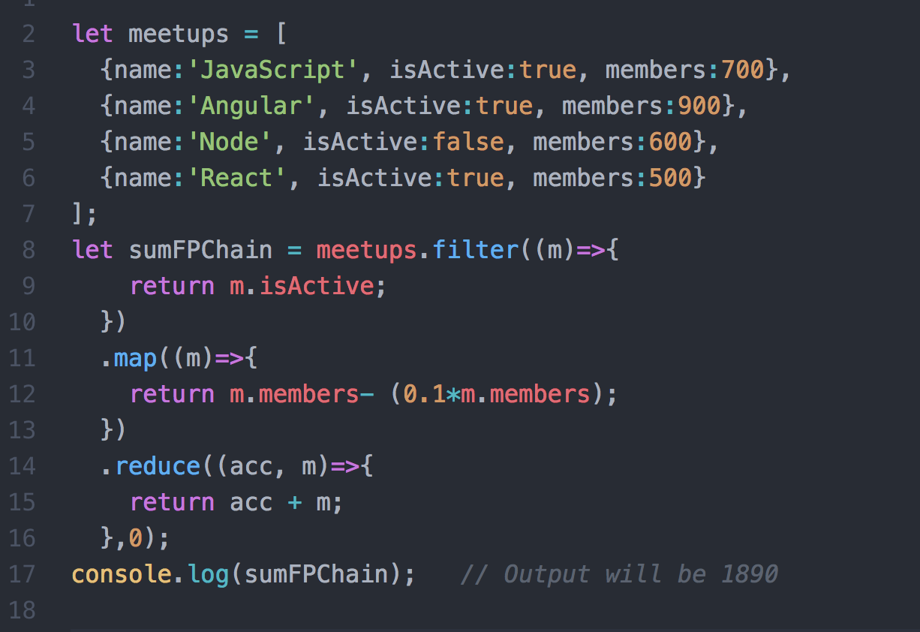

Renze was struggling in a time-consuming video game when he was 13. He then managed to create his first computer program--a script, which helped him reduce a significant amount of time that he spent in the game. Since then, he found a great interest in computer programming. “It’s like building blocks, very cool,” he said. Video games led him into this filed. With heave high school work in China, he still managed time to practice his programming skill. However, for some reasons, he ended up studying mathematics until a special school competition at his university.

The programming competition required Renze to make something fun and engaging. It was strange and challenge mission to a math student. However, Renze demonstrated his creativity and overcame this challenge by creating his first web application---a jet fighter game, with 10 people involved to play with him. With this successful experience, Renze found his passion in web app development field and decided to involve computer science as his second major. Double majoring is challenging, but for Renze it is the first step of his ambition, problem-solving and excellent collaboration ability also come into play.

In his undergraduate research project, Renze completed a research paper about face recognition and associated mathematical algorithm in a group of 4. His team divided the big picture into several aspects: creating Python code to implement algorithms, studied capturing camera and sensors, writing a research paper. Renze took the lead and made a great contribution to his team. He solved problems in programming and analyzed collected data for team discussion while managed his team in brainstorming, scheduling, and building mathematical models. In addition, he implemented this program to a web-based application. With these extracurricular activities, Renze had proved his outstanding problem-solving skill, excellent collaboration ability and his passion for web app development.

Video game led Renze into programming filed; School competition led Renze into web development; Extracurricular activities demonstrated his ability working individually as well as in team setting. With this strong relationship in the field as well as his excellent creative thinking, internal skills, and ambition career goal web application development he has proved himself as a desirable employee for all web application development companies.

References

Perez, S., & Perez, S. (2018, January 17). Global app downloads topped 175 billion in 2017, revenue surpassed $86 billion. Retrieved from

https://techcrunch.com/2018/01/17/global-app-downloads-topped-175-billion-in-2017-revenue-surpassed-86-billion/

Patro, N., & Patro, N. (2018, March 18). Functional Programming in JavaScript – Codeburst. Retrieved February 20, 2019, from https://codeburst.io/functional-programming-in-javascript-e57e7e28c0e5