TECHNICAL SPECIFICATION
ZPPI_SR_PROCESS
TCODE: ZPP001 — Slitting Process – Batch Defined Enhancement

Field | Detail
Document No. | TS-PP-ZPP001-001
Program | ZPPI_SR_PROCESS
TCODE | ZPP001
SAP Module | PP (Production Planning)
System | TRD — ECC 6.0 EHP6 / NW 7.31
Developer | William (Aug 2012) | Carfin (2019) | Fadila (2023)
Doc Date | June 2026
Status | DRAFT

PT. TRIAS SENTOSA TBK
SAP ABAP Development — Production Planning

DAFTAR ISI

1. OVERVIEW

1.1 Tujuan Dokumen
Dokumen ini adalah Technical Specification program custom ABAP ZPPI_SR_PROCESS (TCODE ZPP001). Menjelaskan arsitektur teknis, struktur data, alur proses eksekusi slitting normal, dan proses cancel (PPCL02) process order slit roll di PT. Trias Sentosa Tbk.

1.2 Informasi Program
Atribut | Nilai
Program Name | ZPPI_SR_PROCESS
Include TOP | ZPPI_SR_PROCESS_TOP (1.585 baris)
Include F01 | ZPPI_SR_PROCESS_F01 (16.605 baris — semua business logic)
TCODE | ZPP001
Program Type | Executable Report (TYPE 1)
SAP Module | PP — Production Planning
Line Size | 360
Type-Pools | SLIS
Original Developer | William | August 2012
Last Amendment | Fadila | October 2023
Environment | TRD | ECC 6.0 EHP6 | ABAP 7.31 | Oracle | Linux
User Manual Ref | PP-CL-UM29 Cancel Process Order Slit Roll

1.3 Business Context
Program mengelola proses Slitting di PT. Trias Sentosa Tbk — pemotongan jumbo roll menjadi slit roll sesuai Sales Order. Dua skenario utama:
- Eksekusi Normal (Start/Stop): GI, GR, Confirmation, TECO secara terintegrasi.
- Cancel / Batal Start-Stop (PPCL02): reversal seluruh transaksi — hanya oleh Koordinator.

2. ARSITEKTUR PROGRAM

2.1 Struktur Include
Include | Baris | Deskripsi
ZPPI_SR_PROCESS | 34 | Main program — entry point START-OF-SELECTION
ZPPI_SR_PROCESS_TOP | 1.585 | TYPE, DATA, TABLES, FIELD-SYMBOLS, Selection Screen
ZPPI_SR_PROCESS_F01 | 16.605 | 60+ FORM routines — seluruh business logic

2.2 Main Program Flow
START-OF-SELECTION.
CLEAR: FLAG.
PERFORM VALIDASI_ORDER_TYPE CHANGING FLAG.
IF FLAG EQ SPACE.
PERFORM READ_ORDER.
PERFORM DISPLAY_ORIGINAL_ORDER. "<-- ALV list ditampilkan
ENDIF.
END-OF-SELECTION.

Setelah ALV tampil, semua interaksi user dihandle USER_COMMAND via toolbar button (Start/Stop, Batal Start/Stop, Refresh, Print Label, Get Batch Detail).

2.3 Daftar FORM Routines Utama
FORM | Line | Fungsi
VALIDASI_ORDER_TYPE | 15.239 | Validasi tipe order dari selection screen
READ_ORDER | 154 | Baca data order dari AUFK, AFKO, AFPO, CRHD, VBAK, AUSP
DISPLAY_ORIGINAL_ORDER | 641 | Tampilkan list order ALV
RETRIEVE_DATA_BOXER | 5.873 | Ambil data batch slit roll dari batch characteristic
CHECKING_DATA_BOXER | 7.014 | Validasi data eksekusi (panjang, lebar, grade, stock)
GI | 12.277 | Goods Issue material inputan (mvt 261/901) via BAPI
GR | 10.864 | Goods Receipt hasil slit roll (mvt 101) via BAPI
CONFIRMATION | 11.804 | Posting order confirmation via BDC TCODE CO11N
TECO_ORDER / TECO_COMBINE | 1.323 / 15.766 | Set status TECO pada original & combine order
COLLECT_DATA_CANCEL | 12.780 | Kumpulkan mat.doc yang harus di-cancel dari MKPF/MSEG
PROCESS_CANCEL | 13.071 | Orchestrator: jalankan semua langkah cancel berurutan
CANCEL_GOODSMVT | 13.778 | Wrapper BAPI_GOODSMVT_CANCEL — dipakai tiap step cancel
BAPI_COMMIT | 13.805 | Wrapper BAPI_TRANSACTION_COMMIT (WAIT=X)
REVERSE_ZZEXLENGTH | 13.820 | Kembalikan extra length di batch characteristic
REVERSE_ZZLENGTH_BATCH_INPUTAN | 14.076 | Kembalikan panjang terpakai di batch material inputan
UNDO_CHANGE_BATCH_ORIG_ORDER | 12.902 | Kembalikan characteristic batch original order
CANCEL_CONFIRMATION | 15.523 | Cancel confirmation via BDC TCODE CORS
F_LEPAS_CORE_RTP | 16.041 | Lepas core RTP setelah cancel (Carfin 2019)

3. STRUKTUR DATA

3.1 Tabel SAP yang Digunakan
Tabel | Keterangan
AUFK | Order Master Data — header process order
AFKO | Order Header PP (material, qty, workcenter)
AFPO | Order Item (plant, SO reference, mill order)
AUSP | Batch characteristic values
MCH1 | Batch records per plant
MSEG | Material document item (GI/GR movement)
MKPF | Material document header — filter by BKTXT = order number
AFRU | Order Confirmation — sumber V_RUECK dan V_RMZHL
MCHB | Batch stock per plant/storage location
VBAP / VBAK | Sales Order item / header
CRHD | Work Center header (untuk ARBPL)
ZHEADER | Custom: header process slitting

3.2 Internal Table Utama
Internal Table | Type | Kegunaan
V_AUFK | IT_AUFK | List process order (AUFNR, AUART)
V_AFKO | IT_AFKO | Detail order: material, qty, workcenter, flag
V_AFPO | IT_AFPO | Item order: plant, matnr, SO ref, mill order
IT_MAIN | Structure (80+ field) | Data utama boxer: posisi, 8 grade, batch, panjang, lebar, status, density, dll
IT_INBATCH | Structure inline | Batch inputan (raw): width, length, GI qty, scrap flag
IT_CANCEL | Structure inline | Mat.doc untuk di-cancel: MBLNR, MJAHR, BWART, CHARG, FLAG
IT_REVERSAL | IT_CANCEL | Mat.doc yang sudah punya reversal (untuk filtering)
IT_LOG | Structure inline | Log hasil tiap step cancel: icon + transaksi + message
IT_SCRAP | Structure inline | Data scrap per material document
ITAB_GRADE_CRITERIA | HASHED TABLE | Grade criteria — unique key: GRADE (2 char)
IT_TYCORE | T_TYCORE | Core RTP per posisi batch (tambahan Fadila 2023)

4. ALUR PROSES

4.1 Flowchart Program

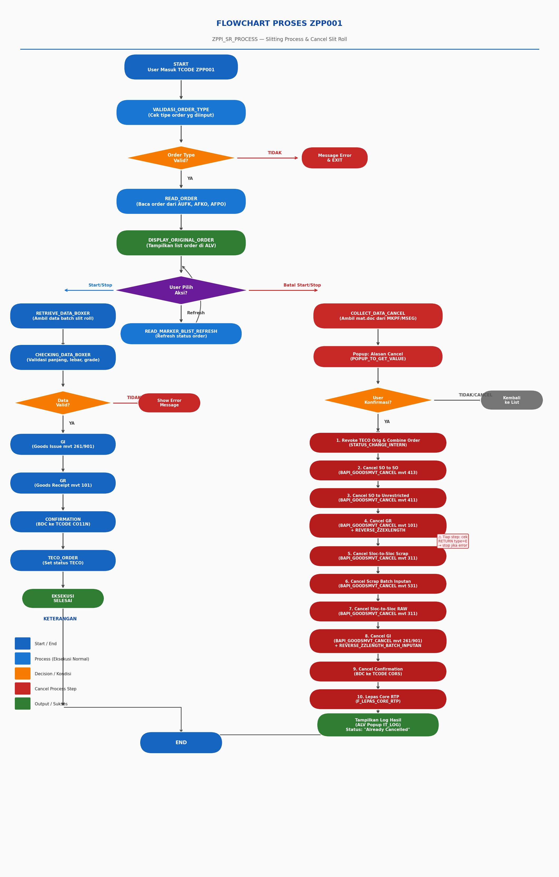
Gambar 1. Flowchart Program ZPPI_SR_PROCESS (ZPP001)

4.2 Proses Eksekusi Normal (Start/Stop)
Ketika user menekan tombol Start/Stop, program menjalankan urutan:

- RETRIEVE_DATA_BOXER — Ambil data batch dari batch characteristic (AUSP).
- CHECKING_DATA_BOXER — Validasi panjang, lebar, grade, dan stock.
- GI (Goods Issue) — Posting goods issue material inputan (mvt 261 / 901).
- SOTOSO / SOTOUN — Transfer raw recycle antar storage location (mvt 413 / 411).
- GR (Goods Receipt) — Posting GR slit roll hasil produksi (mvt 101).
- CONFIRMATION — Posting confirmation via BDC ke TCODE CO11N/CORS.
- TECO_ORDER / TECO_COMBINE — Set status TECO pada original dan combine order.
- CHANGE_BATCH_ORIGINAL_ORDER — Update characteristic batch slit roll.
- CHANGE_BATCH_INPUTAN — Update characteristic material inputan (kurangi panjang terpakai).

4.3 Proses Cancel (Batal Start/Stop — PPCL02)
Cancel hanya dapat dilakukan Koordinator. FORM PROCESS_CANCEL menjalankan urutan berikut:

Step | Aksi | Mvt/TCODE | Keterangan
1 | COLLECT_DATA_CANCEL | MKPF/MSEG | Kumpulkan mat.doc dari header order. Filter: hapus yang sudah di-reverse.
2 | Revoke TECO Orig Order | STATUS_CHANGE_INTERN | I0045 (TECO) inaktif, I0002 (REL) aktif kembali.
3 | Revoke TECO Combine Order | STATUS_CHANGE_INTERN | Sama untuk combine order.
4 | Cancel SO to SO | Mvt 413 | BAPI_GOODSMVT_CANCEL untuk BWART=413.
5 | Cancel SO to Unrestricted | Mvt 411 | BAPI_GOODSMVT_CANCEL untuk BWART=411 SGTXT=UNREST.
6 | Cancel GR | Mvt 101 | BAPI_GOODSMVT_CANCEL. Jika bukan ZZSRSHEET: REVERSE_ZZEXLENGTH.
7 | Cancel Sloc-Sloc Scrap | Mvt 311 | BAPI_GOODSMVT_CANCEL untuk BWART=311 SGTXT=SCRAP.
8 | Cancel Scrap Batch Inputan | Mvt 531 | BAPI_GOODSMVT_CANCEL. Jika XBLNR=SCR*: REVERSE_CHAR_BATCH_INPUTAN.
9 | Cancel Sloc-Sloc RAW | Mvt 311 | BAPI_GOODSMVT_CANCEL untuk BWART=311 SGTXT=RAW.
10 | Cancel GI | Mvt 261/901 | BAPI_GOODSMVT_CANCEL. Setelah sukses: REVERSE_ZZLENGTH_BATCH_INPUTAN.
11 | Cancel Confirmation | CORS (BDC) | BDC ke TCODE CORS. Hanya jalan jika ada V_RUECK (nomor konfirmasi).
12 | F_LEPAS_CORE_RTP | Custom Logic | Lepas core RTP terkait batch slit roll (Carfin 2019).
13 | Tampilkan Log | ALV Popup | IT_LOG ditampilkan: @08@ sukses / @0A@ gagal per step.

4.3.1 Error Handling Cancel
Setiap step cancel dicek via:
LOOP AT RETURN WHERE TYPE = 'E'.
FLAG = 'X'. " Stop — step berikutnya tidak dijalankan
IT_LOG-ICON = '@0A@'. " Tandai error pada log
APPEND IT_LOG.
ENDLOOP.

Jika semua step sukses, log error dihapus dan hanya ditampilkan pesan "Cancel Slitting Process [order] Success".

4.3.2 Kondisi Kritis Cancel
- Stock material slitting dan raw recycle HARUS masih ada — jika tidak, BAPI_GOODSMVT_CANCEL akan error.
- Jika V_RUECK kosong/nol, step Cancel Confirmation dilewati.
- Material class ZZSRSHEET: REVERSE_ZZEXLENGTH tidak dijalankan setelah Cancel GR.
- XBLNR dimulai SCR: menandakan scrap batch inputan — REVERSE_CHAR_BATCH_INPUTAN dijalankan.

5. MOVEMENT TYPES YANG TERLIBAT
Mvt | Deskripsi | Context | Cancel Via
101 | Goods Receipt hasil slit roll | GR Normal | BAPI_GOODSMVT_CANCEL
261 | Goods Issue material inputan | GI Normal | BAPI_GOODSMVT_CANCEL
311 | Transfer Sloc-to-Sloc (RAW) | Transfer raw recycle | BAPI_GOODSMVT_CANCEL (SGTXT=RAW)
311 | Transfer Sloc-to-Sloc (SCRAP) | Transfer scrap | BAPI_GOODSMVT_CANCEL (SGTXT=SCRAP)
411 | SO to Unrestricted stock | Transfer SO batch | BAPI_GOODSMVT_CANCEL (SGTXT=UNREST)
413 | SO to SO transfer | Transfer antar SO | BAPI_GOODSMVT_CANCEL
531 | Scrap batch inputan | Posting scrap | BAPI_GOODSMVT_CANCEL
901 | GI alternatif (Jan 2013) | GI tipe order tertentu | BAPI_GOODSMVT_CANCEL

6. BAPI DAN FUNCTION MODULE
FM / BAPI | Kegunaan
BAPI_GOODSMVT_CANCEL | Cancel / reverse material document (GR, GI, Transfer)
BAPI_TRANSACTION_COMMIT | Commit setelah setiap BAPI cancel (WAIT = X — synchronous)
STATUS_CHANGE_INTERN | Ubah status system order (TECO/Un-TECO) via OBJNR
POPUP_TO_GET_VALUE | Popup input alasan cancel dari user
QMSP_MATERIAL_BATCH_CLASS_READ | Baca class batch (cek apakah ZZSRSHEET)
CALL TRANSACTION CORS (BDC) | Cancel order confirmation
CALL TRANSACTION CO11N (BDC) | Posting order confirmation

7. CATATAN PERFORMANCE

7.1 Oracle Index Hints
Program menyediakan Oracle hint (di-comment) untuk query pada tabel besar AFRU dan MSEG:
SELECT SINGLE RUECK RMZHL FROM AFRU INTO ...
WHERE AUFNR = COM_ORDER AND STOKZ = '' AND STZHL = ''.
* %_HINTS ORACLE 'INDEX("AFRU" "AFRU~Z02")' "<-- aktifkan jika full-scan

7.2 Rekomendasi
- Gunakan ST05 (SQL Trace) untuk monitor query AFRU, MSEG, MKPF saat cancel volume besar.
- COLLECT_DATA_CANCEL: SELECT ke MKPF WHERE BKTXT = order — pastikan index BKTXT tersedia.
- BAPI_TRANSACTION_COMMIT WAIT=X di setiap step menjamin konsistensi namun memperlambat jika dokumen banyak.
- LOOP AT IT_CANCEL dengan nested READ TABLE adalah O(n) — aman untuk volume normal (<100 dokumen per order).

8. TRANSPORT & LIFECYCLE

8.1 Objek dalam Transport Request
Tipe | Objek | Keterangan
PROG | ZPPI_SR_PROCESS | Main program
PROG | ZPPI_SR_PROCESS_TOP | Include TOP — data declaration
PROG | ZPPI_SR_PROCESS_F01 | Include F01 — FORM routines
TRAN | ZPP001 | TCODE mapping ke program

8.2 Landscape
- Transport path: Development (TRD) → Quality Assurance (TRQ) → Production (PRT/TRP)
- Pastikan TCODE ZPP001 dan ketiga program include masuk dalam satu transport request.
- Jika ada perubahan custom table (ZHEADER, ZORDER00, dll), tambahkan SE11 object ke request yang sama.
- Test di TRQ: jalankan skenario eksekusi normal DAN cancel sebelum transport ke Production.

9. AMENDMENT HISTORY
Ref | Tanggal | Developer | Correction | Deskripsi
001 | Aug 2012 | William | Initial | Program created — Slitting Process Batch Defined Enhancement
002 | Jan 2013 | William | Enhancement | Tambah mvt 901 untuk GI alternatif; tambah Unloading Point (ABLAD)
003 | Jan 2013 | William | Enhancement | Pengecekan AUART (order type); cancel GI untuk mvt 901
004 | Apr 2019 | Carfin | Enhancement | Tambah F_LEPAS_CORE_RTP — lepas core RTP setelah cancel
005 | Oct 2023 | Fadila | Enhancement | Tambah T_TYCORE, IT_TYCORE, R_DIAMETER_CORE — pengelolaan core RTP per batch

10. TROUBLESHOOTING

10.1 Issue Umum
Symptom | Solusi
Cancel error — stok tidak cukup | Cek MB52/MMBE. Pastikan stock material slitting dan raw recycle masih ada.
Cancel berhenti di step GR | Cek MCHB. Qty GR > stock available = tidak bisa reverse. Koordinasikan dengan warehouse.
Status order tidak bisa Un-TECO | Cek SM12 untuk lock entries. Cek CO02/CO03. Gunakan SWUD jika ada workflow.
Cancel Confirmation gagal (BDC CORS) | Cek AFRU untuk V_RUECK dan V_RMZHL. Jalankan CORS manual untuk trace error screen.
Program error short dump | Cek ST22. SU53 untuk authorization. Cek field yang tidak terisi.
Cancel parsial (sebagian step sukses) | Lihat IT_LOG ALV popup. Step gagal = @0A@. Lakukan manual reversal di MB08/CORS.

10.2 Urutan Debugging
- Cek ST22 (Short Dump) — lihat program dan baris error.
- Cek SM21 (System Log) — error di level sistem.
- Set breakpoint di PROCESS_CANCEL atau COLLECT_DATA_CANCEL, jalankan ABAP Debugger.
- Cek ST05 (SQL Trace) jika performance lambat.
- Jika cancel parsial: cek IT_CANCEL di Debugger untuk lihat dokumen mana yang gagal.

11. SIGN-OFF
Prepared By | Reviewed By | Approved By
Name: ___________________ | Name: ___________________ | Name: ___________________
Role: ABAP Developer | Role: Senior ABAP / Tech Lead | Role: IT Manager
Date: ___________________ | Date: ___________________ | Date: ___________________

