CH5960: The Nuclear Energy Option
  - Assignment 1 — Monte Carlo Simulation of Reactor Physics
Guhan Swaminathan (CH23B118)
Department of Chemical Engineering, IIT Madras · 5 October 2026

Summary
We follow neutrons one collision at a time, from birth in fission to absorption, through four infinite homogeneous cores. Cross-sections are real evaluated nuclear data, reconstructed pointwise and Doppler-broadened to 293.6 K with NJOY2016. Each core was run with ${10}^{6}$ and with ${10}^{9}$ source neutrons. Because nothing leaks from an infinite core, every neutron ends in capture or fission, so
$$k_{∞}=\frac{\text{fission neutrons produced}}{\text{neutrons born}}=\frac{1}{N_{0}}\sum_{h=1}^{N_{0}}{ν_{h}}, σ_{k}=\sqrt{\left(\overline{ν^{2}}−k_{∞}^{2}\right)/N_{0}} .$$
A core “can go critical” if $k_{∞}>1$: a finite core of the same mixture can then be made large enough to make up for leakage.
 | Core | $k_{∞}$, $N={10}^{6}$ | $k_{∞}$, $N={10}^{9}$ | Can go critical?
1 | Pure U-238 (metal) | 0.2929 ± 0.0009 | running | no
2 | Natural U (metal, 0.711 wt% U-235) | 0.4080 ± 0.0010 | running | no
3 | 2 wt% enriched UO₂ + H₂O ($V_{m}/V_{f}=2$) | 1.2099 ± 0.0012 | running | yes
4 | Natural UO₂ + D₂O ($V_{m}/V_{f}=100$) | 1.1385 ± 0.0012 | running | yes
Table 1: Main result (±1σ, statistical).
All four statements of the assignment are confirmed: pure U-238 and natural uranium cannot sustain a chain reaction even with zero leakage, while 2% enriched uranium with light water and natural uranium with heavy water both can. The margins (0.6–0.7 below 1, and 0.14–0.21 above 1) are thousands of standard deviations, so the conclusions are not statistical accidents. Section 3 compares these numbers with the two reference reports.

1 Model

1.1 Nuclear data (step 0)
The evaluated files were processed with NJOY2016, which we compiled from source: reconr rebuilds the resonances from the resonance parameters (0.1% tolerance), and broadr Doppler-broadens them to 293.6 K. Sources: U-238 from JENDL-3.3; U-235, H-1 and H-2 from ENDF/B-VIII.0. These are the same evaluated libraries the KAERI chart displays. For every nuclide we keep
$$σ_{e}=MT2, σ_{f}=MT18, σ_{c}=∑MT102\text{–}117 \left((n,γ),(n,p),(n,α)…\right), σ_{i}=σ_{t}−σ_{e}−σ_{f}−σ_{c},$$
so $σ_{i}$ holds inelastic scattering and $(n,xn)$. The partial inelastic channels are kept too: discrete levels MT51–90 with their $Q$-values, the continuum MT91, and $(n,2n)$, $(n,3n)$. They are used to pick the outgoing energy. $\overset{‾}{ν}(E)$ is the total $\overset{‾}{ν}$ table (MF1/MT452) of each evaluation: 2.430 (U-235) and 2.488 (U-238) at thermal energy, and 2.646 and 2.630 at 2 MeV. The sandbox could not reach any server holding an evaluated O-16 file, so O-16 uses an approximate model. It has 3.85 b potential scattering, the main elastic resonances (0.43, 1.0, 1.3, 1.65, 1.9 MeV) and the 2.35 MeV minimum, 0.19 mb $1/v$ capture, $(n,α)$ above 2.35 MeV counted as capture, and the 6.05 MeV level for inelastic scattering. Oxygen hardly absorbs and is a weak moderator, so this affects $k_{∞}$ only at the ${10}^{−3}$ level.
The required table. The microscopic cross-sections at $E=(0.2,0.4,0.6,0.8,1.0)×{10}^{y}$ MeV, $y=−8…1$, are listed in Appendix A and plotted as dots in Fig. 1. With only five points per decade, most of the narrow U-238 resonances (6.67, 20.9, 36.7 eV …) fall between table points. The simulation therefore uses the full pointwise data (about ${10}^{5}$ energies per uranium isotope). Section 2.7 shows what happens if only the table is used.
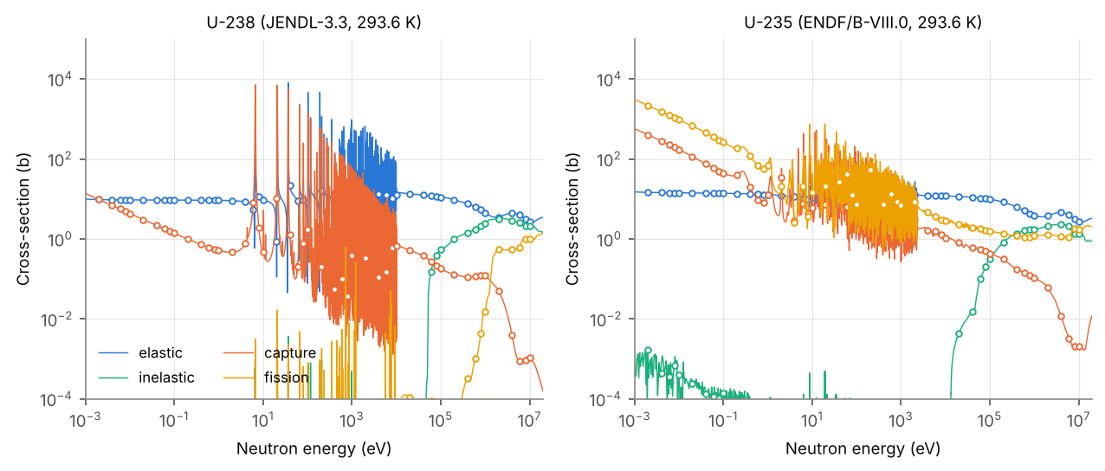
Figure 1: Uranium cross-sections used by the code (lines) and the tabulated values at the 50 required energies (circles). Note the U-238 capture resonances between 6.7 eV and ~10 keV, the U-238 inelastic threshold at 45 keV and its fission threshold near 1 MeV.
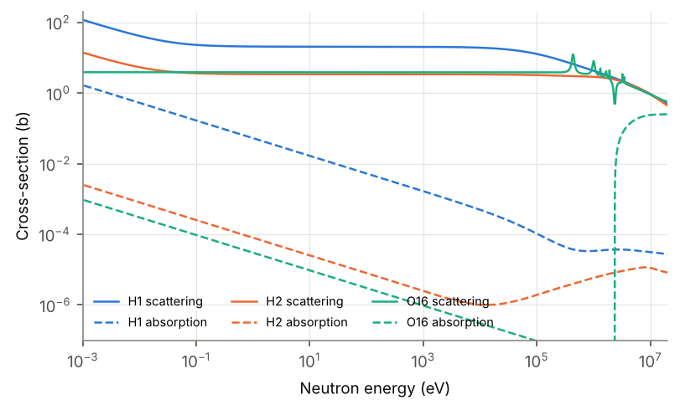
Figure 2: Moderator nuclides: scattering (solid) and absorption (dashed). At thermal energy H-1 absorbs 0.33 b, while H-2 absorbs only 0.5 mb, about 650 times less.

1.2 Compositions (steps i–ii)
Nuclides: U-238, U-235, H-1, O-16, H-2. Uranium metal is 19.05 g cm⁻³ and UO₂ is 10.97 g cm⁻³. Water is 0.998 g cm⁻³, and heavy water is 1.105 g cm⁻³ (100% D₂O). Natural uranium has 0.711 wt% U-235. For the moderated cores, a fuel volume $V_{f}$ and a moderator volume $V_{m}$ are smeared into one homogeneous mixture,
Ni=k​VkVf+Vm ρkNAMk ni,k.
The volume ratios $V_{m}/V_{f}$ come from the scan in Fig. 10: 2 for light water (a typical PWR value, at the optimum) and 100 for heavy water (on the broad maximum).
Core | U-238 | U-235 | H-1 | O-16 | H-2
U-238 | 4.8192e-02 | – | – | – | –
Nat. U | 4.7849e-02 | 3.4703e-04 | – | – | –
2% UO₂/H₂O | 7.9913e-03 | 1.6518e-04 | 4.4493e-02 | 3.8560e-02 | –
Nat. UO₂/D₂O | 2.4049e-04 | 1.7442e-06 | – | 3.3389e-02 | 6.5810e-02
Table 2: Number densities (atoms b⁻¹ cm⁻¹).

1.3 The Monte Carlo steps (iii–vii)
(iii) Birth. $s(E)=0.771\sqrt{E} e^{−0.776E}$ is a Maxwellian with $T=1/0.776=1.289$ MeV and mean $1.5 T=1.933$ MeV. It is sampled exactly with three random numbers:
$$E=−T\left[lnr_{1}+lnr_{2} \cos^{2}​\left({πr_{3}}/2\right)\right].$$
(iv) Flight. Every cross-section is looked up at the neutron’s energy on a union grid (hash table plus bisection, linear interpolation). The flight distance is $d=−lnr/Σ_{t}(E)$ and the flight time is $d/v$, with $v=1.383×{10}^{9}\sqrt{E[MeV]}$ cm s⁻¹.
(v) Nucleus hit, with probability $N_{j}σ_{t,j}(E)/Σ_{t}(E)$.
(vi) Reaction, with probability $σ_{x,j}/σ_{t,j}$: elastic, inelastic, capture or fission.
(vii) Outcome. Capture ends the history. Fission ends it and scores $\overset{‾}{ν}(E)$ neutrons. Elastic scattering is isotropic in the centre-of-mass frame. Above $400 kT≈10$ eV the target is at rest, so
$$E^{′}=E [α+(1−α) r], α={\left(\frac{A−1}{A+1}\right)}^{2}.$$
Below 10 eV the target velocity is sampled from the 293.6 K Maxwellian (free-gas kernel, as in MCNP/OpenMC). This lets thermal neutrons gain as well as lose energy, so the thermal spectrum forms by itself rather than being imposed. Inelastic scattering first picks the channel from the partial cross-sections. For a discrete level with $Q<0$,
$$E^{′}=\frac{E}{(A+1)^{2}}\left[1+A^{2}s^{2}+2Asμ\right], s^{2}=1+\frac{(A+1) Q}{A E},$$
with isotropic $μ$. For the continuum and for $(n,xn)$, outgoing energies come from an evaporation spectrum $E^{′}e^{−E^{′}/θ}$, $θ=\sqrt{E^{*}/(A/10)}$, limited by the available energy $E^{*}$. The extra $(n,2n)$ and $(n,3n)$ neutrons are followed as part of the same history.
Energy groups for the tallies: fast $E≥0.1$ MeV, slowing down $0.625 eV≤E<0.1$ MeV, thermal $E<0.625$ eV (cadmium cut-off). The code also tallies the track-length flux, time and collisions in each group, the lifetime of each neutron, and every absorption by nuclide, reaction and energy. From these tallies $k_{∞}$ splits exactly into the four factors, using absorptions below 0.625 eV as “thermal”:
$$k_{∞}=\underset{ε}{\underset{⏟}{\frac{∑ν}{∑ν_{th}}}} \underset{p}{\underset{⏟}{\frac{A_{th}}{N_{0}}}} \underset{f}{\underset{⏟}{\frac{A_{th,fuel}}{A_{th}}}} \underset{η}{\underset{⏟}{\frac{∑ν_{th}}{A_{th,fuel}}}} .$$

1.4 Code and the ${10}^{9}$ runs
The code is Python, compiled with Numba and run in parallel. It handles about $1.2×{10}^{7}$ collisions s⁻¹ on the 2 available cores. The ${10}^{9}$ runs are done in batches of $5×{10}^{7}$ histories with checkpoints. Cores 1–3 are fully analog at both sizes. For core 4 a neutron makes ≈245 collisions, most of them as a thermal neutron bouncing in D₂O, so an analog ${10}^{9}$ run would take about 12 h on two cores. For that one run the thermal stage was accelerated without any physics approximation: a fully analog run of $2×{10}^{7}$ histories records, for every neutron, what happens after it first drops below 0.625 eV. That record covers the absorbing nuclide and reaction, the energy, $ν$, the time and collisions in each group, and the thermal-stage flux. In the ${10}^{9}$ run each neutron is followed analog through slowing down (where the resonance absorption happens). When it reaches 0.625 eV, the rest of its history is drawn at random from the recorded pool. The estimator is unbiased. The finite pool adds a statistical error of about the analog $2×{10}^{7}$ value ($≈3×{10}^{−4}$). That is still far below the $k_{∞}−1=0.14$ margin. All ${10}^{6}$ results, and the scans, are fully analog.

2 Results and checks
 | U-238 | Nat. U | 2% UO₂/H₂O | Nat. UO₂/D₂O
$k_{∞}$ | 0.29290 | 0.40803 | 1.20992 | 1.13853
$ε$ (fast fission factor) | – | – | 1.1437 | 1.0070
$p$ (resonance escape) | 0.0000 | 0.0000 | 0.6811 | 0.8668
$f$ (thermal utilisation) | – | – | 0.8987 | 0.9787
$η$ (neutrons per thermal abs. in fuel) | – | – | 1.7283 | 1.3328
fission / capture in fuel | 0.1172 | 0.1787 | 1.1708 | 0.9299
absorbed in moderator | 0.00% | 0.00% | 8.39% | 2.78%
neutrons reaching thermal | 0.00% | 0.00% | 68.05% | 86.68%
collisions per neutron | 49.6 | 47.3 | 28.3 | 244.7
collisions 2 MeV → 0.625 eV (mean) | – | – | 20.4 | 30.5
$(n,xn)$ neutrons per source neutron | 4.1e-03 | 4.1e-03 | 9.2e-04 | 1.8e-05
Table 3: Main tallies (${10}^{6}$ neutrons). $ε,p,f,η$ have no meaning for cores 1–2, because no neutron becomes thermal.

2.1 Birth energies
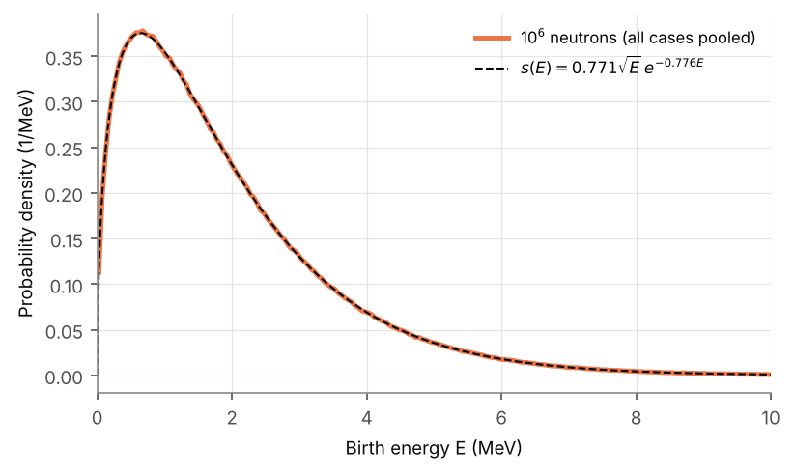
Figure 3: Sampled birth energies (all four cores pooled) against $s(E)$.
The sampled spectrum lies on $s(E)$. The sampled mean is 1.9323 MeV against the exact 1.9330 MeV, and the peak is at $T/2=0.64$ MeV. At ${10}^{6}$ neutrons the histogram is slightly noisy near the peak; at ${10}^{9}$ it is smooth.

2.2 Slowing down
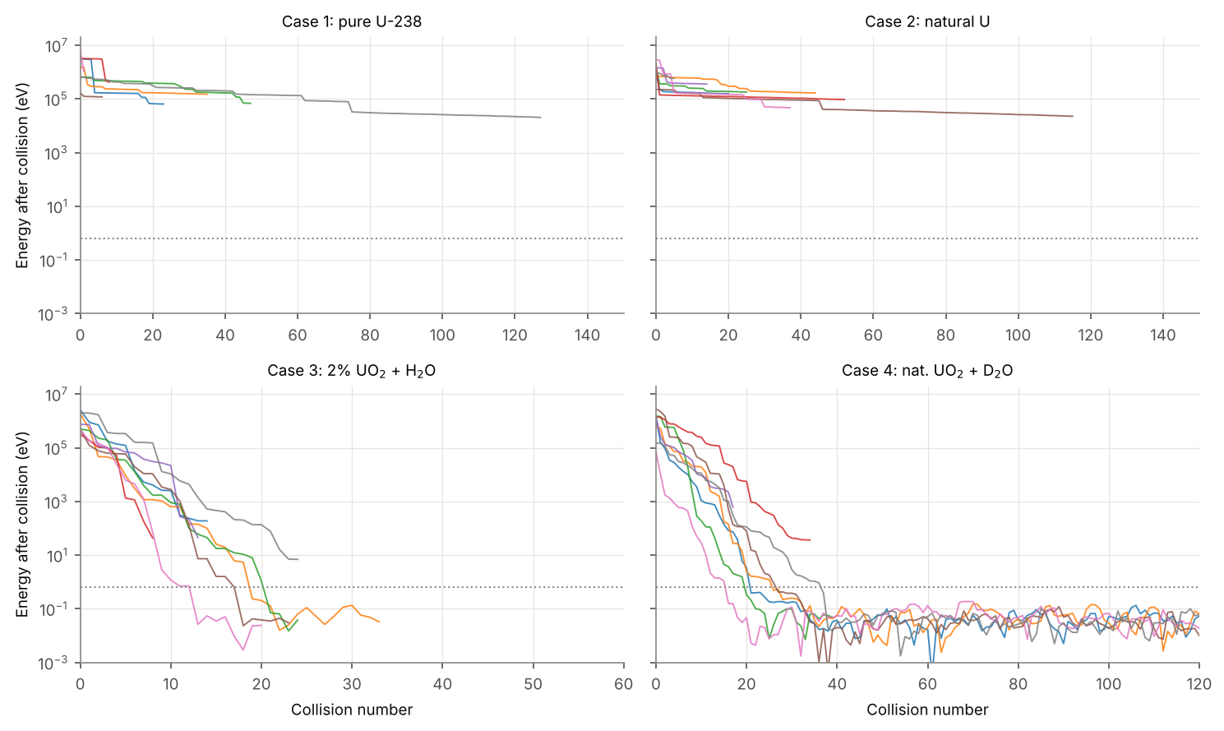
Figure 4: Energy after each collision for eight sample neutrons per core (${10}^{6}$ run). Dotted line: 0.625 eV.
In uranium alone a neutron loses energy mainly through inelastic collisions, down to the ~50–100 keV range. Below the 45 keV first level of U-238 only elastic collisions are possible. These remove on average just $ξ_{U}=0.0084$ in lethargy, so the neutron is stuck at tens of keV until U-238 captures it. Nothing reaches thermal energy. With a moderator the energy falls by eight decades in 20–30 collisions, and the neutron then random-walks around $kT=0.025$ eV, gaining and losing energy, until it is absorbed. Slowing from birth to 0.625 eV took 20.4 collisions in the H₂O core and 30.5 in the D₂O core. With ξ=j​ξjΣs,j/Σs ($ξ_{H}=1$, $ξ_{D}=0.726$, $ξ_{O}=0.120$, $ξ_{U}=0.0084$), the estimate $ln(2 MeV/0.625 eV)/\overset{‾}{ξ}$ gives about 18 and 29. Light water needs a few more collisions than this, because above ~1 MeV the H-1 cross-section falls and many early collisions are with oxygen or with uranium (inelastic).

2.3 Flux spectra
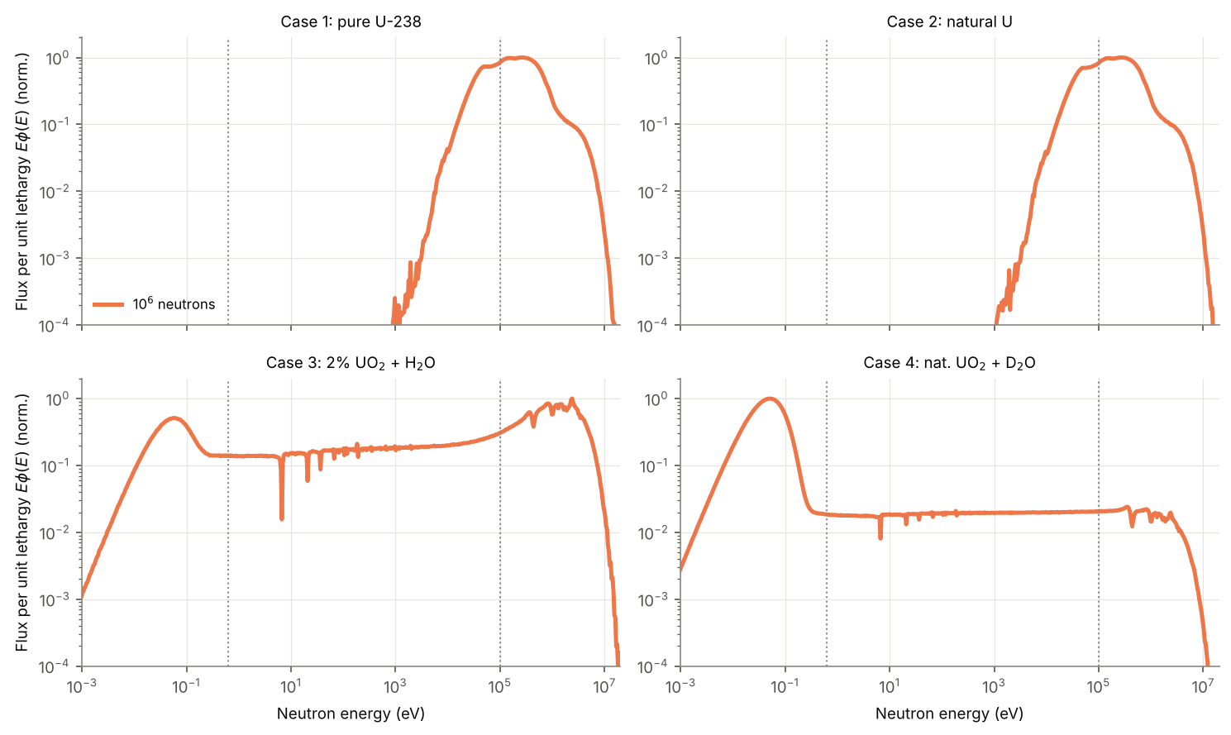
Figure 5: Flux per unit lethargy $Eϕ(E)$, from the track-length estimator and normalised to its peak. Dotted lines: 0.625 eV and 0.1 MeV.
The unmoderated cores show only a degraded fission spectrum: above 1 keV, peaking at about 100 keV. The moderated cores show the textbook three-part shape. There is a fission peak, then a flat $1/E$ slowing-down plateau carrying the U-238 resonance dips (6.67, 20.9, 36.7, 66, 81, 102 eV …), then a thermal Maxwellian peak near 0.05 eV. Resonance self-shielding comes out of the simulation without any special treatment. The thermal peak is far taller in D₂O, because thermal neutrons live much longer there before being absorbed. Because the thermal stage uses a free-gas kernel, the thermal and epithermal parts join smoothly, with no artificial step at the cut-off.

2.4 Neutron lifetimes
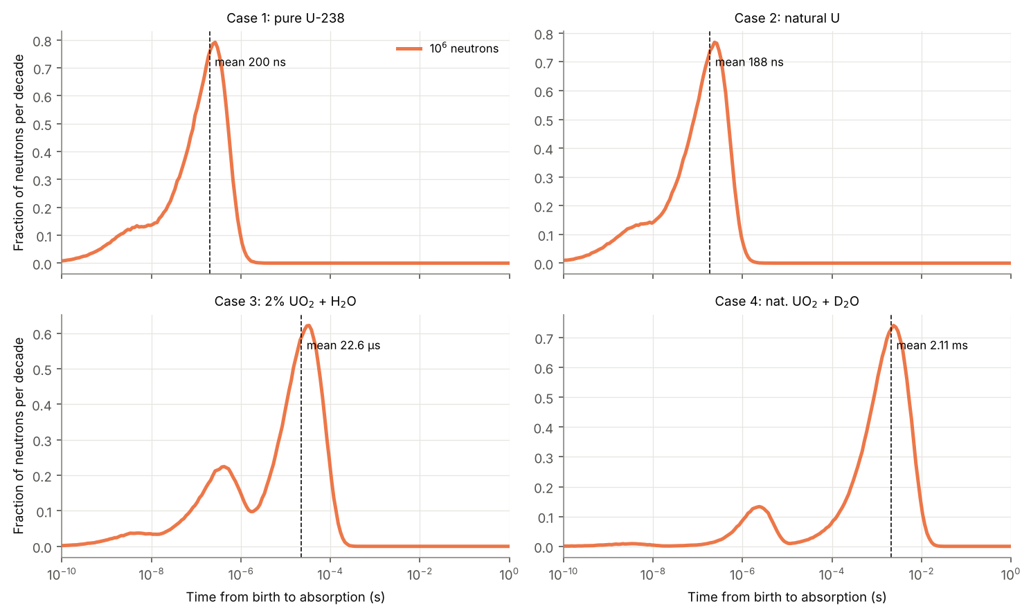
Figure 6: Distribution of the time from birth to absorption (per decade). Dashed line: mean lifetime.
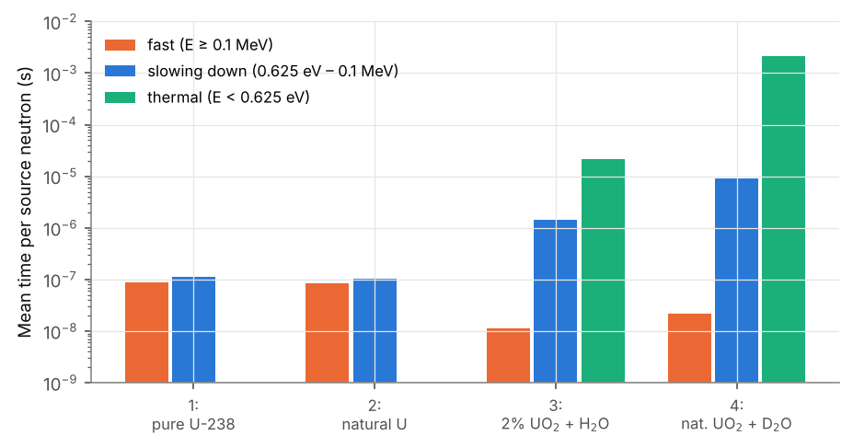
Figure 7: Mean time a neutron spends fast, slowing down and thermal (per source neutron, ${10}^{6}$ run).
Core | fast | slowing down | thermal | mean lifetime | thermal life of thermalised n
U-238 | 87.4 ns | 113.4 ns | – | 199.9 ns | –
Nat. U | 84.8 ns | 104.4 ns | – | 188.3 ns | –
2% UO₂/H₂O | 11.3 ns | 1.41 µs | 21.22 µs | 22.62 µs | 31.19 µs
Nat. UO₂/D₂O | 21.9 ns | 9.28 µs | 2.104 ms | 2.113 ms | 2.428 ms
Table 4: Mean time spent in each group per source neutron, and lifetimes (${10}^{6}$).
Without a moderator a neutron lives about 0.2 µs, all of it fast or at tens of keV. In the moderated cores the fast stage lasts about 10–20 ns and slowing down about 1 µs (H₂O) or 10 µs (D₂O). The thermal stage dominates: tens of µs in light water and about 2 ms in heavy water. The thermal-stage life of a thermalised neutron (last column) is within 1% (D₂O) and 3% (H₂O) of $1/(Σ_{a}v)$ evaluated at 2.2 km s⁻¹ (31.2 vs 30.3 µs; 2.43 vs 2.41 ms). The small excess comes from the free-gas thermal spectrum being slightly hardened by absorption. This is the familiar ordering of prompt-neutron lifetimes: fast systems, then LWRs, then heavy-water reactors. The small early hump in cores 3 and 4 comes from neutrons absorbed during slowing down, mostly in U-238 resonances.

2.5 Absorption in fuel and moderator, and the fission-to-capture ratio
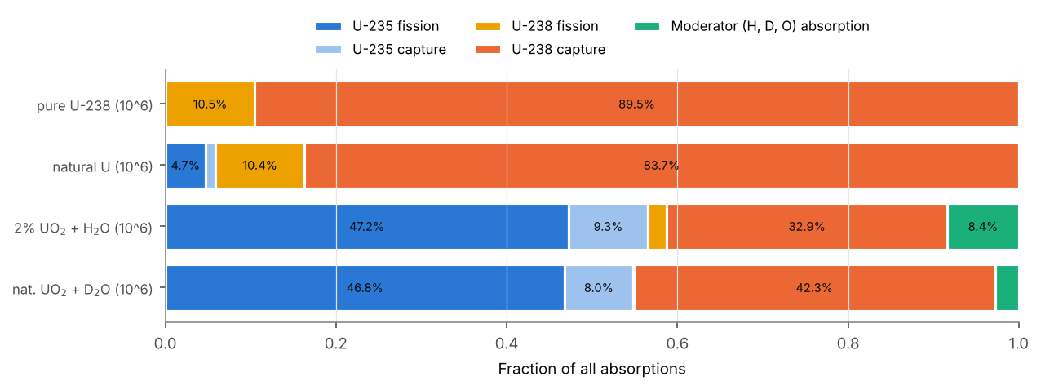
Figure 8: Fraction of all absorptions by nuclide and reaction, for both run sizes.
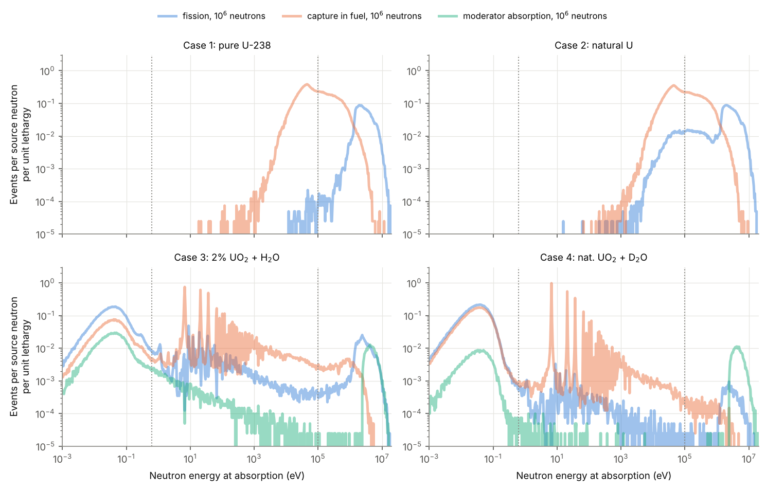
Figure 9: Fissions, captures in the fuel, and absorptions in the moderator, against the energy at which they happen (per source neutron per unit lethargy).
Pure U-238: 89.51% of neutrons are captured by U-238. The only fissions are threshold fissions above ~1.2 MeV, made before the first inelastic collision pushes the neutron below threshold. Fission/capture = 0.117. Natural U: U-235 adds 4.72% fissions in the keV range, where $σ_{f}^{235}$ is only a few barns, but there are 140 times more U-238 nuclei capturing. Fission/capture = 0.179. 2% UO₂/H₂O: 91.61% of absorptions are in the fuel and 8.39% in the water, mostly by hydrogen. Most U-235 fissions are thermal, and fission/capture in the fuel rises to 1.171. The main loss is U-238 resonance capture (the spikes from 6.7 eV to keV). Nat. UO₂/D₂O: only 2.78% is lost in the moderator, so almost every thermal neutron ends in uranium. Fission/capture = 0.930. In the thermal region the U-235 fission and capture curves run parallel, because both are close to $1/v$. Their ratio is $σ_{f}/σ_{γ}≈586.6/99.4=5.9$.

2.6 Why the moderated cores work: moderator scans
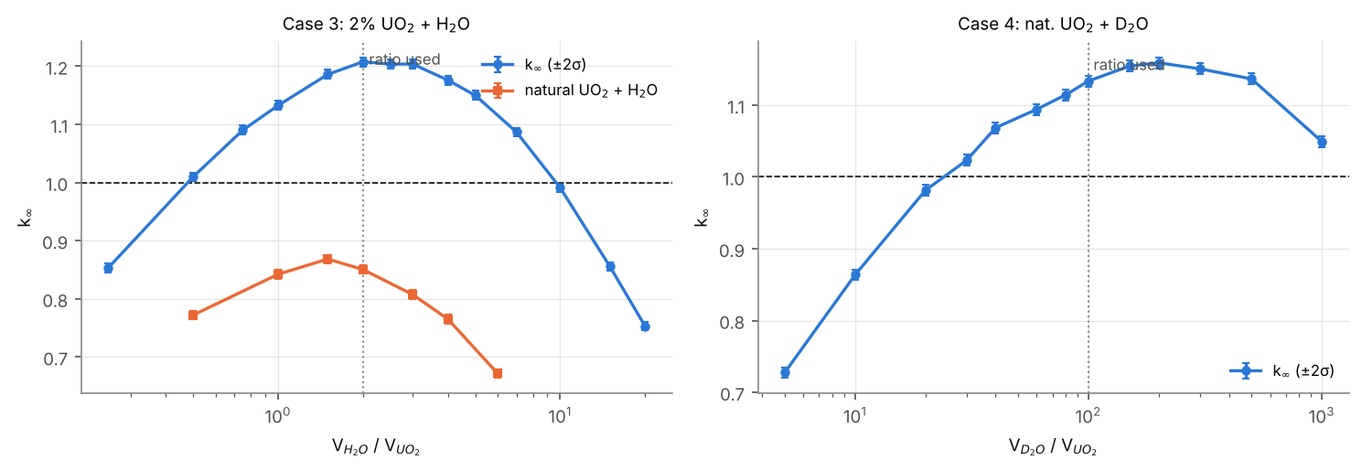
Figure 10: $k_{∞}$ against the moderator-to-fuel volume ratio (${10}^{5}$ analog histories per point, ±2σ). The dashed line is $k_{∞}=1$; the dotted line marks the ratio used.
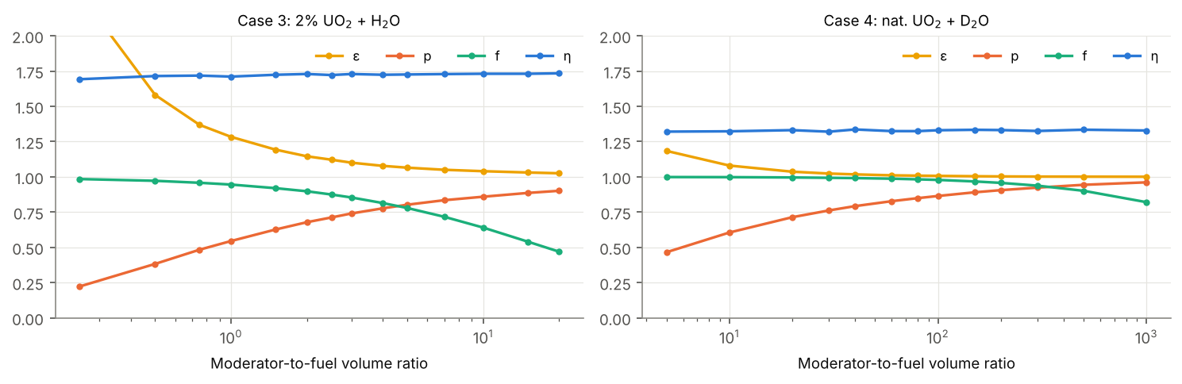
Figure 11: The four factors along the scans: more moderator raises $p$ but lowers $f$.
Each curve has a maximum. With too little moderator, neutrons slow down through the U-238 resonances in a few large steps and many are captured (low $p$). With too much, the moderator absorbs the thermal neutrons (low $f$). For 2% UO₂ + H₂O, $k_{∞}>1$ for $0.5≲V_{m}/V_{f}≲10$, with a maximum 1.208 at about 2. For natural UO₂ + D₂O, $k_{∞}>1$ above $V_{m}/V_{f}≈25$, peaking at 1.159 near 200. Even at $V_{m}/V_{f}=1000$ it is still 1.049, because deuterium absorbs so little. For contrast, natural UO₂ with light water never reaches 1 (best 0.868): $η_{nat}≈1.33$ cannot cover the hydrogen absorption. This is why light-water reactors need enriched fuel while natural-uranium reactors use heavy water. The four factors confirm it: $η$ is fixed by the fuel (1.73 for 2%, 1.33 for natural), and the moderator trades $p$ against $f$.

2.7 Sensitivity: using only the 50-point table
Core | pointwise data | table only (log–log) | difference
U-238 | 0.2929 ± 0.0009 | 0.2678 ± 0.0008 | −0.025
Nat. U | 0.4080 ± 0.0010 | 0.3878 ± 0.0009 | −0.020
2% UO₂/H₂O | 1.2099 ± 0.0012 | 1.4134 ± 0.0012 | +0.203
Nat. UO₂/D₂O | 1.1385 ± 0.0012 | 1.2766 ± 0.0012 | +0.138
Table 5: $k_{∞}$ (${10}^{6}$ neutrons) with the full pointwise data and with log–log interpolation of the 50-point work-up table only.
On the coarse table most U-238 resonances are missed, so resonance capture is badly underestimated and $k_{∞}$ of the moderated cores comes out much too high. In the fast cores, log–log interpolation between 1 and 2 MeV smooths away the steep U-238 fission threshold, and the table also misses the scattering resonances; both shift $k_{∞}$. The yes/no conclusions survive, but the table should be treated as a minimum resolution for presentation and not used as the transport data.

2.8 Statistics: ${10}^{6}$ against ${10}^{9}$
$σ_{k}$ falls as $N^{−1/2}$, from about ${10}^{−3}$ at ${10}^{6}$ to about $3×{10}^{−5}$ at ${10}^{9}$.
[DRAFT — replace with the measured values when the ${10}^{9}$ runs finish] Going from ${10}^{6}$ to ${10}^{9}$ neutrons shrinks the statistical error by $\sqrt{1000}≈32$. The two runs agree within the ${10}^{6}$-run uncertainty: the difference $k_{∞}({10}^{9})−k_{∞}({10}^{6})$ is […] (i.e. […] σ) for each core. The birth, slowing-down and lifetime curves are the same at both sizes; only the rare events (U-235 fission during slowing down, absorptions in single resonances, the moderator $(n,α)$ bump) are noisy at ${10}^{6}$ and smooth at ${10}^{9}$.

3 Comparison with the two reference reports
Reference A is CH23B025 & CH23B043 (MATLAB/C). Reference B is CH23B086 & CH23B036 (Python/Numba, https://github.com/IhsanKT/mc_reactor).
Core | This work (${10}^{6}$) | Ref. A (${10}^{9}$) | Ref. B (${10}^{9}$)
U-238 | 0.2929 | 0.3020 | 0.2299
Nat. U | 0.4080 | 0.4056 | 0.3382
2% UO₂/H₂O | 1.2099 | 1.2188 | 1.2703
Nat. UO₂/D₂O | 1.1385 | 1.1402 | 1.2140
Can go critical? | no, no, yes, yes | no, no, yes, yes | no, no, yes, yes
Table 6: $k_{∞}$ from the three independent codes.
 | ours (2%/H₂O) | Ref. A | Ref. B | ours (nat./D₂O) | Ref. A | Ref. B
$ε$ | 1.1437 | 1.1462 | 1.1188 | 1.0070 | 1.0069 | 1.0034
$p$ | 0.6811 | 0.6841 | 0.7290 | 0.8668 | 0.8725 | 0.9304
$f$ | 0.8987 | 0.8998 | 0.8909 | 0.9787 | 0.9788 | 0.9611
$η$ | 1.7283 | 1.7275 | 1.7482 | 1.3328 | 1.3260 | 1.3530
collisions to 0.625 eV | 20.4 | 20.3 | 18.6 | 30.5 | 30.1 | 30.1
mean lifetime | 22.62 µs | 22.40 µs | 21.20 µs | 2.113 ms | 2.130 ms | 4.050 ms
moderator ratio | $V_{m}/V_{f}=2$ | $V_{m}/V_{f}=2$ | 3 H₂O/U | $V_{m}/V_{f}=100$ | $V_{m}/V_{f}=100$ | 250 D₂O/U
fuel form | UO₂ | UO₂ | U metal | UO₂ | UO₂ | U metal
Table 7: Four-factor breakdown and other checks against the references.
The verdict agrees in all three codes: no, no, yes, yes. The numbers differ in ways that we can trace to modelling choices.
Reference A uses the same evaluated data (JENDL-3.3 U-238, ENDF/B-VIII.0 U-235/H/D, NJOY at 293.6 K) and the same compositions ($V_{m}/V_{f}=2$ and 100, UO₂). Our tabulated cross-sections for U-238, U-235, H-1 and H-2 agree with their Appendix A to the printed digits. For example, U-238 at 0.1 MeV is 11.10/0.5415/0.1797 b (elastic/inelastic/capture) in both. For the moderated cores $k_{∞}$ agrees to 0.009 (H₂O) and 0.002 (D₂O), and $η$ and $f$ agree to about 0.1–0.3%. The remaining differences are physics-model choices: (i) Reference A sets $E^{′}=E/2$ for every inelastic collision. We use the real discrete levels and an evaporation continuum, which on average removes more energy from fast neutrons above the U-238 fission threshold. This is why our pure U-238 and natural-U values and our $ε$ are slightly lower (0.293 vs 0.302 for U-238; $ε=1.144$ vs 1.146). (ii) Reference A replaces the thermal stage by an imposed 293.6 K Maxwellian. We follow it with a free-gas kernel, which keeps the slight absorption-hardening of the thermal spectrum. (iii) Reference A fits $ν(E)$ with straight lines, while we use the evaluated $\overset{‾}{ν}$ tables.
Reference B builds its cross-sections by hand: approximate smooth values on the 50-point grid, plus nine Breit–Wigner U-238 resonances below 200 eV with no Doppler broadening. It uses uranium metal mixed by molecule ratio (3 H₂O and 250 D₂O per U atom). Three things explain its numbers: (i) The U-238 fission cross-section is log–log interpolated between 1 MeV (0.012 b) and 2 MeV (0.53 b). This badly underestimates the threshold region 1.2–2 MeV, where much of the fission spectrum lies. At 1.5 MeV their interpolation gives 0.11 b; the evaluated $σ_{f}$ is 0.35 b there and 0.45 b at 1.7 MeV. The result is fewer fast fissions: 8.2% of neutrons cause fission in pure U-238 against our 10.49%, so $k_{∞}=0.230$ against 0.293. Natural uranium is lower for the same reason. (ii) Only nine resonances are kept, all below 200 eV, and the resonances from 200 eV to the unresolved range are left out. Resonance capture is therefore underestimated, so their $p$ (0.73 and 0.93) is higher than ours and Reference A’s (0.68 and 0.87), and their moderated $k_{∞}$ is higher. A sizeable part of the gap also comes from the different compositions: denser U-metal fuel and their own optimised ratios. (iii) Their thermal treatment, like Reference A’s, uses an equilibrium Maxwellian below $5kT$.
Points of agreement between all three codes: the sampled birth spectrum (mean 1.933 MeV); the collisions needed to thermalise (≈18–20 in H₂O, ≈30 in D₂O); lifetimes of ~0.2 µs (unmoderated), ~20 µs (H₂O) and ms (D₂O); the moderator absorbing ~7–9% in H₂O and ~2–4% in D₂O; $η≈1.73$ for 2% fuel and ≈1.33 for natural fuel, against the lecture estimate 1.32; and the position of the H₂O optimum near $V_{m}/V_{f}≈2$–3 (the same as Reference A’s 2.5).

4 Conclusions and limitations
- Pure U-238: $k_{∞}=0.29290$, so it cannot go critical.
- Natural uranium: $k_{∞}=0.40803$, so it cannot go critical.
- 2% enriched UO₂ + H₂O: $k_{∞}=1.20992$, so it can go critical.
- Natural UO₂ + D₂O: $k_{∞}=1.13853$, so it can go critical.
The birth spectrum, slowing-down tracks, flux spectra, lifetimes, absorption balance and fission-to-capture ratios all behave as expected. The four-factor split shows the essential point. Without a moderator, neutrons stay in the keV range, where U-238 capture beats U-235 fission. A moderator carries them past the U-238 resonances to thermal energy, where U-235 fission dominates. Light water needs enrichment to pay for hydrogen absorption; heavy water does not.
Limitations. The cores are infinite and homogeneous: there is no leakage, and the lumping in a real lattice raises $p$. The free-gas thermal model ignores the chemical binding in water ($S(α,β)$). Scattering is isotropic in the CM frame, and the evaporation temperature is a simple systematics. O-16 uses an approximate data set. There are no fission products, Pu build-up or structural materials, and the D₂O is taken as 100% pure. None of these changes any of the four conclusions.

A Work-up table of microscopic cross-sections
Values are read from the pointwise 293.6 K data at each energy. In the resonance region a value therefore depends on whether that energy falls on or between resonances.
Table 8: U-238 (JENDL-3.3): microscopic cross-sections (b) at 293.6 K.
E (MeV) | elastic | inelastic | capture | fission | total
2.0e-09 | 9.615 | 2.21e-6 | 9.629 | 4.18e-5 | 19.24
4.0e-09 | 9.489 | 0 | 6.811 | 2.96e-5 | 16.3
6.0e-09 | 9.447 | 1.64e-6 | 5.563 | 2.41e-5 | 15.01
8.0e-09 | 9.426 | 0 | 4.819 | 2.09e-5 | 14.24
1.0e-08 | 9.413 | 0 | 4.311 | 1.87e-5 | 13.72
2.0e-08 | 9.386 | 0 | 3.054 | 1.32e-5 | 12.44
4.0e-08 | 9.371 | 4.22e-7 | 2.166 | 9.38e-6 | 11.54
6.0e-08 | 9.364 | 0 | 1.774 | 7.67e-6 | 11.14
8.0e-08 | 9.359 | 3.24e-6 | 1.542 | 6.65e-6 | 10.9
1.0e-07 | 9.355 | 4.02e-21 | 1.383 | 5.96e-6 | 10.74
2.0e-07 | 9.338 | 7.20e-21 | 0.9943 | 4.25e-6 | 10.33
4.0e-07 | 9.307 | 2.28e-6 | 0.7275 | 3.07e-6 | 10.03
6.0e-07 | 9.276 | 0 | 0.6163 | 2.55e-6 | 9.892
8.0e-07 | 9.244 | 0 | 0.5541 | 2.26e-6 | 9.798
1.0e-06 | 9.211 | 0 | 0.5158 | 2.06e-6 | 9.726
2.0e-06 | 9.023 | 2.47e-7 | 0.4639 | 1.65e-6 | 9.486
4.0e-06 | 8.408 | 3.87e-7 | 0.757 | 1.77e-6 | 9.165
6.0e-06 | 5.5 | 4.07e-6 | 8.051 | 6.71e-6 | 13.55
8.0e-06 | 11.27 | 0 | 1.901 | 2.74e-7 | 13.17
1.0e-05 | 9.59 | 1.09e-6 | 0.46 | 4.13e-7 | 10.05
2.0e-05 | 0.8526 | 0 | 10.25 | 2.64e-5 | 11.1
4.0e-05 | 21.35 | 0 | 1.258 | 1.61e-7 | 22.61
6.0e-05 | 8.86 | 5.53e-8 | 0.2037 | 7.45e-7 | 9.064
8.0e-05 | 9.291 | 3.84e-7 | 0.7589 | 2.65e-6 | 10.05
1.0e-04 | 1.101 | 0 | 1.703 | 1.28e-6 | 2.804
2.0e-04 | 16.35 | 7.07e-7 | 0.2042 | 4.93e-7 | 16.55
4.0e-04 | 11.87 | 0 | 0.05434 | 1.26e-7 | 11.92
6.0e-04 | 15.05 | 0 | 0.1009 | 2.83e-6 | 15.15
8.0e-04 | 9.603 | 5.04e-8 | 0.03799 | 1.97e-8 | 9.641
1.0e-03 | 21.34 | 3.59e-6 | 0.388 | 1.26e-8 | 21.73
2.0e-03 | 15.02 | 0 | 0.3288 | 5.36e-9 | 15.35
4.0e-03 | 13.39 | 0 | 0.1124 | 2.83e-9 | 13.5
6.0e-03 | 12.38 | 0 | 0.1518 | 7.30e-9 | 12.53
8.0e-03 | 10.11 | 3.94e-6 | 0.61 | 4.56e-7 | 10.72
1.0e-02 | 12.76 | 3.56e-6 | 0.6524 | 4.31e-5 | 13.41
2.0e-02 | 13.39 | 8.00e-7 | 0.5221 | 1.10e-4 | 13.91
4.0e-02 | 12.48 | 4.70e-6 | 0.3832 | 5.40e-5 | 12.87
6.0e-02 | 11.91 | 0.1535 | 0.2721 | 8.97e-5 | 12.34
8.0e-02 | 11.46 | 0.3793 | 0.2116 | 4.13e-5 | 12.05
1.0e-01 | 11.1 | 0.5415 | 0.1797 | 4.92e-5 | 11.82
2.0e-01 | 9.506 | 1.018 | 0.1294 | 7.14e-5 | 10.65
4.0e-01 | 7.514 | 1.429 | 0.1086 | 3.34e-4 | 9.052
6.0e-01 | 6.355 | 1.708 | 0.1145 | 0.001051 | 8.179
8.0e-01 | 5.34 | 2.08 | 0.1251 | 0.004257 | 7.55
1.0e+00 | 4.551 | 2.46 | 0.1251 | 0.01483 | 7.152
2.0e+00 | 3.52 | 3.193 | 0.05052 | 0.5411 | 7.305
4.0e+00 | 4.44 | 2.877 | 0.004023 | 0.5595 | 7.881
6.0e+00 | 3.924 | 2.552 | 8.79e-4 | 0.6156 | 7.092
8.0e+00 | 3.119 | 2.112 | 9.23e-4 | 1.008 | 6.24
1.0e+01 | 2.689 | 2.098 | 0.001052 | 0.9904 | 5.779
Table 9: U-235 (ENDF/B-VIII.0): microscopic cross-sections (b) at 293.6 K.
E (MeV) | elastic | inelastic | capture | fission | total
2.0e-09 | 14.55 | 0.001677 | 402.1 | 2173 | 2590
4.0e-09 | 14.35 | 4.47e-4 | 282 | 1528 | 1824
6.0e-09 | 14.28 | 3.67e-4 | 228 | 1242 | 1484
8.0e-09 | 14.24 | 6.94e-4 | 195.3 | 1071 | 1281
1.0e-08 | 14.21 | 3.97e-4 | 172.5 | 954.4 | 1141
2.0e-08 | 14.14 | 2.40e-4 | 114.8 | 665 | 794
4.0e-08 | 14.05 | 1.32e-4 | 74.89 | 455 | 543.9
6.0e-08 | 13.97 | 1.17e-4 | 58.62 | 357.8 | 430.4
8.0e-08 | 13.91 | 1.02e-4 | 49.64 | 298.9 | 362.4
1.0e-07 | 13.84 | 1.37e-4 | 44.08 | 259 | 317
2.0e-07 | 13.55 | 8.69e-6 | 39.61 | 182.3 | 235.5
4.0e-07 | 13.48 | 7.18e-5 | 20.21 | 117.3 | 151
6.0e-07 | 13.16 | 5.29e-5 | 9.591 | 67.78 | 90.53
8.0e-07 | 12.89 | 4.39e-5 | 7.963 | 55.52 | 76.38
1.0e-06 | 12.63 | 3.47e-5 | 12.5 | 67.42 | 92.56
2.0e-06 | 11.93 | 3.80e-5 | 33.87 | 20.69 | 66.48
4.0e-06 | 11.44 | 1.83e-5 | 2.782 | 2.63 | 16.85
6.0e-06 | 9.95 | 1.77e-5 | 7.772 | 20.95 | 38.67
8.0e-06 | 9.621 | 1.20e-5 | 4.402 | 3.663 | 17.69
1.0e-05 | 11 | 9.67e-6 | 6.128 | 14.82 | 31.95
2.0e-05 | 12.37 | 1.29e-5 | 7.386 | 20.93 | 40.69
4.0e-05 | 12.37 | 8.80e-6 | 9.722 | 26.38 | 48.48
6.0e-05 | 11.21 | 9.45e-6 | 6.212 | 40.97 | 58.4
8.0e-05 | 10.24 | 3.06e-6 | 4.237 | 12.34 | 26.82
1.0e-04 | 9.95 | 4.50e-6 | 3.439 | 7.38 | 20.77
2.0e-04 | 12.4 | 0 | 32.77 | 54.88 | 100
4.0e-04 | 10.37 | 0 | 6.572 | 7.196 | 24.14
6.0e-04 | 11.36 | 4.73e-6 | 1.474 | 12.98 | 25.81
8.0e-04 | 10.2 | 6.18e-6 | 4.225 | 8.419 | 22.85
1.0e-03 | 9.47 | 5.66e-6 | 2.672 | 6.896 | 19.04
2.0e-03 | 12.55 | 3.16e-6 | 3.185 | 8.605 | 24.34
4.0e-03 | 12.19 | 0 | 1.676 | 4.725 | 18.59
6.0e-03 | 11.99 | 4.50e-6 | 1.561 | 3.554 | 17.1
8.0e-03 | 11.91 | 1.43e-5 | 1.268 | 2.946 | 16.12
1.0e-02 | 11.84 | 1.66e-5 | 1.059 | 2.905 | 15.8
2.0e-02 | 11.46 | 0.004364 | 0.8312 | 2.36 | 14.66
4.0e-02 | 10.98 | 0.01536 | 0.6143 | 1.884 | 13.5
6.0e-02 | 10.55 | 0.09893 | 0.5539 | 1.778 | 12.98
8.0e-02 | 10.17 | 0.1975 | 0.4943 | 1.64 | 12.5
1.0e-01 | 9.818 | 0.3225 | 0.4191 | 1.588 | 12.15
2.0e-01 | 8.279 | 0.8262 | 0.3098 | 1.347 | 10.76
4.0e-01 | 6.247 | 1.353 | 0.1716 | 1.186 | 8.957
6.0e-01 | 5.056 | 1.614 | 0.1417 | 1.11 | 7.922
8.0e-01 | 4.319 | 1.709 | 0.1201 | 1.111 | 7.259
1.0e+00 | 3.873 | 1.721 | 0.1073 | 1.203 | 6.904
2.0e+00 | 3.783 | 2.116 | 0.05993 | 1.288 | 7.247
4.0e+00 | 4.578 | 2.266 | 0.01151 | 1.137 | 7.992
6.0e+00 | 3.923 | 2.094 | 0.003223 | 1.092 | 7.112
8.0e+00 | 3.157 | 1.327 | 0.002076 | 1.785 | 6.271
1.0e+01 | 2.701 | 1.369 | 0.002034 | 1.759 | 5.832
Table 10: H-1 (ENDF/B-VIII.0): microscopic cross-sections (b) at 293.6 K.
E (MeV) | elastic | inelastic | capture | fission | total
2.0e-09 | 84.19 | 6.66e-16 | 1.183 | 0 | 85.38
4.0e-09 | 61.03 | 2.33e-6 | 0.8365 | 0 | 61.87
6.0e-09 | 51.03 | 8.60e-7 | 0.683 | 0 | 51.71
8.0e-09 | 45.22 | 4.62e-6 | 0.5916 | 0 | 45.81
1.0e-08 | 41.34 | 0 | 0.529 | 0 | 41.87
2.0e-08 | 32.29 | 0 | 0.3741 | 0 | 32.67
4.0e-08 | 26.76 | 1.46e-6 | 0.2645 | 0 | 27.03
6.0e-08 | 24.72 | 2.52e-6 | 0.216 | 0 | 24.94
8.0e-08 | 23.66 | 1.04e-6 | 0.1871 | 0 | 23.85
1.0e-07 | 23.02 | 5.00e-7 | 0.1673 | 0 | 23.19
2.0e-07 | 21.73 | 0 | 0.1183 | 0 | 21.85
4.0e-07 | 21.08 | 1.20e-6 | 0.08366 | 0 | 21.17
6.0e-07 | 20.87 | 0 | 0.06832 | 0 | 20.94
8.0e-07 | 20.76 | 2.94e-6 | 0.05918 | 0 | 20.82
1.0e-06 | 20.7 | 0 | 0.05291 | 0 | 20.75
2.0e-06 | 20.57 | 0 | 0.03741 | 0 | 20.6
4.0e-06 | 20.5 | 2.09e-6 | 0.02647 | 0 | 20.53
6.0e-06 | 20.48 | 0 | 0.0216 | 0 | 20.5
8.0e-06 | 20.47 | 4.42e-7 | 0.01871 | 0 | 20.49
1.0e-05 | 20.46 | 0 | 0.01673 | 0 | 20.48
2.0e-05 | 20.45 | 4.00e-7 | 0.01183 | 0 | 20.46
4.0e-05 | 20.44 | 2.02e-6 | 0.008369 | 0 | 20.45
6.0e-05 | 20.43 | 1.09e-7 | 0.006829 | 0 | 20.44
8.0e-05 | 20.43 | 4.13e-6 | 0.005914 | 0 | 20.43
1.0e-04 | 20.43 | 0 | 0.005288 | 0 | 20.43
2.0e-04 | 20.41 | 3.93e-6 | 0.003736 | 0 | 20.41
4.0e-04 | 20.38 | 5.80e-7 | 0.002639 | 0 | 20.39
6.0e-04 | 20.36 | 6.79e-7 | 0.002151 | 0 | 20.36
8.0e-04 | 20.33 | 1.75e-6 | 0.00186 | 0 | 20.33
1.0e-03 | 20.3 | 0 | 0.001661 | 0 | 20.3
2.0e-03 | 20.17 | 0 | 0.001167 | 0 | 20.17
4.0e-03 | 19.91 | 0 | 8.14e-4 | 0 | 19.91
6.0e-03 | 19.66 | 0 | 6.56e-4 | 0 | 19.66
8.0e-03 | 19.42 | 0 | 5.61e-4 | 0 | 19.42
1.0e-02 | 19.18 | 0 | 4.95e-4 | 0 | 19.18
2.0e-02 | 18.1 | 5.40e-7 | 3.29e-4 | 0 | 18.1
4.0e-02 | 16.3 | 6.70e-7 | 2.09e-4 | 0 | 16.3
6.0e-02 | 14.87 | 3.93e-6 | 1.56e-4 | 0 | 14.87
8.0e-02 | 13.71 | 4.92e-6 | 1.25e-4 | 0 | 13.71
1.0e-01 | 12.74 | 0 | 1.05e-4 | 0 | 12.74
2.0e-01 | 9.645 | 0 | 6.00e-5 | 0 | 9.645
4.0e-01 | 6.879 | 2.63e-7 | 3.87e-5 | 0 | 6.879
6.0e-01 | 5.569 | 0 | 3.42e-5 | 0 | 5.57
8.0e-01 | 4.785 | 0 | 3.34e-5 | 0 | 4.785
1.0e+00 | 4.25 | 1.55e-7 | 3.38e-5 | 0 | 4.25
2.0e+00 | 2.908 | 1.25e-7 | 3.69e-5 | 0 | 2.908
4.0e+00 | 1.9 | 0 | 3.64e-5 | 0 | 1.9
6.0e+00 | 1.423 | 0 | 3.43e-5 | 0 | 1.423
8.0e+00 | 1.133 | 3.26e-7 | 3.27e-5 | 0 | 1.133
1.0e+01 | 0.9369 | 0 | 3.14e-5 | 0 | 0.9369
Table 11: H-2 (ENDF/B-VIII.0): microscopic cross-sections (b) at 293.6 K.
E (MeV) | elastic | inelastic | capture | fission | total
2.0e-09 | 10.14 | 1.72e-6 | 0.001798 | 0 | 10.14
4.0e-09 | 7.515 | 1.19e-7 | 0.001272 | 0 | 7.516
6.0e-09 | 6.407 | 1.27e-7 | 0.001038 | 0 | 6.408
8.0e-09 | 5.778 | 5.60e-9 | 8.99e-4 | 0 | 5.779
1.0e-08 | 5.366 | 0 | 8.04e-4 | 0 | 5.367
2.0e-08 | 4.447 | 1.91e-7 | 5.69e-4 | 0 | 4.447
4.0e-08 | 3.932 | 0 | 4.02e-4 | 0 | 3.932
6.0e-08 | 3.753 | 0 | 3.28e-4 | 0 | 3.754
8.0e-08 | 3.664 | 0 | 2.84e-4 | 0 | 3.664
1.0e-07 | 3.61 | 8.47e-22 | 2.54e-4 | 0 | 3.61
2.0e-07 | 3.502 | 2.92e-7 | 1.80e-4 | 0 | 3.503
4.0e-07 | 3.449 | 0 | 1.27e-4 | 0 | 3.449
6.0e-07 | 3.431 | 2.51e-7 | 1.04e-4 | 0 | 3.431
8.0e-07 | 3.422 | 6.62e-8 | 9.00e-5 | 0 | 3.422
1.0e-06 | 3.417 | 7.15e-7 | 8.03e-5 | 0 | 3.417
2.0e-06 | 3.406 | 2.60e-7 | 5.67e-5 | 0 | 3.406
4.0e-06 | 3.4 | 1.09e-7 | 4.02e-5 | 0 | 3.401
6.0e-06 | 3.399 | 2.78e-8 | 3.28e-5 | 0 | 3.399
8.0e-06 | 3.398 | 0 | 2.84e-5 | 0 | 3.398
1.0e-05 | 3.397 | 0 | 2.53e-5 | 0 | 3.397
2.0e-05 | 3.396 | 8.70e-8 | 1.79e-5 | 0 | 3.396
4.0e-05 | 3.396 | 0 | 1.27e-5 | 0 | 3.396
6.0e-05 | 3.395 | 0 | 1.04e-5 | 0 | 3.395
8.0e-05 | 3.395 | 0 | 8.97e-6 | 0 | 3.395
1.0e-04 | 3.395 | 0 | 8.00e-6 | 0 | 3.395
2.0e-04 | 3.395 | 0 | 5.64e-6 | 0 | 3.395
4.0e-04 | 3.395 | 3.49e-7 | 3.98e-6 | 0 | 3.395
6.0e-04 | 3.395 | 7.54e-7 | 3.25e-6 | 0 | 3.395
8.0e-04 | 3.395 | 6.53e-8 | 2.80e-6 | 0 | 3.395
1.0e-03 | 3.395 | 0 | 2.50e-6 | 0 | 3.395
2.0e-03 | 3.395 | 2.40e-7 | 1.76e-6 | 0 | 3.395
4.0e-03 | 3.389 | 0 | 1.30e-6 | 0 | 3.389
6.0e-03 | 3.381 | 0 | 1.14e-6 | 0 | 3.381
8.0e-03 | 3.374 | 0 | 1.06e-6 | 0 | 3.374
1.0e-02 | 3.367 | 0 | 1.00e-6 | 0 | 3.367
2.0e-02 | 3.342 | 0 | 1.03e-6 | 0 | 3.342
4.0e-02 | 3.302 | 1.94e-21 | 1.27e-6 | 0 | 3.302
6.0e-02 | 3.27 | 0 | 1.50e-6 | 0 | 3.27
8.0e-02 | 3.243 | 2.80e-7 | 1.72e-6 | 0 | 3.243
1.0e-01 | 3.22 | 6.01e-8 | 1.94e-6 | 0 | 3.22
2.0e-01 | 3.122 | 0 | 2.74e-6 | 0 | 3.122
4.0e-01 | 3.012 | 1.70e-7 | 3.83e-6 | 0 | 3.012
6.0e-01 | 2.966 | 0 | 4.64e-6 | 0 | 2.966
8.0e-01 | 2.922 | 0 | 5.30e-6 | 0 | 2.922
1.0e+00 | 2.873 | 1.40e-7 | 5.86e-6 | 0 | 2.873
2.0e+00 | 2.54 | 1.80e-7 | 7.82e-6 | 0 | 2.54
4.0e+00 | 1.817 | 0.0135 | 9.87e-6 | 0 | 1.831
6.0e+00 | 1.4 | 0.0602 | 1.11e-5 | 0 | 1.46
8.0e+00 | 1.117 | 0.1027 | 1.17e-5 | 0 | 1.22
1.0e+01 | 0.916 | 0.134 | 1.12e-5 | 0 | 1.05
Table 12: O-16 (approximate model, see Sec. 2.1): microscopic cross-sections (b) at 293.6 K.
E (MeV) | elastic | inelastic | capture | fission | total
2.0e-09 | 3.881 | 0 | 6.76e-4 | 0 | 3.881
4.0e-09 | 3.881 | 0 | 4.78e-4 | 0 | 3.881
6.0e-09 | 3.881 | 0 | 3.90e-4 | 0 | 3.881
8.0e-09 | 3.881 | 0 | 3.38e-4 | 0 | 3.881
1.0e-08 | 3.881 | 0 | 3.02e-4 | 0 | 3.881
2.0e-08 | 3.881 | 0 | 2.14e-4 | 0 | 3.881
4.0e-08 | 3.881 | 0 | 1.51e-4 | 0 | 3.881
6.0e-08 | 3.881 | 0 | 1.23e-4 | 0 | 3.881
8.0e-08 | 3.881 | 0 | 1.07e-4 | 0 | 3.881
1.0e-07 | 3.881 | 0 | 9.56e-5 | 0 | 3.881
2.0e-07 | 3.881 | 0 | 6.76e-5 | 0 | 3.881
4.0e-07 | 3.881 | 0 | 4.78e-5 | 0 | 3.881
6.0e-07 | 3.881 | 0 | 3.90e-5 | 0 | 3.881
8.0e-07 | 3.881 | 0 | 3.38e-5 | 0 | 3.881
1.0e-06 | 3.881 | 0 | 3.02e-5 | 0 | 3.881
2.0e-06 | 3.881 | 0 | 2.14e-5 | 0 | 3.881
4.0e-06 | 3.881 | 0 | 1.51e-5 | 0 | 3.881
6.0e-06 | 3.881 | 0 | 1.23e-5 | 0 | 3.881
8.0e-06 | 3.881 | 0 | 1.07e-5 | 0 | 3.881
1.0e-05 | 3.881 | 0 | 9.56e-6 | 0 | 3.881
2.0e-05 | 3.881 | 0 | 6.76e-6 | 0 | 3.881
4.0e-05 | 3.881 | 0 | 4.78e-6 | 0 | 3.881
6.0e-05 | 3.881 | 0 | 3.90e-6 | 0 | 3.881
8.0e-05 | 3.881 | 0 | 3.38e-6 | 0 | 3.881
1.0e-04 | 3.881 | 0 | 3.02e-6 | 0 | 3.881
2.0e-04 | 3.881 | 0 | 2.14e-6 | 0 | 3.881
4.0e-04 | 3.881 | 0 | 1.51e-6 | 0 | 3.881
6.0e-04 | 3.881 | 0 | 1.23e-6 | 0 | 3.881
8.0e-04 | 3.881 | 0 | 1.07e-6 | 0 | 3.881
1.0e-03 | 3.881 | 0 | 9.56e-7 | 0 | 3.881
2.0e-03 | 3.881 | 0 | 6.76e-7 | 0 | 3.881
4.0e-03 | 3.88 | 0 | 4.78e-7 | 0 | 3.88
6.0e-03 | 3.88 | 0 | 3.90e-7 | 0 | 3.88
8.0e-03 | 3.879 | 0 | 3.38e-7 | 0 | 3.879
1.0e-02 | 3.878 | 0 | 3.02e-7 | 0 | 3.878
2.0e-02 | 3.875 | 0 | 2.14e-7 | 0 | 3.875
4.0e-02 | 3.867 | 0 | 1.51e-7 | 0 | 3.867
6.0e-02 | 3.858 | 0 | 1.23e-7 | 0 | 3.858
8.0e-02 | 3.85 | 0 | 1.07e-7 | 0 | 3.85
1.0e-01 | 3.841 | 0 | 9.56e-8 | 0 | 3.841
2.0e-01 | 3.811 | 0 | 6.76e-8 | 0 | 3.811
4.0e-01 | 6.323 | 0 | 4.78e-8 | 0 | 6.323
6.0e-01 | 3.62 | 0 | 3.90e-8 | 0 | 3.62
8.0e-01 | 3.549 | 0 | 3.38e-8 | 0 | 3.549
1.0e+00 | 8.085 | 0 | 3.02e-8 | 0 | 8.085
2.0e+00 | 2.237 | 0 | 2.14e-8 | 0 | 2.237
4.0e+00 | 1.703 | 0 | 0.1208 | 0 | 1.823
6.0e+00 | 1.302 | 0 | 0.1919 | 0 | 1.494
8.0e+00 | 1.06 | 0.1904 | 0.2239 | 0 | 1.474
1.0e+01 | 0.9009 | 0.2913 | 0.2383 | 0 | 1.43

B Code
File | Purpose
endf/run_*/input | NJOY2016 inputs (moder, reconr, broadr at 293.6 K)
prepare_data.py | step 0: reads the PENDF tapes, builds nucdata.npz and xs_table.csv
mc_reactor.py | steps i–vii: compositions, Monte Carlo transport, tallies, four factors, scans
analyze.py | all figures
make_report.py | this report
python prepare_data.py # nuclear data + work-up table
python mc_reactor.py --n 1e6 --out results_1e6 # ~1 min
python mc_reactor.py --n 1e9 --batch 5e7 --cases 1,2,3 --out results_1e9
python mc_reactor.py --n 1e9 --batch 5e7 --cases 4 --pool 2e7 --out results_1e9_c4
python mc_reactor.py --scan --n 1e5 --out results_scan
python mc_reactor.py --n 1e6 --table-only --out results_1e6_table
python analyze.py results_1e6 results_1e9 results_scan figs
The full transport-kernel listing (mc_reactor.py) is not reproduced here: paste it as a monospaced block (Consolas/Courier New, 8 pt) from the source file.

