**Module 1 Assignment – Myagmarsuren (Miga), Budaasuren**

**Conclusion 1:**

Theater, Music, Film & Video are the most successful categories across all countries.

There is a tendency that the more campaigns, the more successful outcomes. In other words, there is a positive relationship between successful outcome and total number of the campaigns. That gives an idea that these campaigns are on pretty much trial and error bases. The overall ratio between failed and successful is 1.5. (See Figure 1)

Figure 1

**Conclusion 2:**

If you look closely into the subcategories, the obvious winner is the plays in terms on its success rate. it seems like that the main reason for this success rate, is because of the total number of play campaigns. As we already know from Figure 1, there is a strong positive relationship between successful outcome and the total number of campaigns. (See figure 2)

Figure 2

**Conclusion 3:**

The figure 3 shows that overtime the success rate has been increasing. More specific, 2017 was a very good year, mostly because in 2017, theater category did so well. 1/3 of the successful outcomes came from the play category alone.

Figure 3

**Limitation of the dataset:**

-There are 14 live campaigns in the outcome column, however the deadline for those campaigns closed. This means this dataset is not fully up to date.

-There is no data for live category since 2016 (incomplete data).

**Additional analysis 1:**

The below figure shows the relationship between duration of the campaign and the successful outcome. As we can see, initial days have aggressive rate of success, then there is a tendency to slow down. So, the recommendation will be to keep the duration less 20 days. In addition, as we see from Figure 1, we know that the campaigns have hit or miss trends. Therefore, it makes sense to keep the duration shorter than 20 days. If the campaign failed on initials days, there is not much hope for that specific campaign. (See figure 4)

Figure 4

**Additional analysis 2:**

I have checked if there is any spotlight effect on outcomes. As we see from figure 5, there is no significant effect on outcome.

Figure 5

**Bonus 1:**

As we can see from the Figure 6, it is recommended to avoid setting the goal as less than 1000 or 10000-14999 or greater than 50000. Those ranges are the worst performing ones in terms of the failure rates. The rest of ranges are safer to choose from. (See figure 6)

Figure 6

Bonus 2:

The average number of backers for successful is 851, versus the average number of backers for failed is 588. This big difference in backer’s numbers has played a significant role in determining if the outcome is either successful or failed. Also, as we can see from Figure 7 and 8, it is obvious that successful outcomes have way more outliers than failed outcomes. The same observation can be made by looking at the standard perspective deviations, which are 1266 for successful and 962 for failed. The bigger the standard deviation is, the sparser the data is.

Figure 7

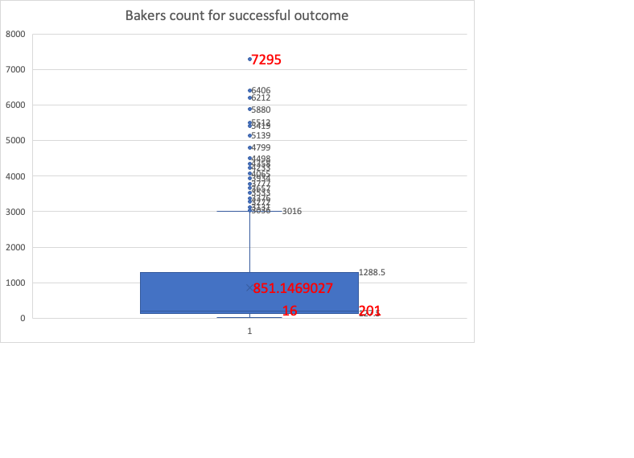

Figure 8

