The best way, to disable menu register

1. Web.php

Change Auth::routes(['register' => true]); to be Auth::routes(['register' => false]);

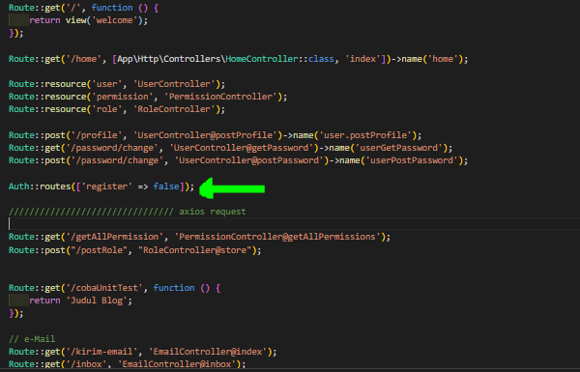

1. Terminal

Writes command

php artisan route:cache

php artisan route:clear



1. login.blade.php

change code

<p class="mb-0">

<a href="{{route('register')}}" class="text-center">Buat Akun Baru</a>

</p>

to be

{{-- <p class="mb-0">

<a href="{{route('register')}}" class="text-center">Buat Akun Baru</a>

</p> --}}

