Project Documentation

1. Project overview
The project is a social platform for evaluating the work of the local administration. The local administration representatives will post about the work that they've done, and the residents will be able to react to the posts, rate the work and leave comments. The system will calculate the scores based on residents' ratings.

2. The purpose of the project
The purpose of the project is to create a platform for sharing the results of the administration representatives' work and collecting people's feedback on it.

﻿﻿﻿3. Target users
Residents should be able to view posts, react to them, rate them, leave comments, view profiles.
Local administration representatives should be able to create and edit posts, add information and photos, respond to comments, view feedback.
System administrator should be able to manage users, moderate posts and comments, manage cities and districts.

﻿﻿﻿4. Stack
- Frontend: React, CSS
- Backend: Node.js, Express.js, JWT, bcrypt
- Database: MongoDB, Mongoose
- Development tools: Git, GitHub, Postman

﻿﻿﻿5. System Architecture
The system will use client-server architecture.
The main components are:
- React frontend
- Node.js and Express.js backend
- REST API
- MongoDB database
The data workflow will look like this:
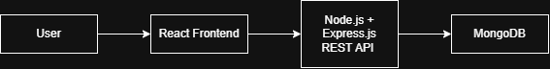
The frontend will provide user interface. The backend will process requests. The database will store system data.

6. Functional requirements

Authentication
- Registration
- Login
- Logout
- Role-based access

Posts
- Create post
- Edit post
- Delete post
- View posts
- Add photos

Ratings
- Give a score from 1 to 5
- Change rating
- Calculate average score

Comments
- Add comment
- Edit comment
- Delete comment
- View comments

Profiles
- View profile
- View posts
- View average score

7. UML
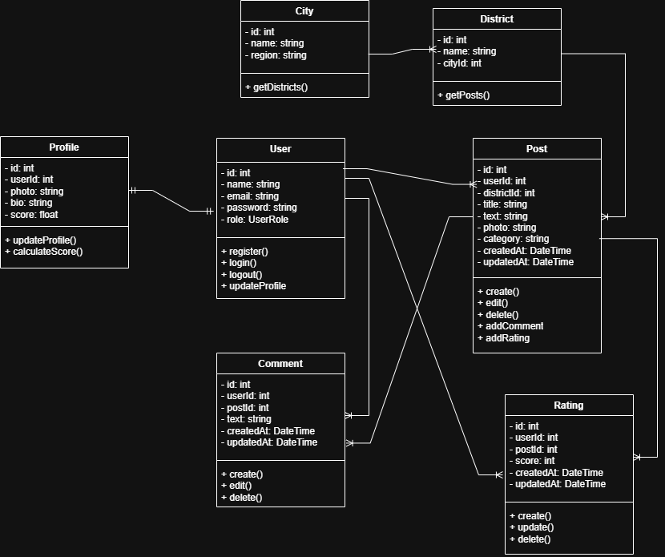

8. API
The backend provides a REST API for communication between the frontend and backend.
Examples of endpoints:
POST /auth/register — registration
POST /auth/login — authentication
GET /posts — get posts
POST /posts — create a post
PUT /posts/:postId — update a post
DELETE /posts/:postId — delete a post
POST /posts/:postId/comments — add a comment
POST /posts/:postId/rating — rate a post
GET /users/:userId — get a user profile

9. Testing
Testing will include:
- registration and login
- role-based access
- creating and editing posts
- adding comments
- rating posts
- score calculation
- viewing profiles
- API requests
- input validation

10. GitHub
The project source code will be stored in a GitHub repository. Git will be used for version control and tracking changes during development.

