Feedback on SNAPFIX app.

Contents

List of Figures 1

**Task 01:** 3

**Thoughts** 3

**Criticisms** 3

**Missing sign up information:** 3

**Login credentials validation:** 3

**Text – Sketch combo for image markups:** 3

**‘Eraser’ behavior, ‘Clear’ and ‘Undo’ option:** 3

**Messages edit history:** 4

**Possible BUG:** 5

**Recommendations** 6

**‘About Us’ Page:** 6

**Security Features:** 6

**Task 02:** 7

**Thoughts:** 7

**Screen – 009 Job bottom bar options:** 7

**Screen – 014 Registration and Login:** 7

**Task 03:** 9

Description: 9

Snapshots: 9

# List of Figures

Figure 1: Mockup with 'Undo' button 3

Figure 2: Mockup with 'Edit History' 4

Figure 3: (Left to Right) New design layout, Modified design layout for login screen. 7

Figure 4: Initial Screen. ID empty - 'Click Me' disabled. 8

Figure 5: Service request failed 8

Figure 6: Service request success - Data displayed 9

Figure 7: Data Screen. ID empty - 'Refresh' disabled 9

# **Task 01:**

## **Thoughts**

Snapfix keeps it simple by encapsulating all the important information regarding a task in a single application. One stop app for building maintenance and team reporting system. The color-coded scheme makes it easy to understand and prioritize the task for the users.

The use of images and markers are a perfect choice for reporting any building related issues. The different tabs architecture makes it easy for the users to keep track of the tasks and their progress.

Being an excellent handy app, an orientation feature across the entire application and zoom capabilities could be some healthy additions for further enhancing its usability as it would help to attract customers with fat finger problems.

## **Criticisms**

### **Missing sign up information:**

There is no information regarding the sign-up procedures available on the login screen of the app to the user. A hyperlink or a disabled text area detailing the signup procedure would be informative for the user.

### **Login credentials validation:**

Incorrect username is validated at the time of login and the error message states “Incorrect username and password. Please try again” even if the username is not a Snapfix account.

It would be nice to display the error message mentioning the unavailability of the username as a Snapfix account as a login error message.

Also, currently the user can attempt to login any number of times. It would be nice to include a suggestion offering to use the “Forgot Password?” option as a part of the login error message after ‘N’ number of failed attempts (for instance, N = 3).

### **Text – Sketch combo for image markups:**

At this moment, after creating a new task, if the user intends to input some description on the picture by adding text, there is no feature for the user to use the text along with the sketch option.

### **‘Eraser’ behavior, ‘Clear’ and ‘Undo’ option:**

Currently ‘Eraser’ removes the portions of the mark up which the user intends to rub off. But if the screen size is small or if the user has shaky hands or fat fingers, erasing precisely the markup under such circumstances is challenging without erasing other nearby markups.

Instead an ‘Undo’ option would assist on making immediate corrections to the markup errors. Also, a ‘Clear’ option would aid in removing all the markups available on the image.

The lack of ‘Undo’ and ‘Clear’ options alongside with the eraser is a clear setback. The following mockup would greatly assist and attract potential customers.

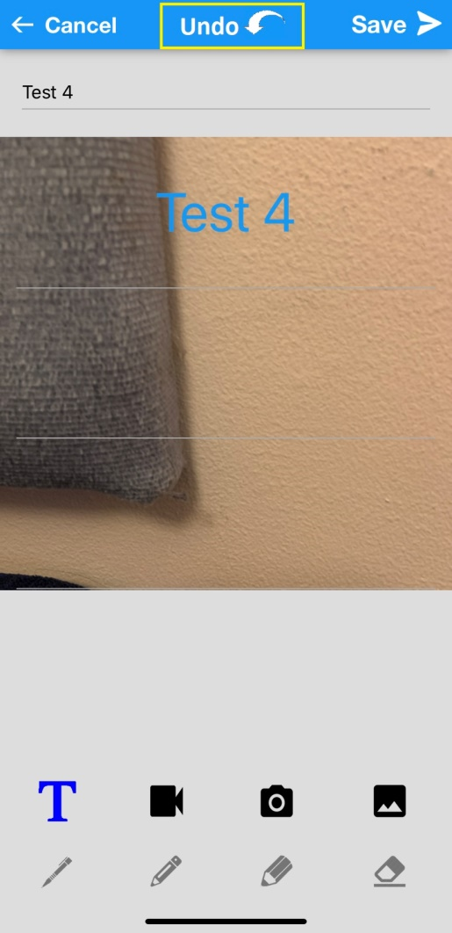

Figure 1: Mockup with 'Undo' button

### **Messages edit history:**

At present, if there is any mistake in the messages sent for a job, there is no option for the sender to edit the messages. The only available options are ‘Copy’ and ‘Delete’.

It would be beneficial to provide the users with an editing feature of the sent messages and keep a track of all the edit changes under a ‘History’ option in ‘Details’ tab.

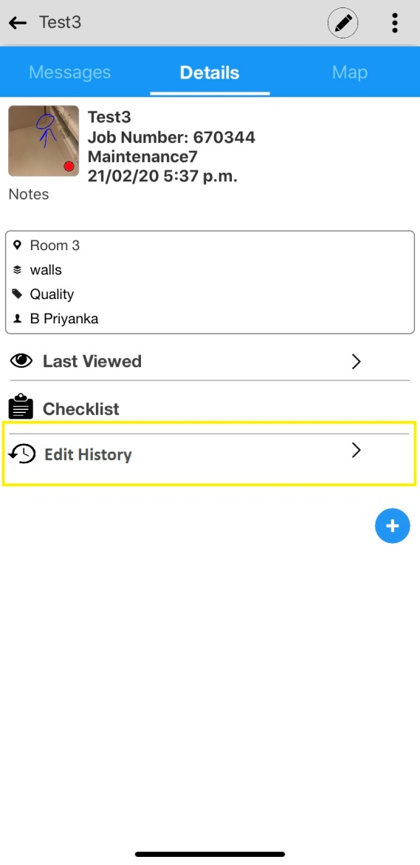

Figure 2: Mockup with 'Edit History'

### **Possible BUG:**

#### **Expected:**

(Based on my limited knowledge) After changing the tag color of a job from ‘Red’ or ‘Yellow’ to ‘Green’, the color of the tag should remain ‘Green’ when the view is in List mode or Grid mode style.

#### **Observation:**

After changing the tag color of a job from ‘Red’ or ‘Yellow’ to ‘Green’, the color of the tag remains ‘Green’ when view is in Grid mode but turns ‘Yellow’ when view in the List mode style.

#### **Steps to reproduce:**

* Select any created or existing job.
* Click on the ‘+’ button and select ‘Color, Flag’ option.
* Select Green and press ‘Ok’.
* Navigate to Green Tab and view in the List Mode.

## **Recommendations**

### **‘About Us’ Page:**

It might prove informative for a new user who desires to know more about the application and our organization. A hyperlink or a button redirecting to a static/dynamic ‘About us’ screen might come in handy.

### **Security Features:**

Since there is no observed limit on the number of unsuccessful login attempts it might be safe to incorporate a captcha to prevent DOS (Denial of service) attacks.

To prevent any sort of impersonation, it might be safer to introduce a new system of sending the basic information such as photograph, name, contact etc. of the authorized maintenance staff which the user can verify.

# **Task 02:**

## **Thoughts:**

### **Screen – 009 Job bottom bar options:**

The shift of the ‘Job bottom bar options’ location from the bottom left corner to using the entire bottom area provides a better user experience as it improves the accessibility to the options. With the former layout there was a high probability that the user might have to utilize both his hands in order to operate with the options. But with the new layout the user is likely to operate with the options using a single hand. The availability of the options in a thumb accessible area appears to be a positive user experience facilitator.

The shift in the design where the background is hidden upon options display, to the design where the options are overlaid on the background also is a better visual experience to the user. Now he is in sync and aware with the outcome of the actions provided by the options if any. The job related information is over shadowed in the existing design but all the same information is available to the user in the new design. Thus the user is now more in-charge of the changes that his selection of options are making to the job in the background and is reasonably aware of them.

Thus, I am in support of the new ‘Job bottom bar’ options design layout.

### **Screen – 014 Registration and Login:**

The new design for the registration and login screen is definitely a positive move from the existing one. That being said, there are a few alteration suggestions which might prove beneficial in improving the user experience with our app.

Instead of the option ‘…use email instead’ and ‘…use mobile no instead’ there should be a label with the name “Snapfix username, email or mobile” on the text box. If the user wishes to use his mobile number as user name then the application should automatically append the country code which the user used at the time of his registration, to the mobile username upon login button click. The application should automatically identify the username type based on the textbox content rather than the user having to switch between options. For instance, if the textbox contains ‘@’, ‘.’ and ends with a Snapfix domain (such as [abc@snapfix.ie](mailto:abc@snapfix.ie) or [abc@snapfix.net](mailto:abc@snapfix.net) etc.) then the username type is a Snapfix username else an email otherwise if the textbox content is a 10 digit numeric literals then the username type is a mobile number.

In addition to the above, having a ‘About Us’ button/hyperlink on the application may prove to be informative to the user by providing him with the basic know-hows of our application, goals and commitment to them. A dedicated page on our website with a brief tutorial for using our app may also enhance the ease with which the user gets acquainted to our app.

The following are the mockups for the above proposed changes:

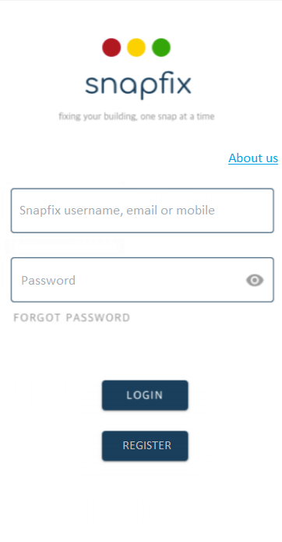 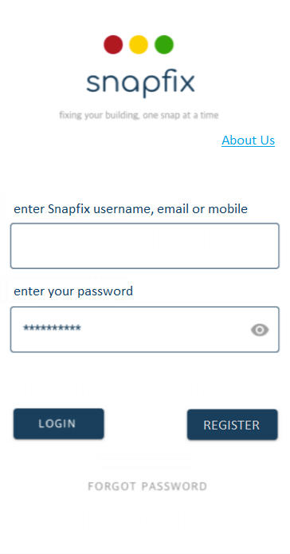

Figure 3: (Left to Right) New design layout, Modified design layout for login screen.

# **Task 03:**

## Description:

The application makes a service request to URL and displays the user information based on the provided ID upon ‘Click Me’ or ‘Refresh’ button clicks. The buttons are disabled for empty ID field. An error message is shown in case the request fails in returning data.

## Snapshots:

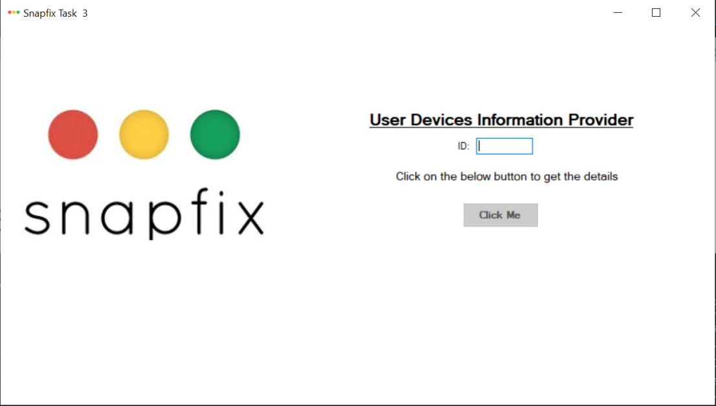

Figure 4: Initial Screen. ID empty - 'Click Me' disabled.

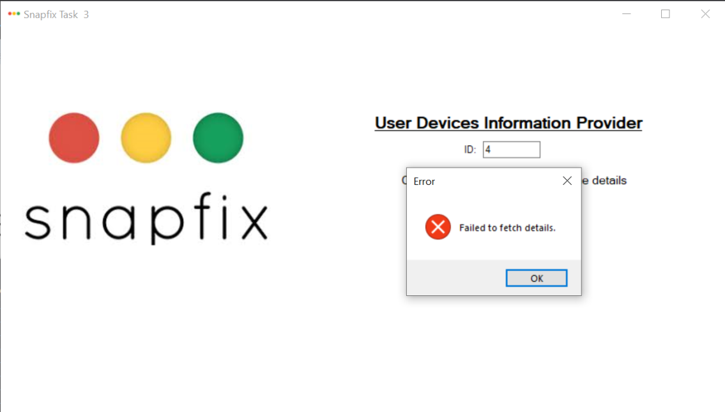

Figure 5: Service request failed

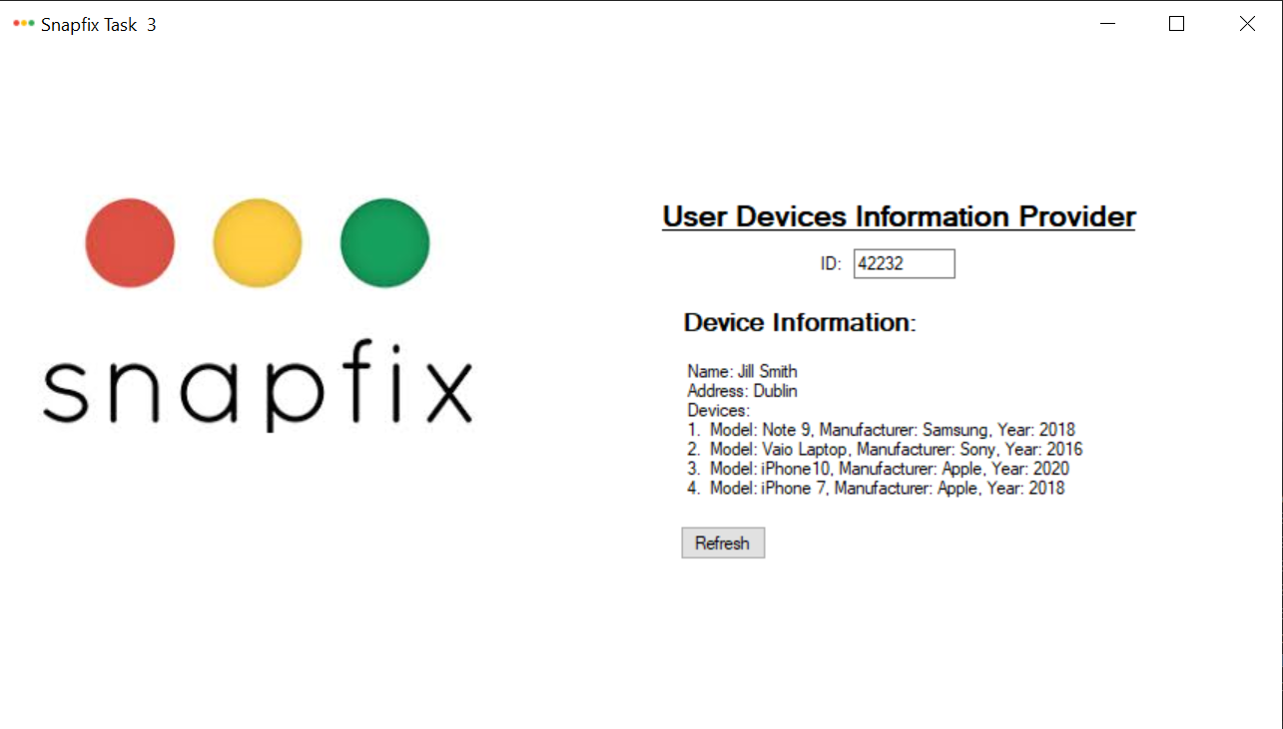

Figure 6: Service request success - Data displayed

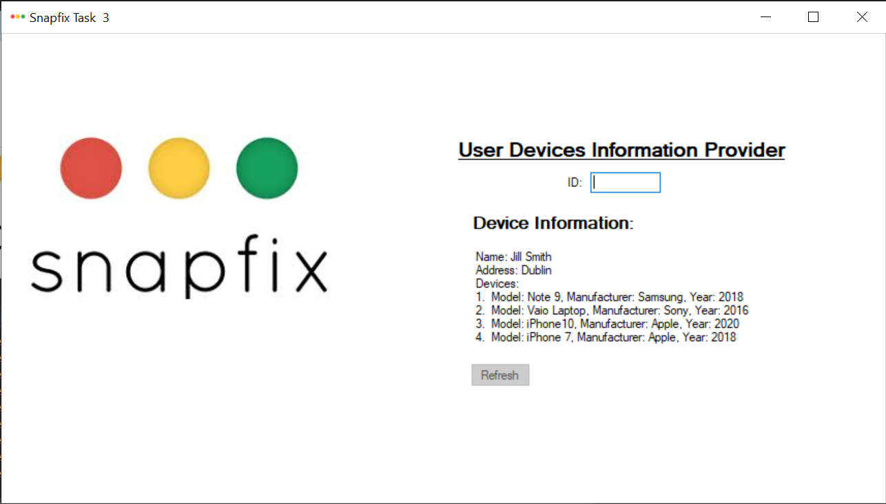

Figure 7: Data Screen. ID empty - 'Refresh' disabled