Contents

Abstract 3

Chapter-01 Introduction 4

Overview 4

Objectives 4

Chapter-02 System Analysis 6

2.1 Identification of Need 6

2.2 Software Requirements Specification (SRS) 7

Product perspective 7

Product Functions 7

Safety Requirements 7

Security Requirements 7

2.2.1 Data Gathering 7

2.2.2 Feasibility study 8

Economic Feasibility 8

Technical Feasibility 8

Behavioral Feasibility 8

Time Feasibility 8

Operational Feasibility 8

2.2.3 Software Process model 9

2.3 Data Flow Diagram (DFD) 10

2.3.1 DFD 0 Level 10

2.3.2 DFD 1 Level 11

2.3.3 DFD 2 Level 12

2.4 Entity Relationship Diagram (ER-Diagram) 13

2.5 Flow Chart 14

Use Case 16

2.7 Class Diagram 18

Chapter -03 System Design 19

3.1 Input Module 19

3.2 Output Module 19

3.3 Modularization Detail 20

3.4 Process Logic 20

3.5 Data Integrity 23

3.6 User Interface Design 23

Chapter -04 Tools and Environment 25

4.1 Hardware Requirements 25

4.2 Software Requirements 25

Chapter -05 Software Description 26

5.1 PHP 26

5.2 MySQL 26

5.3 HTML 26

5.4 CSS 27

5.5 JavaScript 27

5.6 Bootstrap 27

**5.7 Paypal Payment Gateway** 27

5.8 Visual Studio Code 28

5.9 yEd Graph Editor 28

5.10 StarUML 28

# Abstract

Online Course Registration system is a project which aims in developing an online application to provide Online Education, maintain Study Materials, keep Student records and collect Payments. This project has login features, Educator as Admin and Student as an user can login into their own portal separately. The Admin can login, through which the admin can monitor the whole system. This System can be used to search for course, add new courses, edit course, check payment status etc. The Admin after logging into his account can generate reports such as sell Report. The User can login into his account to follow course he purchased and can share his/her feedback.

Overall this project of ours is being developed to help the Educator (Admin) as well as Students (User) to provide Teaching-Learning platform in the best way possible.

# Chapter-01 Introduction

The use of online course technology in higher education institutions is no longer an option but has become a necessity. In an era known as the society of technology and knowledge, where lifelong learning is a way of life, it is important that educational institutions have as a priority the goal of finding effective ways of providing new learning opportunities according to their environment, student characteristics, teacher training, economic crisis and advancing technology in an effort to make learning more efficient, equitable and innovative in higher education.

Normally it has been practised in higher education and corporate and occupational training contexts as a part of lifelong learning. However, with the emergence of new open and mobile platforms and web apps, a range of possibilities has opened to facilitate teaching and learning processes in fully on-site or blended environments. As a result, e-learning has been implemented in all educational systems, transcending the traditional idea of distance education.

## Overview

It is difficult to find time for the training necessary to gain new skills and boost your productivity. With **online course** you’re able to learn at a pace that is comfortable for you. **Online course** is a powerful Learning Management System implementing the latest trends in e-learning. E-Learning is learning utilizing electronic technologies to access educational curriculum outside of a traditional classroom. In most cases, it refers to a course, or program delivered completely online. We define eLearning as courses that are specifically delivered via the internet to somewhere other than the classroom where the professor is teaching. Online course has been proven to be a successful method of training and education is becoming a way of life for many citizens in India and across the World. Online course Publisher is a professional team development environment for the rapid development of e-courses by their own.

Any Person who wants to gain new skills can join online course. A Person/Student/Learner has to fill up registration form which is absolutely Free. Once Learner registers successfully, they will get UserID/Email and Password for login into Student/Learner Panel. After login they can buy any course as per their choice or requirement which is available in online course. They can watch purchased video courses online and can submit their feedback. As well they can update their profile and can change password. Admin of this system will upload new courses which will be available for everyone. Admin can delete or edit student/learner details. Admin can modify course details and can check sells report.

## Objectives

A flexible web-based learning experience allows you to go through a guided curriculum or choose lessons on an as-needed basis. Following are the main objectives:-

* Ability to recall previously learned material – Students/learners can watch video courses as many times as they need. If they forgot something during the course they can come back and watch that specific part anytime.
* Creative way to present lesson – It is very creative way to present lectures. It will surely enhance teaching ability of tutor.
* Low Cost – As nobody needs to travel or rent anything so it’s very cost efficient.
* High Quality – As tutor do not has time boundation so he can teach in his own comfort time.
* Learn anytime from anywhere – Students/Learners can start learning anytime from anywhere they just required internet connection with a compatible device.
* Improve course quality according to learner’s feedback – Tutor can improve their course as per student’s feedback. It will help tutor to improve their ability to teach.
* Earn Money Online– As courses are paid so we can say it’s an online teaching business which has no boundaries means students/learners can join from across the world so this system can make good business with good quality.

# Chapter-02 System Analysis

**S**ystem Analysis is the process of studying a procedure in order to identify its goals and purposes and create systems and procedures that will achieve them in an efficient way. It is a problem solving technique that improves the system and ensures that all the components of the system work efficiently to accomplish their purpose.

A systems analyst researches problem, plans solutions, recommends software and systems, and coordinates development to meet business or other requirements. The main goal of this system analyst is to collect different data from different site, process these data and generate progress as well as daily report.

System analyst operates in a dynamic environment where change is a way of life. The environment may be a business firm, a business application, or a computer system. to construct a system the following key elements must be considered: -

**Input:** Input is what data the system receives to produce a certain output.

**Output:** What goes out from the system after being processed is known as Output.

**Processing:** The process involved to transform input into output is known as Processing.

**Control:** In order to get the desired results it is essential to monitor and control the input, Processing and the output of the system. This job is done by the control.

**Feedback:** The Output is checked with the desired standards of the output set and the necessary steps are taken for achieving the output as per the standards, this process is called as Feedback. It helps to achieve a much better control in the system.

**Boundaries:** The boundaries are nothing but the limit of the system. Setting up boundaries helps for better concentration of the actives carried in the system.

**Environment:** The things outside the boundary of the system are known as environment. Change in the environment affects the working of the system.

**Interfaces:** The interconnections and the interactions between the sub-systems are known as the Interfaces. They may be inputs and outputs of the systems.

## 2.1 Identification of Need

The old manual system was suffering from a series of drawbacks. Since whole of the system was to be maintained offline at one place only, the ease of service was not there. The information (lectures) was never used to be in a systematic order. It was not possible to provide service for large community from different places at the same time. It was seriously affecting the business. For this reason we have provided features present system is automated the whole procedure. Present system can be spread to the world so it would be beneficial for the business.

## 2.2 Software Requirements Specification (SRS)

A software requirements specification is a document that captures complete description about Online course engineering phase.

#### Product perspective

The software product is a Web Application. The application will be made up of two parts, one administrator who has all the rights and the other user who has limited rights to handle the application. The two users of the system, namely the Teacher/Educator (Admin) and Student/Learner (User) interact with the system in different ways.

#### Product Functions

First of all it will authenticate the user whether he is Educator (Admin) or Learner (User) the unauthorized person can’t get access to the application.

The Admin will be able to Add, delete, and modify Student Details. He can also Add, delete and modify Course and Lesson Details. He can use this application to check report related to sells as well as he can check Payment Status.

The User can edit his own profile and upload his profile picture. He will be able to purchase courses published by admin. User can use application to watch purchased course’s lessons. User can write feedback. Feedback will help Admin to improve the quality of content or service.

#### Safety Requirements

All the data will be saved to database for safety purpose so there will be no data loss. These data can be accessed only by an authorized person so data theft is also not possible in this application.

#### Security Requirements

For preventing unauthorized access to the application, this application have login feature so only granted user can access with defined rights.

### 2.2.1 Data Gathering

Data collection is the systematic approach to gathering and measuring information from a variety of sources to get a complete and accurate picture of an area of interest. Data collection enables a person or organization to answer relevant questions, evaluate outcomes and make predictions about future probabilities and trends. Accurate data collection is essential to maintaining the integrity of research, making informed business decisions and ensuring quality assurance.

### 2.2.2 Feasibility study

Feasibility study means to check whether the project is feasible or not, that means possible or not. Some feasibility study regarding this project is as follows: -

#### Economic Feasibility

The project has shown the economic feasibility by the study of the fact that by using this software the increased number of the users can be given service effectively and efficiently and can save a lot time and saving time means saving money. The cost and benefit analysis has shown that cost that have incurred in developing the project is less than the benefits that the project is going to provide once it is developed, so this project has passed the feasibility test.

#### Technical Feasibility

Technical feasibility centers on the existing computer system (Hardware, Software etc.) and to what extent it supports the existing system. As the existing system computer system is viable so there is no matter of technical feasibility that is the system is technically feasible. In this type of feasibility study it is checked whether there is a need of new hardware/software or not. What are the basic requirements of the project? If there is need then how it can be fulfilled. In this context, this project doesn’t need any special hardware or software. It can run on window 7/10 platform. However, Internet and a Web browser is needed to run the web application.

#### Behavioral Feasibility

The Users are also interested in this project, as it will help them to do work with ease and efficiently without complexity, so they supported the development of this project with full enthusiasm. This shows the behavioral feasibility of the project.

#### Time Feasibility

It is the determination of whether a proposed project can be implemented fully within stipulated time frame. The project was decided to be done in three months and was thought to be feasible.

#### Operational Feasibility

In this feasibility study it is determined whether there is need of well qualified operator or simple user. Is there need to train the operator or not? This project is supporting the User friendly Web application; hence operating this project is so simple. Even a person who has a little knowledge of computer can easily handle this well. There is no need of trained operator.

#### 2.2.3 Software Process model

The Software Process Models are the various processes or methodologies that are being selected for the development of the project depending on the project’s aims and goals. There are many development life cycle models that have been developed in order to achieve different required objectives. The models specify the various stages of the process and the order in which they are carried out.

The selection of model has very high impact on the testing that is carried out. It will define the what, where and when of our planned testing, influence regression testing and largely determines which test techniques to use.

Choosing right model for developing of the software product or application is very important.

Based on the model the development and testing processes are carried out.

A Process Model describes the sequence of phases for the entire lifetime of a product. Therefore it is sometimes also called Software Life Cycle. This covers everything from the initial commercial idea until the final de-installation or disassembling of the product after its use.

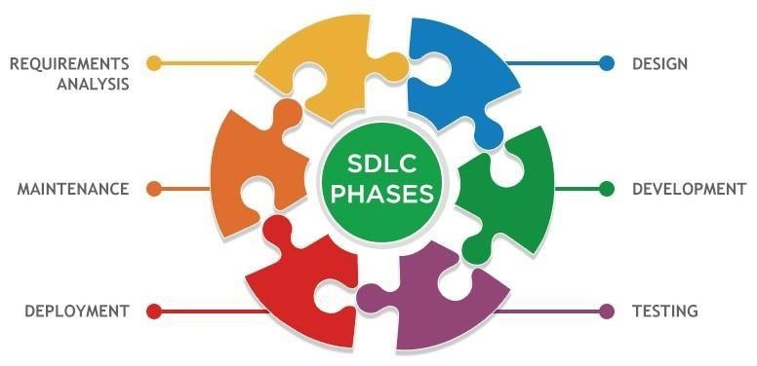

In order to develop the project “onlinecourse” we have adopted the Iterative Enhancement Model also known as **Incremental Model**. This model removes the shortcoming of waterfall model. Since many facts of this system are already known. It is not a new concept and hence no research is required. A working version can be easily created and hence the system can start working. Rest of the functionalities can be implemented in the next iteration and can be delivered later. As the requirement analysis is also not required. It not being a new technology risk involved is also less. So one need not perform detailed risk analysis. If redevelopment staff is less than development can be started with less number of people and in next increments others can be involved. As this model combines the advantage of waterfall model and prototyping, clients are always aware of the product being delivered and can always suggest changes and enhancements and can get them implemented. As less amount of customer communication is required one need not apply spiral model in which all types of analysis is done in detail. As the deadline is affordable one need not to for Rapid Application Development model. Iterative enhancement model is useful when less manpower is available for software development and the release deadlines are specified. It is best suited for in house product development, where it is ensured that the user has something to start with. The complete product is divided into releases and the developer delivers the product release by release.

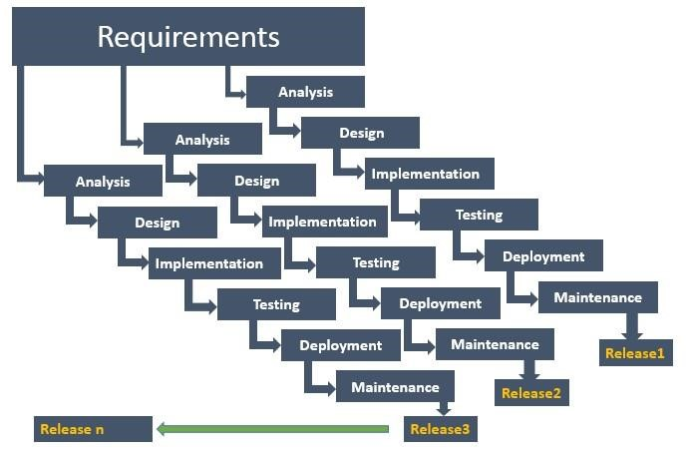

Incremental Model

## 2.3 Data Flow Diagram (DFD)

Data flow diagram is graphical representation of flow of data in an information system. It uses defined symbols like rectangles, circles and arrows, plus short text labels, to show data inputs, outputs, storage points and the routes between each destination. Data flowcharts can range from simple, even hand-drawn process overviews, to in-depth, multi-level DFDs that dig progressively deeper into how the data is handled.

#### 2.3.1 DFD 0 Level

The 0 Level DFD shows flow of data of application. DFD Level 0 is also called a Context Diagram. It’s a basic overview of the whole system or process being analyzed or modeled.



Student/Learner



Admin



/Educator



**O**

**nline**

**course**

**registration**



**O Level DFD**



#### 2.3.2 DFD 1 Level

DFD Level 1 provides a more detailed breakout of pieces of the Context Level Diagram. This DFD describes main functions carried out by the system, as we break down the high-level process of the Context Diagram into its sub-processes.

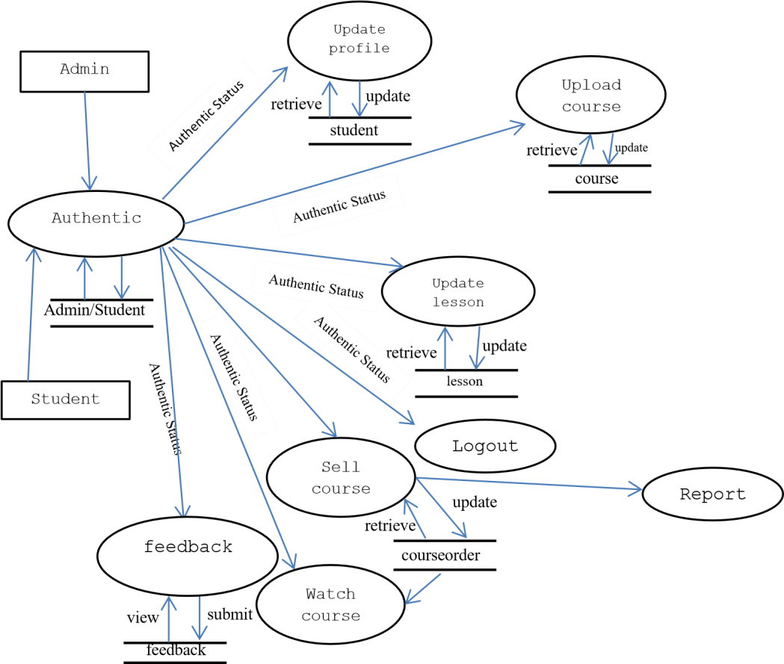

**1 Level DFD**

#### 2.3.3 DFD 2 Level

The DFD 2 Level describes flow of data in more detail. DFD Level 2 goes one step deeper into parts of Level 1. It may require more text to reach the necessary level of detail about the system’s functioning.



update



Add, Remove,



Edit



success



Authentic Status



course



Modify or



Remove



Course



Check



Authentication



Upload



course



lesson



success



Save data



Add, Remove,



Edit



Authentic Status



Modify or



Remove



Lesson



Check



Authentication



Update



Lesson



## 2.4 Entity Relationship Diagram (ER-Diagram)

An Entity Relationship Diagram (ERD) is a visual representation of different entities within a system and how they relate to each other. Entity relationship diagrams are used in software engineering during the planning stages of the software project. They help to identify different system elements and their relationships with each other.

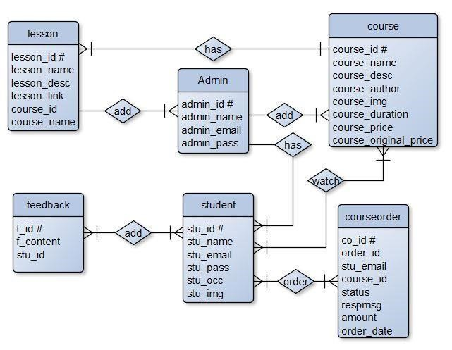

**ERD**

## 2.5 Flow Chart

A flowchart is a diagram that depicts a process, system or computer algorithm. They are widely used in multiple fields to document, study, plan, improve and communicate often complex processes in clear, easy-to-understand diagrams. Flowcharts, sometimes spelled as flow charts, use rectangles, ovals, diamonds and potentially numerous other shapes to define the type of step, along with connecting arrows to define flow and sequence. **Login**

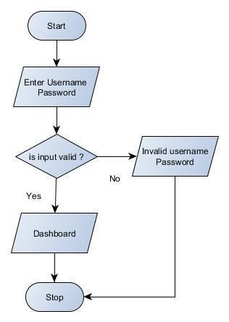

**Add Lesson**

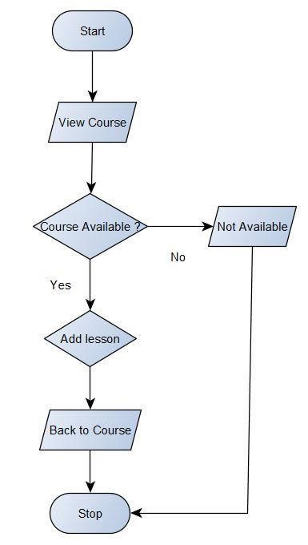

**Payment Status**

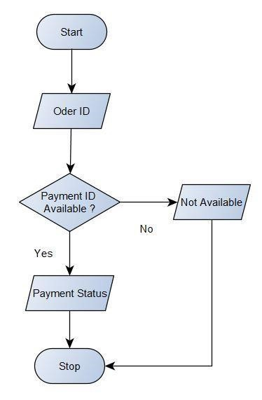

## Use Case

A use case diagram is essentially a picture showing system behavior along with the key actors that interact with the system. The use case represents complete functionality. Use case diagram can be imagined as a black box where only the input, output, and the function of the black box are known. Use Case elements are used to make test cases when performing the testing. The use case should contain all system activities that have significance to the users. A use case can be thought of as a collection of possible scenarios related to a particular goal, indeed. Use cases can be employed during several stages of software development, such as planning system requirements, validating design and testing software. Use case Diagram Objects

Use case diagrams mostly consist of 3 objects: -

**Actor** - Actor is a use case diagram is any entity that performs a role in one given system. This could be a person, organization or an external system.

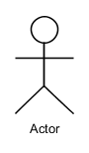

**Use Case** - A Use case represents a function or an action within the system. its drawn as an oval and named with the function.

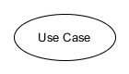

**System** - System is used to define the scope of the use case and drawn as rectangle.

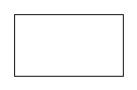

There are two functions: -

**Include** – This represents required. Symbol of this function is dashed arrow and arrow is labeled with the keyword <<include>>

**Extend** – This represents optional and it is also shown with dashed arrow the arrow is labeled with the keyword <<extend>>

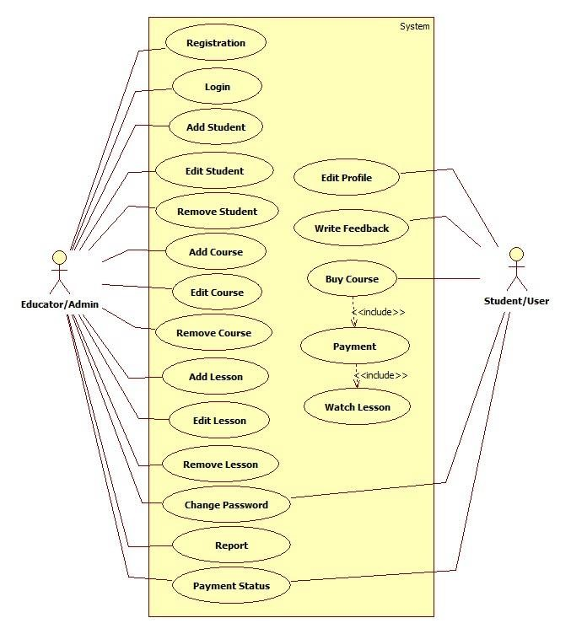

## 2.7 Class Diagram

Class diagrams are the main building block in object-oriented modeling. They are used to show the different objects in a system, their attributes, their operations and the relationships among them.

Classes in class diagrams are represented by boxes that are partitioned into three:-  The top partition contains the name of the class.

* The middle part contains the class’s attributes.
* The bottom partition shows the possible operations that are associated with the class.

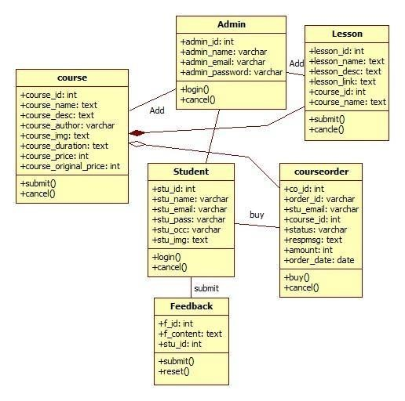

# Chapter -03 System Design

The systems design approach first appeared right before World War II, when engineers were trying to solve complex control and communications problems. They needed to be able to standardize their work into a formal discipline with proper methods, especially for new fields like information theory, operations research and computer science in general. System design is the process of defining the elements of a system such as the architecture, modules and components, the different interfaces of those components and the data that goes through that system. It is meant to satisfy specific needs and requirements of a business or organization through the engineering of a coherent and well-running system.

## 3.1 Input Module

In order to complete the tasks of onlinecourse and to get output by using this application work, there is need of some input based on the work that is to be carried out by using it. Different kinds of input are required for different purposes.

* Student/Learner Registration
* Course
* Lesson
* Feedback
* Payment Status

## 3.2 Output Module

The project named “online course registration **”** is being made keeping in mind to solve the activities that are carried out in the Education. By using this, Admin can easily do many things like as:

* Student/Learner List
* Course Detail
* Lesson Detail
* Sell Report
* Payment Receipt

## 3.3 Modularization Detail

##### **Without Registration**

* Home – This module contains all the links of the application such as Courses, Payment Status, Login, Sign Up, Feedback Section and Contact.
* Courses – This module contains list of all the courses which are available at onlinecourse.
* Payment Status – This module is used to check Payment status after purchasing a course.
* Login – This module is used to login into Student/Learner Panel.
* Sign Up – This module is used to register for the Student/Learner Panel.
* Feedback – This section shows feedback given by registered students/learners.
* Contact – Learner can use this section to contact the admin/tutor for any kind of queries.

##### **Student Panel**

* Profile – This module contains all the details about Student/Learner as well as Student can update their details.
* My Courses – This module contains list of all purchased courses.
* Feedback – This module is used to write feedback.
* Change Password – Students can use this module to change password.
* Logout – This module is used to return back to Home Page.

##### **Admin Panel**

* Dashboard – This module displays overview of whole application.
* Courses – This module contains all the courses.
* Lessons – This module contains all the lesson depends on course id.
* Students – This module displays all the registered student details.
* Sell Report – This module is used to view and print sells report.
* Payment Status – This module displays payment status in more details.
* Feedback – This module displays feedback given by students.
* Change Password – Admin can use this module to change password. • Logout – This module is used to return back to Home Page.

## 3.4 Process Logic

**Home:**

When the user click on this tab, it will display the other modules and pages of the website such as courses, payment status, login, sign up, popular section, feedback section, contact and admin login. This module will be used to display the brief introduction of the project and will show the title of the project.

**Courses:**

Student can view all available courses by clicking on courses tab where he can choose course according to his own interest and by clicking on a particular course, will display more details with lesson title of the course, if he wants to purchase he will be able to make payment (required login).

**Payment Status:**

After purchasing course student will be provided an order id which can be used to get the status of payment using Payment status tab. If student wants he can get print out of his payment status.

**Login:**

This is a login form. Student/Learner can use their own email and password to login into the student panel.

**Sign Up:**

This is a Registration form for new Students/Learners. New Students/Learners can fill up the form for registration and after successful registration they can use their email id and password to login into the application.

**Feedback:**

This is very simple section which displays feedback given by the registered student.

**Contact:**

Learner can use this section to contact the admin/tutor for any kind of queries.

**Student Panel:- Profile:**

Students/Learners can view their student id, registered email id, name, occupation, profile picture as well as they can modify and update the new data if they need.

**My Courses:**

Students can view all courses which they purchased. This is the place where they can start watching lectures by clicking on Watch Course button which leads to course playlist where they can watch the entire lesson of course.

**Feedback:**

Students can view/write feedback.

**Change Password:**

Students can use this module to change password.

**Logout:**

This module is used exit student panel and return back to Home Page.

##### **Admin Panel**

**Dashboard:**

This module displays overview of whole application such as number of course, number of registered students etc.

**Courses:**

This is the most important module of admin panel where Admin can view list of course as well as add new courses and modify or delete courses.

**Lessons:**

Admin can view lesson based on course id as well as new lesson can be added to the course and modification or deletion is also possible using this module.

**Students:**

Admin can view registered students details. Admin can add, edit and delete student. **Feedback:**

Admin can view/delete feedback given by student.

**Sell Report:**

Analyzing sales is very import for any kind of business and this module is perfect for analyzing sales based on date. It will generate sells report which can be possible to print out for office records.

**Payment Status:**

If student file any complaints regarding payment Admin can use this module to display payment status in more details such as bank name, transaction id, payment date etc.

**Change Password:**

Admin can use change password.

**Logout:**

This module is used exit admin panel and return back to Home Page.

## 3.5 Data Integrity

Data integrity is the overall completeness, accuracy and consistency of data. This can be indicated by the absence of alteration between two instances or between two updates of a data record, meaning data is intact and unchanged. Data integrity is usually imposed during the database design phase through the use of standard procedures and rules. The concept of data integrity ensures that all data in a database can be traced and connected to other data. This ensures that everything is recoverable and searchable. Having a single, well-defined and wellcontrolled data integrity system increases stability, performance, reusability and maintainability. Data values are standardized according to a data model and data type. All characteristics of the data must be correct including business rules, relations, dates and definitions for data to be complete. Data integrity is imposed within a database when it is designed and is authenticated through the ongoing use of error checking and validation routines. As a simple example, to maintain data integrity numeric columns/cells should not accept alphabetic data.

## 3.6 User Interface Design

User interface design is concerned with the dialogue between a user and the computer. It is concerned with everything from starting the system or logging into the system to the eventually presentation of desired inputs and outputs. The overall flow of screens and messages is called a dialogue.

* It should be attractive and simple to use.
* The system user should always be aware of what to do next.
* Messages, instruction and information should be displayed long enough to allow the system user to read them.
* An user should not be allowed to proceed without correcting an error.
* An user should never get an fatal error instead provide them understanble errors.

# Chapter -04 Tools and Environment

## 4.1 Hardware Requirements

|  |  |
| --- | --- |
| Processor | 1.6 GHz or Faster Processor |
| RAM | 4 GB |
| Disk Space | 10 GB of Available Hard Disk |
| Graphic | DirectX 9-Capable Video Card |
| Display | 1024 X 768 or Higher Resolution |

## 4.2 Software Requirements

|  |  |
| --- | --- |
| Operating System | Windows 10 |
| Front End | HTML, CSS, JavaScript |
| Back End | PHP |
| Library/ Framework | Bootstrap, JQuery, FontAwesome |
| Plugins Code Editor | Owl Carousel |
| Visual Studio Code 1.33 |
| Database | MySQL |
| Web Server | Apache |
| Web Browser | Google Chrome |
| Payment Gateway | Paypal |
| Drawing Tools | yEd Graph Editor |
| StarUML |

# Chapter -05 Software Description

## 5.1 PHP

PHP is an opensource language and all its components are free to use and distribute. PHP is server-side scripting language. It is embedded in HTML source code. PHP supports all major web servers such as Apache, Microsoft IIS and Netscape etc. All the major database such as Mysql, PostgreSQL, Oracle, Sybase, Microsoft SQL Server is supported by PHP. Following are the some major advantage:-

* Friendly With HTML - PHP and HTML are interchangeable within the page. You can put PHP outside the HTML or inside.
* Interactive Features - PHP allows you to interact with your visitors in ways HTML alone can't.
* Top-Notch Online Documentation - The PHP documentation is the best on the web.

Hands down.

* Compatible With Databases - A good benefit of using PHP is that it can interact with many different database languages including MySQL.

## 5.2 MySQL

MySQL is the most popular open source relational database management system. It is one of the best RDBMS being used to develop web-based applications. It is easy to use and fast RDBMS. Following are the top reason to use MySQL:-

* High Performance
* Robust Transactional Support
* Strong Data Protection
* Open Source Freedom

## 5.3 HTML

Hypertext Markup Language (HTML) is the standard markup language for creating web pages and web applications. With Cascading Style Sheets (CSS) and JavaScript, it forms a triad of cornerstone technologies for the World Wide Web.

Web browsers receive HTML documents from a web server or from local storage and render the documents into multimedia web pages. HTML describes the structure of a web page semantically and originally included cues for the appearance of the document.

## 5.4 CSS

Cascading Style Sheets (CSS) is a style sheet language used for describing the presentation of a document written in a markup language like HTML. CSS is a cornerstone technology of the World Wide Web, alongside HTML and JavaScript.

CSS is designed to enable the separation of presentation and content, including layout, colors, and fonts. This separation can improve content accessibility, provide more flexibility and control in the specification of presentation characteristics, enable multiple web pages to share formatting by specifying the relevant CSS in a separate .css file, and reduce complexity and repetition in the structural content.

## 5.5 JavaScript

JavaScript often abbreviated as JS, is a high-level, interpreted programming language. It is a language which is also characterized as dynamic, weakly typed, prototype-based and multiparadigm.

## 5.6 Bootstrap

Bootstrap is an open source toolkit for developing with HTML, CSS, and JS. Quickly prototype your ideas or build your entire app with our Sass variables and mixins, responsive grid system, extensive prebuilt components, and powerful plugins built on jQuery. Build responsive, mobilefirst projects on the web with the world’s most popular front-end component library.

## **5.7 Paypal Payment Gateway**

Collecting Online Payment for any kind of business is much eaiser with Paypal Payment Gateway. It provides a secure, PCI-compliant way to accept Debit/Credit card, and Paypal wallet payments from your customers. It also provides cancellations feature. It helps to make genuine cancellations a positive experience and maintain customer loyalty.

## 5.8 Visual Studio Code

Visual Studio Code was announced on April 29, 2015 by Microsoft at the 2015 Build conference. A Preview build was released shortly thereafter.

On November 18, 2015, Visual Studio Code was released under the MIT License and its source code posted to GitHub. Extension support was also announced.

On April 14, 2016, Visual Studio Code graduated the public preview stage and was released to web.Visual Studio Code is a source code editor developed by Microsoft for Windows, Linux and macOS. It includes support for debugging, embedded Git control, syntax highlighting, intelligent code completion, snippets, and code refactoring. It is also customizable, so users can change the editor's theme, keyboard shortcuts, and preferences. It is free and open-source, although the official download is under a proprietary license.

## 5.9 yEd Graph Editor

yEd is a powerful Free Desktop Application that can be used to quickly and effectively generate highquality diagrams. yEd can be used to draw many different types of diagrams, including flowcharts, network diagrams, UMLs, BPMN, mind maps, organization charts, and entityrelationship diagrams. yEd can automatically arrange diagram elements using a variety of graph layout algorithms. The program works much like many similar applications.

yEd can export diagrams to various raster and vector formats, including GIF, JPEG, PNG, EMF, BMP, PDF, EPS, and SVG.

## 5.10 StarUML

StarUML is an open source project to develop fast, flexible, extensible and featureful diagrams . With StarUML it is very easy to make Class Diagram. StarUML is implemented to provide many user-friend features such as Quick dialog, Keyboard manipulation, Diagram overview, etc.