Buddhika S. Ranasinghe

[Buddhikasranasinghe96@gmail.com](mailto:Buddhikasranasinghe96@gmail.com)

0712447339

**Question 2**

**Task :** Dr. John is a doctor. He has a private clinic center. Every evening he is treating the patients. He plans to use a system to manage his patients’ information. His decided on a system that needs to achieve the following requirements.

**Project Link :** https://github.com/buddhikasranasinghe/Q2.git

**Technologies :** Django, MySql, Bootstrap, JQuery

**DB name :** cliniccenter

**Interfaces :**

1. . Interface for add patient
2. . Interface for add prescriptions
3. . Interface for check revenue
4. . Interface for check patient details

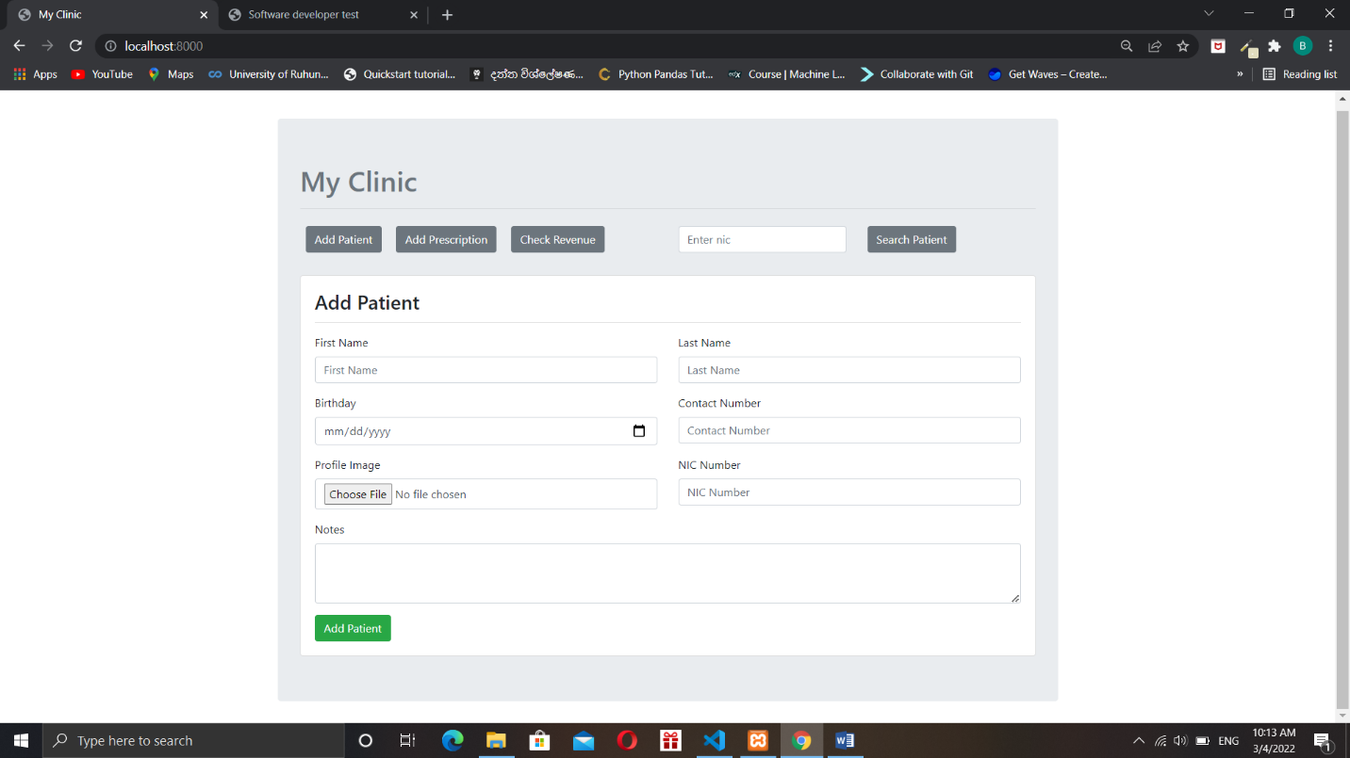

(01)

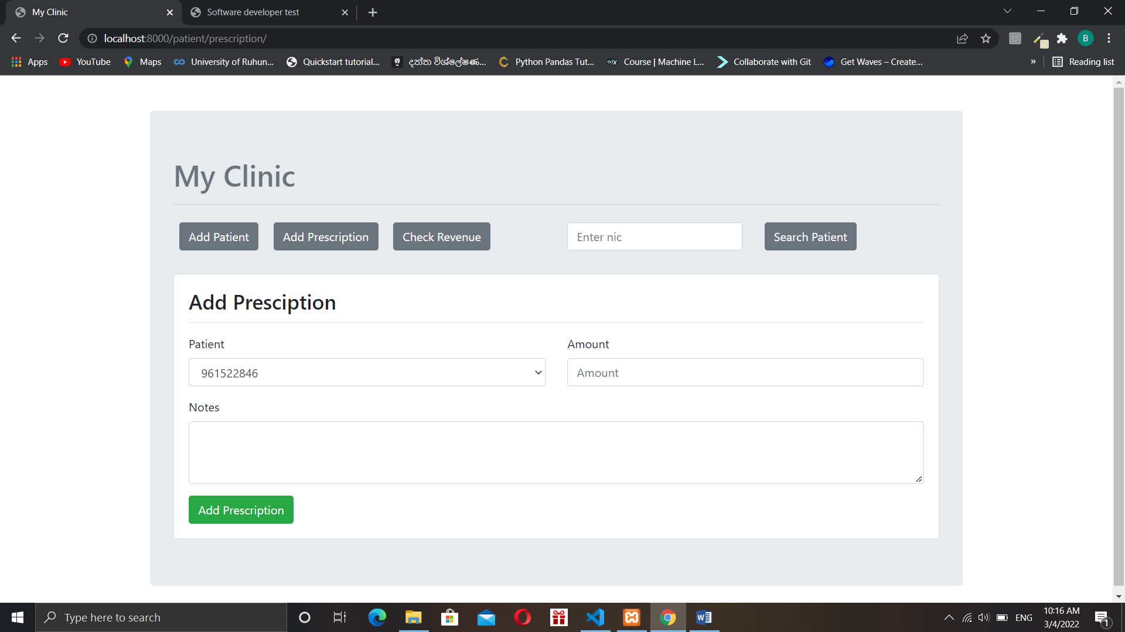

(02)

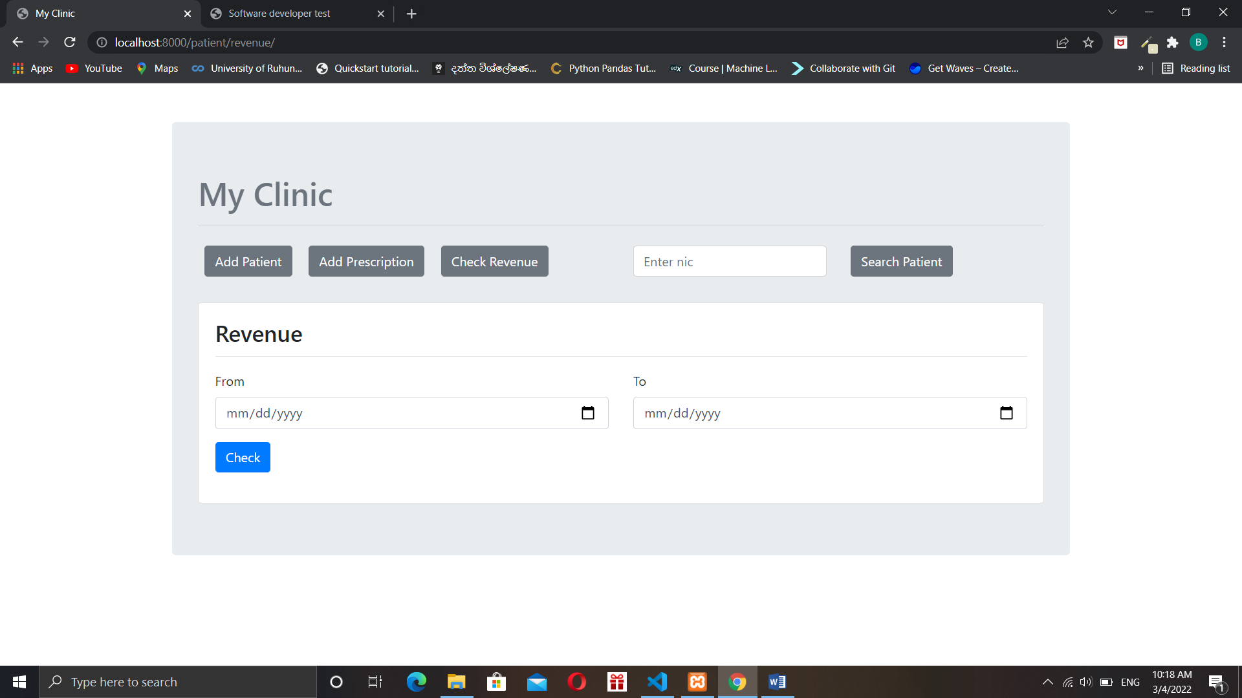

(03)

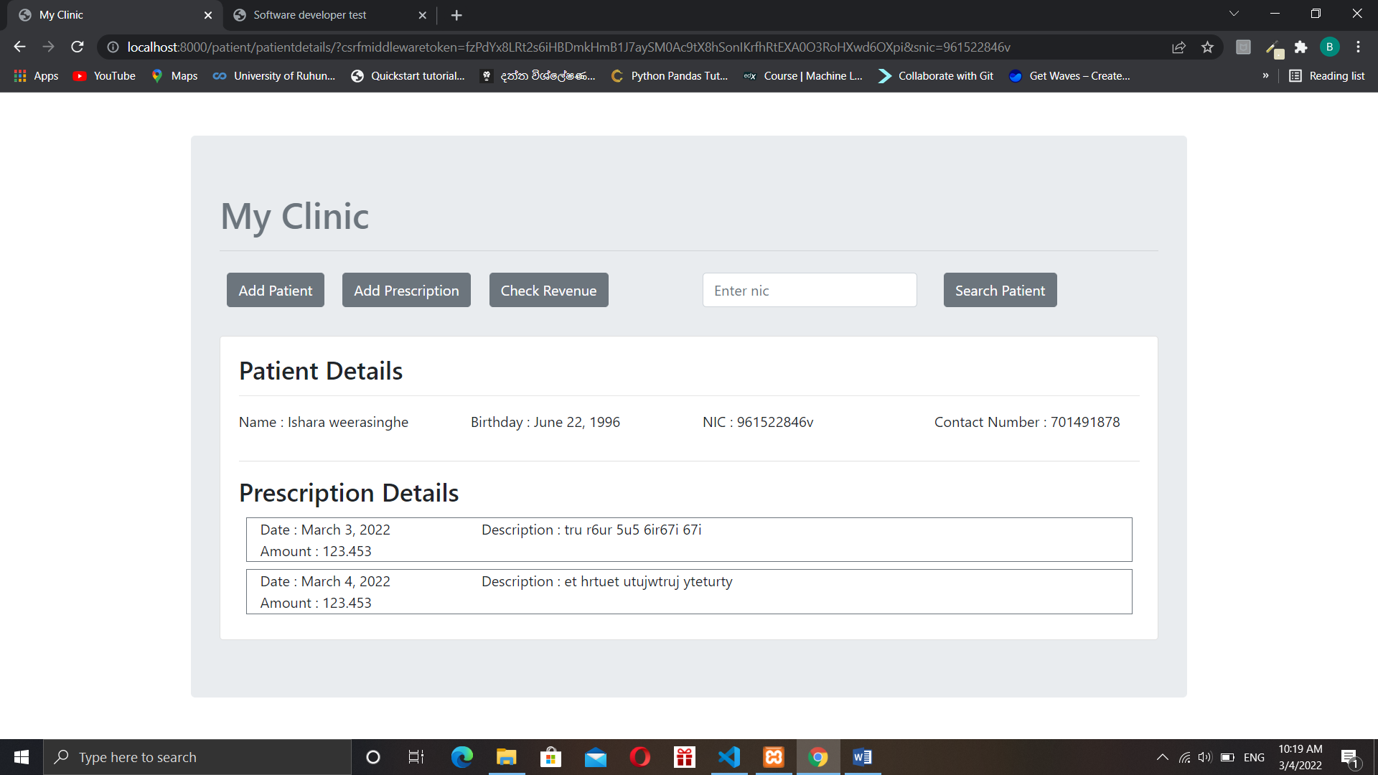

(04)

**Flow Chart for search patient:**

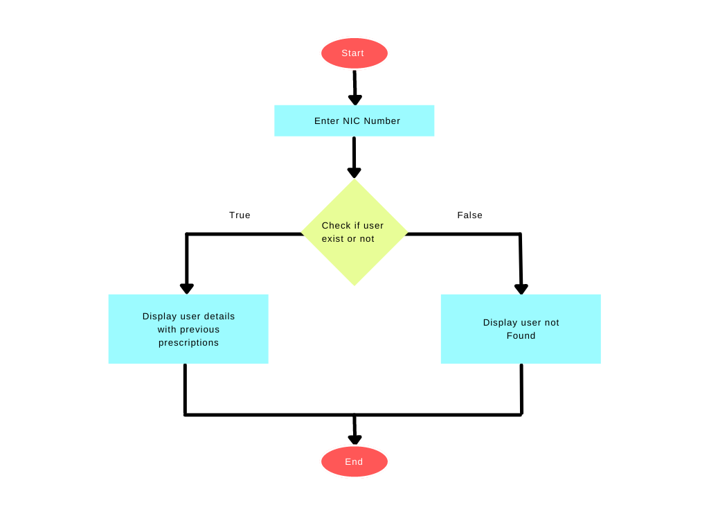

**Flow chart for add prescription:**

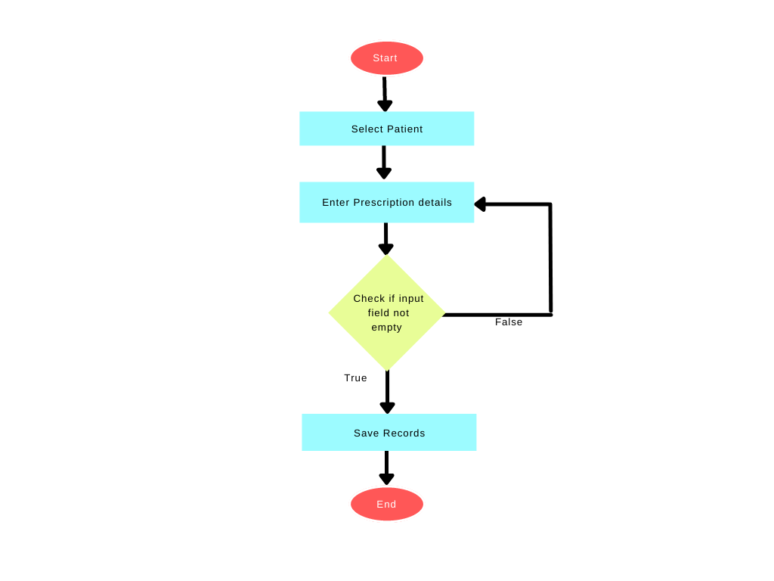

**Flow chart for display revenue:**

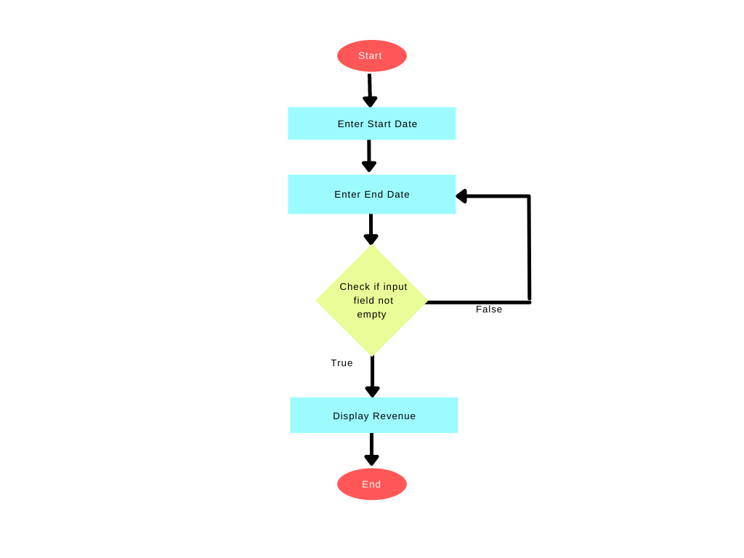

**ER diagram:**

