Fundamentals in Programming

- Assessment Title : Green Lanterns Corps Recyclers - Python - Based Automated E-Waste Management System [ AEWMS ]
- Assessment No : 01
- Module Name : Fundamentals in Programming
- Module No : CSE 4202
- Lecturer : Mr. Navod Nawarthna

- Student Id : SC/HDCSE/CMU/57/01
- Student Name : W. B. Ishani
Content

Task 1 3

Program Development 3
Input – Process – Output Analysis 4
Introduction 3
Data Representation Plan 5
Modularization Map 7
Algorithmic Logic Discussion 8
Python Program Source File 9
Evidence of Program Run 10

TASK 2 19

Testing, Debugging and Documentation 19
Compile and Test the Program 19
Errors and Debugging 25
Documentation Report 26

Reference List 28

Content of Table

Table 1 : Input - Process - Output Table 5

Table 2 : Function Planning Table 7

Table 3 : Test Plan Table 24

Table 4 : Debugging Table 25

Table 5 : Function Table 27

Content of Figure

Figure 1 : Main Menu of the System 12
Figure 2 : Adding a New E-Waste Item 14
Figure 3 : Viewing Stored Item 14
Figure 4 : Searching an E-Waste Item 15
Figure 5 : Updating and Existing Item 16
Figure 6 : Deleting an Item 16
Figure 7 : Monitoring Storage Capacity 17
Figure 8 : Generating System Report 18
Figure 9 : Exit from System 19

Figure 10 : Invalid Category Validation Message 20
Figure 11 : Invalid Weight Input Validation Message 21
Figure 12 : Item not Found Message 21
Figure 13 : Storage Warnning Notification 22
Figure 14 : Storage Full Alert 22

Task 1

Program Development

Introduction
The Green Lantern Corps Recyclers currently depend on manual books and paper registers to manage e-waste collection and recycling information. This manual system causes several problems such as incorrect weight calculations, loss of customer records, poor tracking of recyclable and hazardous waste, storage overflow issues, and delays in preparing reports. To solve these issues, an Automated E-Waste Management System (AEWMS) will be developed using Python. The system will allow staff to record, update, search, and manage e-waste items efficiently while calculating recycling fees, monitoring storage capacity, and generating reports automatically. . This solution is expected to minimize human errors, improve data accuracy, and support better decision-making within the recycling process.

Input – Process – Output Analysis

Requirement | Inputs | Process | Output
Add E-Waste Item | Item ID, Device Name, Category, Weight | Validate inputs and store item details in the list | Item added successfully message
View E-Waste Items | User selection | Retrieve all stored records | Display all e-waste items
Search Item | Item ID or Device Name | Search records in the list | Display matching item details or item not found message
Update Item | Item ID and new details | Locate the item and update information | Updated item details displayed
Delete Item | Item ID | Find and remove the item from the list | Item deleted successfully message
Calculate Recycling Fee | Weight of the item | Calculate fee and apply 5% discount if weight exceeds 50kg | Display total recycling fee
Monitor Storage Capacity | Stored item weights | Calculate total storage usage and compare with maximum capacity | Storage status and warning messages
Generate Report | Stored item records | Calculate total items, total weight, and total fees | Summary report displayed
Input Validation | Category and Weight | Check category validity and positive weight values | Error message for invalid inputs
Exit System | User menu selection | Terminate program execution | Exit confirmation message
Table 1 : Input - Process - Output Table

Data Representation Plan
The system uses python lists and dictionaries to store e-waste item details. Each e-waste item is stored as a dictionary containing item ID, device name, category, weight, recycling fee, and status. All item dictionaries are stored inside a list for easy management and searching, updating, deleting and sorting of records efficiently.

Dictionary
{
"id": "E101",
"name": "Laptop",
"category": "Recyclable",
"weight": 20,
"fee": 700,
"status": "stored"
}

List
items = [item1, item2, item3]

Modularization Map
Function planning is used to identify and organize the main functions of the system. Each functions performs a specific task such as adding items, searching records, updating information calculating fees, and generating reports. Using functions improves code readability, reusability and maintainability.

Function Name | Purpose | Support
add_item() | Add a new e-waste item | Validates category and weight, calculates recycling fee, and stores item details
view_items() | View all e-waste items | Displays all stored records in the system
search_item() | Search an item | Searches for an item using Item ID or Device Name
update_item() | Update item details | Allows users to modify existing item information
delete_item() | Delete an item | Removes selected items from the system
storage_status() | Check storage status | Calculates total storage usage and displays warnings
generate_report() | Generate a report | Displays total items, total weight, and total fees collected

Table 2 : Function Planning Table

Algorithmic Logic Discussion
The Automated E-Waste Management System uses basic programming concepts and logical structures to manage e-waste records efficiently. Decision-making statements (`if`, `elif`, and `else`) are used to validate user inputs, check storage limits, and control system operations.
Looping structures such as `for` and `while` loops are used to display records, search for items, generate reports, and keep the menu running until the user exits the program. A sequential search method is used to find items by their ID or device name.
The system also performs calculations to determine recycling fees based on item weight and applies a discount for items weighing more than 50 kg. Additionally, calculations are used to monitor storage capacity and generate summary reports.
These algorithms and logical structures help the system operate accurately, efficiently, and in a user-friendly manner.
In addition, aggregate calculations such as `sum()` functions are used to calculate the total storage usage, total weight of items, and total recycling fees. These calculations help monitor storage capacity and generate summary reports for users.
Overall, the combination of decision structures, loops, searching techniques, and calculation algorithms enables the system to manage e-waste records accurately and efficiently.

Python Program Source File


FP.zip

# Automated E-Waste Management System

items = []
MAX_STORAGE = 1000
FEE_PER_KG = 10

def add_item():

total_storage = sum(item["weight"] for item in items)

if total_storage >= MAX_STORAGE:
print("Storage Full! Cannot add items.")
return

item_id = input("Enter Item ID: ")
name = input("Enter Device Name: ")

category = input(
"Enter Category (Recyclable/Hazardous/Non-Recyclable): "
)

if category not in [
"Recyclable",
"Hazardous",
"Non-Recyclable"
]:
print("Invalid Category")
return

try:
weight = float(input("Enter Weight (kg): "))

if weight <= 0:
print("Weight must be positive")
return

except ValueError:
print("Invalid Weight")
return

fee = weight * FEE_PER_KG

if weight > 50:
discount = fee * 0.05
fee -= discount
else:
discount = 0

item = {
"id": item_id,
"name": name,
"category": category,
"weight": weight,
"fee": fee,
"status": "Stored"
}

items.append(item)

print("Item Added Successfully")

def view_items():

if len(items) == 0:
print("No items available")
return

for item in items:
print(item)

def search_item():

search = input("Enter Item ID or Name: ")

found = False

for item in items:

if item["id"] == search or item["name"] == search:
print(item)
found = True

if not found:
print("Item Not Found")

def update_item():

item_id = input("Enter Item ID to update: ")

for item in items:

if item["id"] == item_id:

new_weight = float(input("Enter New Weight: "))
item["weight"] = new_weight

item["fee"] = new_weight * FEE_PER_KG

print("Item Updated")
return

print("Item Not Found")

def delete_item():

item_id = input("Enter Item ID to delete: ")

for item in items:

if item["id"] == item_id:
items.remove(item)
print("Item Deleted")
return

print("Item Not Found")

def storage_status():

total_weight = sum(item["weight"] for item in items)

print(f"Current Storage: {total_weight} kg")

if total_weight >= 800:
print("Warning! Storage above 80%")

if total_weight >= MAX_STORAGE:
print("Storage Full")

def generate_report():

total_weight = sum(item["weight"] for item in items)

total_fee = sum(item["fee"] for item in items)

print("\n===== REPORT =====")
print("Total Items:", len(items))
print("Total Weight:", total_weight)
print("Total Fees:", total_fee)

while True:

print("\n===== AEWMS MENU =====")
print("1. Add Item")
print("2. View Items")
print("3. Search Item")
print("4. Update Item")
print("5. Delete Item")
print("6. Storage Status")
print("7. Generate Report")
print("8. Exit")

choice = input("Enter Choice: ")

if choice == "1":
add_item()

elif choice == "2":
view_items()

elif choice == "3":
search_item()

elif choice == "4":
update_item()

elif choice == "5":
delete_item()

elif choice == "6":
storage_status()

elif choice == "7":
generate_report()

elif choice == "8":
print("Program Closed")
break

else:
print("Invalid Choice")

Evidence of Program Run
The following screenshots show the successful execution of the Python-based Automated E-waste Management system. Different system functions were tested to verify the correct operation of the program.

- Main Menu

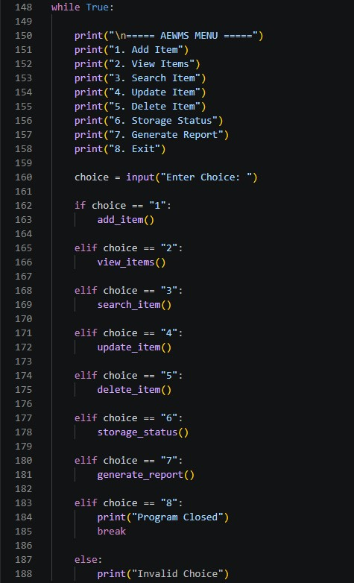
OUTPUT
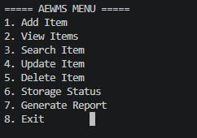
Figure 1 : Main Menu of the System

- Add Item
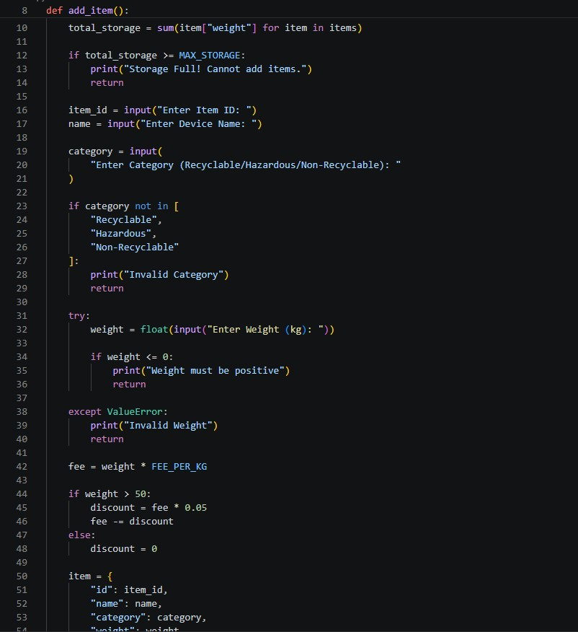

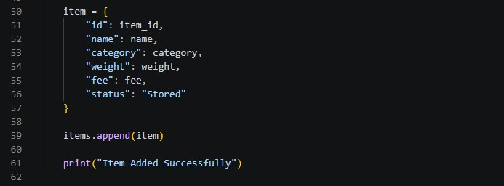
OUTPUT
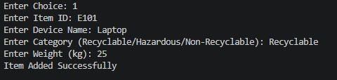
Figure 2 : Adding a New E-Waste Item

- View Item

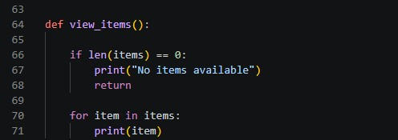
OUTPUT
Figure 3 : Viewing Stored Item

- Search Item
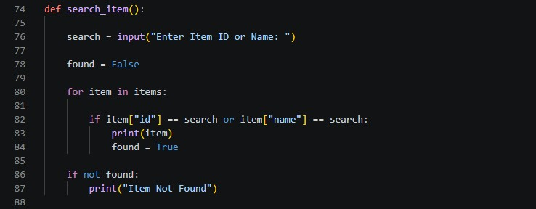
OUTPUT
Figure 4 : Searching an E-Waste Item

- Update Item
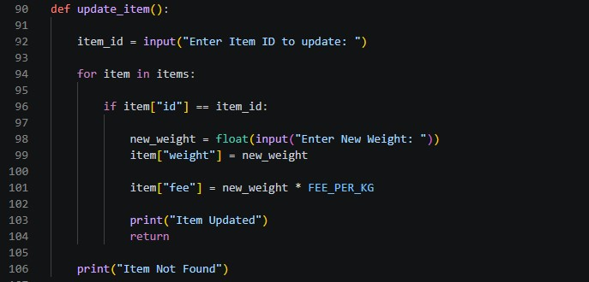

OUTPUT
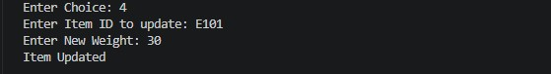
Figure 5 : Updating and Existing Item

- Delete Item
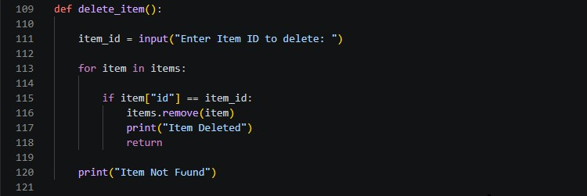
OUTPUT
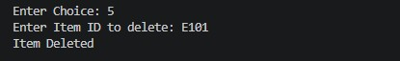
Figure 6 : Deleting an Item

- Storage Status
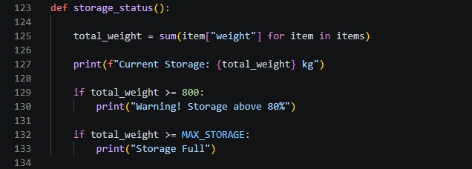
OUTPUT
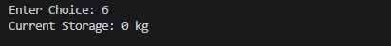
Figure 7 : Monitoring Storage Capacity

- Generate Report

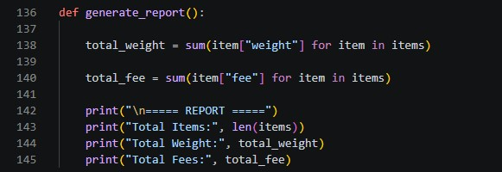

OUTPUT
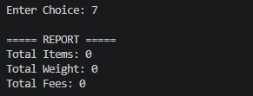
Figure 8 : Generating System Report

- Exit

A]
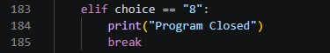
OUTPUT


B]
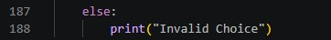

OUTPUT
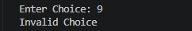
Figure 9 : Exit from System

TASK 2

Testing, Debugging and Documentation

Compile and Test the Program
The following screenshots present the testing of different error handling and validation features of the Automated E-Waste Management system, including invalid inputs, item search and storage status check.
- Invalid category

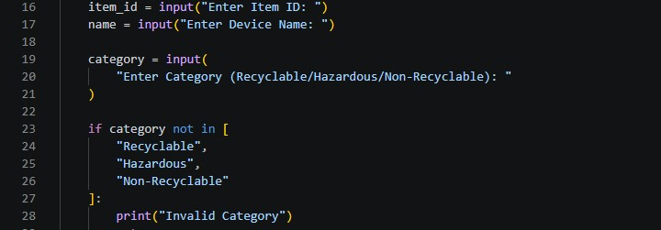
OUTPUT
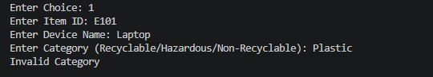
Figure 10 : Invalid Category Validation Message

- Invalid weight
A]
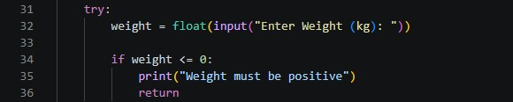
OUTPUT
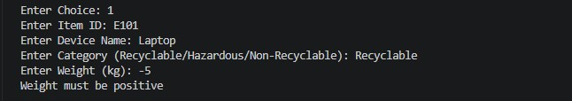

B]

OUTPUT
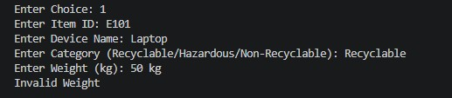
Figure 11 : Invalid Weight Input Validation Message

- Search Invalid Item


OUTPUT
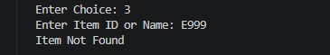
Figure 12 : Item not Found Message

- Storage Warning
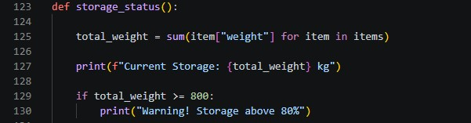
OUTPUT
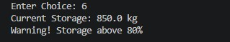
Figure 13 : Storage Warnning Notification

- Storage Full

OUTPUT
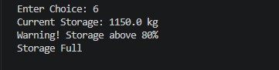
Figure 14 : Storage Full Alert

Test Plan
The purpose of this test plan is to verify that all functions of the Automated E-Waste Management System (AEWMS) operate correctly. Different test cases were carried out using valid and invalid inputs to ensure accurate processing, proper validation, and correct system behavior. The actual outputs were compared with the expected outputs to confirm that the system meets the specified requirements.

Test Case | Input Data | Expected Output | Actual Output | Status
Add Item | E101, Laptop, Recyclable, 25kg | Item added successfully | Item added successfully | PASS
Invalid Category | Plastic | Invalid category message displayed | Invalid category message displayed | PASS
Invalid Weight | -5kg | Invalid weight message displayed | Invalid weight message displayed | PASS
Search Item | E101 | Item details displayed | Item details displayed | PASS
Search Invalid Item | E999 | Item not found message displayed | Item not found message displayed | PASS
Update Item | E101, 30kg | Item updated successfully | Item updated successfully | PASS
Delete Item | E101 | Item deleted successfully | Item deleted successfully | PASS
Storage Status | 500kg | Current storage usage displayed | Current storage usage displayed | PASS
Storage Warning | 850kg | Warning message displayed | Warning message displayed | PASS
Storage Full | 1000kg | Storage full message displayed | Storage full message displayed | PASS
Generate Report | Stored system data | Report generated successfully | Report generated successfully | PASS

Table 3 : Test Plan Table

Errors and Debugging
During the development of the Automated E-Waste Management System, several errors and issues were identified while testing different functions of the program. Debugging was carried out to detect the causes of these problems and implement appropriate solutions. This process helped improve the accuracy, reliability, and overall performance of the system. The table below summarizes some of the common errors encountered during development, their causes, and the corrective actions taken to resolve them.

Error | Cause | Solution
Invalid indentation | Incorrect spacing in code | Fixed indentation properly
Value Error | User entered text instead of number | Use try-except validation
Invalid category | Wrong category input | Added category check list
Item Not Found | Entered ID does not exist in the list | Added search validation or added message to inform the user
Wrong fee calculation | Fee not updated after change | Recalculated fee after update
Storage Full | Total storage exceeded maximum capacity | Added storage limit checking before adding items

Table 4 : Debugging Table

Documentation Report
Automated E-Waste Management System (AEWMS)

System Purpose
The purpose of the Automated E-Waste Management System (AEWMS) is to manage e-waste records efficiently and reduce the problems associated with manual record keeping. The system allows users to add, search, update, and delete e-waste items while automatically calculating recycling fees and monitoring storage capacity. It helps improve accuracy, save time, and support effective e-waste management operations.
Features
- Add e-waste items
- View all items
- Search items
- Update item details
- Delete items
- Calculating fee
- Monitor storage status
- Generate reports
Functions
Function | Purpose
add_item() | Add new e-waste item
view_items() | Display all items
search_item() | Search item by ID or name
update_item() | Update item
delete_item() | Delete item
storage_status() | Check monitor storage capacity
generate_report() | Display/generate report

Table 5 : Function Table
Testing Summary
The Automated E-Waste Management System was tested using a variety of valid and invalid input values to ensure that all functions operated correctly. Testing was carried out for adding, viewing, searching, updating, and deleting e-waste records, as well as storage monitoring and report generation features. The results showed that the system performed as expected and produced accurate outputs for valid inputs. Invalid inputs such as incorrect categories, negative weights, and non-numeric values were successfully identified through validation checks. Error handling mechanisms prevented program crashes and displayed appropriate messages to guide the user. Overall, the testing process confirmed that the system is reliable, functional, and user-friendly.

Limitations
- No database (data not stored permanently)
- Console-based system only
- No Graphical User Interface (GUI)
- No user login system

Reflection
This assignment provided valuable practical experience in developing a real-world application using Python programming. Through the development process, I improved my understanding of functions, loops, conditional statements, lists, dictionaries, and input validation techniques. I also gained experience in problem-solving, debugging, and testing programs to ensure accurate and reliable performance. Furthermore, the assignment helped me understand the importance of program planning, modular design, and documentation in software development. Overall, this project enhanced both my technical programming skills and my ability to develop structured and maintainable software solutions.

Reference List
- Python Software Foundation (2025) *Python Documentation*. Available at: https://docs.python.org/3/ (Accessed: 3 June 2026).

- Sweigart, A. (2019) *Automate the Boring Stuff with Python: Practical Programming for Total Beginners*. 2nd edn. San Francisco: No Starch Press.

- Downey, A.B. (2015) *Think Python: How to Think Like a Computer Scientist*. 2nd edn. Sebastopol, CA: O'Reilly Media.

- Reitz, K. and Schlusser, T. (2016) *The Hitchhiker’s Guide to Python*. Available at: https://docs.python-guide.org/ (Accessed: 3 June 2026).

- W3Schools (2026) *Python Tutorial*. Available at: https://www.w3schools.com/python/ (Accessed: 3 June 2026).

