Assignment Cover Sheet




Higher Diploma in Computing & Software Engineering

- Module :
CSE4204 - Database Design and Development

- Student Name & No :
W.Buddhini Ishani - ST/HDCSE/CMU/57/01

Acknowledgement

I want to say thanks everyone who helped me during finish my Database design and development assignment based on SkyDeliver Drone Delivery Management System.
I would like to express my gratitude to my lecturer who provided us knowledge during this module and the advice and feedback given during the assignment. The knowledge gained from lectures and learning materials provided helped me to understand more about database such as data modelling, Entity Relationship Diagrams (ERD), relational database design, normalization, SQL, database security and testing.
I also want to thank the ICBT Campus for giving me the opportunity to learn and providing the learning facilities and resources which supported me to complete this assignment.
Last but not least, I want to thank my family and friends for the support and encouragement they gave me during the preparation of this assignment. They encouraged me and motivated so that I can complete the assignment on time

Executive Summary

The main objective of this assignment is to design and develop a database system for SkyDeliver drone delivery service. The database will store information about customers, deliveries, drones, hubs, assignments, maintenance, and battery charging.

The Relational Model and Document based NoSQL Model options will be discussed. The Relational Model will be chosen to design the database because the information stored in the database is highly structured. The Entity-Relationship Diagram will be developed and then transformed into a relational database by introducing primary and foreign keys. The tables will be normalized to the third normal form to eliminate data redundancies and dependencies. The developed database will be implemented in MS SQL Server by creating a database, tables, constraints, sample data, queries, stored procedures, and triggers. The testing process will be carried out to ensure that the database was implemented correctly. The database will also be backed up, secured, and recovered to maintain its integrity and availability.

Table of Contents

Acknowledgement I
Executive Summary II
List of Tables IV
List of Figures VI
Introduction VIII
TASK 1 - Data Model and Comparison 1
TASK 2 - Entity Relationship Diagram (ERD) 5
TASK 3 - I Relational Schema 7
TASK 3 - II Normalization to 3NF 9
TASK 4 - Database Implementation 26
TASK 5 - SQL queries 40
TASK 6 - Database Security, Backup and Recovery 45
TASK 7 - Test Plan and Test Cases 50
Conclusion 65
References 66
Appendix 68

List of Tables

Table 1 : Relational Model 2
Table 2 : Document-Based NoSQL Model 3
Table 3 : Comparison of Relational Model vs NoSQL Model 4
Table 4 : UNF Customer 9
Table 5 : UNF DeliveryStatus 10
Table 6 : UNF DistributionHub 11
Table 7 : UNF Drone 11
Table 8 : UNF Delivery 11
Table 9 : UNF DroneAssignment 11
Table 10 : UNF Maintenance 11
Table 11 : UNF BatteryCharging 12
Table 12 : 1NF Customer 12
Table 13 : 1NF DeliveryStatus 13
Table 14 : 1NF DistributionHub 14
Table 15 : 1NF Drone 14
Table 16 : 1NF Delivery 14
Table 17 : 1NF DroneAssignment 15
Table 18 : 1NF Maintenance 15
Table 19 : 1NF BatteryCharging 15
Table 20 : 2NF Customer 17
Table 21 : 2NF Customer_Phone 17
Table 22 : 2NF 2. DeliveryStatus 18
Table 23 :2NF DistributionHub 19
Table 24 : 2NF Drone 19
Table 25 : 2NF Delivery 19
Table 26 : 2NF DroneAssignment 19
Table 27 : 2NF Maintenance 20
Table 28 : 2NF BatteryCharging 20
Table 29 : 3NF Customer 21
Table 30 : 3NF Customer_Phone 21
Table 31 : 3NF DeliveryStatus 22
Table 32 : 3NF DistributionHub 23
Table 33 : 3NF Drone 23
Table 34 : 3NF Delivery 24
Table 35 : 3NF DroneAssignment 24
Table 36 : 3NF Maintenance 25
Table 37 : 3NF BatteryCharging 25
Table 38 : Database Roles 46
Table 39 : Backup and Recovery Schedule 49
Table 40 : Test Resources 53
Table 41 : Test Schedule 54
Table 42 : Test Cases 64

List of Figures

Figure 1 : ERD for the SkyDeliver Drone Delivery Management System 6
Figure 2 : Relational Schema 8
Figure 3 : Create Database 26
Figure 4 : Create Customer Table 26
Figure 5 : Create Delivery Status Table 27
Figure 6 : Create DistributionHub Table 27
Figure 7 : Create Drone Table 27
Figure 8 : Create Delivery Table 28
Figure 9 : Create DroneAssignment Table 28
Figure 10 : Create Maintenance Table 29
Figure 11 : Create BatteryCharging Table 29
Figure 12 : Insert Customer Records 30
Figure 13 : Insert Delivery Status Records 30
Figure 14 : Insert DistributionHub Records 31
Figure 15 : Insert Drone Records 31
Figure 16 : Insert Delivery Records 32
Figure 17 : Insert DroneAssignment Records 32
Figure 18 : Insert Maintenance Records 33
Figure 19 : Insert BatteryCharging Records 33
Figure 20 : Fetching Customer Data 34
Figure 21 : Fetching DeliveryStatus Data 34
Figure 22 : Fetching DistributionHub Data 35
Figure 23 : Fetching Drone Data 35
Figure 24 : Fetching Delivery Data 36
Figure 25 : Fetching DroneAssignment Data 36
Figure 26 : Fetching Maintenance Data 37
Figure 27 : Fetching BatteryCharging Data 37
Figure 28 : Stored Procedure 38
Figure 29 : Test Stored Procedure 38
Figure 30 : Create Trigger 39
Figure 31 : Query 1 40
Figure 32 : Query 2 41
Figure 33 : Query 3 42
Figure 34 : Query 4 43
Figure 35 : Query 5 44
Figure 37 : TC001 54
Figure 38 : TC002 55
Figure 39 : TC003 55
Figure 40 : TC004 56
Figure 41 : TC005 56
Figure 42 : TC006 57
Figure 43 : TC007 58
Figure 44 : TC008 58
Figure 45 : TC009 59
Figure 46 : TC 010 60
Figure 47 : TC 011 61
Figure 48 : TC 012 62
Figure 49 : TC 013 63
Figure 50 : TC 014 64

Introduction

The rapid growth of online shopping and on-demand delivery services has increased the need for fast, reliable, and efficient delivery solutions. Traditional delivery methods can face problems such as traffic congestion, delivery delays, and high operational costs. Drone-based delivery provides an alternative solution, especially for deliveries within urban areas.
SkyDeliver is a proposed drone-based delivery management system designed to manage and monitor parcel deliveries. Customers can place delivery requests through a mobile application by providing pickup and drop-off locations. The system can assign suitable drones based on availability, battery level, and payload capacity.
The database is a central part of SkyDeliver because it stores important information such as customer details, delivery requests, delivery status, drones, distribution hubs, assignments, maintenance, and battery charging records. It also supports the analysis of delivery performance and drone utilization.
This assignment focuses on designing and implementing a suitable database for SkyDeliver. It covers data model comparison, ERD development, relational schema design, normalization up to 3NF, SQL Server implementation, queries, security, backup and recovery, and database testing.
Overall, the proposed database is designed to provide a reliable, secure, and maintainable solution for supporting SkyDeliver's drone delivery operations.

TASK 1 - Data Model and Comparison

What is a Data Model ?

A data model is the description of how data is organised, stored, related, and managed in a database management system. It enables the designer to create databases with good quality, structure, and ease of maintenance.

The two broad classes of data models are the relational model and the NoSQL model. The relational model uses a table-based approach for storing data, whereas the NoSQL databases use various approaches such as document, key-value pair, column, and graph.

Relational Model

The Relational Model stores information in tables consisting of rows and columns. Usually, these tables represent some entities with the help of rows, columns, primary, and foreign keys. For instance, there can be a table for Customers and another one for Drones. Every table has a primary key that helps identify each entry uniquely, and foreign keys enable the connection between tables.

For example, SkyDeliver database can consist of several tables, such as Customer, Delivery, Drone, and DistributionHub. The first table’s primary key can be CustomerID, and Delivery can have CustomerID as a foreign key. Moreover, the relational model typically uses Structured Query Language to design, create, manage, and manipulate databases. It has SQL constraints to ensure the data integrity of databases, such as primary and foreign keys, NOT NULL and UNIQUE constraints, etc.

Feature | Relational Model
Data structure | Tables, rows and columns
Schema | Predefined and structured
Relationships | Primary keys and foreign keys
Query language | SQL
Data integrity | Strong constraints and referential integrity
Best suited for | Structured and highly related data
SkyDeliver suitability | High
Table 1 : Relational Model

Document Based NoSQL Model

Instead of using conventional rows and columns, data is stored as documents in a document-based NoSQL database. JSON-like formats are frequently used to describe documents, and depending on the needs, they may have a variety of fields.
For instance, a SkyDeliver delivery document can have the delivery ID, client information, delivery address, drone details, and delivery status all in one document. Because various papers don't always have to have the same fields, this allows for flexibility.
Applications handling a lot of semi-structured or constantly changing data can benefit from document databases. One well-known example of a document-based NoSQL database is MongoDB.

Feature | Document-based NoSQL
Data structure | Documents / JSON-like objects
Schema | Flexible
Relationships | Usually embedding or references
Querying | Database-specific query languages
Data integrity | Often more application dependent
Best suited for | Flexible and rapidly changing data
SkyDeliver suitability | Possible, but less suitable for strict relationships
Table 2 : Document-Based NoSQL Model

Relational Model vs Document Based NoSQL

Feature | Relational Model | Document-Based NoSQL
Data storage | Tables containing rows and columns are used to store data. | Documents are used to store data, typically in a JSON-like format.
Schema | Uses a predefined and structured schema | Provides a flexible schema
Relationships | Uses primary keys and foreign keys to represent relationships | Relationships can be represented using references or embedded documents
Data integrity | Strong data integrity through constraints and relationships | Data integrity depends more on application and database design
Query language | SQL is commonly used | Query methods depend on the NoSQL database
Normalisation | Supports normalisation to reduce data redundancy | Data may be denormalised to improve performance
Transactions | Strong support for ACID transactions | Transaction support varies, although modern document databases support transactions
Scalability | Traditionally focuses on vertical scaling, although modern systems can also scale horizontally | Generally designed with horizontal scalability in mind
Flexibility | Changes to the structure may require schema modifications | Easier to store data with changing structures
Suitable data | Structured and highly related data | Semi-structured and rapidly changing data
Table 3 : Comparison of Relational Model vs NoSQL Model

Why Relational Databases Remain Widely Used

Relational databases are still widely used because they offer data consistency organized data handling, powerful SQL queries, support for transactions and reliable integrity rules. These features make them a solid choice for business systems where accurate and dependable transactions matter a lot.

NoSQL databases have become more popular as modern applications often deal with amounts of data constantly changing data formats and large numbers of users. Their flexible schema design and ability to scale horizontally make them useful for web apps, cloud platforms real-time systems and big data setups.

So the decision between these two types comes down to what the system needs. For the SkyDeliver delivery management system the relational model fits better since it handles structured data and many key relationships. However a document-based NoSQL database might also be considered for flexible data, like drone telemetry and extensive flight logs.

TASK 2 - Entity Relationship Diagram (ERD)

An Entity Relationship Diagram (ERD) can be referred to as a ‘data model’. The purpose of it is to show the main objects within the system, known as entities, specify their keys, and identify their relationships with one another.
For the proposed SkyDeliver drone-based delivery management system, the ERD identifies customers, deliveries, drones, distribution hubs, drone assignments, maintenance activities, battery charging, and delivery statuses.

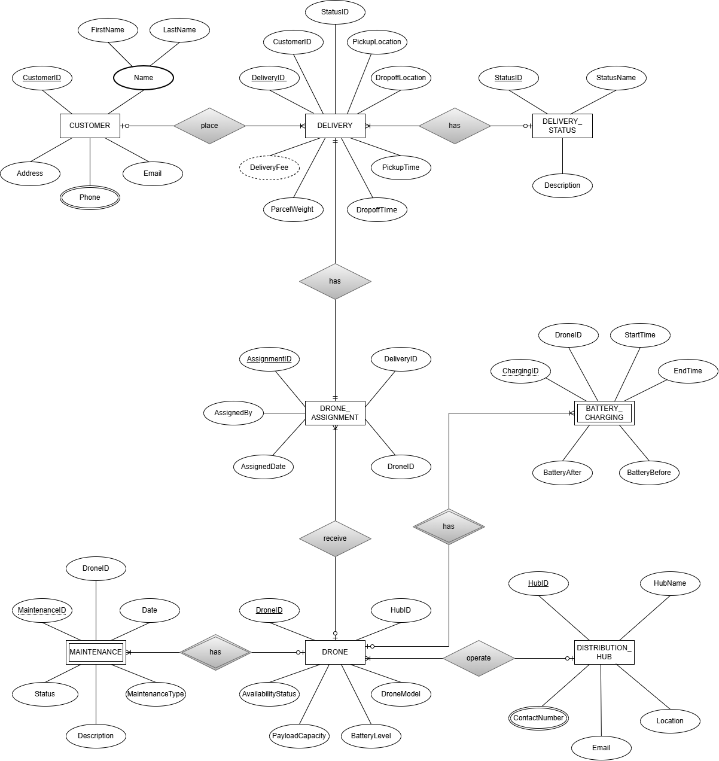
Figure 1 : ERD for the SkyDeliver Drone Delivery Management System

TASK 3 - I Relational Schema

A relational schema shows how a database is built with tables. In the SkyDeliver system the ERD that we created can be turned into tables by following the right mapping rules. Every strong entity becomes a table. The primary keys are. Foreign keys are added so the tables can talk to each other.

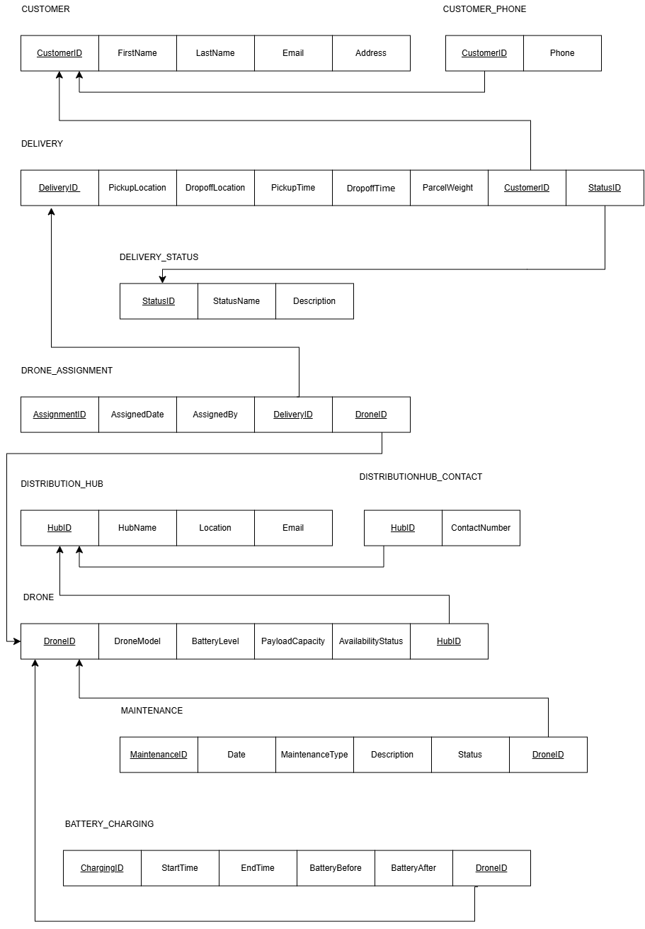
Figure 2 : Relational Schema

TASK 3 - II Normalization to 3NF

Normalization is the process of arranging data in a database. The goal is to make sure the data is organized properly. This helps to cut down on repeated data and make the data more reliable. The process includes using things, like Unnormalized Form, First Normal Form, Second Normal Form and Third Normal Form. The main purpose of normalization is to stop data from being repeated much. It also helps to avoid problems when adding, changing or removing data.

Unnormalized Form (UNF)

In the original Customer table, the Phone attribute can contain more than one phone number for a customer.

1. Customer Table
Customer  ID | First  Name | Last  Name | Email | Address | Phone
1 | Kamal | Perera | kamal.perera@gmail.com | Colombo 03 | 0771234567, 0705897801
2 | Nimal | Fernando | nimal.fernando@gmail.com | Kandy | 0712345678
3 | Saman | Silva | saman.silva@gmail.com | Galle | 0753456789, 0789567345
4 | Amal | Perera | amal.perera@gmail.com | Negombo | 0764567890,  0712538797
5 | Kasun | Fernando | kasun.fernando@gmail.com | Gampaha | 0785678901
Table 4 : UNF Customer
The Phone attribute contains multiple values, so the table is in UNF.

2. DeliveryStatus Table
StatusID | StatusName | Description
ST001 | Pending | Delivery request has been received and is waiting for processing.
ST002 | Confirmed | Delivery request has been confirmed by the system.
ST003 | Assigned | A drone has been assigned to the delivery.
ST004 | Pickup Scheduled | Pickup has been scheduled for the delivery.
ST005 | Ready for Pickup | Parcel is ready to be collected from the pickup location.
Table 5 : UNF DeliveryStatus

There are no repeating or multivalued attributes.

3. DistributionHub Table
HubID | HubName | Location | ContactNumber | Email
HUB001 | Colombo Central Hub | Colombo 01 | 0112345678 | colombo@distributionhub.lk
HUB002 | Kandy Distribution Hub | Kandy | 0812345678 | kandy@distributionhub.lk
HUB003 | Galle Distribution Hub | Galle | 0912345678 | galle@distributionhub.lk
HUB004 | Gampaha Distribution Hub | Gampaha | 0332345678 | gampaha@distributionhub.lk
HUB005 | Negombo Distribution Hub | Negombo | 0312345678 | negombo@distributionhub.lk
Table 6 : UNF DistributionHub

There are no multivalued attributes.

4. Drone Table
DroneID | HubID | DroneModel | BatteryLevel | Payload  Capacity | AvailabilityStatus
Table 7 : UNF Drone

5. Delivery Table
DeliveryID | Customer  ID | StatusID | Pickup  Location | Dropoff  Location | Pickup  Time | Dropoff  Time
Table 8 : UNF Delivery

6. DroneAssignment Table
AssignmentID | DeliveryID | DroneID | AssignedDate | AssignedBy
Table 9 : UNF DroneAssignment

7. Maintenance Table
MaintenanceID | DroneID | Date | MaintenanceType | Description | Status
Table 10 : UNF Maintenance

8. BatteryCharging Table
ChargingID | DroneID | StartTime | EndTime | BatteryBefore | BatteryAfter
Table 11 : UNF BatteryCharging

First Normal Form (1NF)

Rule:
- Each column should contain atomic values.
- There should be no repeating groups or multiple values in one field.

- Customer Table
The multiple phone numbers are separated into individual rows.

Customer  ID | First  Name | Last  Name | Email | Address | Phone
1 | Kamal | Perera | kamal.perera@gmail.com | Colombo 03 | 0771234567
1 | Kamal | Perera | kamal.perera@gmail.com | Colombo 03 | 0705897801
2 | Nimal | Fernando | nimal.fernando@gmail.com | Kandy | 0712345678
3 | Saman | Silva | saman.silva@gmail.com | Galle | 0753456789
3 | Saman | Silva | saman.silva@gmail.com | Galle | 0789567345
4 | Amal | Perera | amal.perera@gmail.com | Negombo | 0764567890
4 | Amal | Perera | amal.perera@gmail.com | Negombo | 0712538797
5 | Kasun | Fernando | kasun.fernando@gmail.com | Gampaha | 0785678901
Table 12 : 1NF Customer

- Primary Key: CustomerID + Phone
- Now, each phone number is stored as a single value.
- Therefore, the table satisfies 1NF.

2. DeliveryStatus Table
StatusID | StatusName | Description
ST001 | Pending | Delivery request has been received and is waiting for processing.
ST002 | Confirmed | Delivery request has been confirmed by the system.
ST003 | Assigned | A drone has been assigned to the delivery.
ST004 | Pickup Scheduled | Pickup has been scheduled for the delivery.
ST005 | Ready for Pickup | Parcel is ready to be collected from the pickup location.
Table 13 : 1NF DeliveryStatus
- Primary Key: StatusID
- All values are atomic, so the table is in 1NF.

3. DistributionHub Table
HubID | HubName | Location | ContactNumber | Email
HUB001 | Colombo Central Hub | Colombo 01 | 0112345678 | colombo@distributionhub.lk
HUB002 | Kandy Distribution Hub | Kandy | 0812345678 | kandy@distributionhub.lk
HUB003 | Galle Distribution Hub | Galle | 0912345678 | galle@distributionhub.lk
HUB004 | Gampaha Distribution Hub | Gampaha | 0332345678 | gampaha@distributionhub.lk
HUB005 | Negombo Distribution Hub | Negombo | 0312345678 | negombo@distributionhub.lk
Table 14 : 1NF DistributionHub

- Primary Key: HubID
- All values are atomic, so the table is in 1NF.

4. Drone Table
DroneID | HubID | DroneModel | BatteryLevel | Payload  Capacity | AvailabilityStatus
Table 15 : 1NF Drone

- Primary Key: DroneID
- All values are atomic, so it is in 1NF.
5. Delivery Table
DeliveryID | Customer  ID | StatusID | Pickup  Location | Dropoff  Location | Pickup  Time | Dropoff  Time
Table 16 : 1NF Delivery

- Primary Key: DeliveryID
- All values are atomic, therefore the table is in 1NF.

6. DroneAssignment Table
AssignmentID | DeliveryID | DroneID | AssignedDate | AssignedBy
Table 17 : 1NF DroneAssignment

- Primary Key: AssignmentID
- All values are atomic, therefore it is in 1NF.

7. Maintenance Table
MaintenanceID | DroneID | Date | MaintenanceType | Description | Status
Table 18 : 1NF Maintenance

- Primary Key: MaintenanceID
- All values are atomic, so it is in 1NF.

8. BatteryCharging Table
ChargingID | DroneID | StartTime | EndTime | BatteryBefore | BatteryAfter
Table 19 : 1NF BatteryCharging

- Primary Key: ChargingID
- All values are atomic, therefore it is in 1NF.

Second Normal Form (2NF)

Rule:
- Must be in 1NF.
- There should be no partial dependency.
- Non-key attributes must depend on the whole primary key.

- Customer Table
- In the 1NF table, the primary key is: CustomerID + Phone
- However:
- CustomerID - FirstName, LastName, Email, Address
- This means customer details depend only on CustomerID, not on the whole composite key.
- Therefore, there is a partial dependency.
- To remove this dependency, the table is divided into two tables.

Customer  ID | First  Name | Last  Name | Email | Address
1 | Kamal | Perera | kamal.perera@gmail.com | Colombo 03
1 | Kamal | Perera | kamal.perera@gmail.com | Colombo 03
2 | Nimal | Fernando | nimal.fernando@gmail.com | Kandy
3 | Saman | Silva | saman.silva@gmail.com | Galle
3 | Saman | Silva | saman.silva@gmail.com | Galle
4 | Amal | Perera | amal.perera@gmail.com | Negombo
4 | Amal | Perera | amal.perera@gmail.com | Negombo
5 | Kasun | Fernando | kasun.fernando@gmail.com | Gampaha
Table 20 : 2NF Customer
- Primary Key: CustomerID

Customer_Phone Table
CustomerID | Phone
1 | 0771234567
1 | 0705897801
2 | 0712345678
3 | 0753456789
3 | 0789567345
4 | 0764567890
4 | 0712538797
5 | 0785678901
Table 21 : 2NF Customer_Phone
- Primary Key: CustomerID + Phone
- Foreign Key: CustomerID

- The partial dependency has now been removed.
- Therefore, the tables are in 2NF.

- DeliveryStatus Table
StatusID is a single-attribute primary key.
Therefore, there is no partial dependency.
StatusID | StatusName | Description
ST001 | Pending | Delivery request has been received and is waiting for processing.
ST002 | Confirmed | Delivery request has been confirmed by the system.
ST003 | Assigned | A drone has been assigned to the delivery.
ST004 | Pickup Scheduled | Pickup has been scheduled for the delivery.
ST005 | Ready for Pickup | Parcel is ready to be collected from the pickup location.
Table 22 : 2NF 2. DeliveryStatus
The table is in 2NF.

3. DistributionHub Table
HubID | HubName | Location | ContactNumber | Email
HUB001 | Colombo Central Hub | Colombo 01 | 0112345678 | colombo@distributionhub.lk
HUB002 | Kandy Distribution Hub | Kandy | 0812345678 | kandy@distributionhub.lk
HUB003 | Galle Distribution Hub | Galle | 0912345678 | galle@distributionhub.lk
HUB004 | Gampaha Distribution Hub | Gampaha | 0332345678 | gampaha@distributionhub.lk
HUB005 | Negombo Distribution Hub | Negombo | 0312345678 | negombo@distributionhub.lk
Table 23 :2NF DistributionHub
Since HubID is a single primary key, there is no partial dependency.
Therefore, it is in 2NF.

4. Drone Table
DroneID | HubID | DroneModel | BatteryLevel | Payload  Capacity | AvailabilityStatus
Table 24 : 2NF Drone
DroneID is a single primary key, so there is no partial dependency.
Therefore, it is in 2NF.

5. Delivery Table
DeliveryID | Customer  ID | StatusID | Pickup  Location | Dropoff  Location | Pickup  Time | Dropoff  Time
Table 25 : 2NF Delivery
DeliveryID is a single primary key, so there is no partial dependency.
Therefore, the table is in 2NF.

6. DroneAssignment Table
AssignmentID | DeliveryID | DroneID | AssignedDate | AssignedBy
Table 26 : 2NF DroneAssignment
There is no partial dependency because AssignmentID is a single primary key.
Therefore, it is in 2NF.
7. Maintenance Table
MaintenanceID | DroneID | Date | MaintenanceType | Description | Status
Table 27 : 2NF Maintenance
There is no partial dependency.
Therefore, it is in 2NF.
8. BatteryCharging Table
ChargingID | DroneID | StartTime | EndTime | BatteryBefore | BatteryAfter
Table 28 : 2NF BatteryCharging
There is no partial dependency because ChargingID is a single primary key.
Therefore, it is in 2NF.

Third Normal Form (3NF)

Rule:
- Must be in 2NF.
- There should be no transitive dependency.
- Non-key attributes should not depend on other non-key attributes.

For the Customer table:
All the non-key attributes are dependent upon CustomerID.
There is no such dependency as:
CustomerID - Non-key attribute - Another non-key attribute
Hence, there is no transitive dependency.

- Customer Table
CustomerID | FirstName | LastName | Email | Address
1 | Kamal | Perera | kamal.perera@gmail.com | Colombo 03
2 | Nimal | Fernando | nimal.fernando@gmail.com | Kandy
3 | Saman | Silva | saman.silva@gmail.com | Galle
4 | Amal | Perera | amal.perera@gmail.com | Negombo
5 | Kasun | Fernando | kasun.fernando@gmail.com | Gampaha
Table 29 : 3NF Customer

Customer_Phone Table
CustomerID | Phone
1 | 0771234567
1 | 0705897801
2 | 0712345678
3 | 0753456789
3 | 0789567345
4 | 0764567890
4 | 0712538797
5 | 0785678901
Table 30 : 3NF Customer_Phone
Therefore, the Customer data is in 3NF.

- DeliveryStatus Table
StatusID | StatusName | Description
ST001 | Pending | Delivery request has been received and is waiting for processing.
ST002 | Confirmed | Delivery request has been confirmed by the system.
ST003 | Assigned | A drone has been assigned to the delivery.
ST004 | Pickup Scheduled | Pickup has been scheduled for the delivery.
ST005 | Ready for Pickup | Parcel is ready to be collected from the pickup location.
Table 31 : 3NF DeliveryStatus

There is no transitive dependency because StatusName and Description depend directly on StatusID.
Therefore, the table is in 3NF.

3. DistributionHub Table
HubID | HubName | Location | ContactNumber | Email
HUB001 | Colombo Central Hub | Colombo 01 | 0112345678 | colombo@distributionhub.lk
HUB002 | Kandy Distribution Hub | Kandy | 0812345678 | kandy@distributionhub.lk
HUB003 | Galle Distribution Hub | Galle | 0912345678 | galle@distributionhub.lk
HUB004 | Gampaha Distribution Hub | Gampaha | 0332345678 | gampaha@distributionhub.lk
HUB005 | Negombo Distribution Hub | Negombo | 0312345678 | negombo@distributionhub.lk
Table 32 : 3NF DistributionHub

All non-key attributes depend directly on HubID.
There is no transitive dependency.

4. Drone Table
DroneID | HubID | DroneModel | BatteryLevel | Payload  Capacity | AvailabilityStatus
DRN001 | HUB001 | Sky-X1 | 95.50 | 9.00 | Available
DRN002 | HUB002 | Sky-X2 | 88.20 | 9.00 | Available
DRN003 | HUB003 | Sky-Pro1 | 76.80 | 7.50 | In Use
DRN004 | HUB005 | Sky-Pro2 | 92.40 | 2.70 | Available
DRN005 | HUB005 | Sky-X3 | 65.30 | 9.00 | Maintenance
Table 33 : 3NF Drone
All non-key attributes depend directly on DroneID

5. Delivery Table
DeliveryID | Customer  ID | Status  ID | Pickup  Location | Dropoff  Location | Pickup  Time | Dropoff  Time
1 | 1 | ST006 | Colombo 03 | Colombo 01 | 2026-08-01 09:00 | 2026-08-01 10:30
2 | 2 | ST011 | Kandy | Peradeniya | 2026-08-02 10:00 | NULL
3 | 3 | ST007 | Galle | Unawatuna | 2026-08-03 09:30 | 2026-08-03 11:20
4 | 4 | ST011 | Negombo | Katunayake | 2026-08-04 11:00 | NULL
5 | 5 | ST007 | Gampaha | Kadawatha | 2026-08-05 09:00 | NULL
Table 34 : 3NF Delivery

6. DroneAssignment Table
AssignmentID | DeliveryID | DroneID | AssignedDate | AssignedBy
1 | DL001 | DRN001 | 2026-08-01 | Admin
2 | DL002 | DRN003 | 2026-08-02 | Admin
3 | DL003 | DRN006 | 2026-08-03 | System
4 | DL004 | DRN009 | 2026-08-04 | Admin
5 | DL005 | DRN007 | 2026-08-05 | Manager
Table 35 : 3NF DroneAssignment

There is no transitive dependency.
All non-key attributes depend directly on DeliveryID, and there is no transitive dependency.

7. Maintenance Table
MaintenanceID | DroneID | Date | MaintenanceType | Description | Status
1 | DRN001 | 2026-07-01 | Routine Inspection | Battery and motor inspection | Completed
2 | DRN002 | 2026-07-02 | Battery Check | Battery performance checked | Completed
3 | DRN003 | 2026-07-03 | Motor Service | Motor performance checked | Completed
4 | DRN004 | 2026-07-04 | Software Update | Flight software updated | Completed
5 | DRN005 | 2026-07-05 | Motor Repair | Motor maintenance required | In Progress
Table 36 : 3NF Maintenance

All non-key attributes depend directly on MaintenanceID, so there is no transitive dependency.

8. BatteryCharging Table
ChargingID | StartTime | EndTime | BatteryBefore | BatteryAfter | DroneID
CHG001 | 2026-08-01 06:00 | 2026-08-01 07:30 | 35.00 | 95.00 | DRN001
CHG002 | 2026-08-02 06:30 | 2026-08-02 08:00 | 40.00 | 96.00 | DRN002
CHG003 | 2026-08-03 07:00 | 2026-08-03 08:30 | 28.00 | 90.00 | DRN003
CHG004 | 2026-08-04 06:00 | 2026-08-04 07:20 | 32.00 | 94.00 | DRN004
CHG005 | 2026-08-05 05:30 | 2026-08-05 07:00 | 25.00 | 92.00 | DRN005
Table 37 : 3NF BatteryCharging

There is no transitive dependency because all non-key attributes depend directly on ChargingID.

TASK 4 - Database Implementation

IshaniB.sql

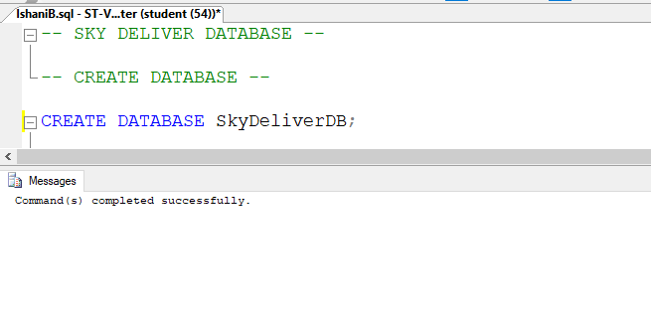
Figure 3 : Create Database

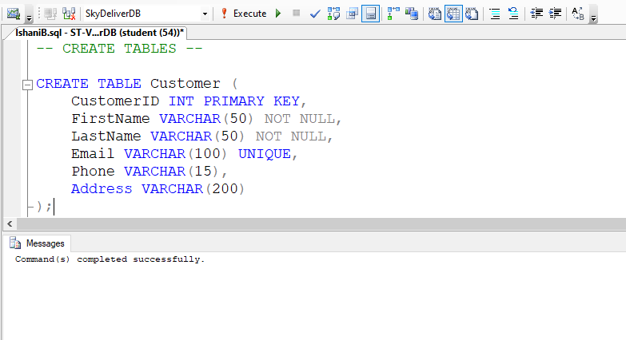
Figure 4 : Create Customer Table

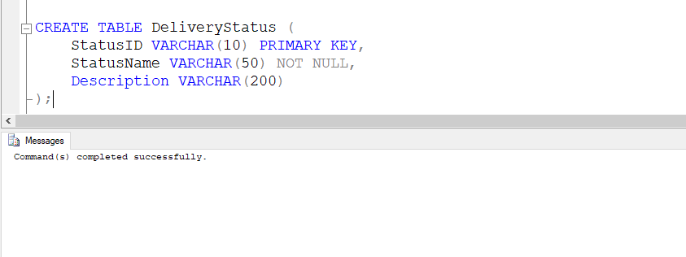
Figure 5 : Create Delivery Status Table

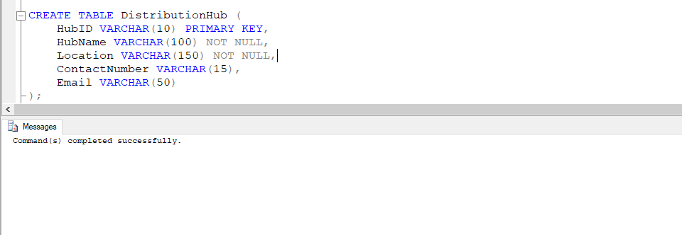
Figure 6 : Create DistributionHub Table

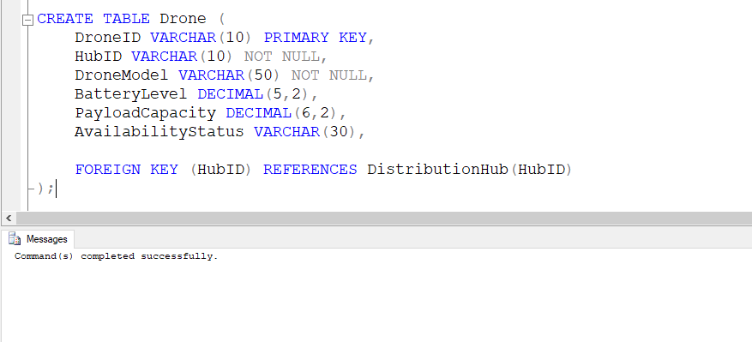
Figure 7 : Create Drone Table

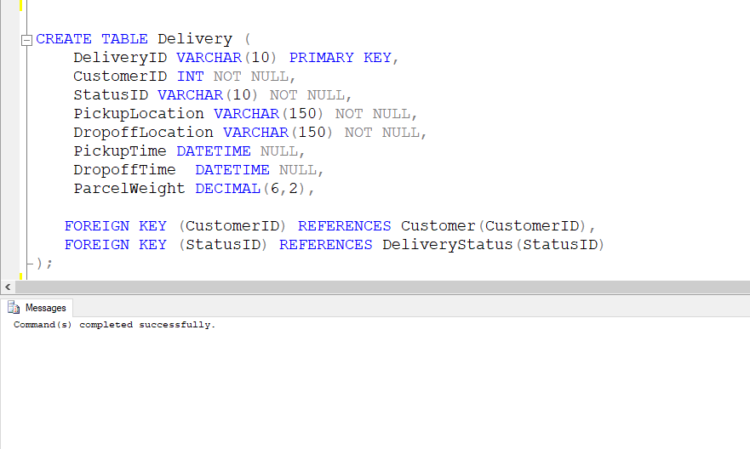
Figure 8 : Create Delivery Table

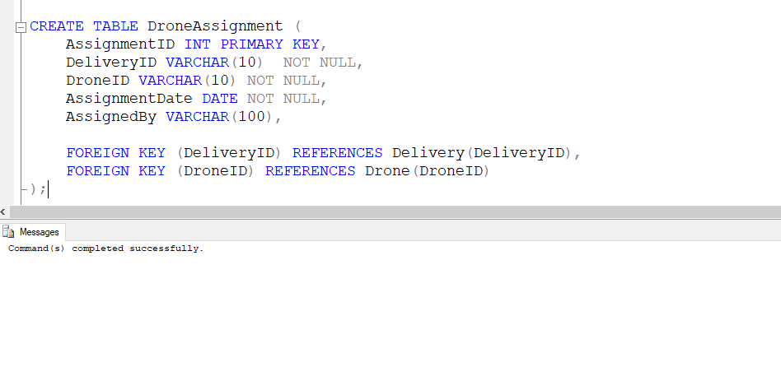
Figure 9 : Create DroneAssignment Table

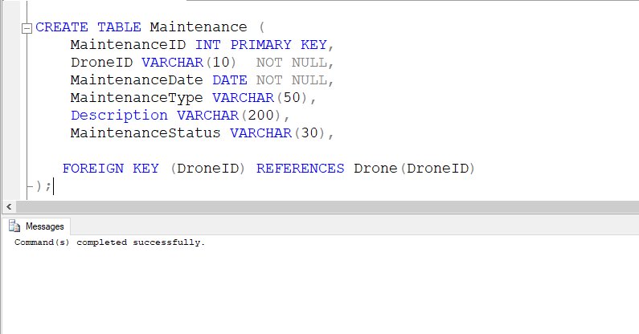
Figure 10 : Create Maintenance Table

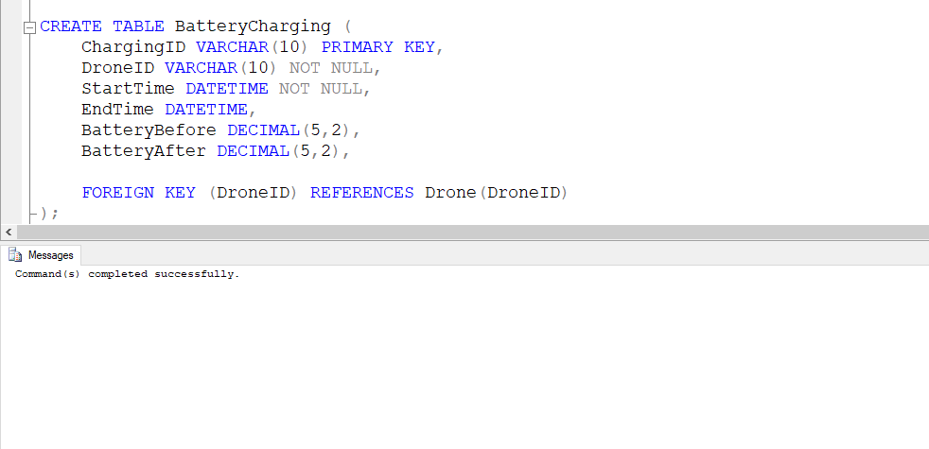
Figure 11 : Create BatteryCharging Table
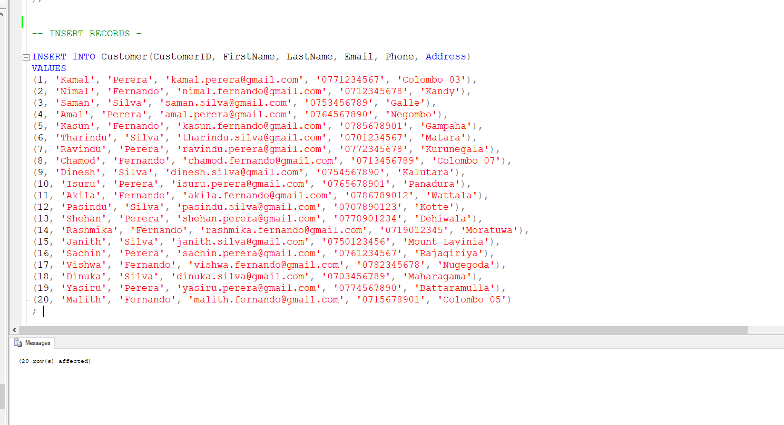
Figure 12 : Insert Customer Records

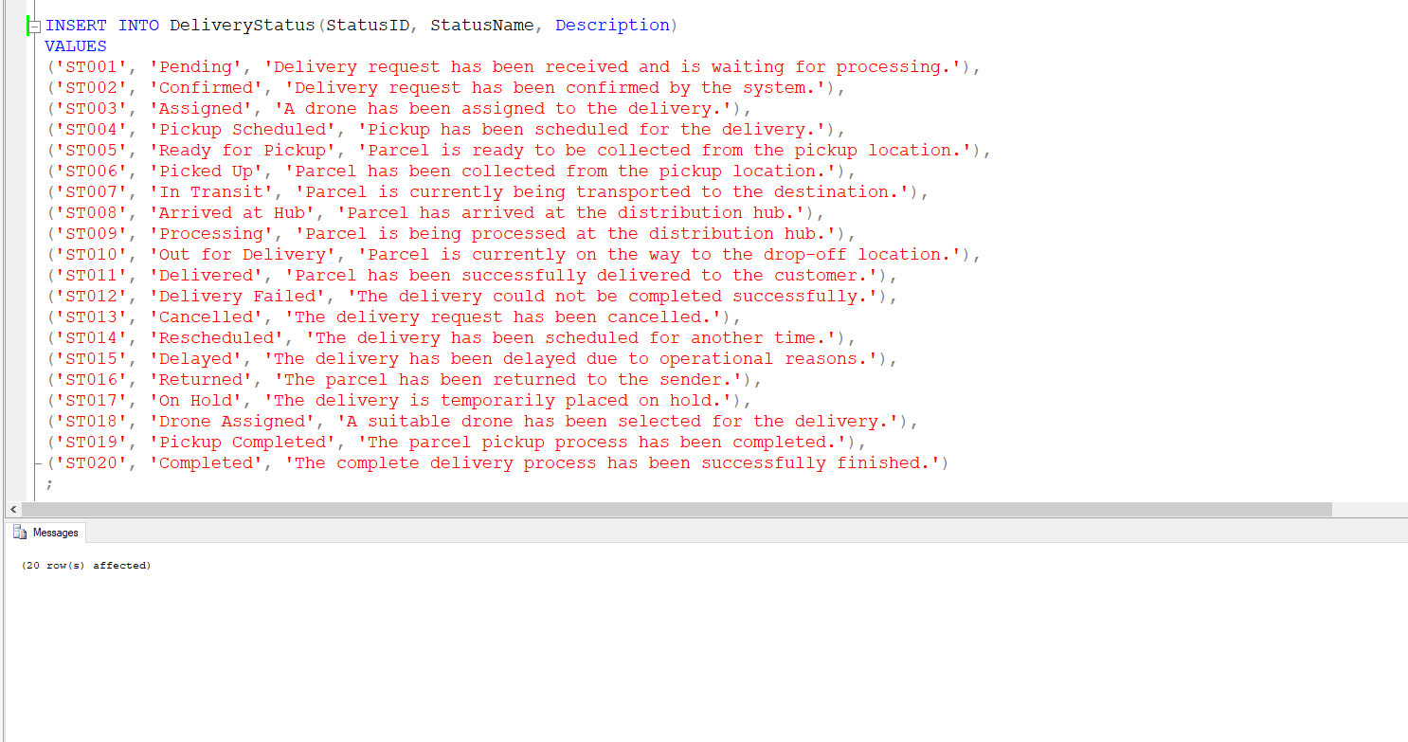
Figure 13 : Insert Delivery Status Records

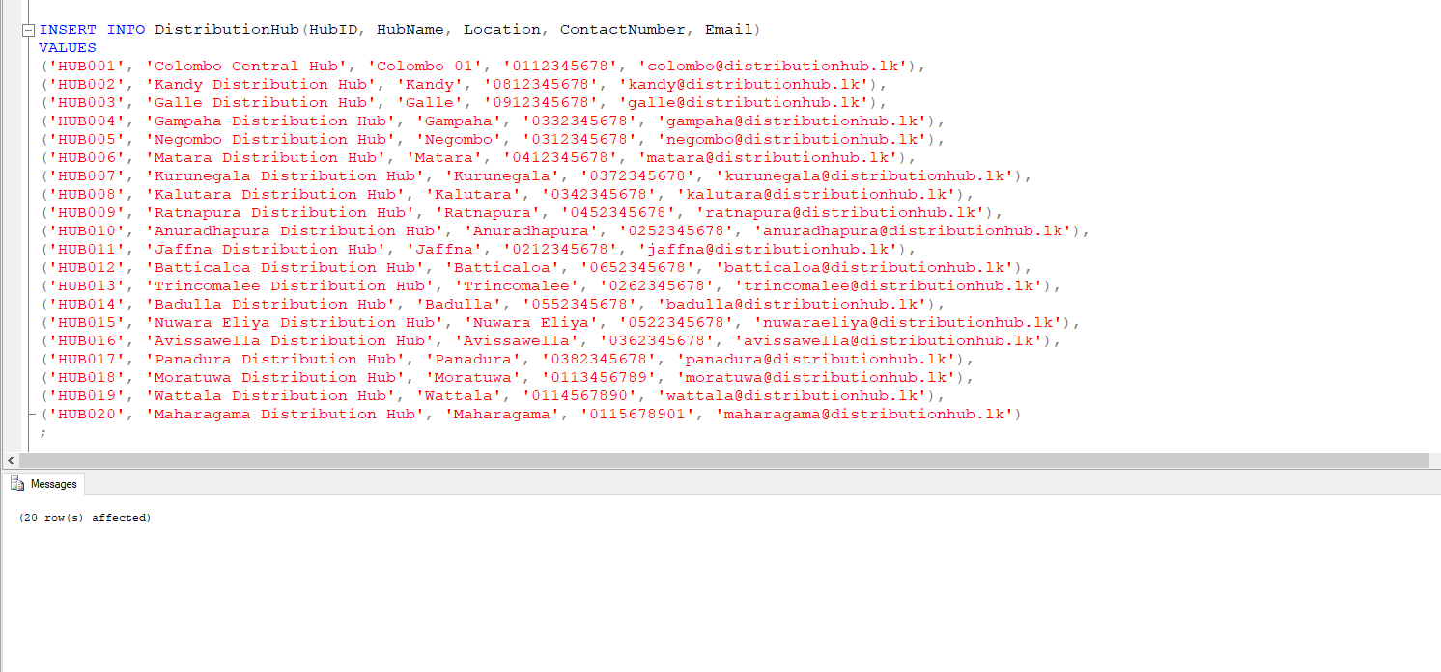
Figure 14 : Insert DistributionHub Records

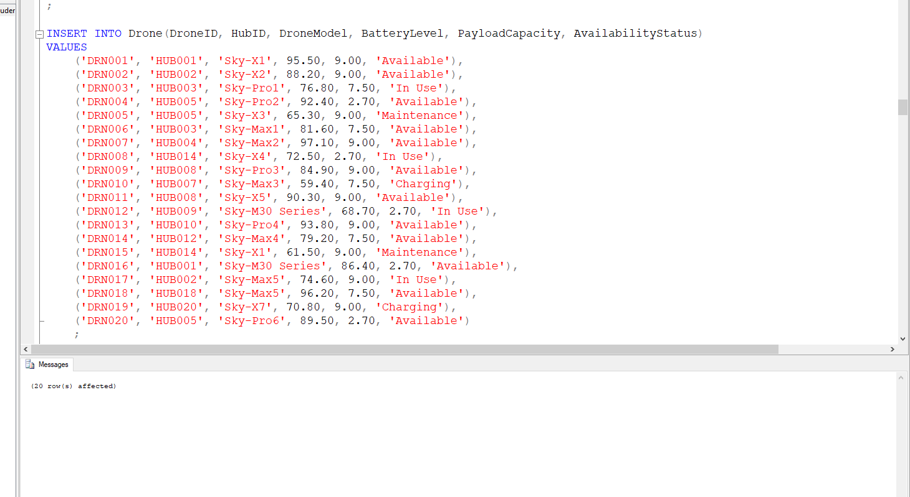
Figure 15 : Insert Drone Records

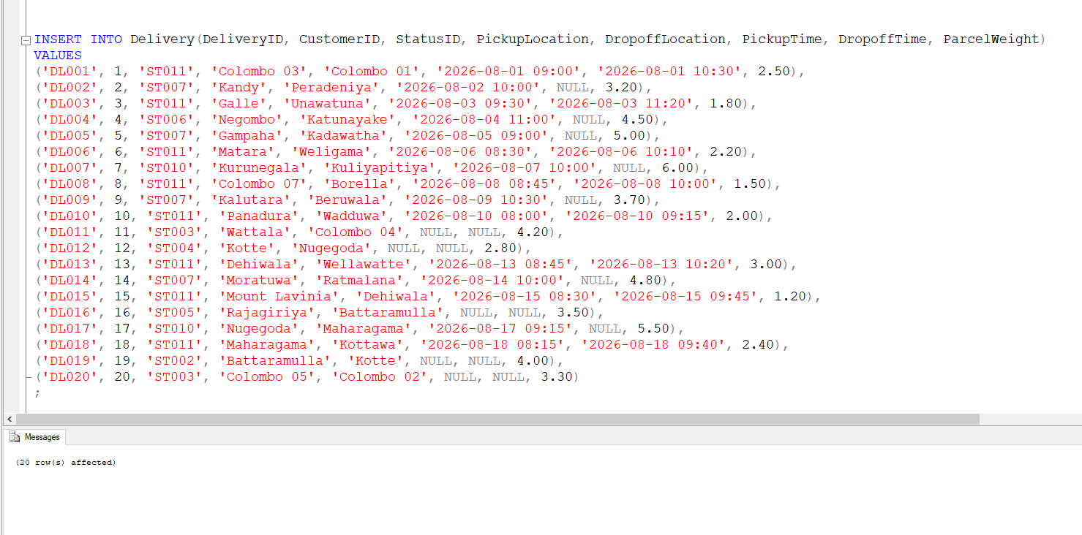
Figure 16 : Insert Delivery Records

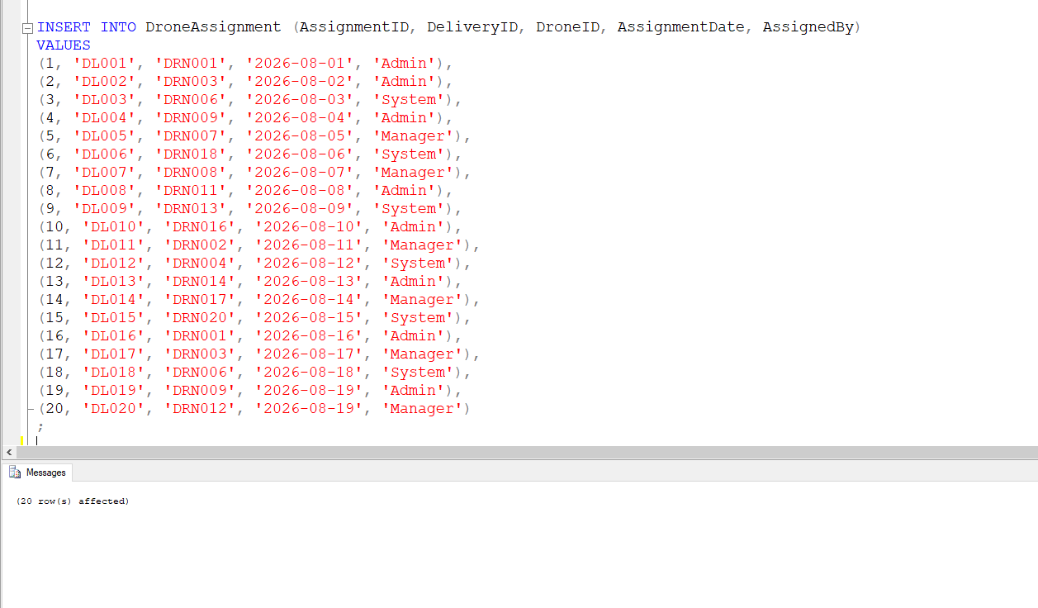
Figure 17 : Insert DroneAssignment Records

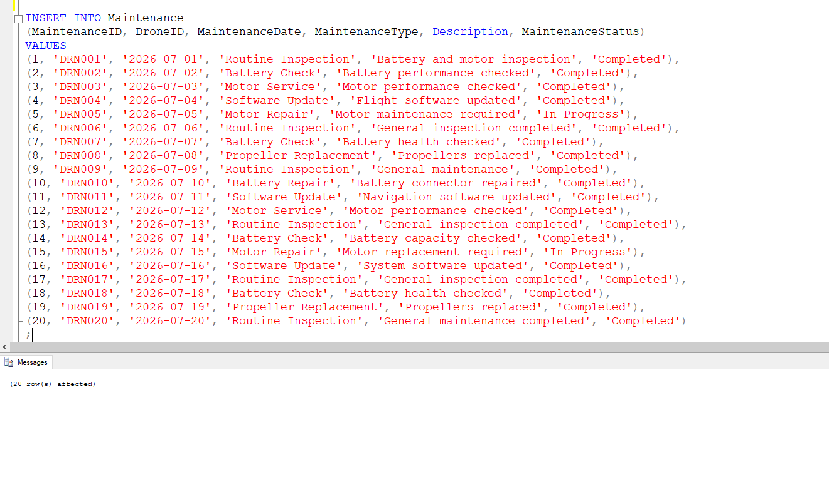
Figure 18 : Insert Maintenance Records

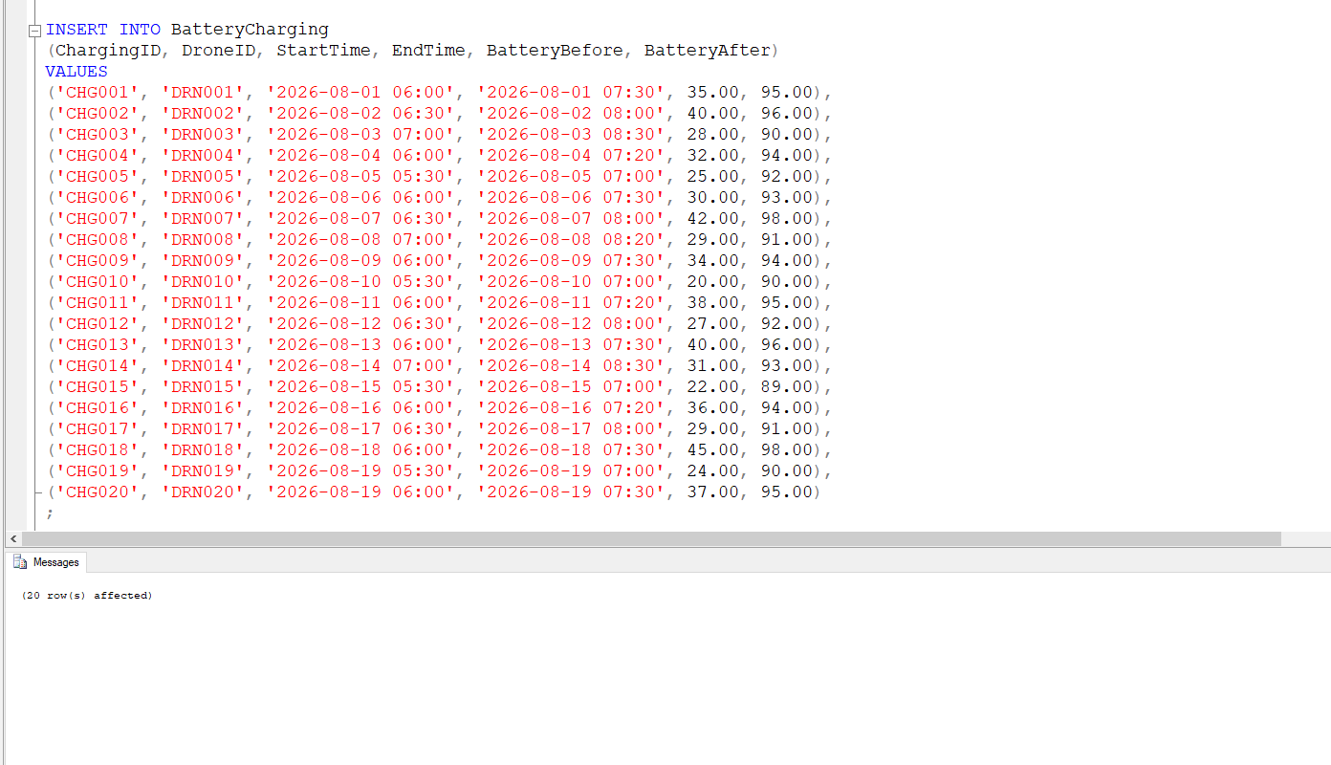
Figure 19 : Insert BatteryCharging Records

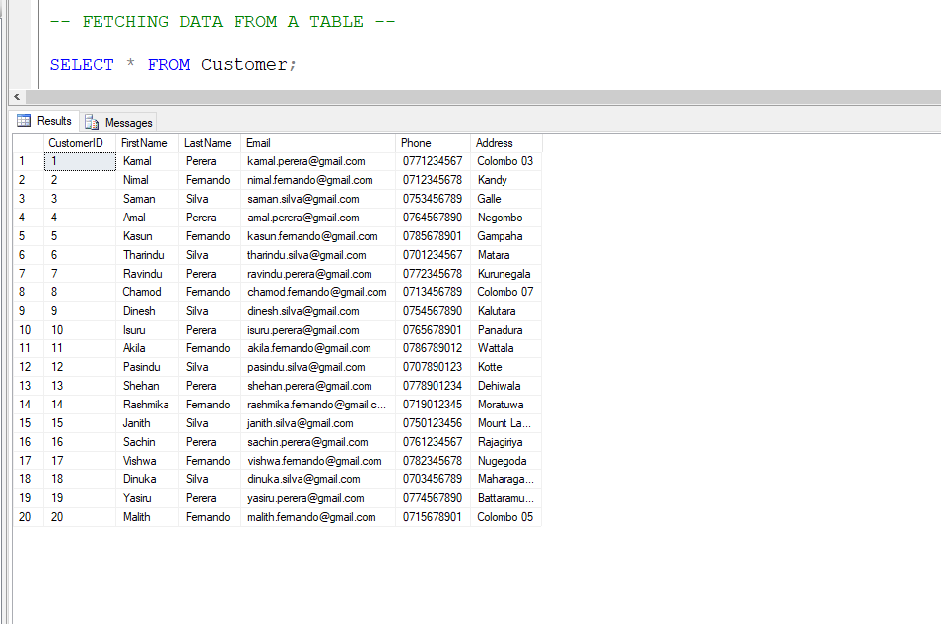
Figure 20 : Fetching Customer Data

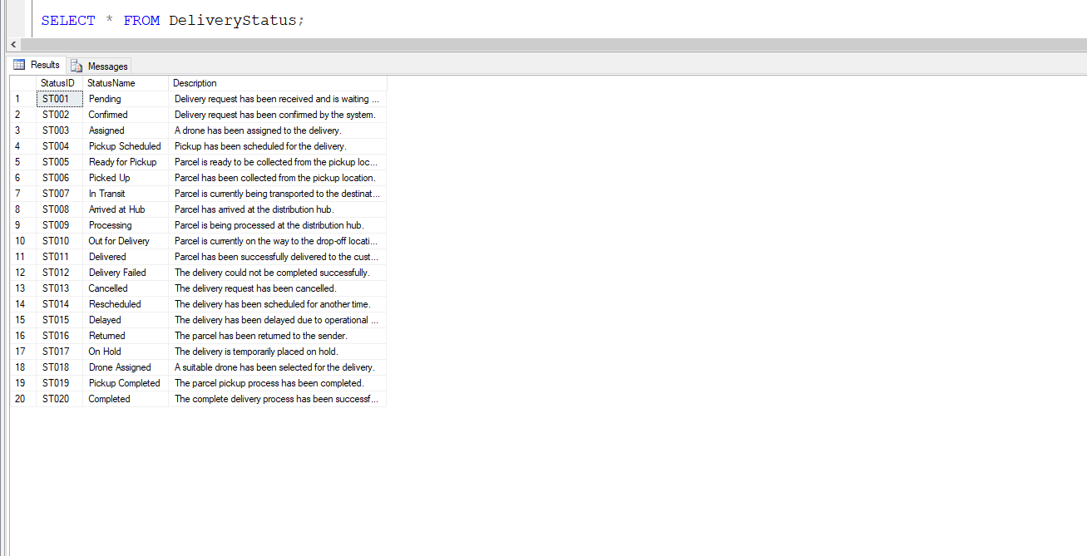
Figure 21 : Fetching DeliveryStatus Data

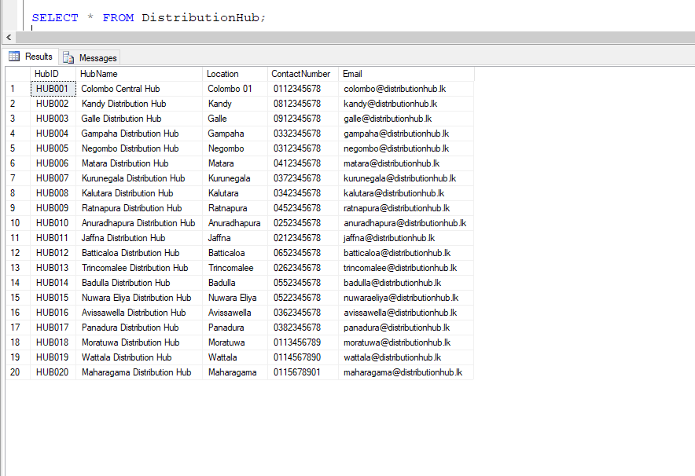
Figure 22 : Fetching DistributionHub Data

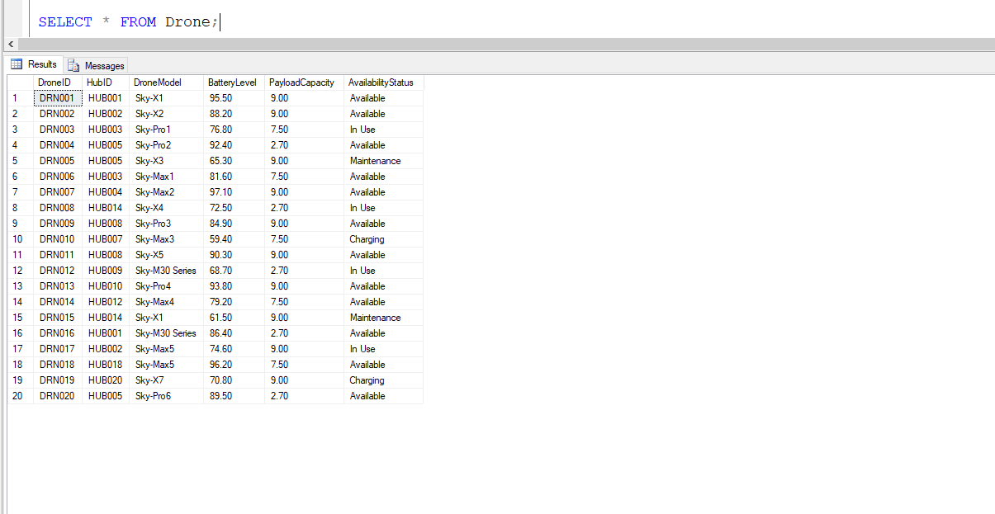
Figure 23 : Fetching Drone Data

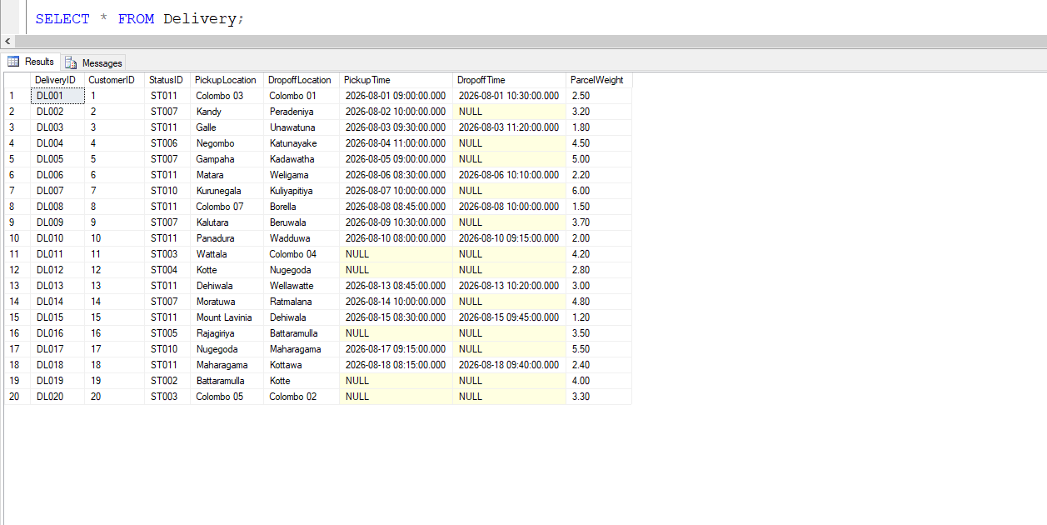
Figure 24 : Fetching Delivery Data

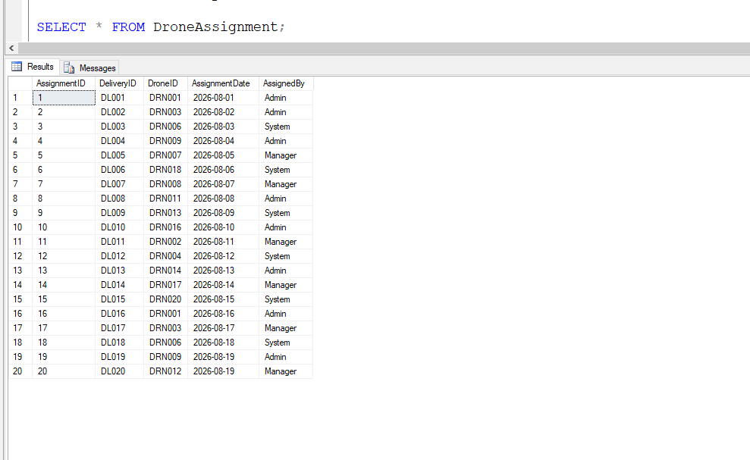
Figure 25 : Fetching DroneAssignment Data

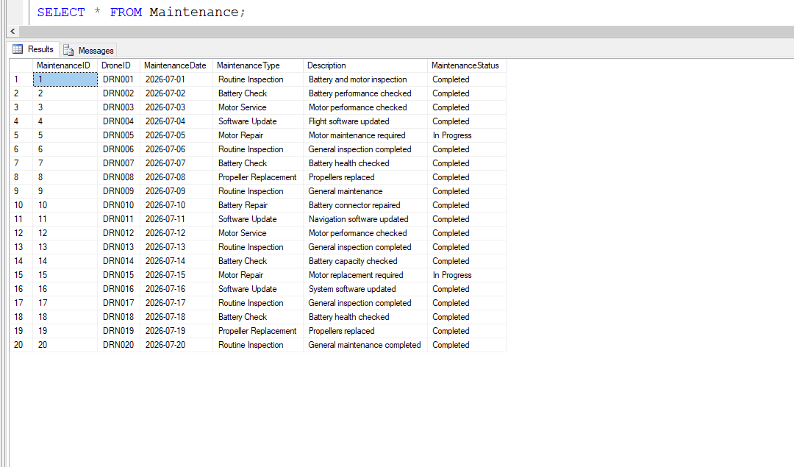
Figure 26 : Fetching Maintenance Data

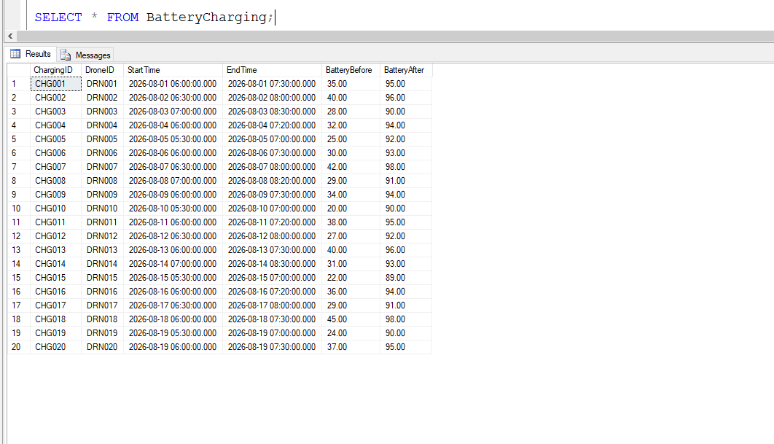
Figure 27 : Fetching BatteryCharging Data

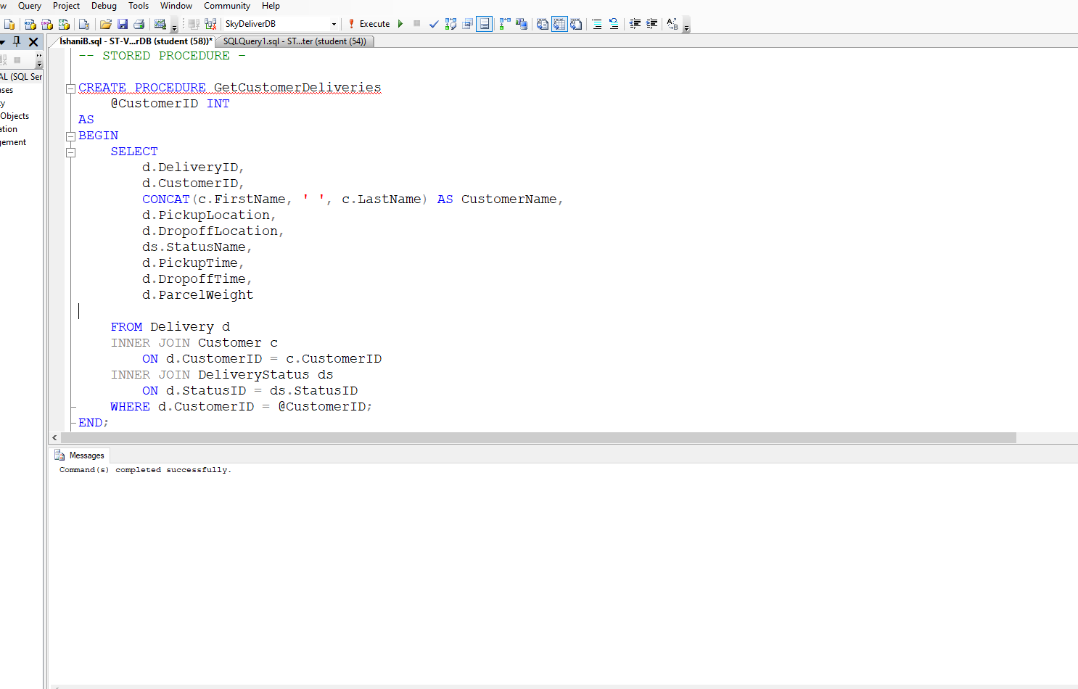
Figure 28 : Stored Procedure

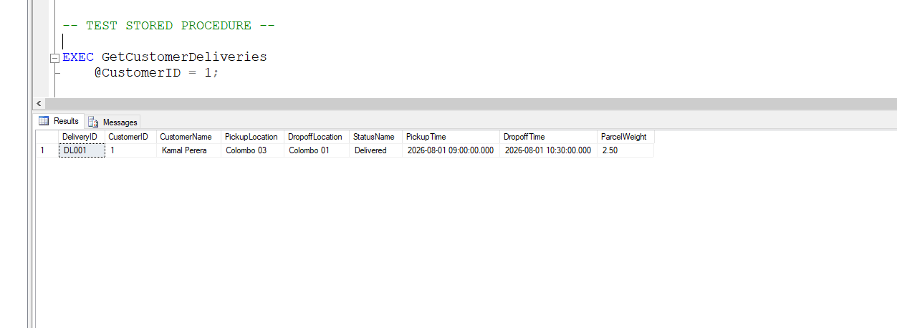
Figure 29 : Test Stored Procedure

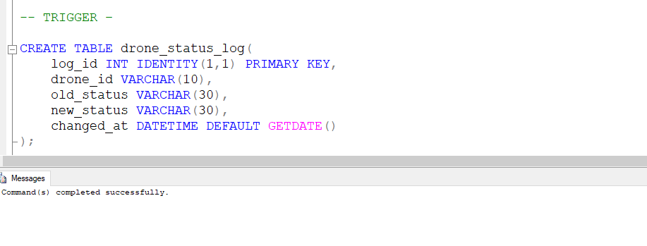
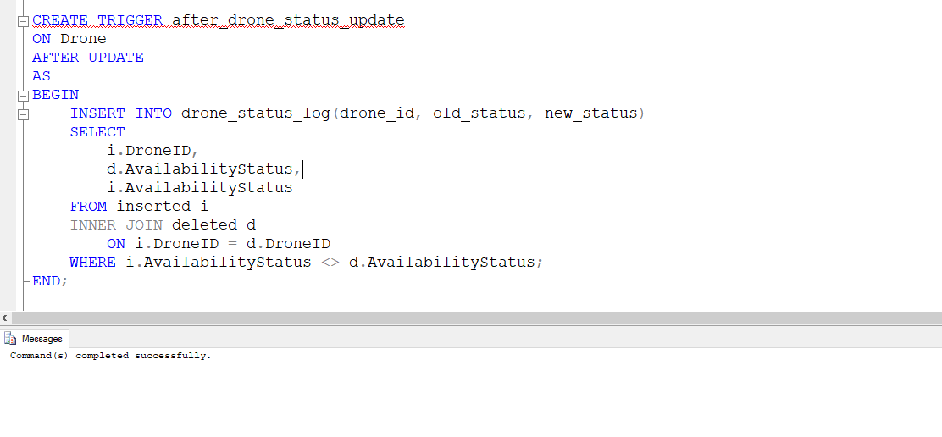
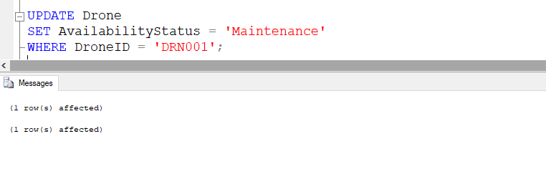
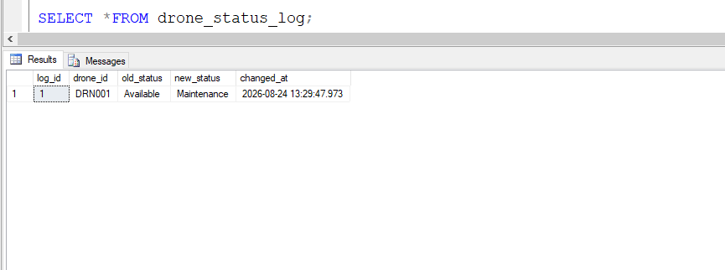
Figure 30 : Create Trigger

TASK 5 - SQL queries

- List all drones with their current status and battery level

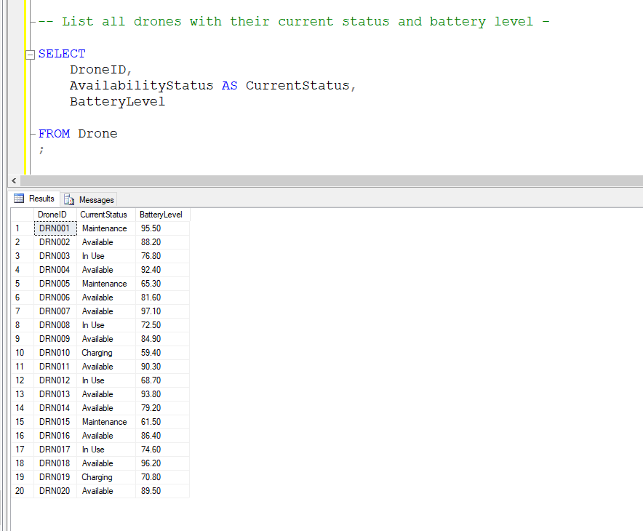
Figure 31 : Query 1

- Find all deliveries that are currently 'In Transit'

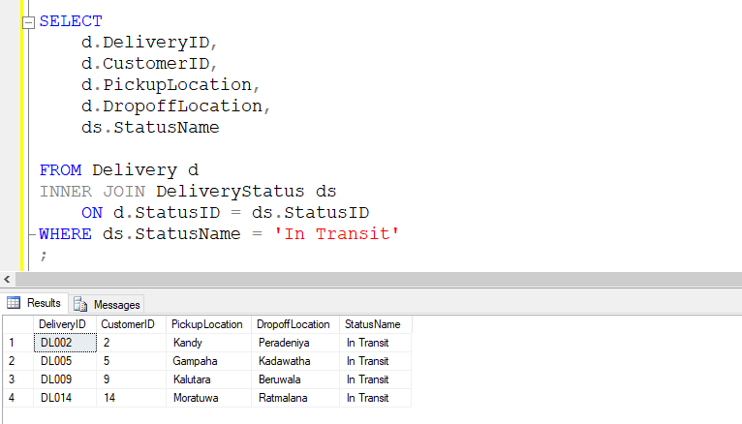
Figure 32 : Query 2

- Display deliveries with customer names and assigned drone IDs

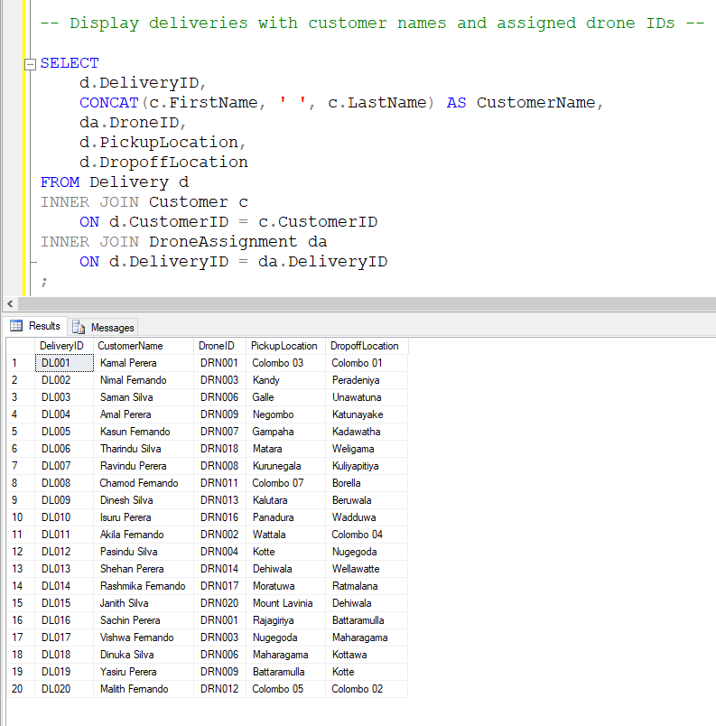
Figure 33 : Query 3

- Calculate total number of deliveries handled by each drone

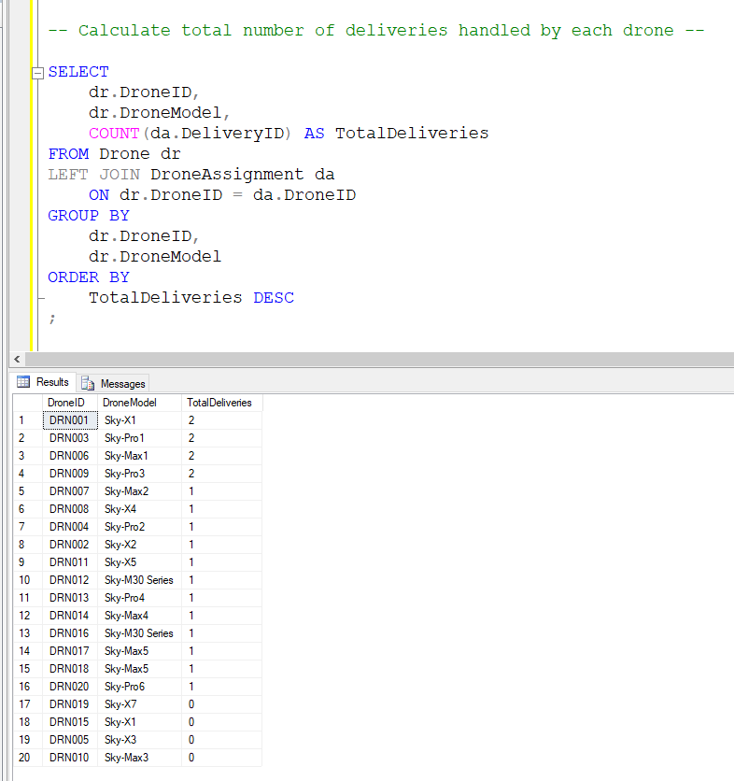
Figure 34 : Query 4

- Find the top 3 most efficient drones (least average delivery time)

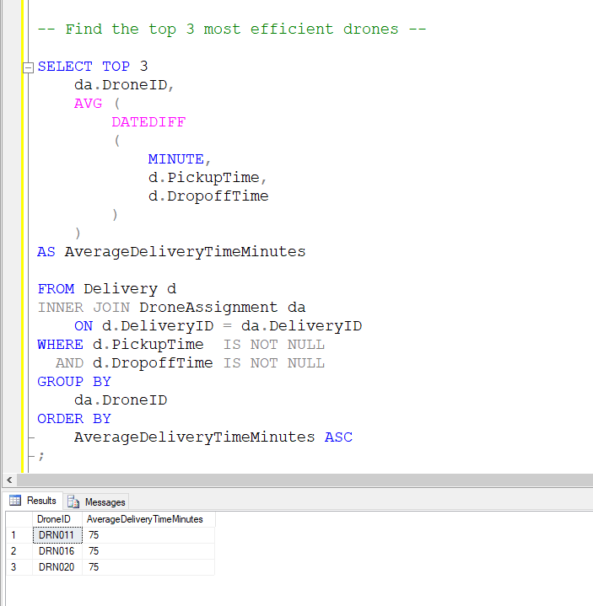
Figure 35 : Query 5

TASK 6 - Database Security, Backup and Recovery

Database security is very important for the SkyDeliver drone delivery system because the database stores important information about customers, delivery requests, drones, distribution hubs, maintenance records and delivery status. If unauthorized users access the database, they may change or delete important information. Therefore, suitable security, access control, backup and recovery strategies should be implemented to protect the SkyDeliver database.

Database Security

Access Control
Access control is one of the methods to ensure that only authorized users can access the database. The level of access has to be regulated depending on the user’s responsibilities to avoid illegal access and alteration of significant data.

The SkyDeliver system can use the following database roles:
Role | Responsibilities | Access
Database Administrator | Manage the complete database, users and security | Full access
Operations Manager | Manage deliveries, drone assignments and hubs | SELECT, INSERT, UPDATE
Delivery Staff | View and update delivery information | SELECT, UPDATE
Maintenance Staff | Manage drone maintenance and charging records | SELECT, INSERT, UPDATE
Reporting User | Generate delivery and performance reports | SELECT only
Table 38 : Database Roles
For example, a Reporting User only needs to view information and generate reports. Therefore, this user should not have permission to change or delete database records. This follows the principle of least privilege, where users receive only the access required for their work.

User Authentication

Users should log in using a username and strong password before accessing the system. Passwords should not be stored as plain text. They should be stored using secure password hashing.
For administrator accounts, Multi-Factor Authentication (MFA) can provide an additional layer of security. User accounts should also be reviewed regularly, and accounts that are no longer required should be disabled or removed.

Data Protection

SkyDeliver should protect customer and operational data from unauthorized access. Data transferred between the mobile application and server should use secure communication such as HTTPS/TLS.
The database server should also be protected using a firewall, and only trusted applications and authorized users should be allowed to connect to it.
Input validation and parameterized queries should be used to reduce the risk of SQL injection attacks. Primary keys, foreign keys and other database constraints should also be used to maintain data integrity.

Database Backup Strategy

Regular backups are required because database data can be lost due to hardware failures, software errors, accidental deletion or cyberattacks.
The SkyDeliver database can use the following backup methods:
- Full Backup:
A complete copy of the database can be created daily.
- Incremental Backup:
Data that has been changed since the last backup set is preserved by incremental. Incremental is suitable for saving space and reducing the time of the backup process.
- Transaction Log Backup:
Transaction logs can be backed up regularly to help recover recent database changes.
Backup copies should not be stored only on the main server. At least one copy should be stored in a separate secure location or cloud storage.

Backup Security

Backup files may include sensitive customer and business information. Thus, backups must be encrypted and only accessible to authorized database administrators.
The company can also adopt the 3-2-1 rule, which involves storing 3 copies of the data, saving them on 2 different mediums and keeping at least 1 copy offline.
Regular testing of the backups is also required to ensure that a restore is possible.

Database Recovery Strategy

A recovery strategy is required to restore the SkyDeliver database after a failure or data loss.If the main database server fails, the latest full backup can be restored first. Then the latest incremental backup and transaction log backups can be applied to recover recent changes.
For example, after a database failure, the company should be able to recover important information such as delivery requests, drone assignments and delivery statuses. Recovery testing should also be performed regularly to make sure the database can be restored successfully.

Disaster Recovery

SkyDeliver should have a disaster recovery plan for serious problems such as server failure, fire, natural disasters or major cyberattacks.
A backup database or cloud-based recovery system can be maintained so that the service can be restored if the main database becomes unavailable.
The recovery plan should include backup locations, recovery procedures, responsible staff members and regular recovery testing.

Backup and Recovery Schedule

Activity | Frequency | Purpose
Full Backup | Daily | Create a complete copy of the database
Incremental Backup | Every few hours | Store recent changes
Transaction Log Backup | Regular intervals | Recover recent transactions
Backup Verification | Weekly | Check that backups are usable
Recovery Testing | Monthly | Confirm that the database can be restored
Table 39 : Backup and Recovery Schedule

This schedule helps reduce the risk of permanent data loss and ensures that recent backup copies are available when required.

TASK 7 - Test Plan and Test Cases

Testing is an essential part of the SkyDeliver Drone Delivery Management System database development process. The objective of testing activities is to ensure that the database works correctly and consistently stores all the data, providing the right results for different inputs and operations.

The testing process focuses on validating database tables, relationships, constraints, SQL queries, stored procedures, and data retrieval operations. Both positive and negative test cases are used to identify whether the system behaves as expected.

Test Plan

Test Objectives

The testing of the SkyDeliver database is carried out to ensure that the system works correctly and handles data safely. The main objectives are:
- To check whether all database tables are created correctly.
- To confirm that valid data can be added successfully.
- To test primary and foreign key constraints.
- To check that required fields do not allow invalid NULL values.
- To ensure SQL queries provide correct results.
- To verify the operation of the stored procedure.
- To check the accuracy of drone and delivery information.
- To evaluate delivery performance results.
- To find and fix errors before finalizing the database.

Test Scope

The testing covers the main database components of the SkyDeliver system.

- In Scope,
The following areas will be tested:
- Customer table
- Delivery table
- Delivery Status table
- Distribution Hub table
- Drone table
- Drone Assignment table
- Maintenance table
- Battery Charging table
- Primary key constraints
- Foreign key constraints
- NOT NULL constraints
- SQL queries
- Stored procedures
- Data retrieval
- Delivery and drone relationships

- Out of Scope
The following areas are outside the scope of this database testing:
- Mobile application user interface
- Actual drone hardware
- Physical drone flight operations
- GPS hardware testing
- Real-world delivery operations
- Payment gateway integration
Testing Methods

Several testing methods will be used to validate the SkyDeliver database.

1. Functional Testing
Functional testing verifies whether the database performs the required operations correctly, such as inserting, updating, retrieving, and deleting data.

2. Constraint Testing
Primary key, foreign key, NOT NULL, UNIQUE, and other constraints will be tested to ensure that invalid data cannot be stored.

3. Query Testing
The SQL queries required by the assignment will be executed using the test data. The returned results will be compared with the expected results.

4. Negative Testing
Invalid inputs will be entered to verify that the database correctly rejects incorrect data.
For example, an invalid CustomerID can be used when inserting a delivery to test the foreign key constraint.

5. Integration Testing
Relationships between tables will be tested using SQL JOIN operations to verify that related records are retrieved correctly.

6. Stored Procedure Testing
The stored procedure implemented in the database will be executed with valid parameters and its output will be compared with the expected result.

Test Resources

The following resources are required to perform the testing.
Resource | Purpose
SQL Server | Database management and testing
SQL Server Management Studio (SSMS) | Execute SQL scripts and queries
SkyDeliver Database | System under test
Sample Test Data | Validate database operations
SQL Scripts | Create tables, constraints and database functions
Computer | Execute and document testing
Screenshots | Provide evidence of test results
Table 40 : Test Resources

Test Schedule

The testing activities can be carried out according to the following schedule.
Testing Activity | Duration
Database/table testing | Day 1
Sample data testing | Day 1
Constraint testing | Day 2
Relationship testing | Day 2
SQL query testing | Day 3
Stored procedure testing | Day 3
Error/negative testing | Day 4
Final verification | Day 4
Screenshot/documentation | Day 5
Table 41 : Test Schedule

Test Cases

The following test cases are designed to validate the SkyDeliver database.
Test ID | Test Case | Description | Expected Output |  | Actual Result | Status
TC001 | Insert Valid Customer | Verify that a valid customer record can be inserted into the Customer table | The new customer record should be inserted successfully |  | The customer record was inserted successfully | PASS
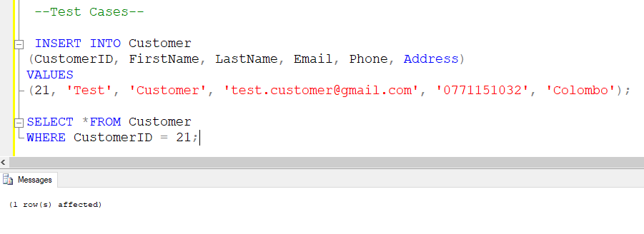

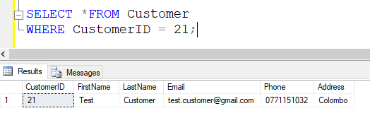
Figure 37 : TC001

TC002 | Duplicate Primary Key | Verify that the Customer table does not allow duplicate CustomerID values | The database should reject the record because CustomerID 1 already exists |  | The database rejected the record and displayed a primary key violation | PASS
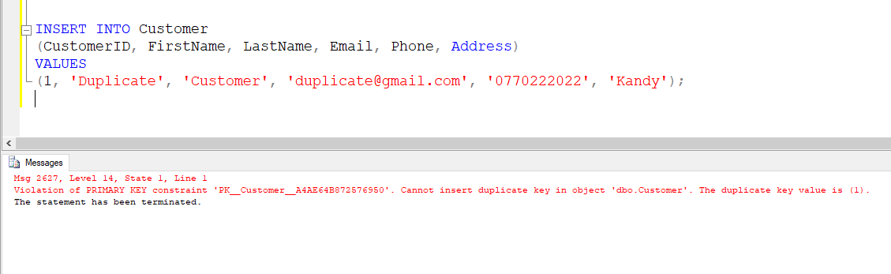
Figure 38 : TC002

TC003 | Invalid Foreign Key | Verify that an invalid CustomerID cannot be inserted into the Delivery table | The database should reject the record because CustomerID 999 does not exist in the Customer table |  | The database rejected the record due to the foreign key constraint | PASS
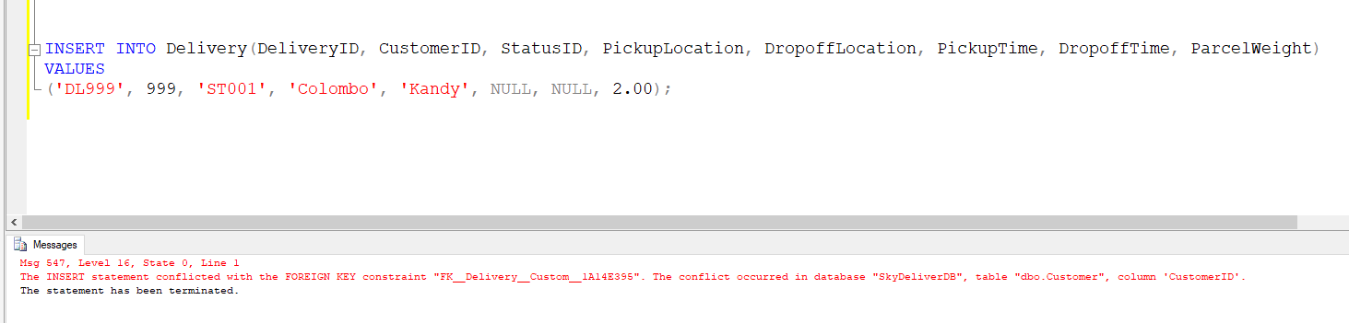
Figure 39 : TC003

TC004 | NOT NULL Validation | Verify that required fields cannot contain NULL values | The database should reject the record because FirstName is a required field |  | The database rejected the record because of the NOT NULL constraint | PASS
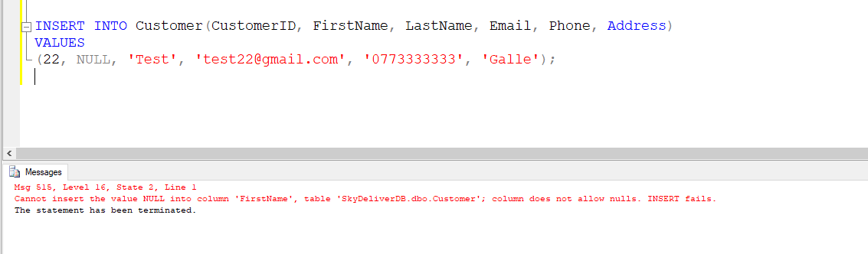
Figure 40 : TC004

TC005 | Find In Transit Deliveries | Verify that the database correctly identifies deliveries that are currently in transit | Only deliveries with the status In Transit should be displayed |  | The query returned the deliveries with the In Transit status | PASS
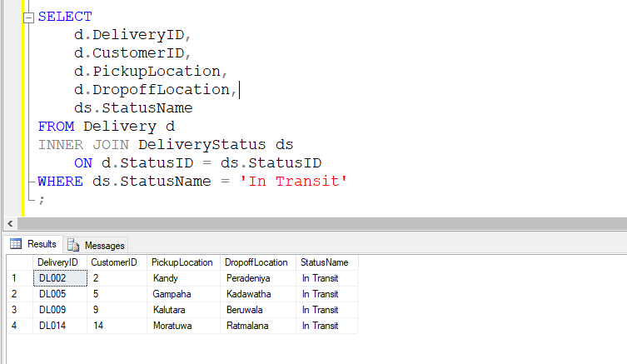
Figure 41 : TC005

TC006 | Display Customer Names and Assigned Drone IDs | Verify that delivery information can be combined with customer names and assigned drone IDs | The query should display each delivery with the relevant customer name and assigned DroneID |  | Customer names and assigned DroneIDs were displayed correctly | PASS
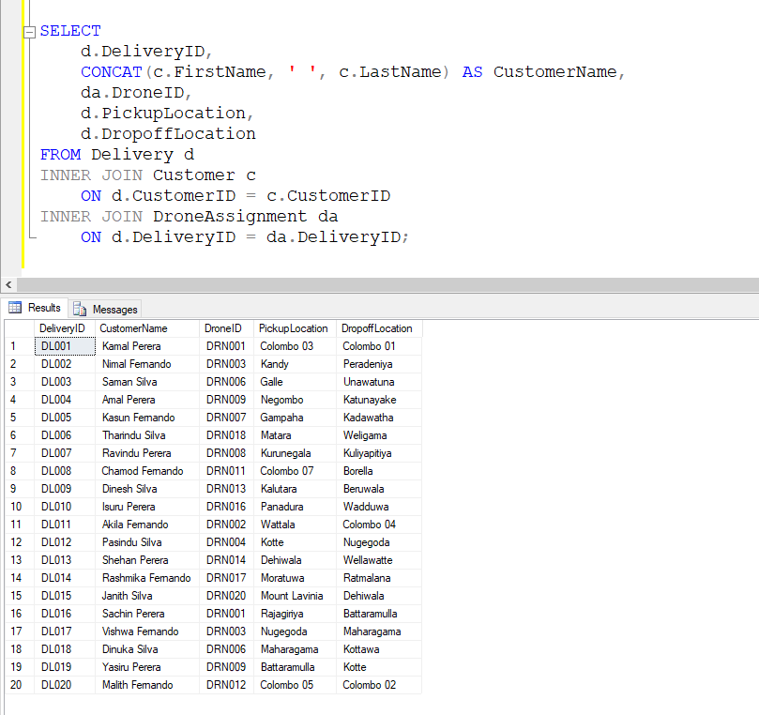
Figure 42 : TC006

TC007 | Stored Procedure Testing | Verify that the stored procedure correctly retrieves deliveries belonging to a selected customer | Only the deliveries belonging to CustomerID 1 should be displayed |  | The stored procedure returned the delivery records belonging to CustomerID 1 | PASS
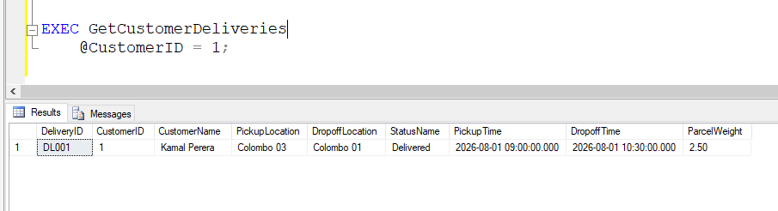
Figure 43 : TC007

TC008 | Top 3 Most Efficient Drones | Verify that the database can identify the three most efficient drones based on average delivery time | The three drones with the lowest average delivery time should be displayed |  | The query returned the three drones with the lowest average delivery time | PASS
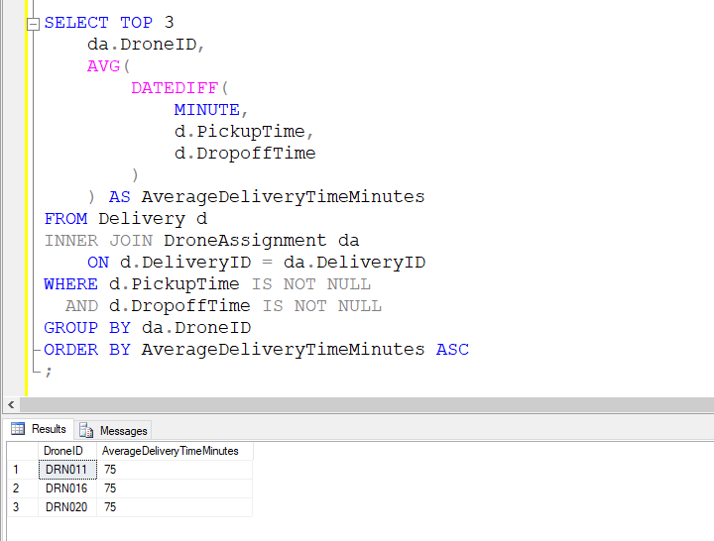
Figure 44 : TC008

TC009 | List All Drones with Status and Battery | Verify that the database can display all drones with their current status and battery level |  | All drones should be displayed with their DroneID, current status, and battery level | The query displayed all drones with their current status and battery level | PASS
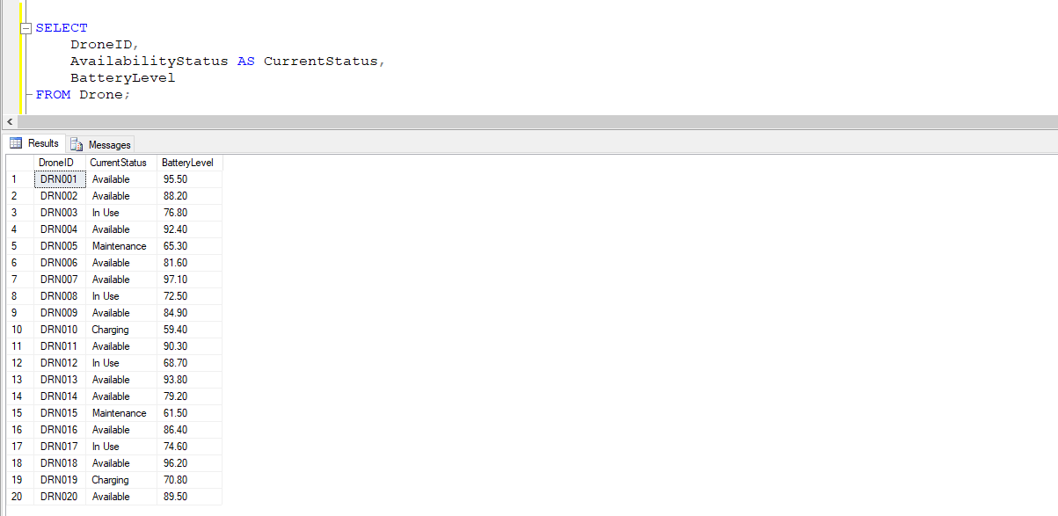
Figure 45 : TC009

TC010 | Find In-Transit Deliveries | Verify that the database can identify deliveries that are currently in transit |  | Only deliveries with the 'In Transit' status should be displayed | The query returned only deliveries with the 'In Transit' status | PASS
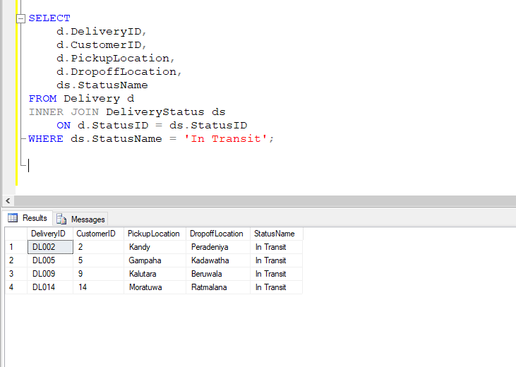
Figure 46 : TC 010

TC011 | Display Customer and Assigned Drone Details | Verify that the database can display delivery details with customer names and assigned drone IDs |  | Delivery ID, customer name, assigned drone ID, pickup location, and drop-off location should be displayed | The query successfully displayed delivery details with customer names and assigned drone IDs | PASS
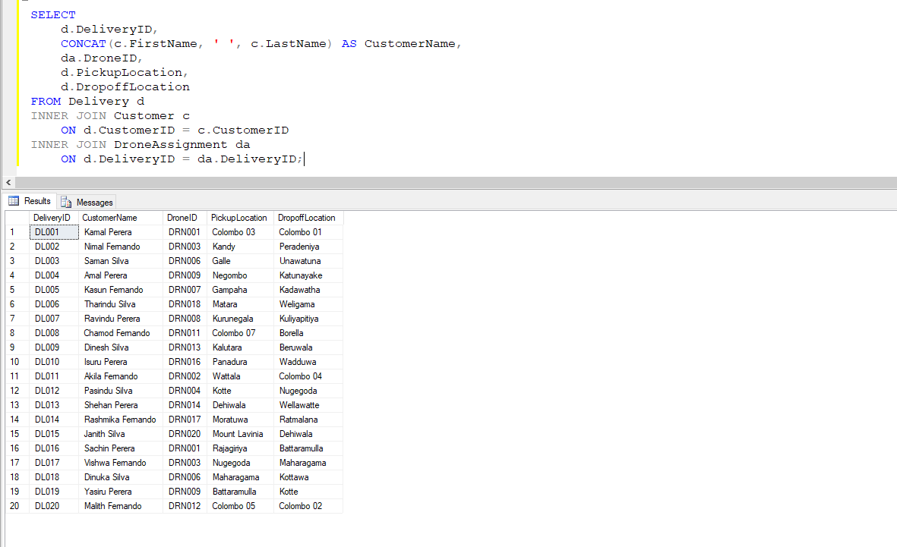
Figure 47 : TC 011

TC012 | Calculate Total Deliveries per Drone | Verify that the database can calculate the total number of deliveries handled by each drone |  | Each drone should be displayed with its total number of assigned deliveries in descending order | The query successfully calculated and displayed the total deliveries handled by each drone | PASS
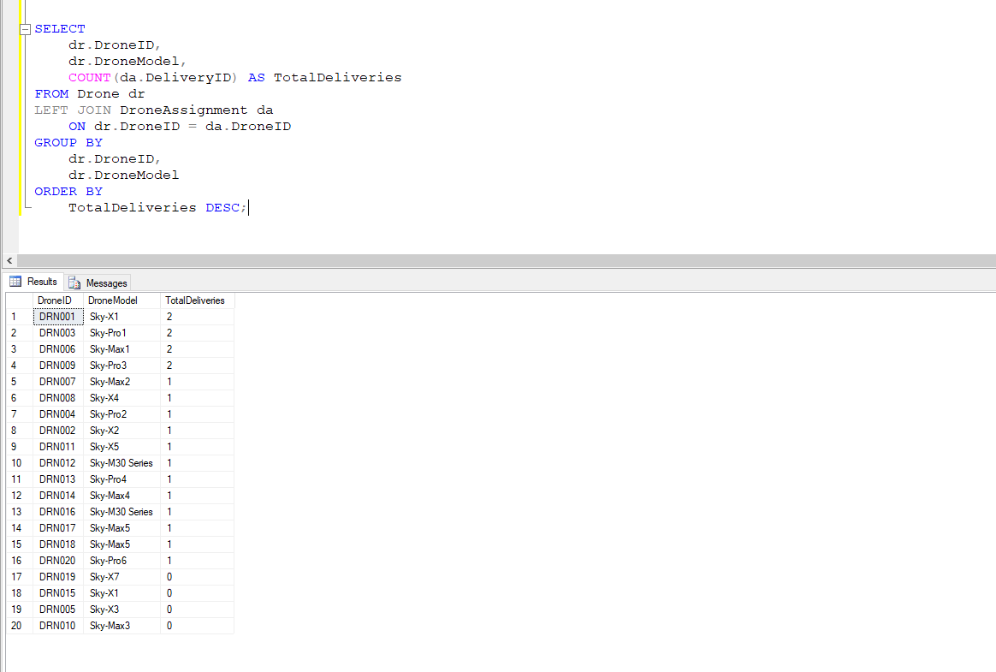
Figure 48 : TC 012

TC013 | Get Customer Delivery Details | Verify that the stored procedure can retrieve delivery details for a selected customer |  | All deliveries belonging to the specified CustomerID should be displayed with customer name and delivery status | The stored procedure successfully returned the delivery details for the selected customer | PASS
Figure 49 : TC 013

TC014 | Log Drone Status Changes | Verify that the trigger records changes to a drone's availability status |  | The drone ID, old status, new status, and change time should be recorded in the status log | The trigger successfully recorded the drone status change in the drone_status_log table | PASS
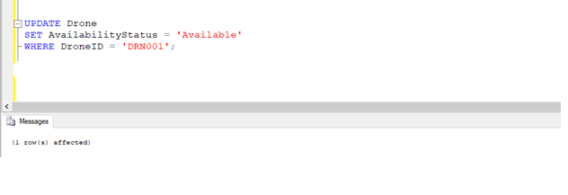
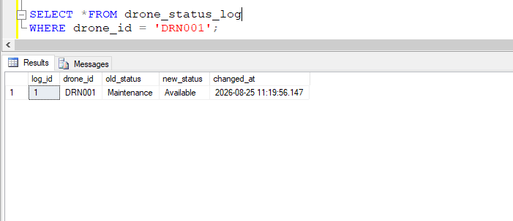
Figure 50 : TC 014

Table 42 : Test Cases

Conclusion

The SkyDeliver database was developed to support the main activities of a drone delivery service, including customers, deliveries, drones, hubs, assignments, maintenance, and battery charging.
A relational database was chosen because the system contains structured data and clear relationships. The ERD, primary keys, foreign keys, and 3NF normalization help maintain data accuracy and reduce unnecessary duplication.
The database was implemented using SQL Server with tables, constraints, sample data, and SQL queries. Testing was carried out to check the database operations and relationships. Security, access control, backup, and recovery were also considered to protect the data.
Overall, the database provides a reliable foundation for SkyDeliver. In the future, features such as GPS tracking, automated drone selection, demand prediction, and mobile application support could be added.

References

- Connolly, T. and Begg, C. (2015) Database Systems: A Practical Approach to Design, Implementation, and Management. 6th edn. Harlow: Pearson.
- Coronel, C. and Morris, S. (2019) Database Systems: Design, Implementation, & Management. 13th edn. Boston: Cengage Learning.
- Date, C.J. (2019) Database Design and Relational Theory: Normal Forms and All That Jazz. 2nd edn. Berkeley, CA: Apress.
- Elmasri, R. and Navathe, S.B. (2016) Fundamentals of Database Systems. 7th edn. Boston: Pearson.
- Garcia-Molina, H., Ullman, J.D. and Widom, J. (2009) Database Systems: The Complete Book. 2nd edn. Upper Saddle River, NJ: Pearson.
- Hernandez, M.J. (2013) Database Design for Mere Mortals: A Hands-On Guide to Relational Database Design. 3rd edn. Boston, MA: Addison-Wesley.
- IBM (2026) What is a relational database? Available at: IBM relational database overview (Accessed: 17 August 2026).
- ISO/IEC (2011) ISO/IEC 25010:2011 Systems and software engineering – Systems and software Quality Requirements and Evaluation (SQuaRE) – System and software quality models. Geneva: International Organization for Standardization.
- Microsoft (2026) SQL Server documentation. Available at: Microsoft SQL Server documentation (Accessed: 17 August 2026).
- Microsoft (2026) SQL Server security. Available at: SQL Server security documentation (Accessed: 17 August 2026).
- Microsoft (2026) Transact-SQL (T-SQL) documentation. Available at: Transact-SQL documentation (Accessed: 17 August 2026).
- Microsoft (2026) Backup and restore SQL Server databases. Available at: Microsoft SQL Server backup and restore documentation (Accessed: 17 August 2026).
- MongoDB (2026) MongoDB Documentation – Documents. Available at: MongoDB documentation (Accessed: 17 August 2026).
- Myers, G.J., Sandler, C. and Badgett, T. (2011) The Art of Software Testing. 3rd edn. Hoboken, NJ: John Wiley & Sons.
- Oracle (2026) Database Concepts. Available at: Oracle Database Documentation (Accessed: 17 August 2026).
- Ramakrishnan, R. and Gehrke, J. (2003) Database Management Systems. 3rd edn. New York: McGraw-Hill.
- Silberschatz, A., Korth, H.F. and Sudarshan, S. (2019) Database System Concepts. 7th edn. New York: McGraw-Hill Education.

Appendix



