Tab 1

Comprehensive Report

for the Creation of Knowledge Graphs and Mindmaps of Agricultural Texts: A Study of Rain Prediction Methods in the Kr̥ṣiparāśara

As a part of the Course:

RDT 601- Design Thinking for Rural Applications

Under the Guidance of
Prof. (Dr.) Ganti Suryanarayana Murthy



Submitted by
Buddhodev Ghosh
PhD Student (2501192002)
Centre for Rural Development and Technology (CRDT)
Indian Institute of Technology, Indore

Introduction
Ancient Indian farmers did not have modern instruments, satellites, or weather forecasts. Still, they were able to predict rain with considerable accuracy. One of the oldest and most respected agricultural texts is Kṛṣiparāśara. In this text, the sage Parāśara explains various traditional methods for predicting when rain will come, how much rain may fall, and what type of rain it will be. These methods are based on observing the sky, stars, clouds, wind, animals, and even human experiences.
Today, we aim to convert this old knowledge into modern tools, such as knowledge graphs, mind maps, and advisory systems. These tools can help farmers understand traditional wisdom in a simple, visual way. They can also be used to design new rural technologies that support farming and climate resilience.

Importance of Rain in Agriculture

Rain is the most important support system for agriculture. Without rain, farming is not possible, and human life itself becomes difficult. This truth was clearly understood even in ancient times. The agricultural text Kṛṣiparāśara strongly states that all farming depends on rain and even life depends on rain. Therefore, farmers must first learn how to understand rain. This is why ancient scholars gave great importance to rain prediction and developed many powerful methods to predict rainfall. That’s why Parāśara says:
वृष्टिमूला कृषिः सर्वा वृष्टिमूलञ्च जीवनम्।
तस्मादादौ प्रयत्नेन वृष्टिज्ञानं समाचरेत्।। 10
This report extracts and structures the rain prediction methods from Kṛṣiparāśara into a framework useful for:
- Agricultural decision-making tools
- Mobile-based advisory systems
- Early warning systems
- Knowledge system digitisation
- Curriculum and training for rural communities

Knowledge Architecture in Kṛṣiparāśara
Rain prediction in Kṛṣiparāśara is based on three big ideas:
- How much rain will fall
- What type of rain will fall
- When will the rain fall
Everything described in the text can be placed under one of these three headings.

Two Main Methods of Rain Prediction

Kṛṣiparāśara explains that rain prediction is done in two main ways.

The first method is the observational method, where rain is predicted by watching nature, animals, clouds, wind, lightning, and even human bodily signs.

The second method is the calculation method, where planetary positions, stars, and mathematical calculations are used. Both methods together give strong and reliable predictions.

Yearly Ruler Planet and Its Effect on Rain

Every year is ruled by a specific planet. The ruling planet is found using a formula based on the Śaka year. Once the ruler planet is known, that planet decides how rainfall will be in that year.

If the Sun rules the year, rainfall will be average.

If the Moon rules, rainfall will be heavy and beneficial.

If Mars rules, rainfall will be very poor and harmful.

If Mercury rules, rainfall will be good and healthy.

If Jupiter rules, rainfall will be auspicious and balanced.

If Venus rules, rainfall will be excellent and abundant.

If Saturn rules, rainfall will be very weak with drought and dust.

Along with the ruler planet, there is also a minister planet, which also supports rainfall prediction in the same way.

Cloud Types and Their Meaning

The text explains that clouds also show rainfall patterns. There are four main types of clouds:

Āvarta – Rain in only a few places

Saṁvarta – Rain everywhere

Puṣkara – Very little rain

Droṇa – Very heavy rain, earth gets filled with water

These cloud types are calculated using the Śaka year number.

Measuring the Quantity of Rainfall

Rainfall quantity is measured using an ancient unit called Āḍhaka. The position of the Sun and Moon in zodiac signs decides how many āḍhakas of rain will fall. Different zodiac combinations give different rainfall volumes such as 50, 80, 96, or 100 āḍhakas. This method helps farmers estimate how wet the year will be.

The rain Lord Indra is said to distribute rain in this way:

Most rain goes to oceans

Then to mountains

Then to plains and farming lands

Prediction of Rain Using Wind in the Month of Pauṣa

The wind direction in the month of Pauṣa (December–January) is used to predict rainfall for the year.

Wind from north and west = rainfall

Wind from south and east = no rainfall

No wind = drought

Irregular wind = irregular rainfall

A simple wooden stick with a cloth flag is used to observe wind day and night.

Special signs in Pauṣa like fog, dust storms, heavy clouds, or lightning indicate that the land will be flooded with rain later in the year.

Rain Prediction in Māgha, Phālguna, and Caitra

During Māgha (January–February), if storms or thunder happen on special lunar days, it indicates a good monsoon and good crops.
If clouds stay low till November, continuous rain is assured.

In Phālguna, certain star and sun combinations decide whether rainfall will be weak, medium, heavy, or excessive.

In Caitra, rainfall depends on:

Which weekday the bright fortnight begins

Which nakṣatra dominates the sky

If Caitra begins on Monday, the whole year becomes very wet. If it begins on Saturday, severe drought happens.

Rain Prediction in Vaiśākha Using Ritual Method

In Vaiśākha, a unique ritual method is used. A wooden stick is fixed in flowing water at night after chanting a mantra. In the morning, the water level on the stick is checked:

If the water level is same, rainfall will be same as last year

If the water level is lower, rainfall will be less

If the water level is higher, rainfall will be double

This is a symbolic but practical water-based forecasting method.

Rain Prediction in Jyeṣṭha and Āṣāḍha

In Jyeṣṭha, if the sky is cloudless on certain stars but rain happens later in Śrāvaṇa, then the year is very prosperous.

In Āṣāḍha, wind direction on full-moon day decides rainfall:

East wind gives good rain

South gives crop destruction

West gives thunder rain

North gives prosperous crops

If rain falls on the 9th day of Āṣāḍha, rain will surely continue throughout the year.

Rain Prediction in Śrāvaṇa

If it rains when the Sun is in Rohiṇī nakṣatra, then rains continue till November.
If no rain falls in Rohiṇī, famine and crop failure are strongly indicated.

Sudden Rain Prediction Using Natural and Living Signs

Kṛṣiparāśara gives very practical signs for sudden rain:

Ants carrying eggs and migrating

Frogs croaking loudly

Cats, mongooses, snakes running

Children playing with mud

Peacocks dancing

Birds drying their wings

Crickets chirping

Body pain during damp air

All of these clearly indicate rain will start very soon.

Prediction Using Planetary Movement

Rain also comes during:

Planetary rising and setting

Retrograde (vakra) movement

Jupiter’s movement in Citra and Svāti

Sometimes these cause sudden cloud bursts and heavy rain.

Indications of Famine

Certain planetary positions cause drought:

If Mars moves through specific nakṣatras

If the Sun moves behind Mars

If Venus gets blocked

These create conditions of severe dryness and famine.

Mindmap Layout (Basic Textual Design)

Main Subject: “Rain Prediction — Kṛṣiparāśara”
Branches:
- Rainfall Amount
→ Astronomical
- Rain Type
→ Cloud-based
→ Famine-related
- Rainfall Timing
  - General Prediction
→ Planets
→ Stars
→ Conjunctions
  - Sudden Rain
→ Nature
→ Animals
→ Humans
  - Prior Rain
    - Daily: Winds
    - Monthly: Cloud, stars, wind, festivals
    - Yearly: Planetary ruler, minister, clouds
Application in Rural Applications

A. Weather Advisory App Based on IKS
- Integrate natural indicators (birds, insects, wind direction)
- Combine with astronomical markers
- Presented in simple icons for farmers

B. Community Training Material
- Posters with colour-coded mindmaps
- Audio/manual explaining each sign

C. Early Warning Systems
- Daily, monthly, yearly modules
- Identification of famine indicators

D. Integration with AI–IKS Hybrid Models
- Sensor data + traditional observational data
- Probabilistic rainfall prediction

Conclusion
Kṛṣiparāśara demonstrates how ancient Indian agriculture utilised a combination of astronomy, natural observation, and everyday experience to comprehend the weather. These methods are easy, practical, and based on common-sense observation that anyone can learn.
By creating knowledge graphs and mind maps from these methods, we can present this wisdom in simple visual forms. This can help farmers, students, researchers, and rural innovators use traditional knowledge in modern agriculture, and this structured representation enhances the applicability of traditional agricultural wisdom to modern rural development and climate resilience.
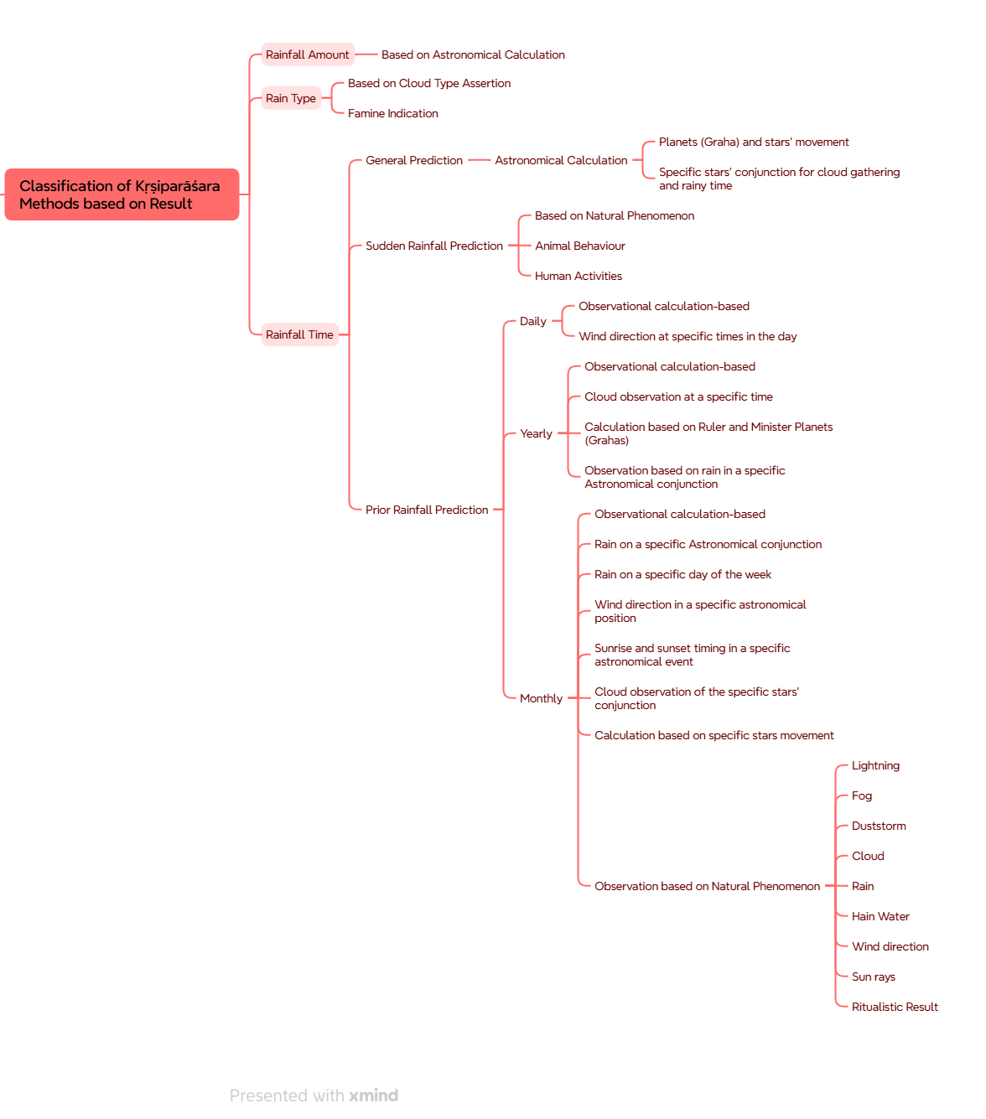
The Basic Mind Map (Extend one is attached in the next page)

