# esp32-home-XMasMan

Batterie 3,3 V (3,0V)

300mA current max. ~250mA nominal

PIN Setup:

#define PIN_GPIO_PIR_DATA 14

#define PIN_RELAY_OUT 15

#define PIN_ANI_POT 2

Possible Potentiometer settings:

20s – 120s output enable after detection

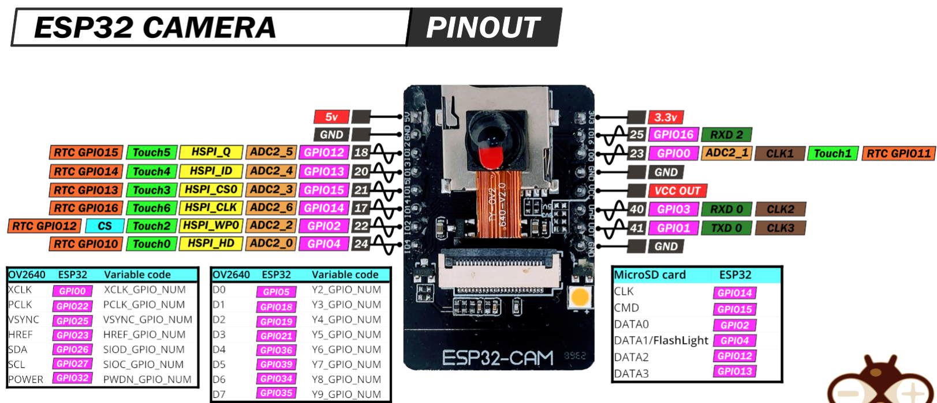

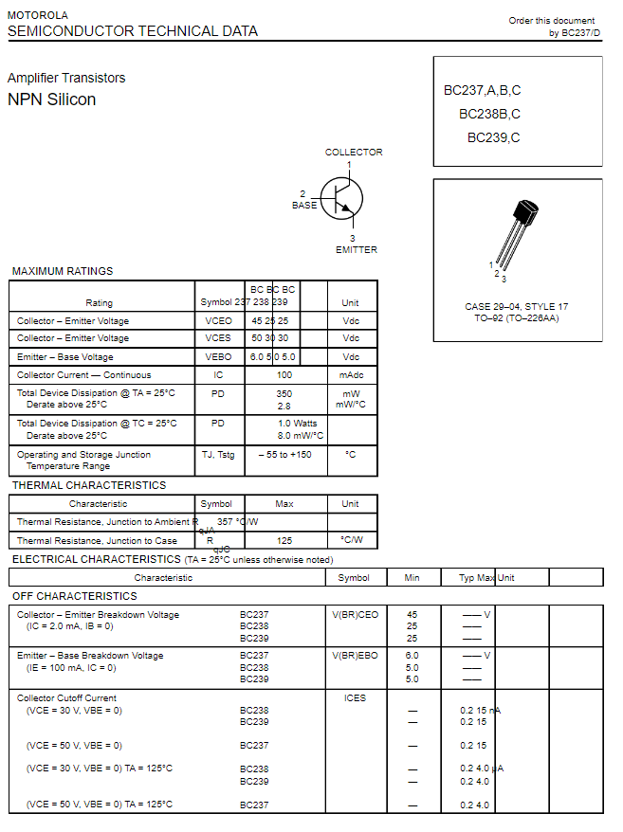

<https://cdn-reichelt.de/documents/datenblatt/A100/BC140_141_6_10_16-CDIL.PDF>

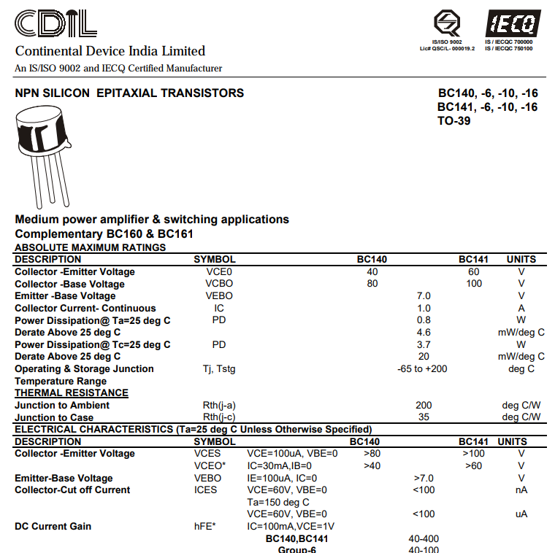

### HC-SR501 PIR Sensor

