

**Masters Project Interim Report**

**Date**

|  |  |  |  |  |
| --- | --- | --- | --- | --- |
| **Project Title** | IT based tool for School Library Information Management | | | |
| **Student Name** | R. B. T. De Zoysa | | | |
| **Registration No. & Index No.** | 2011/MIT/008  11550083 | | | |
| **Supervisor’s Name** | Mr. K. P. M. K. Silva | | | |
| **Please Circle the appropriate** | **Masters Program** | | **Type** | |
| **MIT** | **MCS** | **Research** | **Implementation** |

|  |
| --- |
| **For Office Use ONLY** |
|  |
|  |

IT Based Tool for School Library Information Management

**R. B. T. De Zoysa**

**2015**

Contents

List of Tables iii

List of Figures iv

List of Abbreviations v

**Chapter 1 – Introduction** - 1 -

1.1 Purpose - 1 -

1.2 Problem Domain - 1 -

1.3 Aims and Objectives - 1 -

1.4 Scope - 2 -

1.5 Limitation - 3 -

1.6 Document Structure - 3 -

1.7 Summary - 3 -

**Chapter 2 – Background** - 4 -

2.1 Purpose - 4 -

2.2 Introduction - 4 -

2.3 Similar Existing Library Management Systems - 4 -

2.3.1 Koha - 4 -

2.3.2 Pusthaka - 5 -

2.3.3 LIBSYS - 6 -

2.3.4 NewGenLib - 7 -

2.3.5 OpenBibilo - 8 -

2.4 Criticism - 9 -

**Chapter 3 – Analysis & Design** - 10 -

3.1 Propose - 10 -

3.2 Current Situation - 10 -

3.3 Requirement Gathering and Analysis - 10 -

3.4 Problems of Existing Process and Proposed Solution - 11 -

3.5 Design Approach - 12 -

3.6 Proposed System Architechture - 13 -

3.7 Requirments of the LIMS - 13 -

3.7.1 User Levels - 14 -

3.7.2 Functional Requirements - 14 -

3.7.3 Non Functional Requirements - 15 -

3.8 System Use Cases - 15 -

3.8.1 Common Module - 16 -

3.8.2 Class Module - 16 -

3.8.3 Library Module - 17 -

3.8.4 Notification Module - 17 -

3.8.5 Financial Module - 18 -

3.8.6 Inventory Module - 18 -

3.9 Database Design - 19 -

**Chapter 4 – Progress to Date and Project Plan** - 20 -

4.1 Introduction - 20 -

4.2 Project Progress - 20 -

**References** - 21 -

List of Tables

Table 1 - Problems in the existing processes and proposed solution - 12 -

Table 2 - Different user levels and their access - 14 -

List of Figures

Figure 1 - Scope of proposed implementation - 2 -

Figure 2 – Home page of Koha Library Management System - 5 -

Figure 3 - Pusthaka Library Information System in UCSC Library - 6 -

Figure 4 - NewGenLib system - 7 -

Figure 5 - Main screen of OpenBiblio - 8 -

Figure 6 - Requirements Gathering and Analysis Process - 11 -

Figure 7 - High Level System Architecture - 13 -

Figure 8 - Use case diagram for common functionalities - 16 -

Figure 9 - Use case diagram for class module - 16 -

Figure 10 - Use case diagram for library module - 17 -

Figure 11 - Use case diagram for notification module - 17 -

Figure 12 - Use case diagram for financial module - 18 -

Figure 13 - Use case diagram for inventory module - 18 -

Figure 14 - Database design for LIMS - 19 -

Figure 15 - Gantt chart - 20 -

List of Abbreviations

|  |  |
| --- | --- |
| **Abbreviation** | **Definition** |
| LIMS | Library Information and Management System |
| UCSC | University of Colombo School of Computing |
| UI | User Interface |
| ERP | Enterprise Resource Planning |
| RFID | Radio Frequency Identification |
| GWT | Google Web Toolkit |
| OPAC | Online Public Access Catalog |
| GPL | General Public License |
| CSS | Cascade Style Sheet |

Chapter 1 – Introduction

1. Purpose

This document consist the overview of an IT based information system for library information management and highlights its objectives. In this chapter emphasis a brief idea about the problem and how IT helps to provide a suitable solution for overcome existing difficulties.

1. Problem Domain

Kotahena Central College is one of leading national school in Sri Lanka which was founded on 1918 by Mr. P. A. Evans and begun under the name of “Nil Veediya Government Mix School”. Recently Kotahena Central College has been upgrade to 1AB super school and “Mahindodaya” Technical laboratory was constructed with nearly 50 computers and new Multimedia equipments. Its currently serve around 1000 students in Colombo area including grade 6 to grade 13. And also there are nearly 75 teachers and non-academic staff members [1].

The school library contains more than 5000 titles and daily/ monthly publications all are available to refer for any student or staff member. Moreover to that they keep inventory of ministry of education’s publications and distribute those among academic staff and students in the school and get information of current inventory in each end of the academic year. All the tasks which perform manually by the library staff and keep records on books. Annually the library staffs is getting new releases/publications from publishers and based on those they prepare a requisition to buy new books which they need to spend considerable time to finalize it. Also there is no any systematic way to keep the track of financial information as well.

1. Aims and Objectives

Below points are mentioned as the aims and objectives of implementing the LIMS in the Kotahena Central College’s library.

* Automate and centralized the inventory activities belongs to library
* Increase the participation of members to library activities
* Increase the awareness of class teacher about his/ her student’s library activities
* Decrease the time consumption of preparing school’s text book requirements to the Department of Education Publication
* Decrease the time consumption of preparing year end auditing of library inventory
* Decrease the time consumption of preparing financial statement for each month
* Graphical representations for required places to have a big picture of a scenario
* Increase the monitoring of library activities for each hierarchy level
* Use as a tool for decision making when requesting new books to the library

1. Scope

The scope of this project is to come up with the suitable design and implementation of a computer based information system for the school’s library to facilitate their objectives mentioned in section 1.3 which replaces the existing manual process by re-engineering them to some extent. The below figure describes the high-level picture of the LIMS scope.

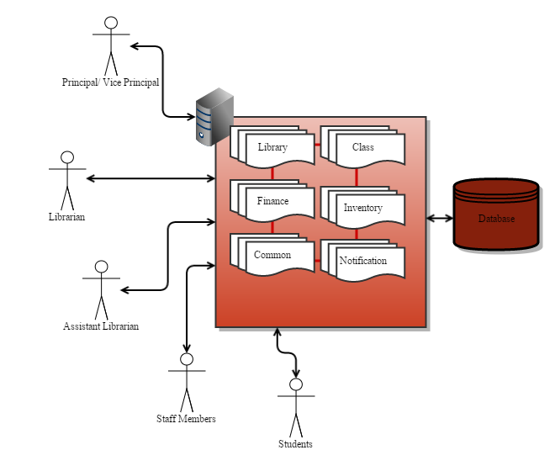

Figure 1 - Scope of proposed implementation

1. Limitation

The significant limitation which identified during the designing of the LIMS is the unavoidable legal bonds associated with the library and school processes that have to adhere. Especially when the re-engineering existing manual processes to automated processes it has to keep some existing activities as same.

1. Document Structure

Under this section of the document it is described the structure of rest of document and content of following chapter.

* Chapter 2 – Background

This chapter is explained in detail about existing system available in the internet and their content and behavior followed by a literary review.

* Chapter 3 – Design of the System

This chapter is discussed the methodology used in the system design and development and the various design diagrams of the proposed system. Also detail about existing processes following as library activities, the functional and non-functional requirements of the LIMS.

* Chapter 4 – Progress

This chapter is discussed actual progress of the project to date and the problems encountered during that time. It also includes a detailed plan of work for the rest of the project.

1. Summary

Under this section it is clearly summarized the author’s motivation for the project and the overall and high level view of his approach in delivering this computerized automated solution for the problem. The chapter concluded with a concise overview of the chapters contained in this report.

Chapter 2 – Background

1. Purpose

In this chapter is described the background information of library management system including brief analysis of popular library management systems which similar to the proposed solution. It also described the limitations of each information system as well.

1. Introduction

Integrated Library Management Systems [2] is a kind of information system [3] available in the today world. The term ‘Library Management’ is an important section of library & information science [4] stream which deals with the activities of resources planning in the library. By the evolution of computers and information era, professionals were tend to develop computerized solutions for library management to overcome the issues they faced. By today there are hundreds of thousands library management system solutions available in the internet which in free and open source as well as proprietary once [5]. Also some of applications are developed by individuals with their own processes as well.

1. Similar Existing Library Management Systems

Following popular library management systems are chosen to refer and analyze the behaviors and appearance with regards to proposed solution for Kotahena Central College. It is also helped to identify the lacking functionalities of existing information system.

1. Koha

“Koha”, free library system [6] is most popular and well known integrated library system available free to use. It has series of versions release from 1999 under GNU GPLv3 license and latest is version 3.20. Koha is a web based system developed using ‘Perl’ language and ‘MySQL’ database. It is supported most of the common functionalities in the library management like customizable catalog search, catalog reservation, borrowing management using cart, etc… [7].

“LibLime Koha” [8], [9] is a functionality advanced version of Koha, which is developed based on Koha 3.0 version.

The new version of Koha has quite good UI arrangement with the use of CSS styles as it has very large number of community influence to increase its functionality as well as the UI/UX. Also Koha is supported for different languages like French and Spanish.

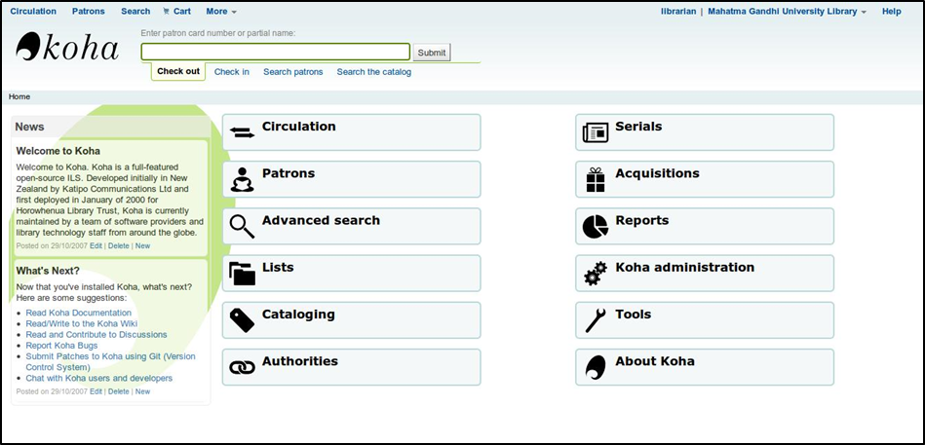

Figure 2 – Home page of Koha Library Management System

1. Pusthaka

“Pusthaka” [10], [11],[12] is another popular open source library management system available in GitHub which is developed by Mr. Nalaka Jayasena [13]. This is a web based solution which is developed using ‘PHP’, ‘JavaScript’ and ‘HTML’ with backend supported by ‘MySQL’ database. Pusthaka is released under GNU GPLv3. This has almost all the core functionalities of the library including advance search facility, user logins, book lending and returning tracking, library inventory management, etc…

The significant drawbacks of this solution are lack of having finance related activities tracking option such as fine calculation, book prior reservations, etc.... Also the user interfaces are implemented using pretty ordinary UI elements and components which are not feel comfortable to end users. However the UCSC library is used this library management system for their library [14] to keep the track of their library activities.

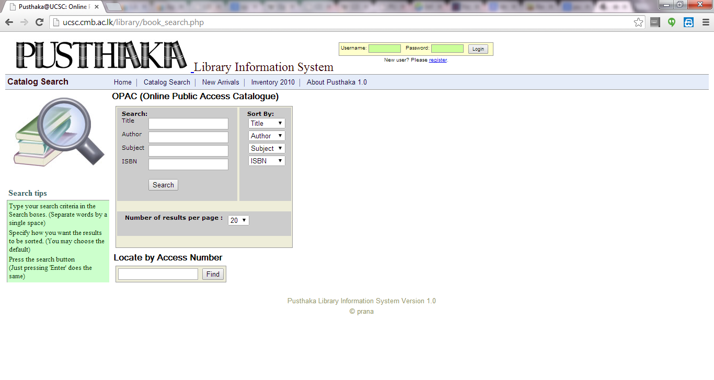

Figure 3 - Pusthaka Library Information System in UCSC Library

1. LIBSYS

“LIBSYS Ltd.”, [15] a popular commercial software development company based on India which is providing automated library management solution for various institutions around the world. It develops a comprehensive series of library management systems [16] suite for different type of libraries and their usage.

* LSEase [17], [18] – The most affordable solution of the LIBSYS product range with basic modules and functionalities of library automation.
* LSAcademia [19] – A comprehensive ERP solution for large scale libraries which helps to integrate with different administrative departments to ensure the information flows among them smoothly. This has a high number of core modules as well as the support modules such as Admission management, Student and Academic staff management, fee management, hostel management, etc. This allows to sharing information among all stakeholders in the libaray like students, staffs, parents, etc. and has different interfacing with email, SMS, Payment gateways and RFID.
* LIBSYS7 [20], [21] – This solution is support to next generation library automation activities which supports an end to end manageability of library operations. This has rich UIs based on GWT with multitasking features. This version is fully compatible with Unicode, RSS feeds and integration with Google Books, Book Finder, etc. and supports OPAC [22].
* LSDigital [23] – A complete digital resource management solution provided by LIBSYS to manage the digital resources of a library. This is supported to different document formats like PDF, Word docs, etc.

1. NewGenLib

“NewGenLib” [24], [25] is another popular open source library management system available which is developed by bunch of developers in Verus Solutions (Pvt.) Ltd., in India. NewGenLib is developed under GNU General Public License and current stable release is 3.0.4 R2 that released on 4th March 2013. This solution is a standalone solution which is developed using Java and Java based frameworks like Spring [26] and Hibernate [27].

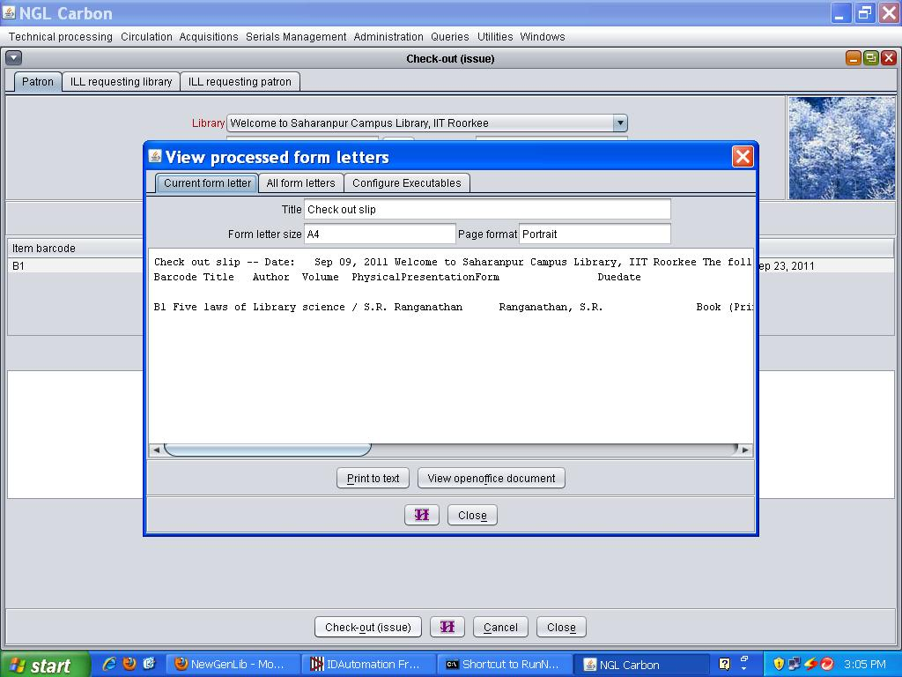

Figure 4 - NewGenLib system

NewGenLib has almost covered the entire core functionalities of a library with new features like OPAC, RSS feeds, SMS for proof of transaction, email integration and Android mobile and tablet capability. Also this has attractive reporting functionality to generate and send various reports. Since this is a standalone solution only one user can use this system at any time.

1. OpenBibilo

“OpenBiblio” [28], [29] is a free and open source library management system available in the internet which distribute under GNU GPL. This is one of a popular library system among small and rural libraries worldwide.

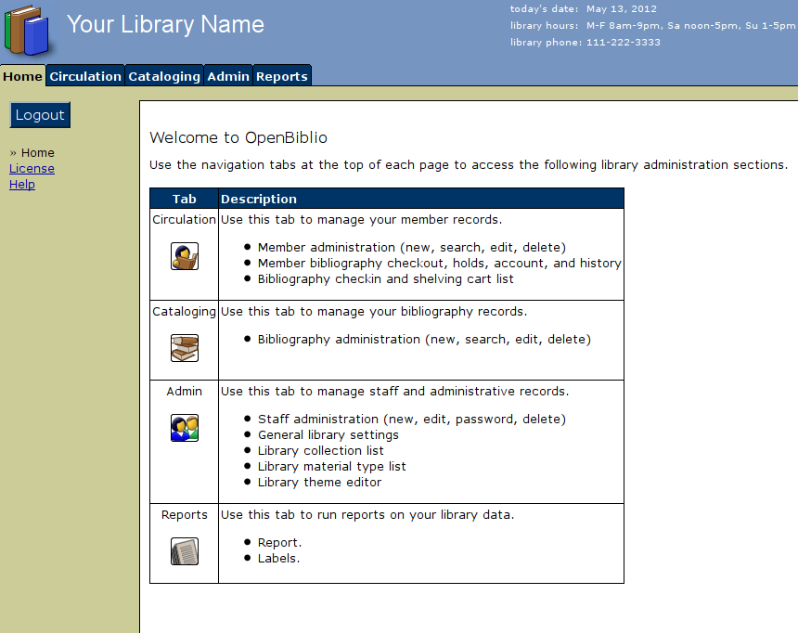

Figure 5 - Main screen of OpenBiblio

OpenBiblio is developed using PHP and HTML with MySQL backend database and the latest version 0.7.1 is released on 2012. OpenBiblio is provided all the essentials functionalities for a small scale library and some new features like OAPC, circulations, cataloging, fine calculation and management and report generation. The UI aspect of this application is not quite good as it uses only very basic HTML UI component in the entire application which the end user doesn’t get any real feeling on that.

1. Criticism

An integrated library management system can find from internet very easily since there are huge numbers of solution available and couple of most common library management system compare and contrast in the above section 2.3.

By looking at them it can be figured out there are focused to cover or impalement the core and essential functionality with their solution. Also there is a key similarity of the UI/UX part since most of them use basic HTML components which is very lack of usage some upcoming technologies like HTML5, CSS and jQuery.

LIMS is designed to cover more than the core library functionalities with including the inventory, finance and teacher module together. An information system like LIMS is unable to find in the internet. The proposed LIMS is fully designed by the latest web technologies like HTML5, CSS, jQuery and JavaScript to enhance the UI/UX to deals with the different kind of users in the school.

Chapter 3 – Analysis & Design

1. Propose

Successfulness of any type of information system is depended on good analysis of the problem that is going to solve and designing on the proposed solution. This chapter is to detail discussion on analysis and designing approaches which undertaken by the project team to implement the LIMS solution.

1. Current Situation

Successfulness of any type of information system is depended on good analysis of the problem that is going to solve and designing on the proposed solution. This chapter is to detail discussion on analysis and designing approaches which undertaken by the project team to implement the LIMS solution.

1. Requirement Gathering and Analysis

In the software project development, understanding the correct requirement is a very important factor and it ultimately direct to produce customer satisfied solution.

During the initial phase of problem analysis, couple of face to face interviews were conducted with major stake holders, the principal of the college and the librarian. The interviews were led to identify the problem and define the scope of the solution.

In order to produce the detail analysis of requirements it was conducted series of discussion with librarian and assistant librarian. Interviews were conducted in informal manner as the key stakeholders were known and it was helped to understand the big picture of the problem easily. Also most of processes were understand by observation, document referencing during the visit to school library. Requirements are pretty much clear, straight forward and were not changed rapidly as they followed standard library processes and adhere to the terms of Department of Education, Sri Lanka.

Data requirements were also identified during the visit by referring the various log books and documents used for their day to day activities.

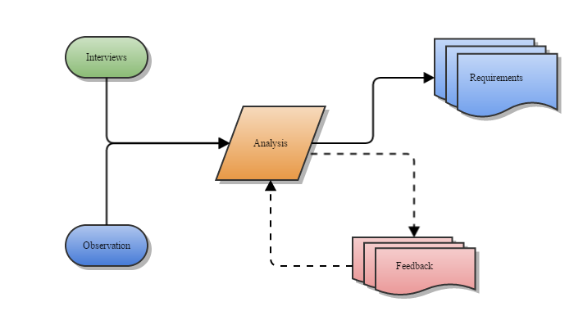

Figure 6 - Requirements Gathering and Analysis Process

1. Problems of Existing Process and Proposed Solution

Following table is discussed the problems encountered with existing processes in the library activities and respective solutions for them.

|  |  |  |
| --- | --- | --- |
| **#** | **Problem** | **Proposed Solution** |
| 1 | Data are stored in scattered manner in the different log books. | Data will be stored in centralized database |
| 2 | Arrangement of student’s library cards for each class’s time period | Student list and their lending listed down by comparing the system time |
| 3 | Librarian is informed about the students list who has overdue books to respective class teacher formally | Class teacher will be able to view the status of lending of his/ her class students |
| 4 | Time consuming activity of finding book from the library for teachers and non-academic staff | A sophisticated online searching functionality will be available in the LIMS |
| 5 | Following to item #4, staff members are hard to reserve a library book in advance | A prior book reservation functionality will be available in the LIMS along with book search facility |
| 6 | Following to item #5, staff member does not have reminding option when reserved book is available | A SMS notification will be sending to received person once the reserved book available |
| 7 | Year-end inventory auditing is highly time consuming task which consuming 2-3 weeks currently | An inventory management functionality will be available in the LIMS which supports to get quick inventory audit reports within few minutes |
| 8 | The librarian must go to the Principal each and every time when take his sign for financial amendments | An approval process for financial amendments will be implemented with LIMS |
| 9 | Decision making for request new library books | Decision making will be much easy when selecting new books using the various graphical diagram based on the members current choices |

Table 1 - Problems in the existing processes and proposed solution

1. Design Approach

Iterative and incremental software development model [30] is selected as a software engineering methodoogy for anylysis and design for the LIMS. The reasons behind to choose this method are;

* LIMS is planned to developed module by module due to number of integration points with other modules
* Get the stakeholders feedbacks early as possiable
* Plan to integrate the LIMS with future information systems
* Requirments are very clear and well structued
* Stakeholders are well aware about the requirments
* Less inolvement of object oriented concetps as this is planned to develop by web based scripting language

1. Proposed System Architechture

Following digram is described the high-level system architecture of LIMS and how user interactions to the proposed application.

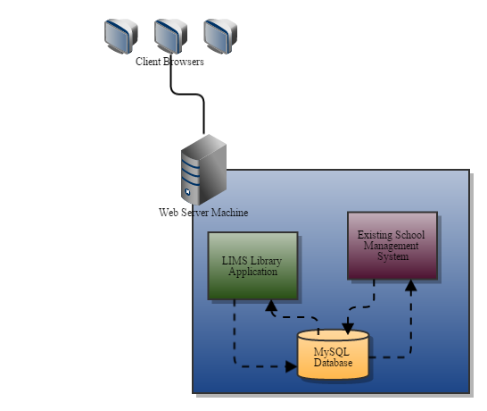

Figure 7 - High Level System Architecture

1. Requirments of the LIMS

In this section is breifly described about the high-level system requirments identified during the requirment gathering phase.

1. User Levels

LIMS is desinged to enable to access different users of the school and each user category has access limitation fot it. During the requirment gathering and analysis phase it identified following user levels and system access levels for LIMS.

|  |  |
| --- | --- |
| **Access/ User Level** | **Responsibility** |
| Administrator | Special privilaged user that having all the access |
| Principal | Has all the access related to library administration and finance amendments |
| Vice Principal |
| Librarian | Has all the access related to library, finance and inventory management |
| Assistant Librarian | Has limited access related to library and inventory management |
| Teacher | Has system access to view and reserve library catelogs. There is a special scenario when a teacher has assigned as a class teacher; he/ she has all access related to his/ her class’s activities |
| Staff | Has system access to view and reserve library catelogs |
| Student | There are no system access to students. They only able to search the library catalog |

Table 2 - Different user levels and their access

1. Functional Requirements

The functional requirements are described under the section 3.8 by categorizing with the respective modules.

1. Non Functional Requirements

Non-functional requirements can be described as the attributes that are indirectly connected with the functional requirements or attributes which should be provided by the system to make the best performance and optimum customer satisfaction.

* **UI/UX requirement** – Web interfaces is designed based on schools theme colors. Navigation menu should always display to support users to navigate to pages easily.
* **Security requirement** – Functionality is limited based on the user type. It should be properly handled by the system.
* **Performance requirements** – All the users’ requests should maintained maximum of 5 seconds for response time.

1. System Use Cases

Based on the gathered requirments the high level system use cases were desinged for the LIMS. It is decided to breakdown the all use cases under different modules in order to keep the diagram simple.

1. Common Module

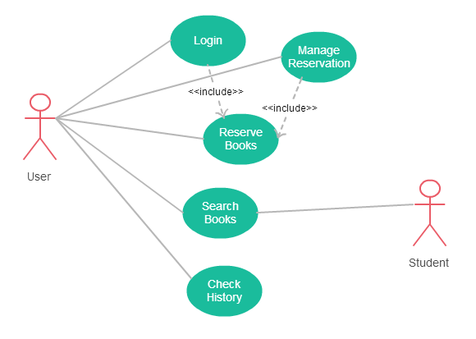

Figure 8 - Use case diagram for common functionalities

1. Class Module

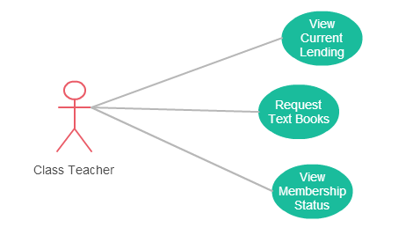

Figure 9 - Use case diagram for class module

1. Library Module

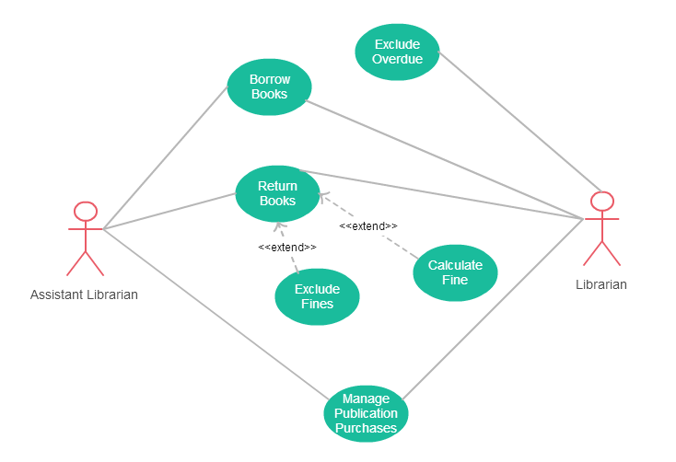

Figure 10 - Use case diagram for library module

1. Notification Module

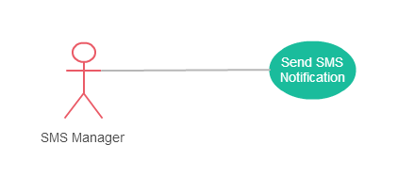

Figure 11 - Use case diagram for notification module

1. Financial Module

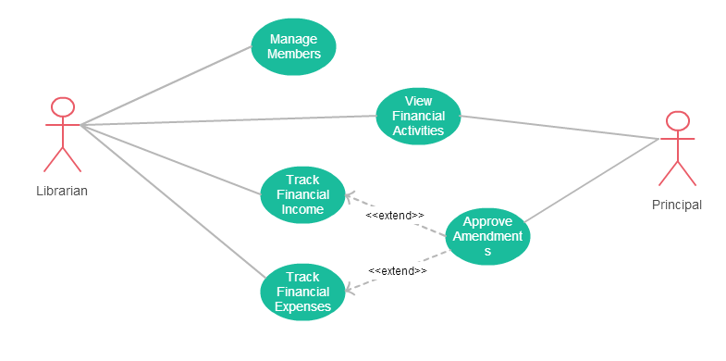

Figure 12 - Use case diagram for financial module

1. Inventory Module

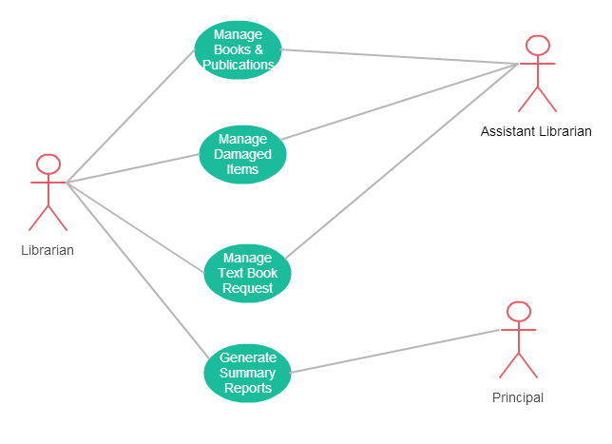

Figure 13 - Use case diagram for inventory module

1. Database Design

Since the Kotahena Central College is currently operating a in-house developed school management system with MySQL database, it is decided LIMS application to go with same MySQL database. The reasons behind the decision are;

* Keep the whole school’s database as a centralized manner
* Easy to maintain
* LIMS can be easily worked with existing table data. (E.x: Staff and Student details)
* Strong compatibility with PHP

The high level database table structure is included below diagram.

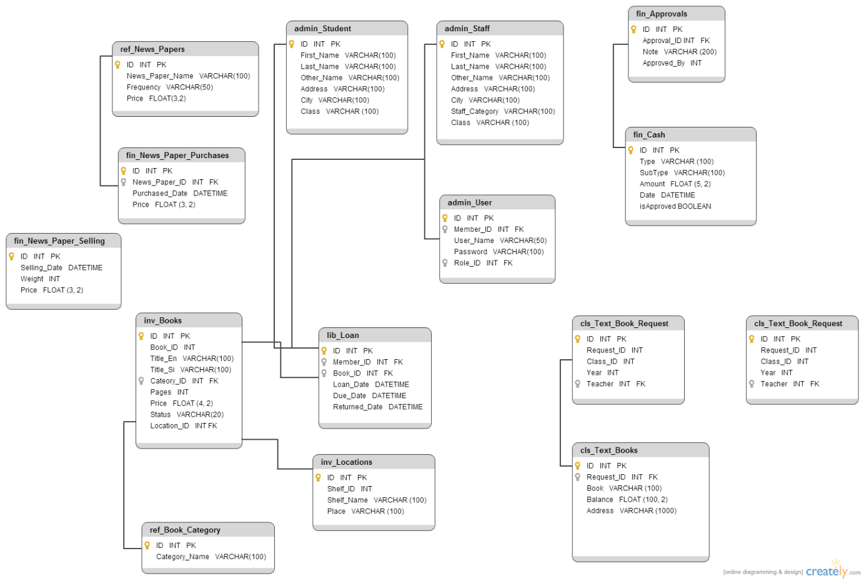

Figure 14 - Database design for LIMS

Chapter 4 – Progress to Date and Project Plan

1. Introduction

Under this chapter it is described the time lines of the project, work carried out up to now and remaining work plan until the end of project.

1. Project Progress

The planned work was able to carry out accordingly without severe changes. However there was bit delay on gathering requirements due to drag of meeting with librarian with her allocated work and due to extension of interim report submission time line is dragged bit further. Work plan will be changed according to the delay and match with final delivery dates. Expecting some minor changes mainly in the design, especially in financial module integration with other modules and those will be tracked as change requests.

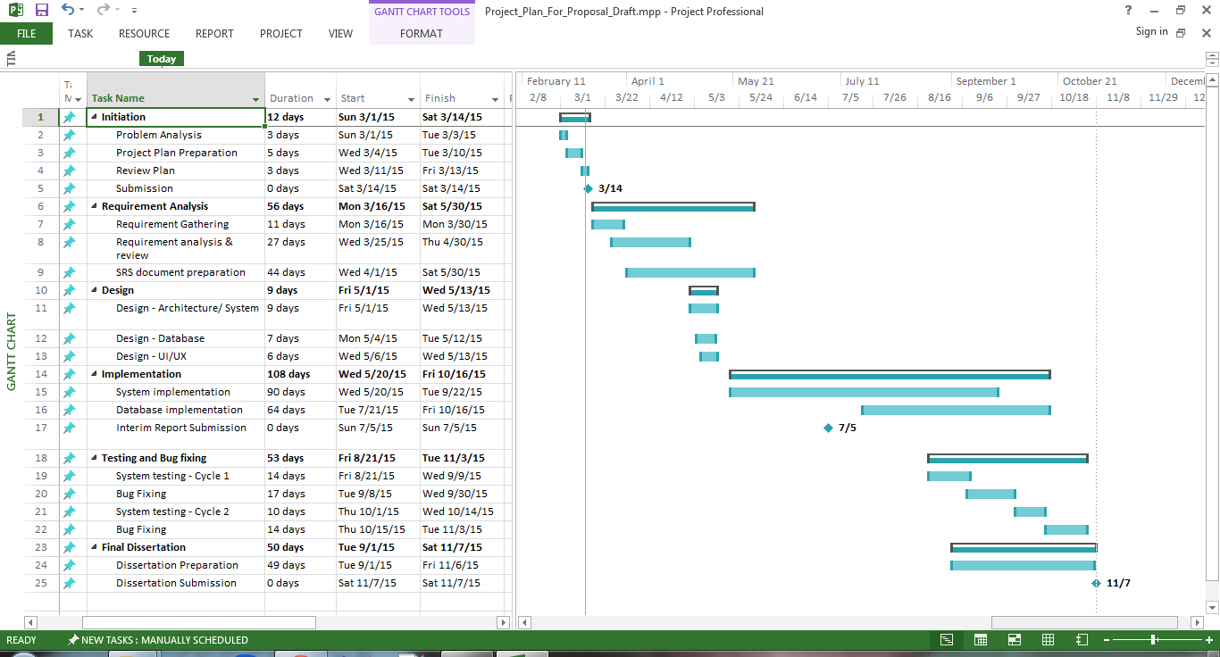

Figure 15 - Gantt chart

# References

|  |  |
| --- | --- |
| [1] | Kotahena Central College, "Kotahena Central College-Colombo,Sri Lanka," 2009. [Online]. Available: http://www.kotahenacc.sch.lk/index.html. [Accessed 30 June 2015]. |
| [2] | Wikipedia, "Integrated library system - Wikipedia, the free encyclopedia," Wikipedia, 4 June 2014. [Online]. Available: http://en.wikipedia.org/wiki/Integrated_library_system. [Accessed 4 June 2014]. |
| [3] | Wikipedia, "Information systems - Wikipedia, the free encyclopedia," Wikipedia, 3 June 2014. [Online]. Available: http://en.wikipedia.org/wiki/Information_systems. [Accessed 4 June 2014]. |
| [4] | Wikipedia, "Portal:Library and information science - Wikipedia, the free encyclopedia," Wikipedia, 21 May 2014. [Online]. Available: http://en.wikipedia.org/wiki/Portal:Library_and_information_science. [Accessed 4 June 2014]. |
| [5] | Capterra Inc, "Top Library Automation Software | 2014 Reviews of the Best Systems," Capterra Inc, [Online]. Available: http://www.capterra.com/library-automation-software. [Accessed 4 June 2014]. |
| [6] | Koha Community, "Official Website of Koha Library Software," Koha Community, 1999. [Online]. Available: http://koha-community.org/. [Accessed 4 June 2014]. |
| [7] | Wikipedia, "Koha (software) - Wikipedia, the free encyclopedia," Wikipedia, 27 June 2015. [Online]. Available: http://en.wikipedia.org/wiki/Koha_(software)#Features. [Accessed 5 July 2015]. |
| [8] | LibLime, "Koha - Open Source ILS - Integrated Library System," LibLime, 2015. [Online]. Available: http://www.koha.org/. [Accessed 5 July 2015]. |
| [9] | Wikipedia, "LibLime - Wikipedia, the free encyclopedia," Wikipedia, 14 February 2015. [Online]. Available: https://en.wikipedia.org/wiki/LibLime. [Accessed 5 July 2015]. |
| [10] | N. Jayasena, "Pusthaka Integrated Library System," GitHub, [Online]. Available: http://pusthaka.org/. [Accessed 4 June 2014]. |
| [11] | N. Jayasena, "nalaka/pusthaka · GitHub," [Online]. Available: https://github.com/nalaka/pusthaka. [Accessed 16 June 2013]. |
| [12] | Prana Private Limited, "Prana- Information Technology Solutions," Prana Private Limited, [Online]. Available: http://www.prana.lk/#Products. [Accessed 16 June 2013]. |
| [13] | LinkedIn, "Nalaka Jayasena - Sri Lanka | LinkedIn," LinkedIn Corporation, [Online]. Available: http://lk.linkedin.com/in/nalakajayasena. [Accessed 4 June 2014]. |
| [14] | "ULMS: UCSC Library Management System 1.0," [Online]. Available: http://ucsc.cmb.ac.lk/library/. [Accessed 16 June 2013]. |
| [15] | LIBSYS Ltd., "Library Management, Automation Software System – LIBSYS Ltd," LIBSYS Ltd., 1984. [Online]. Available: http://www.libsys.co.in/. [Accessed 30 June 2014]. |
| [16] | LIBSYS Ltd., "LIBSYS Offerings – An overview of Software Products by LIBSYS," LIBSYS Ltd., 1984. [Online]. Available: http://www.libsys.co.in/offerings-main.html. [Accessed 30 June 2014]. |
| [17] | LIBSYS Ltd., "LIBSYS | Offerings | LSEase," LIBSYS Ltd., [Online]. Available: http://www.libsys.co.in/offerings-lsease.html. [Accessed 30 June 2014]. |
| [18] | LIBSYS Ltd., [Online]. Available: http://www.libsys.co.in/download/lsease_brochure.pdf. [Accessed 30 June 2014]. |
| [19] | LIBSYS Ltd., "LIBSYS | LSAcademia," LIBSYS Ltd., [Online]. Available: http://www.libsys.co.in/offerings-lsacademia.html. [Accessed 30 June 2014]. |
| [20] | LIBSYS Ltd., "LIBSYS | LIBSYS7," LIBSYS Ltd., [Online]. Available: http://www.libsys.co.in/offerings-libsys7.html. [Accessed 30 June 2014]. |
| [21] | LIBSYS Ltd., [Online]. Available: http://www.libsys.co.in/download/libsys7_brochure.pdf. [Accessed 30 June 2014]. |
| [22] | Wikipedia, "Online public access catalog - Wikipedia, the free encyclopedia," Wikipedia, [Online]. Available: http://en.wikipedia.org/wiki/Online_public_access_catalog. [Accessed 30 June 2014]. |
| [23] | LIBSYS Ltd., "LIBSYS | Offerings | LSDigital," LIBSYS Ltd., [Online]. Available: http://www.libsys.co.in/offerings-lsdigital.html. [Accessed 30 June 2014]. |
| [24] | Wikipedia, "NewGenLib - Wikipedia, the free encyclopedia," Wikipedia, [Online]. Available: http://en.wikipedia.org/wiki/NewGenLib. [Accessed 30 June 2014]. |
| [25] | Verus Solutions, "NGL Open Source | Best Open Source Integrated Library System," Verus Solutions, [Online]. Available: http://www.verussolutions.biz/web/. [Accessed 30 June 2014]. |
| [26] | Wikipedia, "Spring Framework - Wikipedia, the free encyclopedia," Wikipedia, [Online]. Available: http://en.wikipedia.org/wiki/Spring_framework. [Accessed 30 June 2014]. |
| [27] | Wikipedia, "Hibernate (Java) - Wikipedia, the free encyclopedia," Wikipedia, [Online]. Available: http://en.wikipedia.org/wiki/Hibernate_(Java). [Accessed 30 June 2014]. |
| [28] | OpenBiblio development team, "OpenBiblio | Main / OpenBiblio browse," OpenBiblio development team, [Online]. Available: http://obiblio.sourceforge.net/. [Accessed 30 June 2014]. |
| [29] | Wikipedia, "OpenBiblio - Wikipedia, the free encyclopedia," Wikipedia, [Online]. Available: http://en.wikipedia.org/wiki/OpenBiblio. [Accessed 30 June 2014]. |
| [30] | Wikipedia, "Iterative and incremental development - Wikipedia, the free encyclopedia," Wikipedia, 14 May 2014. [Online]. Available: http://en.wikipedia.org/wiki/Iterative_and_incremental_development. [Accessed 5 June 2014]. |