MCS/MIT 3020 Individual/Group Project

Project Proposal Form

- One copy of this form is to be completed by each student submitting a project proposal.
- The student and the supervisor must sign the form (Hard Copy version).
- The original is to be submitted to the Academic & Publication Branch of the UCSC. A softcopy (without signatures) should be uploaded to the PGVLE with your login. Both versions will be used when evaluating the project proposal.
- Any deviation from the proposal should be communicated with the supervisor and the written approval from the Board of Study for Research & Higher Degrees should be obtained before submitting your dissertation for evaluation.
- The candidate should keep a copy of the project proposal form.
- The proposal should not exceed 4 pages for section 1 to 7 in the proposal document. Work Breakdown Structure & Supervisor Details should not be counted for that limit.

Name of Candidate: R. Buddika Tharanga De Zoysa
Registration No.: 2011/MIT/008Index No.: 11550083
Email Address: ibt603@gmail.comContact No: 077 2 891 899
Title of Project: Library Information and Management System (LIMS) for Kotahena CC
This Project: New Project Repeat Project

The Problem (A brief introduction to the problem that you are trying to solve/investigate through your project)
Kotahena Central College is one of leading national school in Sri Lanka which is currently serve around 1000 students and nearly 75 teachers and non-academic staff members. The school library currently contains more than 5000 different titles available for staff and students to use as references and lending purposes. A librarian and two assistant librarians are currently allocated to library activities. There are no computerized information system is involved to perform these library activities that entire process record in the log books manually. Also any staff member can reserve any book but there are no such a way to inform them once the book is available. Annually the library staffs is getting new releases/publications from publishers and based on those they prepare a requisition to buy new books which they need to spend considerable time to finalize it. Also there is no any systematic way to keep the track of financial information as well. There are number of free and open source library management systems available in the internet but those are specific to core library functionalities which they cannot applicable for their other activities specially to exclude fines and borrowing books by member. Also they wanted to cut down the time of year end auditing the library inventory.

Objective of Project
Following points are highlighted as the objectives of this project;
Analyse the current manual process of school’s library functionalities and align their process to computer based automated information and management system for the school to increase efficiency and accuracy of library functions and eliminate the manual human effort
Get awareness of class teachers about the student’s borrowing activities

Project Proposal Form
✓

- Reminding message sending through SMS to respective staff member
- Helps to making decisions by providing statistics about reading interests of members which used to place new requisition
- Make the purposed system integrate with existing staff and student information system
- Related Projects(Others who are proposing logically related work or previous projects which were based for your proposal)
There are large number of computer based library management solutions available in the internet freely as well as proprietary. Also there are many solutions developed by some institutions as in-house development. In Sri Lanka most of the institutes tend to use such kind of application to manage their library activities in efficient manner with the school’s infrastructure development by the Ministry of Education. The UCSC uses the ‘Pusthaka’ library management system for their library which would be the most nearest example for the related project.

- Scope of Project
The LIMS will contain following main modules and functionalities;
- User/Common Module – These are common functionalities for every user who can login to the application.
- Search book details with advance option – Searching based on different criteria like book title, author, category, etc.
- Book prior reservation and management
- Customize and Change application settings – Change password, Manage user details (in restricted manner)
- Check the borrowing history
- Class Teacher Module - This is enables for teachers who assigned as a class teacher and following are the functionalities of it
- View the list of books in hand with students
- View the list of membership payment information of respective class students

- Library Module - This contains the core functionalities of the library section
- Lending and borrowing books
- Fine calculation
- Keep the track of purchases of daily publications
- Overdue exclusion for teachers
- Fine exclusion for members
- Send SMS notifications for reminding reservations for staff members
- Finance Module - Under the finance module it will be listed functionalities related to financial activities done by the library.
- Keep the track of fund received from various sources (From the department of education, aids and funds, etc.)
- Membership management – keep the track of membership fees
- Keep the track of expenses - expenses for daily publication, purchase of new library books
- View financial summary for different criteria (monthly, quarterly, yearly)
- Principal approvals for amendments of financial entries
- Inventory Module - Library books and other publication management functionalities are listed down under the Inventory section. This are helped to manage inventory of book and publications of the school and allows getting quick reports based on various criteria.
- Manage books and publications
- Manage store locations
- Manage damaged books
- Manage text books request – make consolidated text book request, distribution and re-collect text books
- Generate summary reports – available book count, damaged books, top barrowing book categories, etc.
- Administration Module - Under the administration module it will be listed the supportive administration functionalities for LIMS.
- Library time slot assigning for classes
- Manage library settings – maximum of borrowing books, fine rate, etc.
The LIMS’s aim is to interpret the existing manual functionalities to computer based centralized automated system to increase their efficiency and accuracy. Also this system is developed to be compatible with school’s existing staff and student information system as this LIMS to be required exiting information it has.

- Is this Project Work Related? (if Yes, Please indicate clearly your planned contribution)
No

- Client / Customer for the Project (If applicable)
- Mr. Dharmadasa Galabada, Principal, Kotahena Central College, Colombo 13.
- Ms. Nilmini Karunarathne, Librarian, Kotahena Central College, Colombo 13.

- List of Deliverables (All deliverables should be presented at the end of project and any deviation should be justified)
- LIMS - Library Information and Management System
- Database configuration scripts
- Database upgrade script for alter existing database tables
- Test scenarios, test cases and test results
- Installation and configuration guide
- Dissertation
- Final Presentation
- Work Breakdown Structure (A Gantt Chart should be included)
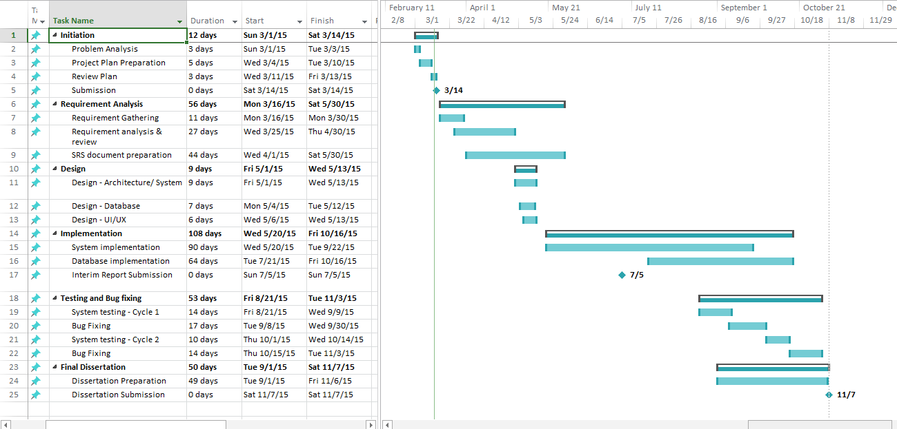
- Additional Information

…………………………………
Signature of candidate Date: ….. /….. /2015

10. Details of Project Supervisor(s):

 | Supervisor (USCS Staff Member) | Advisor (Can be outside of UCSC_)
Name | Mr. K. P. M. K. Silva
Designation | Lecturer – UCSC
Comment
(To be filled by the supervisor/ Advisor)
Supervisor’s / Advisor’s Signature | …………………………………….  Date: | ………………………………….  Date:

********

