Link to GitHub:

<https://github.com/buddyboy52/csd-340>

GitHub Repository:

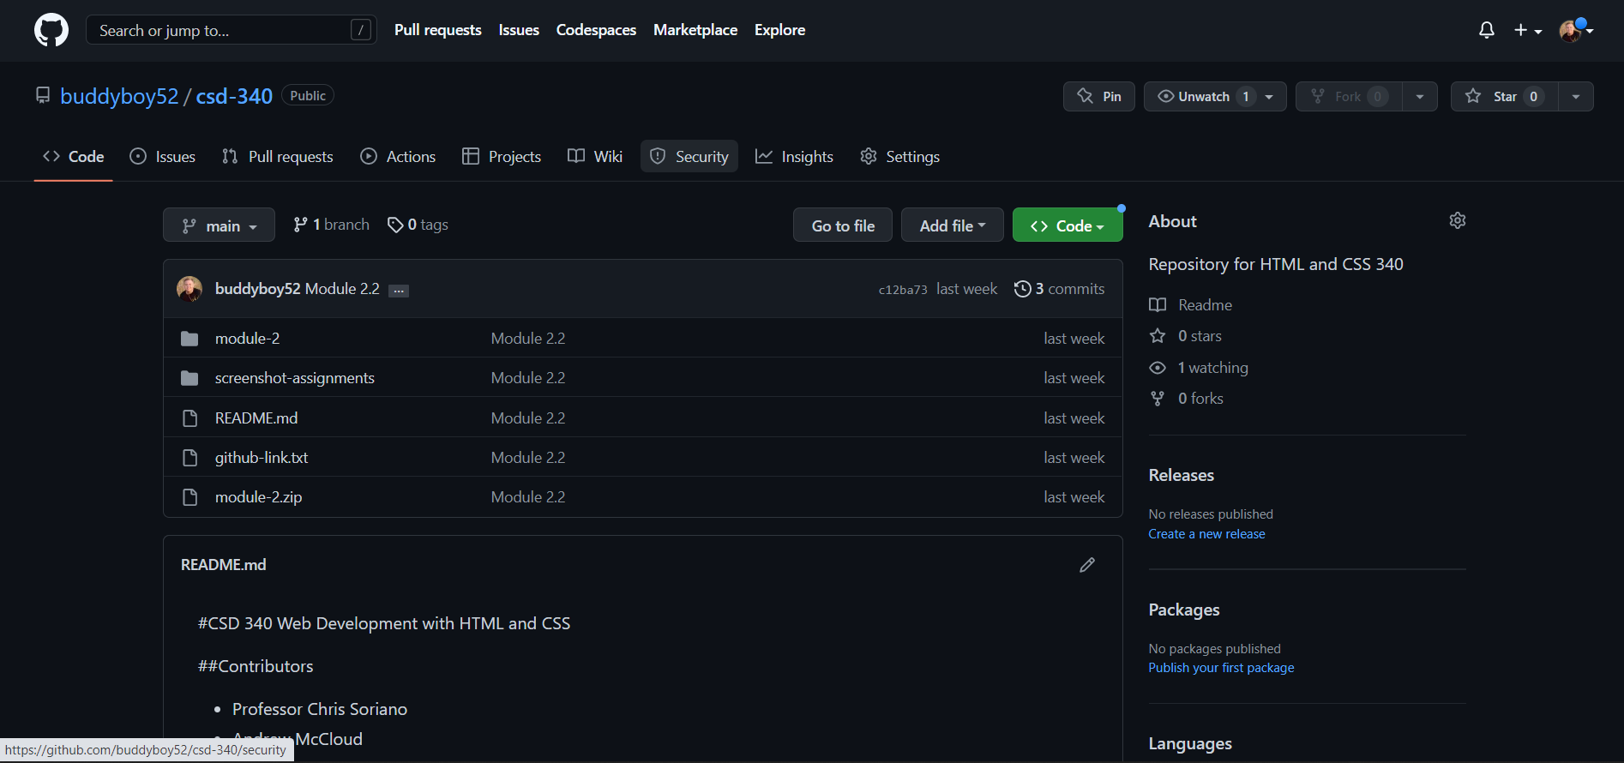

Local Repository:

