Sales Performance Dashboard - Design Documentation
Power BI project: SalesPerformance.pbip | Source: dashboard.xlsx (500 orders, 2022-2024, 27 columns)

1. Target audience analysis
Audience | Needs | Where served
Executive leadership | Headline KPIs, attainment vs target, mobile access | Sales Overview (KPI band, variance waterfall); mobile layout; paginated monthly report
Sales managers / regional leads | Where targets are missed; reps and regions to coach | Geographic Performance, Customer Analysis (rep table with drill-through), Sales Rep Detail
Product / category owners | Mix, margin, discount impact, drivers | Product Analysis (field-parameter explorer, treemap, decomposition tree)
Finance / planning | What-if on price, volume, cost | Scenario Planner
Distribution recipients | Formal printable monthly pack | Paginated report (RDL)

Adoption barrier from the brief (complex past tools) drove three rules: one consistent page template, at most five slicers per page in a fixed band, and plain-language chart titles that state the question each visual answers.

2. Page architecture and information hierarchy
Page | Purpose | Hierarchy (top to bottom)
Sales Overview | How are we doing against target and budget? | Header + nav -> 5 slicers -> KPI band -> trend (drill Year>Quarter>Month) and category chart (drill Category>Subcategory) -> variance waterfall
Product Analysis | What sells, at what margin? | Slicers incl. two field parameters -> KPIs -> metric/view explorer -> category mix -> decomposition tree
Customer Analysis | Who buys and what drives hitting target? | Slicers -> KPIs -> segment donut, stage funnel, rep scatter -> key influencers (AI) + rep table (drill-through)
Geographic Performance | Where do we win and lag? | Slicers -> KPIs -> country/region treemap, region>country drill bars, region x category matrix
Scenario Planner | What if price, volume or cost change? | 3 what-if slicers + context -> scenario KPIs -> baseline vs scenario charts -> attainment gauge
Sales Rep Detail (drill-through) | Everything about one rep | Back button -> KPIs -> trend + category mix -> order table

3. Visual branding
- Palette: navy #1F3A5F (primary/actual), teal #2A9D8F (selection, scenario), orange #F4A261 (target), slate #6C7A89 (budget/baseline), purple/sky/amber/red for additional series. Page background #F4F6F9, cards white with a 6px-radius border.
- Typography: Segoe UI throughout (safe across Desktop, Service and mobile); Segoe UI Semibold for titles; 24pt callouts, 12pt visual titles, 10pt slicer labels.
- Layout standard: 1280x720, 24px outer margin, 12px gutters, 64px navy header band, 76px slicer band at y=70, KPI band at y=152, content from y=252. Implemented in a deterministic generator (build/gen_report.py) so pages cannot drift.
- Theme file SalesTheme-7c1d2e3f.json carries data colours, text classes and the default card style.

4. Visualization selections and rationale
Visual | Where | Why
Multi-value card | KPI band on every page | Five headline numbers in one container, consistent across pages
Line chart (3 measures) | Overview | Sales vs target vs budget over time; drill Year>Quarter>Month
Clustered column | Overview, Scenario | Compare actual vs target across few categories; drill Category>Subcategory
Waterfall (advanced) | Overview | Shows how each region contributes to the total miss against target
Clustered bar (field parameters) | Product | One visual, 6 metrics x 6 dimensions
Treemap | Product, Geography | Part-to-whole with many members
Decomposition tree (advanced) | Product | Ad-hoc root-cause exploration of gross profit
Key influencers (AI) | Customer | Automatically ranks what makes an order On Track (>=75% of target) vs At Risk
Donut / funnel / scatter | Customer | Segment share; pipeline stages; rep satisfaction vs margin with sales as size
Table / matrix | Customer, Geography, Rep Detail | Exact values; region x category cross-tab; drill-through source
Gauge | Scenario | Single attainment number against 100%

Total distinct visual types used: card, line, clustered column, column, waterfall, clustered bar, treemap, decomposition tree, key influencers, donut, funnel, scatter, table, matrix, gauge, slicer, button, textbox (18).
Known limitation: the Azure Maps visual is blocked in this tenant (admin switch for cross-region processing), so the geographic page uses a country/region treemap instead of a map. Re-enable the map by asking the tenant admin to allow Azure Maps, then swap the visual.

5. Interaction design strategy
- Slicers: 25 slicer instances across pages (dropdown, 76px band). Year and Region are sync-grouped across pages; the rest are page-local to avoid surprising hidden filters.
- Drill-down hierarchies: Date Hierarchy (Year>Quarter>Month) on the trend line; Product Hierarchy (Category>Subcategory) on the category chart; Geography Hierarchy (Region>Country) on the geography bars. The model also defines a Customer Hierarchy.
- Drill-through: Sales Rep Detail filtered by Sales Rep. Right-click a rep in the Customer page table (or the scatter) and choose Drill through. A Back button returns to the source.
- Navigation: five page buttons in every header; the active page is highlighted teal.
- Bookmarks (3) on Sales Overview with buttons: Chart view and Table view swap the trend chart and a detail table (visibility only; slicers are preserved); Reset filters restores the default chart view with data state cleared.
- Cross-visual interactions: default cross-filtering is kept; every visual title states what it shows so highlighted results stay explainable.

6. Parameter decisions
Parameter | Type | Options | Used by
Metric Selector | Field parameter | Sales, Gross Profit, Orders, Units Sold, Avg Order Value, Target Attainment | Product explorer bar chart
View By | Field parameter | Region, Product Category, Customer Segment, Channel, Age Group, Sales Stage | Product explorer bar chart
Price Change | What-if | -15% to +15%, step 1% | Scenario Sales
Volume Change | What-if | -25% to +25%, step 1% | Scenario Sales / COGS
Cost Inflation | What-if | 0% to +20%, step 1% | Scenario COGS

Dynamic titles are DAX measures: Title Explorer (follows both field parameters), Title Sales Trend (follows the Year filter), Title Scenario, Rep Detail Title, Title Top Performer and Selection Context. Scenario formulas: Sales x (1+price) x (1+volume); COGS x (1+volume) x (1+inflation); profit and attainment derive from those.
Data note: no order in the source reaches its Target (Sales < Target on all 500 rows; overall attainment 76.9%), so a binary Met/Missed flag carries no information. Target Status is therefore defined as On Track when Sales >= 75% of Target (282 orders) and At Risk otherwise (218). Change the 0.75 threshold in the Sales table's Power Query step to retune it.

7. Mobile design considerations
A phone layout is defined for Sales Overview (visual-level mobile.json files, 360px wide): KPI card first at full width, then the trend line, then the category chart. Rationale: executives scan the headline, then the trend, then the breakdown; the dense waterfall, slicers and bookmark buttons are omitted from the phone canvas (navigation buttons on the desktop pages are 44px tall). Status: authored and schema-validated; not previewed on a phone or in the Power BI mobile app in this session.

8. Model summary
- Tables: Sales (fact, loaded from the Data sheet via Power Query, 3 derived columns), Date (generated 2022-2024), Metric Selector, View By, Price Change, Volume Change, Cost Inflation.
- One relationship: Sales[Order Date] -> Date[Date] (many-to-one, single direction). Measures are grouped in display folders: Core, Performance, Time Intelligence, Dynamic Text, Scenario (41 total).
- Source path is the parameter SourcePath (expressions.tmdl); update it if dashboard.xlsx moves.

9. Performance optimization
- Import mode, star-like model with one relationship; all measures are simple aggregations or iterate over at most a few dozen rows.
- Only needed columns are exposed; source helper columns (Year, Quarter, Month, MonthNumber, Date) are hidden in favour of the Date table.
- Page visual counts: 17-21 visuals per page including layout shapes and buttons; no more than 9 data visuals on any page.
- No bidirectional relationships, no calculated columns on the fact table (derived columns are computed in Power Query).

10. Screenshots

Sales Overview
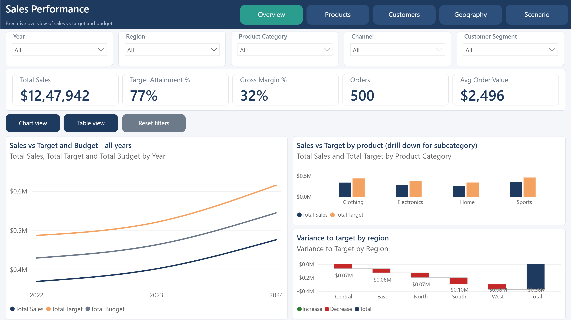

Product Analysis
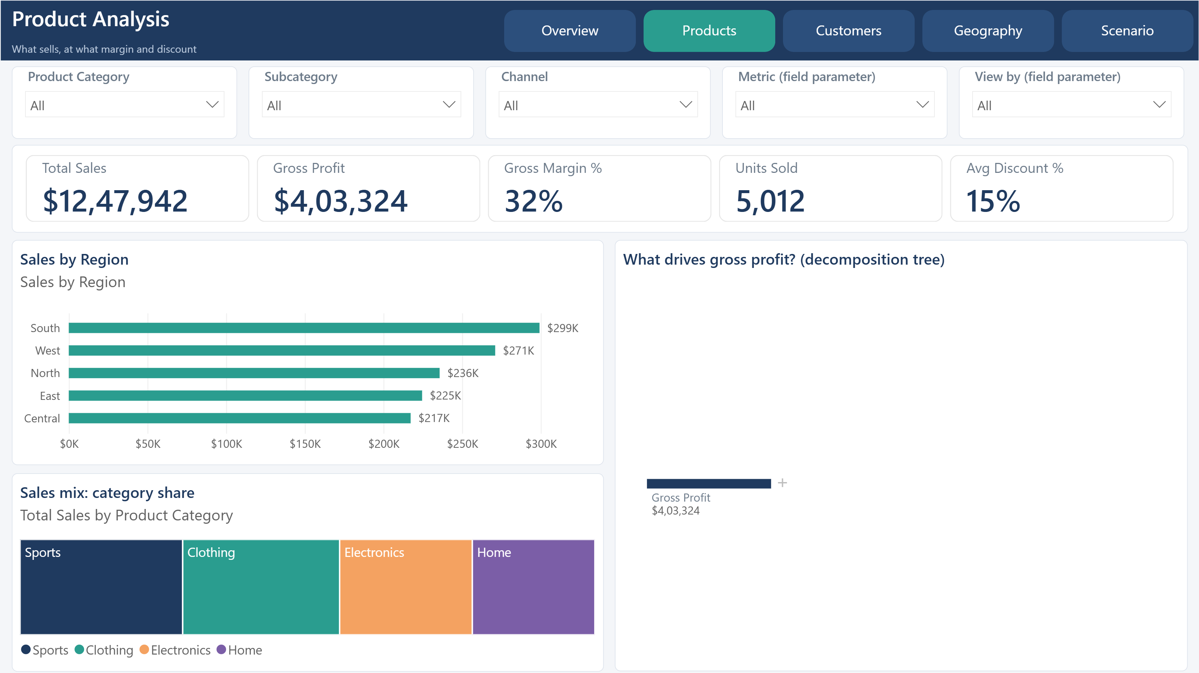

Customer Analysis
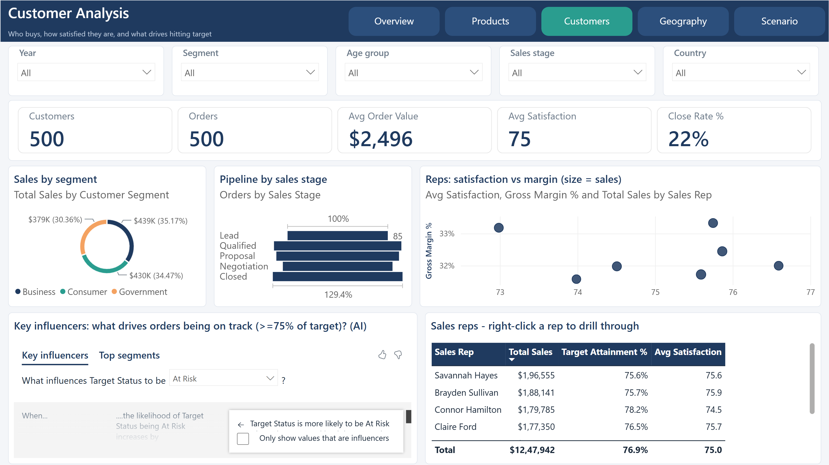

Geographic Performance
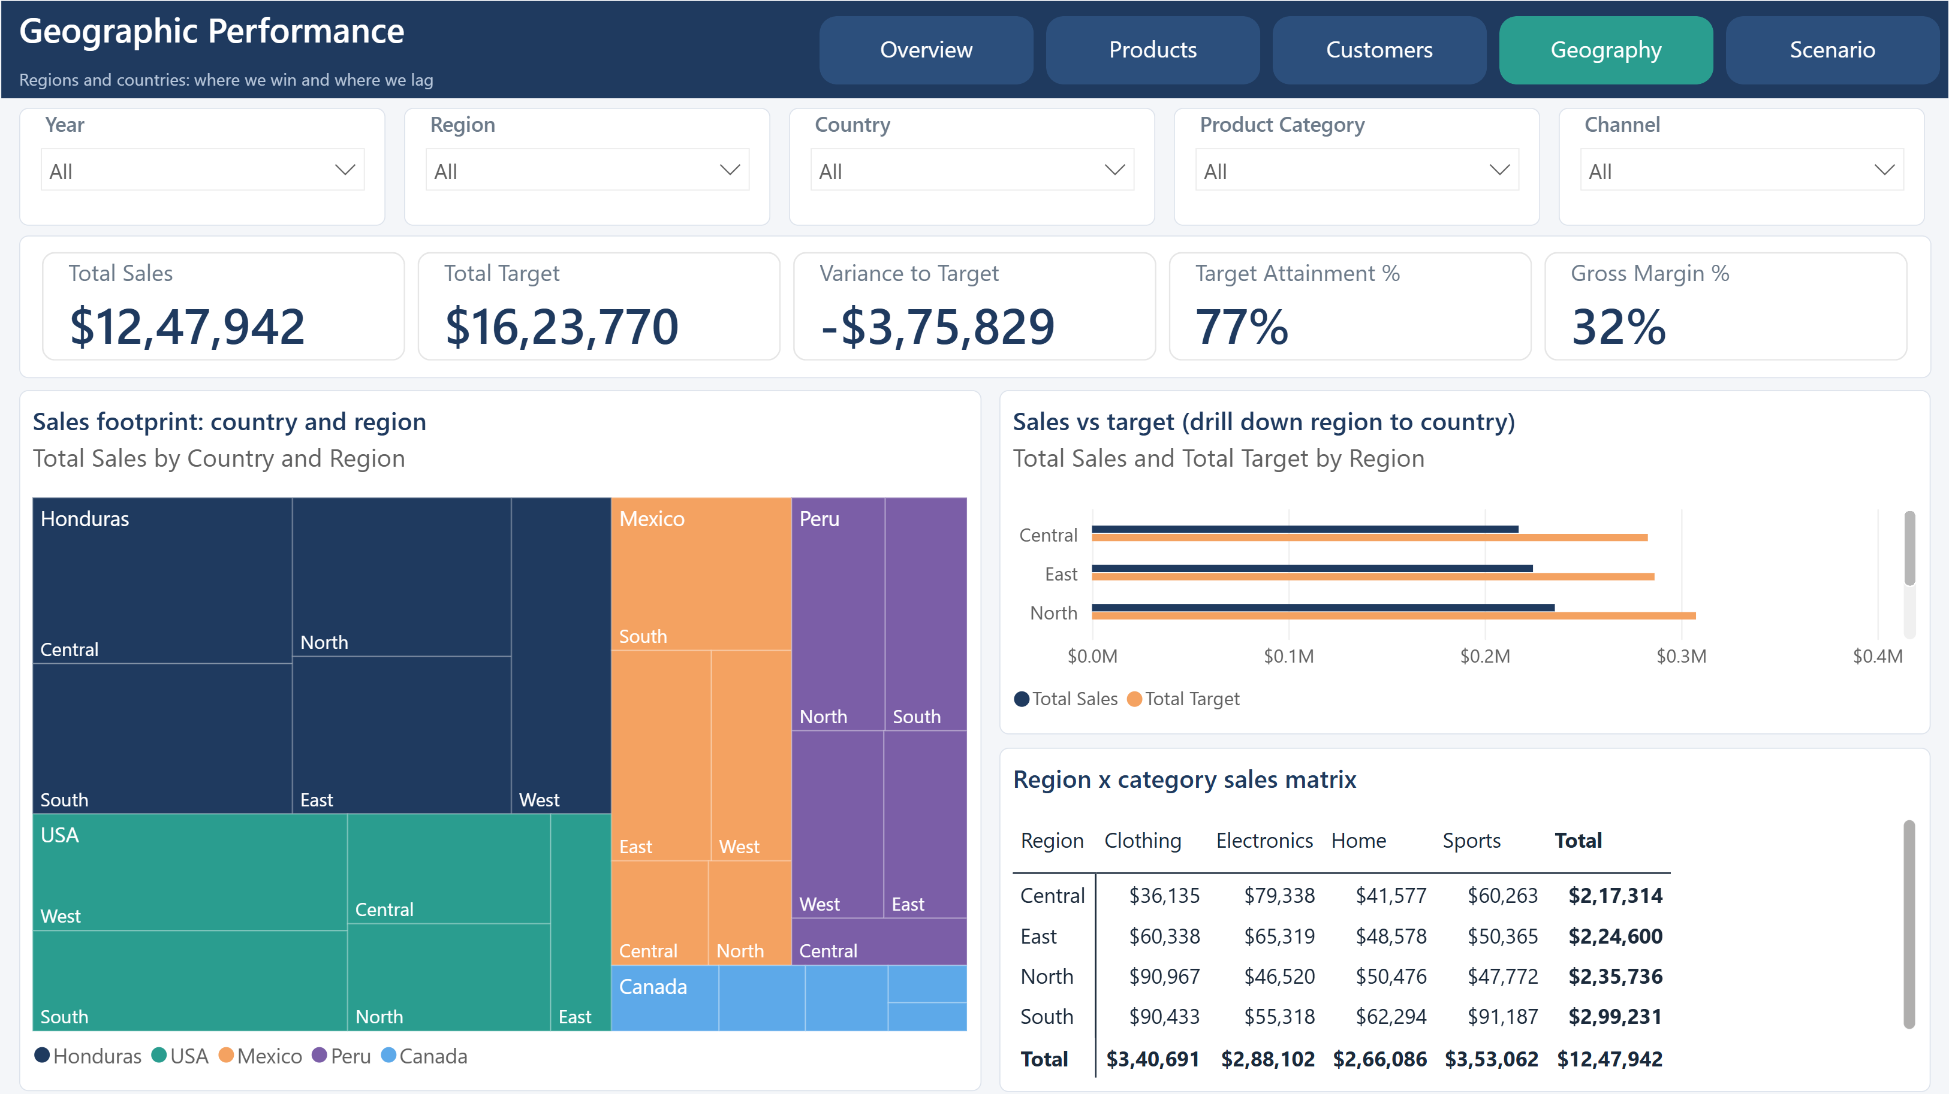

Scenario Planner
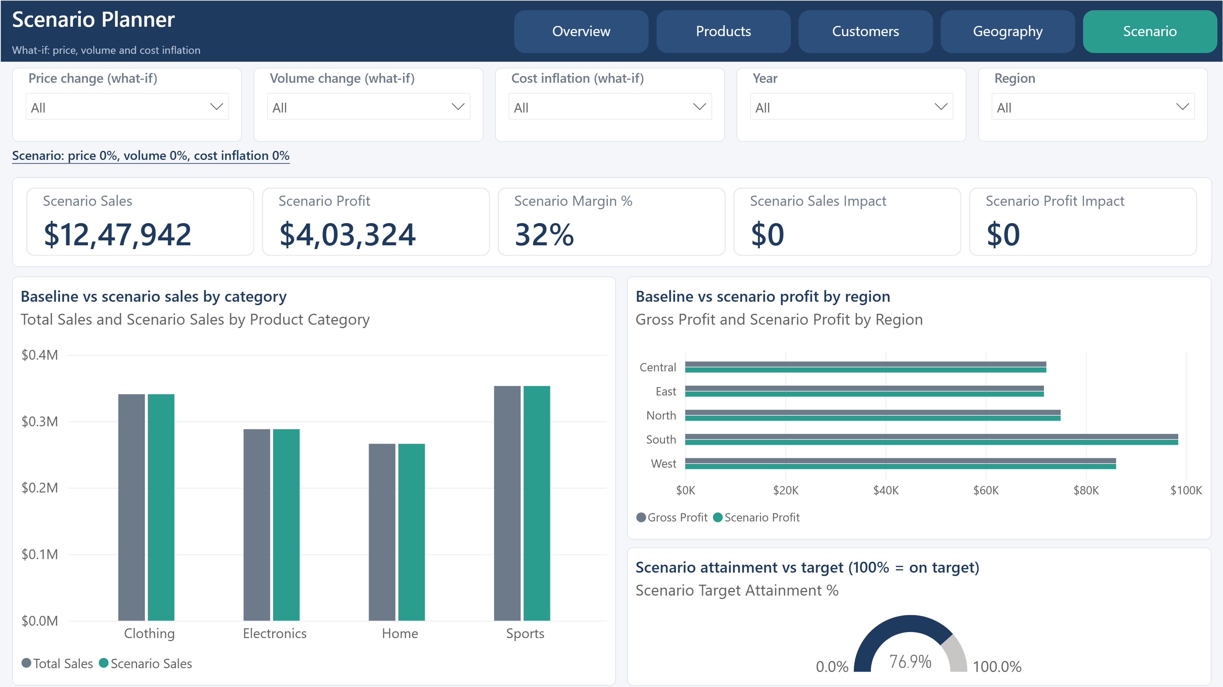

Sales Rep Detail
