# How to Set Up Jupyter Notebook in Visual Studio Code (Windows, no Conda)

## 1. Install Visual Studio Code

Download: <https://code.visualstudio.com/download>

1. Run the downloaded VSCodeUserSetup-x64.exe installer.  
2. Keep the default settings and check “Add ‘Open with Code’ action…”.  
3. Launch VS Code.  
4. Press Ctrl+Shift+X and install these extensions:  
 - Python and Jupyter

-



## 2. Install Python 3.9.7 or Higher

Download: <https://www.python.org/downloads/windows/>

1. Run the Python installer.  
2. Check “Add python.exe to PATH.” (critical)  
3. (Optional) Select “Install for all users.”  
4. Finish installation.  
5. (Optional) Verify installation in PowerShell:  
 python --version  
 py -V  
 py -3.9 -m pip --version

## 3. Point VS Code to Python

1. In VS Code, press Ctrl+Shift+P → Python: Select Interpreter.

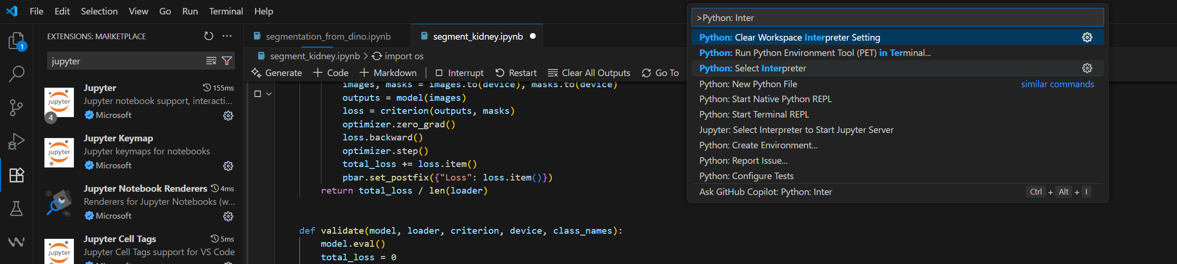  
2. Select your Python 3.9.7 interpreter.



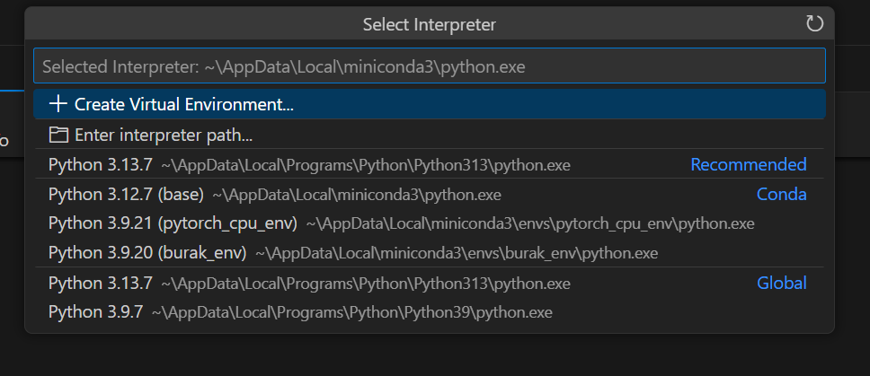  
3. If it doesn’t appear, choose “Enter interpreter path…” and browse to:  
 C:\Users\<you>\AppData\Local\Programs\Python\Python312\python.exe  
 or C:\Program Files\Python312\python.exe

## 4. Install Common Packages

1. Open VS Code.

2. Click File → New File.

3. Save it as setup.ipynb (or any name ending in .ipynb).

When the notebook opens, at the top-right, select your kernel → choose Python 3.9.7 (system).

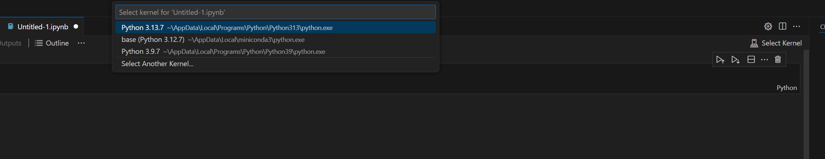



4. Run the following cell  
pip install tqdm pydicom opencv-python numpy matplotlib



pip install torch torchvision torchaudio --index-url https://download.pytorch.org/whl/cu118