>

**Q1.Write a PHP program to create a simple calculator that can accept two numbers & perform operations like add,subtract, multiplication and divide (using Self processing forms)**

<html>

<body>

<form method="post" action="<?php echo $_SERVER['PHP_SELF'] ?>">

Enter first value : <input type=text name=a><br><br>

Enter Second value :<input type=text name=b><br><br>

<b>Select ARtichmatic operation</b><br><br>

<input type="radio" name="choice" value="1">Addition<br><br>

<input type="radio" name="choice" value="2">Subtraction<br><br>

<input type="radio" name="choice" value="3">Multiplication<br><br>

<input type="radio" name="choice" value="4">Division<br><br>

<input type="submit" name="submit" value="calculate"><br>

</form>

<?php

$c="";

if(isset($_POST['submit']))

{

$a=$_POST['a'];

$b=$_POST['b'];

$ch=$_POST['choice'];

if($ch=='1')

{

$c=$a+$b;

echo"Addition = $c";

}

if($ch=='2')

{

$c=$a-$b;

echo"Substraction = $c";

}

if($ch== '3')

{

$c=$a*$b;

echo"Multiplication = $c";

}

if($ch== '4')

{

$c=$a/$b;

echo "Division = $c";

}

}

?>

</body>

</html>

</body>

**Output**

**___________________________________________________________________________**

**Q2. Create a login form with a username and password. Once the user logs in, the second form should be displayed to accept user details (name, city, phoneno). If the user doesn't enter information within a specified time limit, expire his session and give a warning otherwise Display Details($_SESSION).**

File 1 : 18login.php

<html>

<form method="POST" action="logon.php">

<p>Username: <input type="text" name="user"><br>

<p>Password: <input type="password" name="password"><br><br>

<input type="submit" value="login"><br>

</form>

</html>

**Output**

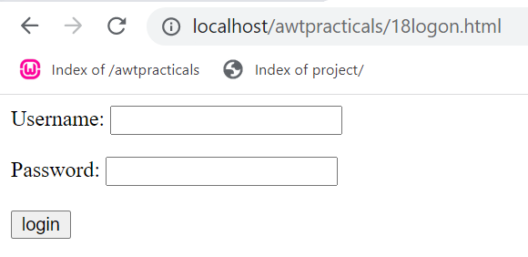

File 2 : logon.php

<?php

$auth_yes=0;

session_start();

/*session_register();*/

$tm=time();

?>

<form method="GET" action="newlogon.php">

<fieldset>

<legend>Enter username and Password</legend>

<p>Roll_no:&nbsp&nbsp&nbsp<input type="text" name="rno"><br>

<p>Name:&nbsp&nbsp&nbsp<input type="text" name="nm"><br>

<p>city:&nbsp&nbsp&nbsp : &nbsp&nbsp&nbsp<input type="text" name="ct"><br><br>

<input type="submit" value=Submit>

</form>

**Output**

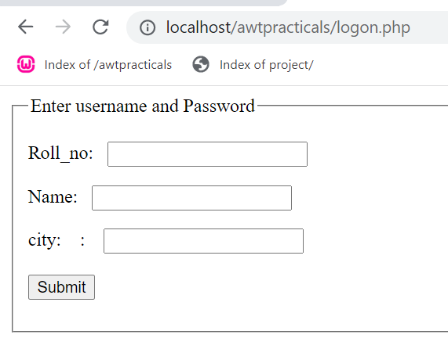

File 3 : newlogon.php

<?php

$a=$_GET['rno'];

$b=$_GET['nm'];

$c=$_GET['ct'];

session_start();

$tm=time();

$newt = $tm+60;

if($newt > time ())

echo "timeout";

else

{

echo"roll_no=$a"."<br>";

echo"name=$b"."<br>";

echo"City=$c"."<br>";

}

session_destroy();

?>

**Output**

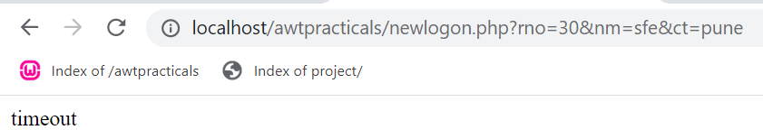

**___________________________________________________________________________**

**Q3.Write a PHP Script create login form and validate it (Use database and Sticky form concept)**

<html>

<head>

<title>Sticky form</title>

</head>

<body>

<form action="<?php echo $_SERVER['PHP_SELF']?>" method=post>

<input type=text name=tname value="<?php if(isset($_POST['tname']))echo $_POST['tname'];?>"></br>

<input type=password name=tpass value="<?php if(isset($_POST['tpass']))echo $_POST['tpass'];?>"></br>

<input type=submit value="Login" name=submit>

<?php

if(isset($_POST['submit']))

$tname=$_POST['tname'];

$tpass=$_POST['tpass'];

$host="localhost";

$user="ro";

$pass="";

$db="mydb2";

$conn = mysqli_connect("localhost","ro","","mydb2")

or

die("Error connecting to Database" .mysqli_error());

echo("Connected to Mysql <br>");

$sql = "SELECT * FROM login1 WHERE uname='$tname' AND upass='$tpass' ";

$result = $conn->query($sql);

$flag=0;

while($row=$result->fetch_assoc())

{

$flag++;

}

if($flag==1)

echo "login validated";

else

echo "username or password invalid";

?>

</body>

</html>

**output**

**___________________________________________________________________________**

**4)Create a form to accept employee details like name, address and mobile number. Once the employce information is accepted, then accept LIC information like policy_no, name, premium. Display employee details and LIC details on next form.(use COOKIE)**

File 1 : q4.html

<html>

<body>

<form method="POST" action="Lic.php">

Enter EMP No : <input type=text name="eno"><br>

Enter EMP Name : <input type=text name="name"><br>

Enter Address : <input type=text name="addr"><br>

<input type=submit value=Submit>

</form>

</body>

</html>

**Output**

File 2 : lic.php

<?php

session_start();

$_SESSION['eno']=$_POST['eno'];

$_SESSION['name']=$_POST['name'];

$_SESSION['addr']=$_POST['addr'];

echo"Hello ".$_SESSION['name']." enter LIC details<br>";

?>

<form method="POST" action="Display.php">

Plan No:<input type="text" name="pno"><br>

Plan Name :<input type="text" name="pname"><br>

Premium :<input type="text" name="pre"><br>

<input type=submit value=Display>

</form>

**Output**

File 3: display.php

<?php

session_start();

echo"<Center>"."<b>Employee Details</b>"."<br>";

echo"Emp No:".$_SESSION['eno']."<br>";

echo"Emp name:".$_SESSION['name']."<br>";

echo"Address:".$_SESSION['addr']."<br>"."<hr>";

echo"<b>LIC Plan Details:</b>"."<br>";

echo"Plan No:".$_REQUEST['pno']."<br>";

echo"Plan Name:".$_REQUEST['pname']."<br>";

echo"Premium:".$_REQUEST['pre']."<br>"."<hr>";

?>

**Output**

**___________________________________________________________________________**

**5) Write a script to keep track of number of times the web page has been accessed (use S_COOKIE).**

<html>

<head>

<title>PHP code to count no of visitors using cookies:</title>

</head>

<body>

<?php

if (!isset($_COOKIE['count'])) {

echo "welcome! THis is the first time you have viewed this page. ";

$cookie= 1;

setcookie("count", $cookie);

}

else

{

$cookie = ++$_COOKIE['count'];

setcookie("count", $cookie);

echo "you have viewed this page ".$_COOKIE['count']."times.";

}

?>

</body>

</html>

**Output**

**___________________________________________________________________________**

**(6) Write a PHP script to accept username and password. If in the first three chances, username and password entered is correct, then display second form, otherwise display error message. (Use Session)**

File 1: newq6.html

<html>

<head>

<script>

function getans()

{

st1=document.getElementById('txtname').value;

st2=document.getElementById('txtpass').value;

ob=new XMLHttpRequest();

ob.onreadystatechange=function()

{

if(ob.readyState==4 && ob.status==200)

{

if(ob.responseText==3)

{

alert("sorry you lost the chances to login");

location="error.html";

}

else if(ob.responseText=="correct")

{

alert("you entered correct details");

}

else alert(ob.responseText);

}

}

ob.open("GET","error.php?n="+st1+"&p="+st2);

ob.send();

}

</script>

</head>

<body>

<input type=text id=txtname placeholder="username"></br>

<input type=password id=txtpass placeholder="password"></br>

<input type="button" onclick="getans()" value="Login">

</body>

</html>

File 2: error.php

You Entered the wrong credentials 3 times

PHP file :

<?php

session_start();

$nm=$_GET['n'];

$ps=$_GET['p'];

if($nm==$ps)

{

echo "correct";

}

else if(isset($_SESSION['cnt']))

{

$x=$_SESSION['cnt'];

$x=$x+1;

$_SESSION['cnt']=$x;

echo $_SESSION['cnt'];

if($_SESSION['cnt']>=3)

$_SESSION['cnt']=1;

}

else

{

$_SESSION['cnt']=1;

echo "1";

}

?>

**Output**

**___________________________________________________________________________**

**7) Create a form to accept student information (name, class, address). Once the student information is accepted, accept marks in next form (Java, PHP. ST, IT, pract1, and project). Display the mark sheet for the student in the next form containing name, class, marks of the subject, total and percentage(Use $_COOKIE).**

File 1: First.php

<html>

<body>

<form method="post" action="second.php">

<b>Student No:- </b><input type="text" name="sno"></br>

<b>Student Name:- </b><input type="text" name="sname"></br>

<b>Student class:- </b><input type="text" name="class"></br>

<b>Student address:- </b><input type="text" name="address"></br>

<input type="submit" value="save">

</form>

</body>

</html>

**Output**

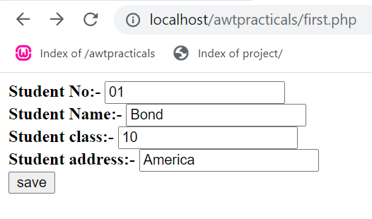

File 2: Second.php

<html>

<body>

<?php

setCookie('sno',$_POST["sno"]);

setCookie('sname',$_POST["sname"]);

setCookie('class',$_POST["class"]);

setCookie('address',$_POST["address"]);

echo"Hello".$_POST["sname"]."!Enter Marks....<br>";

?>

<form method="post" action="third.php">

<b>JAVA</B><input type="text" name="JAVA"></br>

<b>PHP</B><input type="text" name="PHP"></br>

<b>ST</B><input type="text" name="ST"></br>

<b>IT</B><input type="text" name="IT"></br>

<b>Practical</B><input type="text" name="Practical"></br> <input type="submit" name="submit" value="DISPLAY">

</form>

</body>

</html>

**Output**

File 3: third.php

<html>

<body>

<?php

echo "<b> Student Details</b><br>";

echo" Student No:".$_COOKIE["sno"]."<br>";

echo"Student Name:".$_COOKIE["sname"]."<br>";

echo"Student class:-".$_COOKIE["class"]."<br>";

echo"Student address:-".$_COOKIE["address"],"<br>";

echo "<b> Student Marks</b><br>";

echo"Java:".$_REQUEST["JAVA"]."<BR>";

echo"PHP:".$_REQUEST["PHP"]."<BR>";

echo"ST:".$_REQUEST["ST"]."<BR>";

echo"IT:".$_REQUEST["IT"]."<BR>";

echo"Practical:".$_REQUEST["Practical"]."<BR>";

if(isset($_POST['submit']))

{

$JAVA=(int)$_POST['JAVA'];

$PHP=(int)$_POST['PHP'];

$ST=(int)$_POST['ST'];

$IT=(int)$_POST['IT'];

$Practical=(int)$_POST['Practical'];

$total = $JAVA+$PHP+$ST+$IT+$Practical;

echo"Total=".$total;

}

?>

</body>

</html>

**Output**

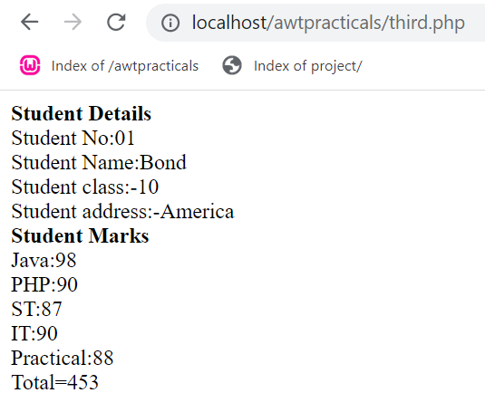

**___________________________________________________________________________**

**(8) Write a program to create a shopping mall. User must be allowed to do purchase from three pages. Each page should have a page total. The fourth page should display a bill, which consists of a page total of whatever the purchase has been done and print the total. (Use $_SESSION).**

File1 and pg1 : q8.php

<?php

session_start();

if(!isset($_SESSION['total']))

{

$_SESSION['total']=0;

}

if(isset($_POST['submit']))

{

$_SESSION['pname']="Arabian Nights Book";

$_SESSION['amt']="100";

$_SESSION['total']=$_SESSION['total']+100;

}

?>

<html>

<head>

</head>

<body>

<h1><center><b>Shopping Mall<b></center>

<center>Total :<span style="color:red<?php if(isset($_SESSION['total'])){echo $_SESSION['total'];}?>" </span></h1> </center>

<table style="width:100%">

<tr>

<th><a href="1.php">1</a></th>

<th><a href="2.php">2</a></th>

<th><a href="3.php">3</a></th>

<th><a href="Final.php">Final</a></th>

</tr>

</table>

Product 1:

<FORM ACTION="<?php $_SERVER['PHP_SELF']; ?>" method="POST">

<table style="width:90%" border=1>

<tr>

<th>Product Image</th>

<th>Product Name</th>

<th>Price </th>

<th>action</th>

</tr>

<tr>

<th><img src="an.png"height="200" Width="200"> </th>

<th>Arabian Nights Book</th>

<th>100</th>

<th>

<input type=submit name=submit value="buy">

</form></th>

</tr>

</table>

</body>

</html>

**Output**

File 2 and pg 2: 2.php

<?php

session_start();

if(!isset($_SESSION['total']))

{

$_SESSION['total']=0;

}

if(isset($_POST['submit']))

{

$_SESSION['pname']=$_SESSION['pname'].","."Bucky Barnes Action Figure";

$_SESSION['amt']=$_SESSION['amt'].","."500";

$_SESSION['total']=$_SESSION['total']+500;

}

?>

<html>

<head>

</head>

<body>

<h1<center>shopping mall</center> Total :<span style="color:red;"><?php if(isset($_SESSION['total'])){echo $_SESSION['total'];}?></span></h1>

<table style="width:80%">

<tr><br> <th><a href="q8.php">1</a></th>

<th><a href="2.php">2</a></th>

<th><a href="3.php">3</a></th>

<th><a href="Final.php">Final</a></th>

</tr>

</table>

Product 2:

<FORM ACTION="<?php $_SERVER['PHP_SELF']; ?>" method="POST">

<table style="width:80%" border=1>

<tr>

<th>Product Image</th>

<th>Product Name</th>

<th>Price </th>

<th>action</th>

</tr>

<tr>

<th><img src="bucky.png"height="200" Width="200"> </th>

<th>Bucky Barnes Action Figure</th>

<th>500</th>

<th>

<input type=submit name=submit value="buy">

</form></th>

</tr>

</table>

</body>

</html>

**Output**

File 3 and pg3: 3.php

<?php

session_start();

if(!isset($_SESSION['total']))

{

$_SESSION['total']=0;

}

if(isset($_POST['submit']))

{

$_SESSION['pname']=$_SESSION['pname'].","."recliner chair";

$_SESSION['amt']=$_SESSION['amt'].","."7000";

$_SESSION['total']=$_SESSION['total']+7000;

}

?> <html>

<head>

</head>

<body>

<h1><center>shopping mall</center> Total <span style="color:red;"><?php if(isset($_SESSION['total'])){echo $_SESSION['total'];}?></span></h1>

<table style="width:70%">

<tr>

<th><a href="q8.php">1</a></th>

<th><a href="2.php">2</a></th>

<th><a href="3.php">3</a></th>

<th><a href="Final.php">Final</a></th>

</tr>

</table>

Product 3:

<FORM ACTION="<?php $_SERVER['PHP_SELF']; ?>" method="POST">

<table style="width:80%" border=1>

<tr> <th>Product Image</th>

<th>Product Name</th>

<th>Price </th>

<th>action</th>

</tr<br> <tr>

<th><img src="recliner.png"height="200" Width="200"> </th>

<th>Recliner Chair</th>

<th>7000</th>

<th>

<input type=submit name=submit value="buy" >

</form>

</tr>

</table>

</body>

</html>

**Output**

File 4 page 4: final.php

<?php

session_start();

?>

<html>

<head>

<script>

function myFunction()

{

window.print();

}

</script>

</head>

<body>

<h1><center>shopping mall</center> Total :<span style="color:red<?php if(isset($_SESSION['total'])){echo $_SESSION['total'];}?></span> <table style="width:100%">

<tr>

<th><a href="q8.php">1</a></th>

<th><a href="2.php">2</a</th>

<th><a href="3.php">3</a></th>

<th><a href="Final.php">Final</a></th>

</tr>

</table>

<br>

<br>

<h2><center>Final Bill</center> Total :</h2>

<table style="width:80%" border=1>

<tr><br> <th>Product Name</th>

<th>Amount </th>

<th>Total</th>

<th>Print</th>

</tr>

<tr>

<th><?php if(isset($_SESSION['pname'])){echo $_SESSION['pname'];}?></th>

<th><?php if(isset($_SESSION['amt'])){echo $_SESSION['amt'];}?></th>

<th><span style="color:red;"><?php if(isset($_SESSION['total'])){echo $_SESSION['total'];}?></span></th>

<th><button onclick="myFunction()">Print </button>

</tr>

</table>

</body>

</html>

**Output**

**___________________________________________________________________________**

**9) Write a PHP script for the following: Design a form to accept a number from the user. Perform the operations and show the results.**

**1) Factorial of a number using Recursion.**

**2) Add the digits of that number to reduce it to single digit. 4 (use the concept of self processing page.)**

<html>

<body>

<form action="<?php echo $_SERVER['PHP_SELF']?>" method=POST>

<h1><center>Enter a String to find out the Factorial using recursion <br>

And the Sum of the Number Reduced to Single Digit <br> </h1> </center>

<center> <input type name=txtnumber placeholder="Enter a number "></center>

<center><input type=submit name="submit"></center>

</form>

<?php

if (isset($_POST['submit']))

{

error_reporting(0);

function fact($n)

{

if($n==1)

{

return 1;

}

else

{

return($n*fact($n-1));

}

}

function singleval($n)

{

while($n>9)

{

$sum=0;

while($n)

{

$r=$n%10;

$sum=$sum+$r;

$n=$n/10;

}

$n=$sum;

}

return $n;

}

echo " Factorial: ";

echo fact($_POST['txtnumber']);

echo " <br>";

echo " sum of the number reduced to single digit: ";

echo singleval($_POST['txtnumber']);

echo " <br>";

}

?>

</body>

</html>

**Output**

**___________________________________________________________________________**

**(10) Create student registration form and display details in the next page. (Use sticky form**

**concept).**

File 1: q10html.php

<html>

<body>

<table border=1>

<tr><th colspan=2>

<form action="<?php echo $_SERVER['PHP_SELF']?>" method=post>

<tr><td>Enter Name</td><td><input type="text" name="nm" value="<?php if(isset($_POST['nm']))echo $_POST['nm']?>"<td></tr>

<tr><td>Enter Roll No</td><td><input type="text" name="rno" value="<?php if(isset($_POST['rno']))echo $_POST['rno']?>"</td></tr>

<tr><td>Enter State</td><td><input type="text" name="st" value="<?php if(isset($_POST['st']))echo $_POST['st']?>" </td></tr>

<tr><td>Enter City</td><td><input type="text" name="ct" value="<?php if(isset($_POST['ct']))echo $_POST['ct']?>"</td></tr>

<tr><td>Enter Percentage</td><td><input type="text" name="per" value="<?php if(isset($_POST['per']))echo $_POST['per']?>"</td></tr>

<tr><td><input type="submit" value="Submit" name="submit"></td>

<td><nput type="reset" value="Reset"></td></tr>

</form>

</table>

<?php

if(isset($_POST['submit']))

{

$nm=$_POST['nm'];

$rno=$_POST['rno'];

$st=$_POST['st'];

$ct=$_POST['ct'];

$perc=$_POST['per'];

}

if((!empty($nm)) && (!empty($rno)) && (!empty($st)) && (!empty($ct)) && (!empty($perc)))

{

setcookie('nm',$nm);

setcookie('rno',$rno);

setcookie('st',$st);

setcookie('ct',$ct);

setcookie('perc',$perc);

echo "Registration Complete, Click Show To check the details <br>";

}

?>

<a href="q10.php">show

</body>

</html>

**Output**

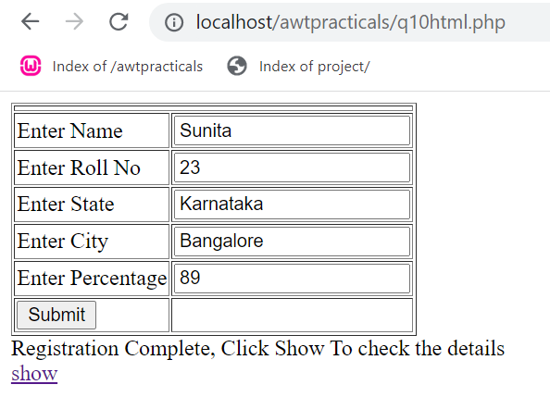

File 2: q10.php

<?php

echo "Your name is $_COOKIE[nm] </br>";

echo "Your Roll No Is : $_COOKIE[rno]</br>";

echo "Your State Is : $_COOKIE[st]</br>";

echo "Your City Is : $_COOKIE[ct]</br>";

echo "Your Percentage Is : $_COOKIE[perc]</br>";

?>

**Output**

pital

hospital

<?php

$hosp=$_GET['hname'];

$con=mysqli_connect("localhost","yogita","");

$d=mysqli_select_db($con,'q25');

$q=mysqli_query($con,"Select doc.dno, dname, addr, area from doc, hospital, dochosp where hname='$hosp' and dochosp.dno=doc.dno and dochosp.hno=hospital.hno");

echo "<tr><td> doctor number || </td><td> doctor name || </td><td> doctor address || </td><td> area|| </td></tr>";

while($row=mysqli_fetch_array($q))

{

echo"<br><tr><td>".$row[0]."</td>||<td>".$row[1]."</td>||<td>".$row[2]."</td>||<td>".$row[3]."</td></tr>";

}

mysqli_close($con);

?>

create table dochosp(dno int, foreign key(dno) references doc(dno), hno int, foreign key(hno) references hospital(hno));

<html>

<body>

<form method="get" action="dochosp.php">

Enter hospital name:<br>

<input type="text" name="hname"><br>

<input type="submit" value="submit"><br>

</form>

</body>

</html>

Microsoft Windows [Version 10.0.19042.1466]

(c) Microsoft Corporation. All rights reserved.

C:\Users\91762>cd\

C:\>cd windows\system32

C:\Windows\System32>cd..

C:\Windows>E:

E:\>cd xampp\mysql\bin

E:\xampp\mysql\bin>mysql -u root --port 3306

Welcome to the MariaDB monitor. Commands end with ; or \g.

Your MariaDB connection id is 210

Server version: 10.4.20-MariaDB mariadb.org binary distribution

Copyright (c) 2000, 2018, Oracle, MariaDB Corporation Ab and others.

Type 'help;' or '\h' for help. Type '\c' to clear the current input statement.

MariaDB [(none)]> create user yogita;

ERROR 1396 (HY000): Operation CREATE USER failed for 'yogita'@'%'

MariaDB [(none)]> create database q25;

Query OK, 1 row affected (0.001 sec)

MariaDB [(none)]> use q25;

Database changed

MariaDB [q25]> grant all privileges on q25.* to yogita@localhost;

Query OK, 0 rows affected (1.751 sec)

MariaDB [q25]> create table doc(dno int primary key, dname varchar(20), addr varchar(20), city varchar(20), area varchar(20));

Query OK, 0 rows affected (1.997 sec)

MariaDB [q25]> create table hospital( hno int primary key, hname varchar(20), hcity varchar(20));

Query OK, 0 rows affected (1.995 sec)

MariaDB [q25]> create table dochosp(dno int, foreign key(dno) references doc(dno), hno int, foreign key(hno) references hospital(hno));

Query OK, 0 rows affected (2.049 sec)

MariaDB [q25]> insert into doc values(1, 'vivaan', 'viman nagar','pune','mh');

Query OK, 1 row affected (1.743 sec)

MariaDB [q25]> insert into hospital values(101, 'budhrani', 'kp');

Query OK, 1 row affected (0.399 sec)

MariaDB [q25]> insert into dochosp values(1,101);

Query OK, 1 row affected (0.140 sec)

MariaDB [q25]>

person

<?php

$con=mysqli_connect("localhost", "yogita","");

if(!$con)

die("Could not connect: ".mysqli_error($con));

if(mysqli_query($con,"Create Database demo"))

{

echo "databse created";

}

else{

die("error creating database ".mysqli_error($con));

}

mysqli_select_db($con,"demo");

$sql="create table persons(firstname varchar(15), lastname varchar(15), age int)";

mysqli_query($con,$sql);

mysqli_query($con,"insert into persons(firstname, lastname, age) values('peter','pan',10)");

mysqli_query($con,"insert into persons(firstname, lastname, age) values('harry','potter',25)");

mysqli_close($con);

?>

Microsoft Windows [Version 10.0.19042.1466]

(c) Microsoft Corporation. All rights reserved.

C:\Users\91762>cd\

C:\>cd windows\system30

The system cannot find the path specified.

C:\>cd windows\system38

The system cannot find the path specified.

C:\>cd windows\system32

C:\Windows\System32>cd..

C:\Windows>E:

E:\>cd xampp\mysql\bin

E:\xampp\mysql\bin>mysql -u root --port 3306

Welcome to the MariaDB monitor. Commands end with ; or \g.

Your MariaDB connection id is 46

Server version: 10.4.20-MariaDB mariadb.org binary distribution

Copyright (c) 2000, 2018, Oracle, MariaDB Corporation Ab and others.

Type 'help;' or '\h' for help. Type '\c' to clear the current input statement.

MariaDB [(none)]> grant all privileges on demo.* to yogita@localhost;

Query OK, 0 rows affected (1.749 sec)

MariaDB [(none)]> grant all privileges on demo.* to yogita@localhost;

Query OK, 0 rows affected (0.203 sec)

MariaDB [(none)]> use demo;

Database changed

MariaDB [demo]> select * from persons

-> ;

ERROR 1146 (42S02): Table 'demo.persons' doesn't exist

MariaDB [demo]> select * from persons;

+-----------+----------+------+

| firstname | lastname | age |

+-----------+----------+------+

| peter | pan | 10 |

| harry | potter | 25 |

+-----------+----------+------+

2 rows in set (0.000 sec)

MariaDB [demo]>

Movie and actor

<html>

<body>

<form action="movieactor.php" method="get">

<h3>Enter Actor name:<input type="text" name="name">

<input type="radio" name="a" value="1">Display Movie Name<br><br>

<h3> Enter movie no:<input type="text" name="mno"></h3>

<h3> Enter movie name:<input type="text" name="mname"></h3>

<h3> Enter release year:<input type="text" name="ryear"></h3>

<h3> Enter actor no:<input type="text" name="ano"></h3>

<h3> Enter actor name:<input type="text" name="aname"></h3>

<input type="radio" name="a" value="2">Insert new movie info<br><br>

<input type="submit" value="ok">

</form>

<div id="place"></div>

</body>

</html>

<?php

$r=$_GET['a'];

$con=mysqli_connect("localhost","yogita","","q26");

if($r==1)

{

$actor_name= $_GET['name'];

$q=mysqli_query($con, "select mname from movie, actor, ma where movie.mno=ma.mno and actor.ano=ma.ano and aname='$actor_name' ");

echo"<br>Movie Name<br>";

while($row=mysqli_fetch_array($q))

{

echo $row[0]."<br>";

}

}

else if($r==2)

{

$mno=$_GET['mno'];

$mname=$_GET['mname'];

$ryear=$_GET['ryear'];

$ano=$_GET['ano'];

$aname=$_GET['aname'];

$q=mysqli_query($con,"insert into movie values($mno, '$mname',$ryear)" );

$q1=mysqli_query($con,"insert into actor values($ano,'$aname') ");

$q2=mysqli_query($con,"insert into ma values($mno,$ano)");

echo "value inserted";

}

mysqli_close($con);

/*

E:\xampp\mysql\bin>mysql -u root --port 3306

Welcome to the MariaDB monitor. Commands end with ; or \g.

Your MariaDB connection id is 82

Server version: 10.4.20-MariaDB mariadb.org binary distribution

Copyright (c) 2000, 2018, Oracle, MariaDB Corporation Ab and others.

Type 'help;' or '\h' for help. Type '\c' to clear the current input statement.

MariaDB [(none)]> create database q26;

Query OK, 1 row affected (0.002 sec)

MariaDB [(none)]> use q26;

Database changed

MariaDB [q26]> grant all privileges on q26.* to yogita@localhost;

Query OK, 0 rows affected (1.817 sec)

MariaDB [q26]> create table movie(mno int primary key, mname varchar(20), ryear int);

Query OK, 0 rows affected (2.012 sec)

MariaDB [q26]> create table actor(ano int primary key, aname varchar(20));

Query OK, 0 rows affected (2.009 sec)

MariaDB [q26]> create table ma(mno int, foreign key(mno) references movie(mno), ano int, foreign key(ano) references actor(ano));

Query OK, 0 rows affected (1.995 sec)

*/

?>

login

<html>

<head>

<title>Sticky Form</title>

</head>

<body>

<form action="<?php echo $_SERVER['PHP_SELF']?>" method="post">

<input type="text" name="txtuname" value="<?php if(isset($_POST['txtuname'])) echo $_POST['txtuname'];?>" ><br>

<input type="password" name="txtupass" value="<?php if(isset($_POST['txtupass'])) echo $_POST['txtupass'];?>" ><br>

<input type="submit" value="login" name="submit">

<?php

if(isset($_POST['submit']))

$nm=$_POST['txtuname'];

$ps=$_POST['txtupass'];

$con=mysqli_connect("localhost","yogita","","q3");

$result=mysqli_query($con,"select * from login where uname='$nm' and upass='$ps' ");

$flag=0;

while($row=mysqli_fetch_array($result))

{

$flag++;

}

if($flag==1)

echo "login validated";

else

echo "username or psswrd invalid";

?>

</body>

</html>

Employee derpartment

<html>

<body>

<form action="empdept.php" method="get">

<center> <h2> fill employee details: </h2>

<table>

<tr> <td>enter employee no:</td> <td><input type="text" name="eno"></td></tr>

<tr> <td>enter employee name:</td> <td><input type="text" name="ename"></td></tr>

<tr> <td>enter address:</td> <td><input type="text" name="addr"></td></tr>

<tr> <td>enter phone:</td> <td><input type="text" name="phn"></td></tr>

<tr> <td>enter salary:</td> <td><input type="text" name="sal"></td></tr>

<tr> <td>enter department no:</td> <td><input type="text" name="dno"></td></tr>

<tr> <td>enter department name:</td> <td><input type="text" name="dname"></td></tr>

<tr> <td>enter location:</td> <td><input type="text" name="loc"></td></tr>

<tr><td></td><td><input type="submit" value="ok"></td></tr>

</table>

</center>

</form>

</body>

</html>

<!---

/*Microsoft Windows [Version 10.0.19042.1466]

(c) Microsoft Corporation. All rights reserved.

C:\Users\91762>cd\

C:\>cd windows\system32

C:\Windows\System32>cd..

C:\Windows>E:

E:\>cd xampp\mysql\bin

E:\xampp\mysql\bin>mysql -u root --port 3306

ERROR 2002 (HY000): Can't connect to MySQL server on 'localhost' (10061)

E:\xampp\mysql\bin> mysql -u root --port 3306

Welcome to the MariaDB monitor. Commands end with ; or \g.

Your MariaDB connection id is 16

Server version: 10.4.20-MariaDB mariadb.org binary distribution

Copyright (c) 2000, 2018, Oracle, MariaDB Corporation Ab and others.

Type 'help;' or '\h' for help. Type '\c' to clear the current input statement.

MariaDB [(none)]> create database q24;

Query OK, 1 row affected (0.340 sec)

MariaDB [(none)]> use q24;

Database changed

MariaDB [q24]> grant all privileges on q24.* to yogita@localhost;

Query OK, 0 rows affected (1.820 sec)

MariaDB [q24]> create table emp(eno int primary key, ename varchar(20), addr varchar(20), phone varchar(11), salary int);

Query OK, 0 rows affected (1.993 sec)

MariaDB [q24]> create table dept(dno int primary key, dname varchar(20), loc varchar(20));

Query OK, 0 rows affected (1.981 sec)

MariaDB [q24]> drop table dept;

Query OK, 0 rows affected (0.255 sec)

MariaDB [q24]> create table dept(dno int primary key, dname varchar(20), loc varchar(20), eno int, foreign key(eno) references emp(eno));

Query OK, 0 rows affected (2.054 sec)

MariaDB [q24]>

-->

Cookie

<?php

$pno=$_GET['pno'];

$name=$_GET['name'];

$premium=$_GET['premium'];

if(isset($_COOKIE['ename'])&&isset($_COOKIE['address'])&&isset($_COOKIE['mobile']))

{

echo "<br><b>employee details</b><br>";

echo "Employee name: ".$_COOKIE['ename']." <br>";

echo "Employee Address: ".$_COOKIE['address']."<br>";

echo "Mobile no. ".$_COOKIE['mobile']."<br>";

echo "<br><b>lic policy details</b><br>";

echo "policy no. : $pno<br>";

echo "policy name: $name<br>";

echo "premium: $premium";

}

?>

Employee min max

<?php

$eno=$_GET['eno'];

$ename=$_GET['ename'];

$addr=$_GET['addr'];

$phn=$_GET['phn'];

$sal=$_GET['sal'];

$dno=$_GET['dno'];

$dname=$_GET['dname'];

$loc=$_GET['loc'];

$con=mysqli_connect("localhost","yogita","","q24");

$q=mysqli_query($con,"insert into emp values($eno,'$ename','$addr',$phn,$sal)");

$q1=mysqli_query($con,"insert into dept values($dno,'$dname','$loc',$eno)");

$q2=mysqli_query($con,"select MIN(salary),MAX(salary),SUM(salary) from emp, dept where emp.eno=dept.eno");

echo "<table><tr><td>Minimum salary---</td><td>Maximum salary------</td><td>Sum of salary</td></tr>";

while($row=mysqli_fetch_array($q2))

{

echo "<tr><td>".$row[0]."</td><td>".$row[1]."</td><td>".$row[2]."</td></tr>";

}

echo "</table>";

mysqli_close($con);

?>