**FINITE ELEMENT METHODS IN CIVIL ENGINEERING**

**(CE 723A)**

HOMEWORK ASSIGNMENT II

PREPARED BY:

**BUDHADITYA DE**

**M.TECH IN STRUCTURAL ENGG.**

**ROLL-21103033**

UNDER THE GUIDANCE OF:

**DR. SUPARNO MUKHOPADHYAY**

**DEPARTMENT OF CIVIL ENGINEERING**

**INDIAN INSTITUTE OF TECHNOLOGY KANPUR**

**YEAR: 2021/22 SEMESTER: I**

[**NOTE:** All Handwritten parts are provided in the PDF file. This doc file includes the necessary MATLAB outputs and any accompanied explanation of the results if needed]

**Q1)** HW#1 results for comparison: (MATLAB code is also attached in the folder)

MATLAB OUTPUT:

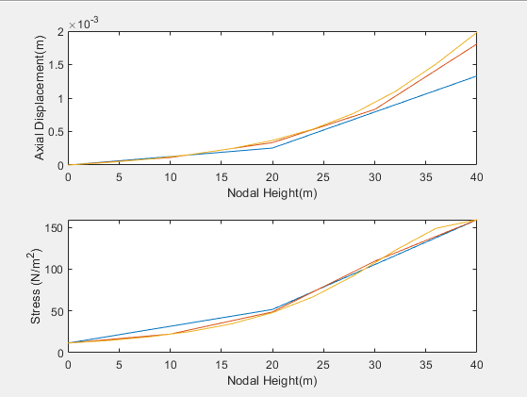

Fig1. Axial Displacement and Stresses vs nodal height with varying no of elements. Colours indicated are: BLUE: 2 Elements RED: 4 Elements ORANGE: 10 Elements.

1. 3-Noded Quadratic elements with number of gauss pts=2

MATLAB OUTPUT:

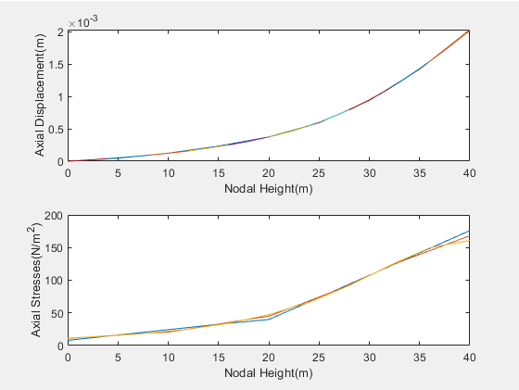

Fig2. Axial Displacement and Stresses vs nodal height with varying no of elements. Colours indicated are: BLUE: 2 Elements RED: 4 Elements ORANGE: 10 Elements.

1. 2-Noded Linear elements with number of gauss points=2

MATLAB OUTPUT:

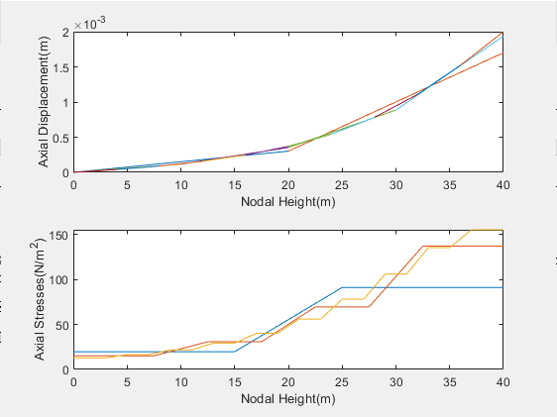

Fig3. Axial Displacement and Stresses vs nodal height with varying no of elements. Colours indicated are: BLUE: 2 Elements RED: 4 Elements ORANGE: 10 Elements.

1. 2-Noded Linear elements with number of gauss points=1

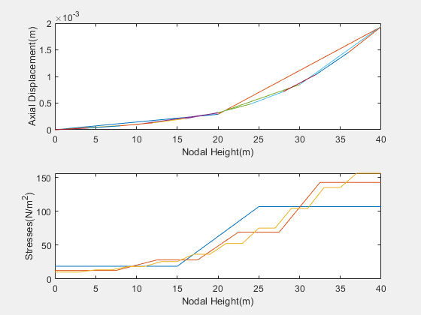

Fig4. Axial Displacement and Stresses vs nodal height with varying no of elements. Colours indicated are: BLUE: 2 Elements RED: 4 Elements ORANGE: 10 Elements.

We observe that the quadratic 3-noded shape functions are more versatile and accurate as compared to the linear elements. Also, the accuracy of the solution for a particular type of element (2 or 3 noded etc) is more and more refined with the increase in the meshing. On an overall basis we should try to incorporate the quadratic shape functions wherever possible in order to capture the minute variations in the field variable and with a suitable degree of meshing to improve our accuracy of the FEA analysis compared to the analytic solution.

**Q7)a)** Graphical Comparison of the various weighted residual methods (Quadratic polynomial approximation of the field variable u with the exact solution:

DESMOS PLOT FOR VARIATION OF U WITH X:

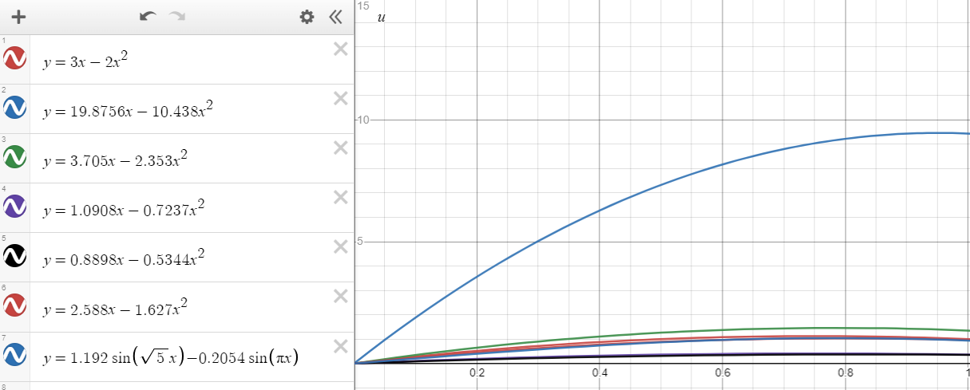

Fig5. The various weighted residual methods against the exact solution

The Respected colour codings are:

1)RED: POINT COLLOCATION (x=0.5,1)

2)BLUE: POINT COLLOCATION (x=0.25,1)

3)GREEN: SUBDOMAIN COLLOCATION (0<x<1)

4)PURPLE: CONTNUOUS LEAST SQUARES (α=1)

5)BLACK: POINT LEAST SQUARES (α=1 and x=0.25,0.75,1)

6)RED: POINT LEAST SQUARES (α=1 and x=0.5,1)

7)ORANGE: GALERKIN’S APPROACH

8)DARK BLUE: EXACT SOLUTION (ANALYTICAL)

DESMOS PLOT FOR VARIATION OF U’(SLOPE) WITH X:

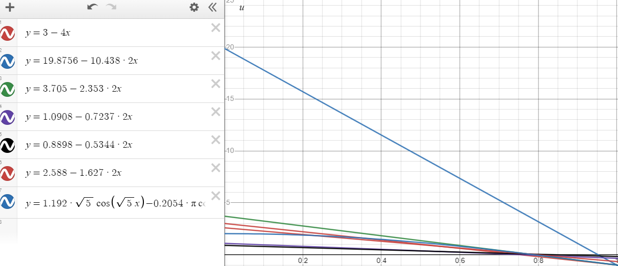

Fig6. The various weighted residual methods against the exact solution(slope)

The Respected colour codings are:

1)RED: POINT COLLOCATION (x=0.5,1)

2)BLUE: POINT COLLOCATION (x=0.25,1)

3)GREEN: SUBDOMAIN COLLOCATION (0<x<1)

4)PURPLE: CONTNUOUS LEAST SQUARES (α=1)

5)BLACK: POINT LEAST SQUARES (α=1 and x=0.25,0.75,1)

6)RED: POINT LEAST SQUARES (α=1 and x=0.5,1)

7)ORANGE: GALERKIN’S APPROACH

8)DARK BLUE: EXACT SOLUTION (ANALYTICAL)

We observe that the Galerkin’s Approach gives the best approximation of the actual variation of the field variable followed by the point collocation method with x=0.5. The point collocation with x=0.25 gives the worst approximation and thus we can conclude that the point collocation method is very much dependant on the choice of the points on the body and leads to either very close approximation or very wide varying approximation. Also, the least squares collocation gives a stiffer solution as compared to the exact solution.

**b)** Graphical Comparison of the various weighted residual methods (Cubic polynomial approximation of the field variable u with the exact solution:

DESMOS PLOT FOR VARIATION OF U WITH X:

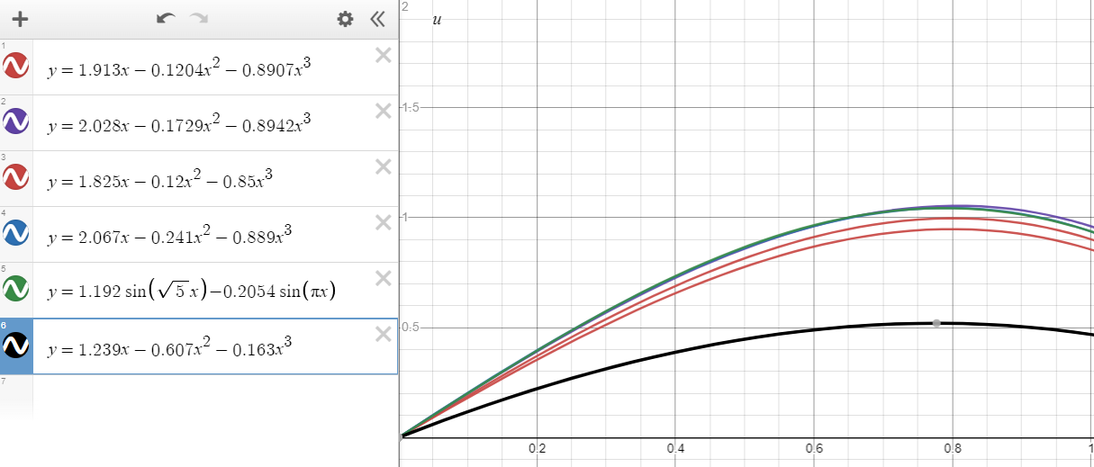

Fig7. The various weighted residual methods against the exact solution

The Respected colour codings are:

1)RED: POINT COLLOCATION (x=0.25,0.75,1)

2)PURPLE: SUBDOMAIN COLLOCATION (0<x<0.5, 0.5<x<1)

3)BROWN: POINT LEAST SQUARES (α=1, x=0.25,0.5,0.75)

4)BLUE: GALERKIN' APPROACH

5)BLACK: CONTINUOUS LEAST SQUARES(α=1)

6)GREEN: EXACT SOLUTION

P.T.O

Graphical Comparison of the various weighted residual methods (Cubic polynomial approximation of the field variable u with the exact solution:

DESMOS PLOT FOR VARIATION OF U’(SLOPE) WITH X:

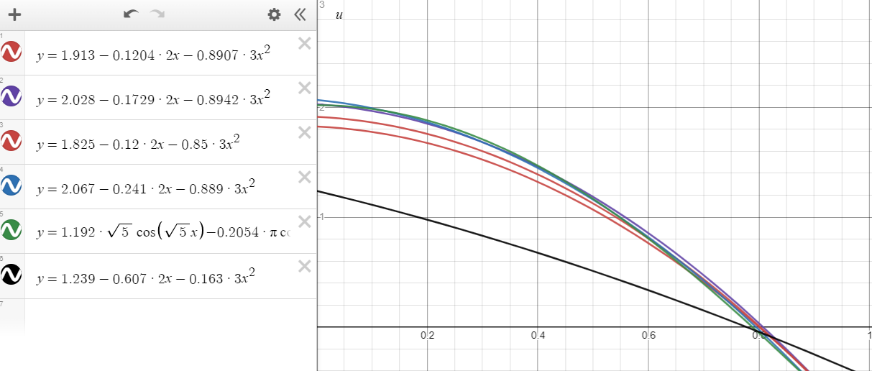

Fig8. The various weighted residual methods against the exact solution

The Respected colour codings are:

1)RED: POINT COLLOCATION (x=0.25,0.75,1)

2)PURPLE: SUBDOMAIN COLLOCATION (0<x<0.5, 0.5<x<1)

3)BROWN: POINT LEAST SQUARES (α=1, x=0.25,0.5,0.75)

4)BLUE: GALERKIN' APPROACH

5)BLACK: CONTINUOUS LEAST SQUARES(α=1)

6)GREEN: EXACT SOLUTION

Here we again see that the Galerkin’s method gives the best approximation for the cubic polynomial representation of the field variable. Here the marking difference from the quadratic representation is that the continuous least squares method gives the worst approximation

[**Note**: In questions 8,9 and 10 there are some parts where the help of MATLAB was taken for quick computation purposes (for example using **inv()** for matrix inversion etc). For those cases separate programs are not written. Those were performed directly in the command window using necessary commands and the results were used in the hand written solution]

**Q11)a)** PENALTY FUNCTION METHOD (11 done entirely on MATLAB)

MATLAB OUTPUT:

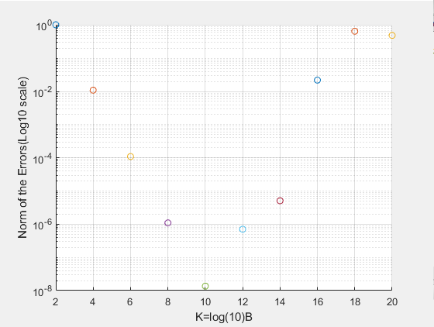

Fig9. Log(10) of the error norm vs the various powers of B

We observe that the minimum error occurs for k=10 i.e. for B=10^10, we get the nodal displacements computed to be the closest to the given actual solution. Pertaining to this result, we extract the nodal displacements computed corresponding to this minimum error case and then use it to compute the nodal forces inc. the reactions due to the constraints and compare with the given exact result. The computed forces are given on the next page due to space shortage.

It is also observed that as the value of k becomes very large, the modified stiffness matrix becomes rank deficient as all the terms in the matrix become very negligible as compared

P.T.O

MATLAB OUTPUT:

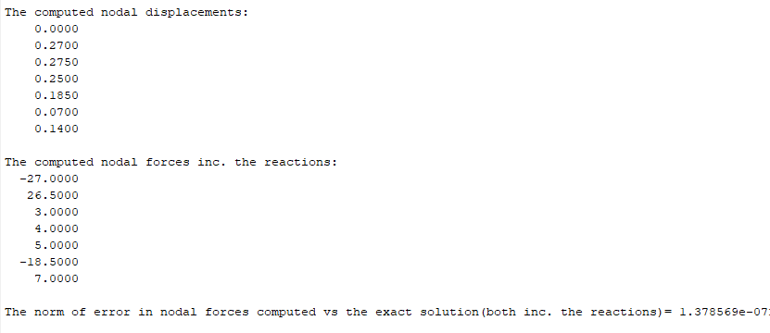

Fig10. Computed nodal displacements and forces (inc. constraints)

It is seen that the computed forces including the constraints and the nodal displacements are almost exactly same as the given in the question.

**b)** LAGRANGE MULTIPLIER METHOD:

MATLAB OUTPUT 1:

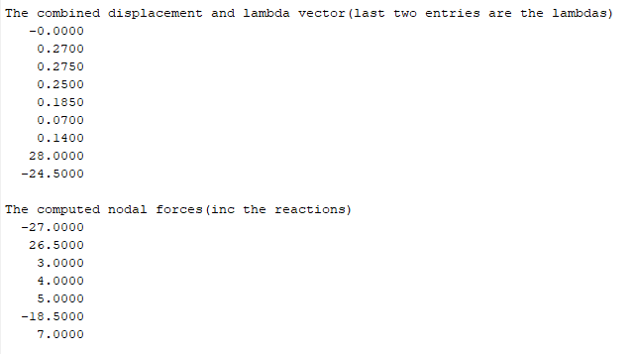

Fig11. Computed nodal displacements and forces (inc. constraints)

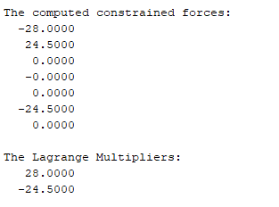MATLAB OUTPUT 2:

Fig 12: The computed constraint forces(separately) and the lagrange multipliers.

Thus we see again that the computed results are exactly same as our analytical results and the lagrange multipliers are actually the Negative of the Constraint forces coming on to the system.

.