**[Note: All hand written parts of the solutions (SFDs & BMDs) are present after the MATLAB outputs.]**

**Prob 1) Done in hand completely.**

**Prob 2) 3-D Truss MATLAB output:**

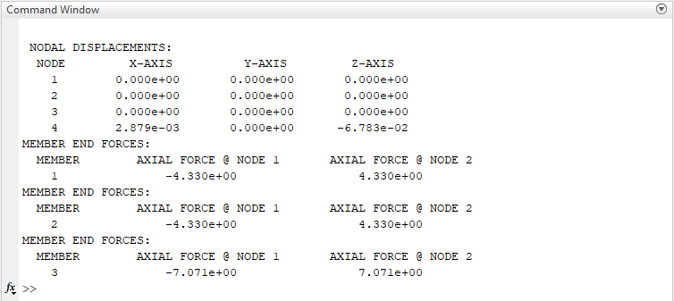

Fig.1) Nodal displacements (in m) and member forces (in N)

**Prob 3) Bar of varying thickness MATLAB output:**

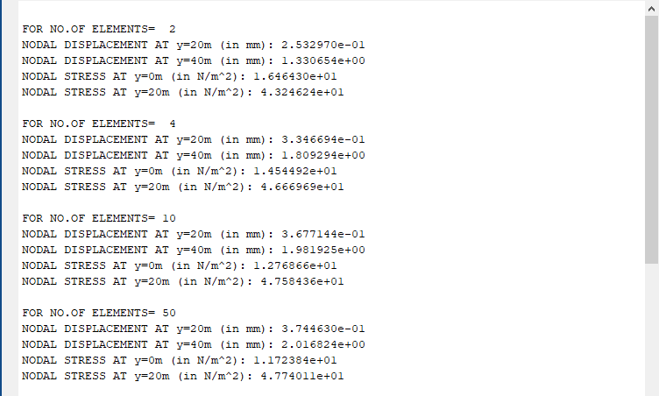

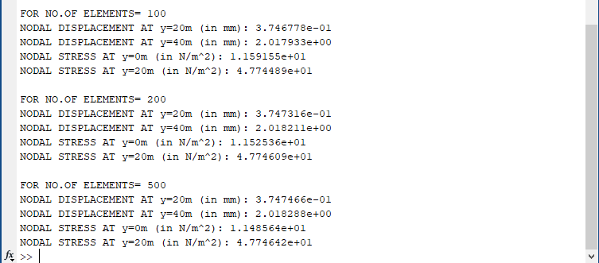

Fig. 2) Nodal displacements and Stresses at the respective nodes for different no. of element

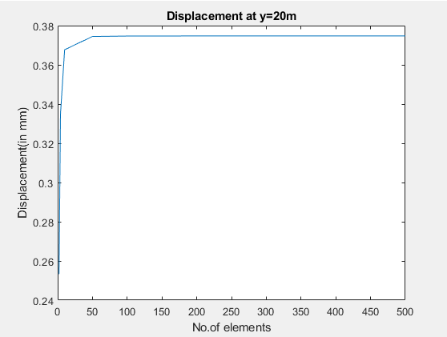

Fig 3) Variation of nodal displacement at y=20 m with increasing no of elements. (True value = 0.375 mm)

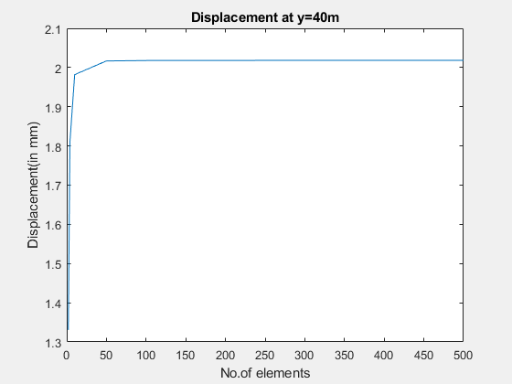

Fig 4) Variation of nodal displacement at y=40 m with increasing no of elements. (True value = 2.018 mm)

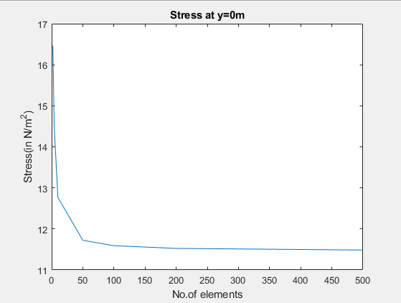

Fig 5) Variation of stress at y=0 m with increasing no of elements. (True value = 11.485 N/m^2)

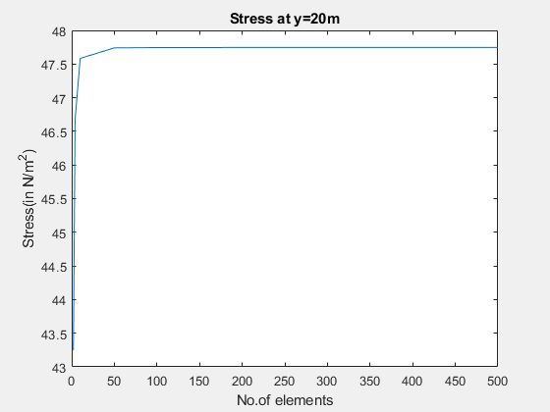

Fig 6) Variation of stress at y=20 m with increasing no of elements. (True value = 47.746 N/m^2)

**Prob 4a) 2-D truss MATLAB output:**

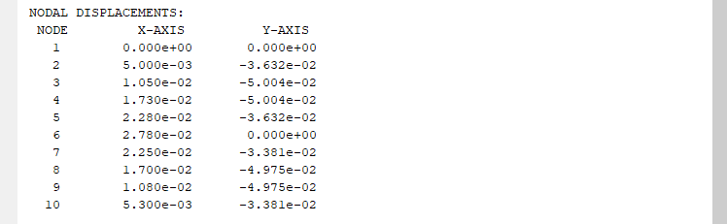

Fig 7) Nodal displacements (in m)

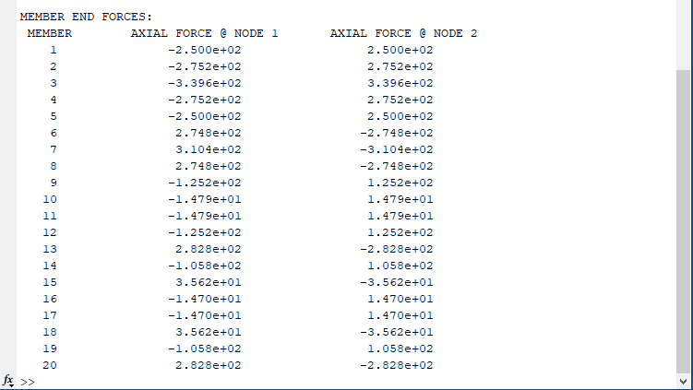

Fig 8) Member Forces along the axis of the members (in N) (-ve in the node 1 indicates Tension and +ve is Compression)

**Prob 4(b): 2-D Truss Unknown Elastic Moduli of the members MATLAB output:**

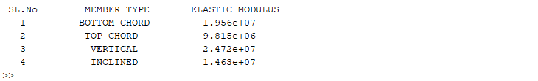

Fig 9) Unknown Elastic Moduli of the different category of members (in N/m^2)

**Prob 5(a): Overhanging Beam MATLAB output:**

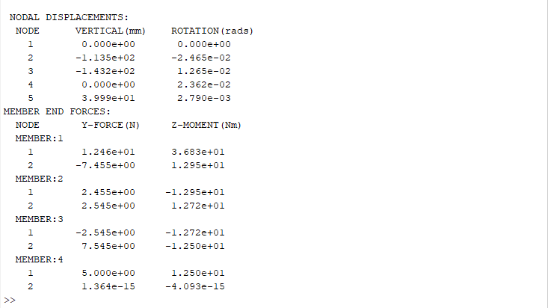

Fig 10) Nodal displacements and member end forces in appropriate units

**Prob 5(b): Unknown Stiffnesses of the Springs attached to the beam MATLAB output:**

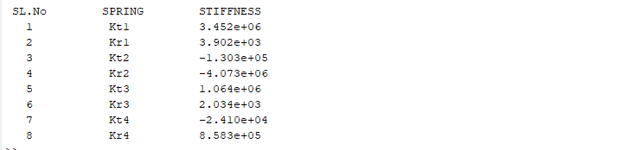

Fig 11) Unknown Stiffnesses of the Springs (translationals have unit N/m and rotationals have unit N/rads)

*We see that Kt2, Kr2 and Kt4 are coming to be negative, which physically has no meaning because it implieswith increase in deflection, it spring will push the node further rather than pulling it back which cannot happen in reality. So those springs are not required.

**Prob 6(a): 2-D Frame with Internal Hinge MATLAB output:**

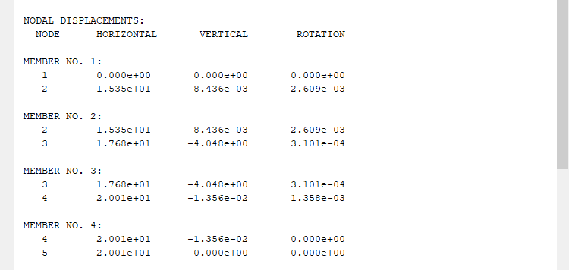

Fig 12) Nodal Displacements and rotations (in mm and rads resp.)

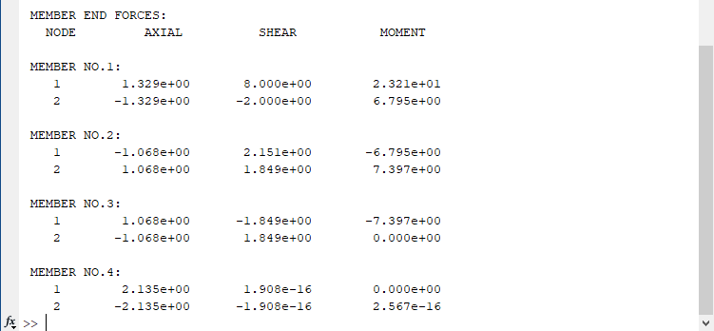

Fig 13) Member end Forces and Moments (in KN and KNm resp.)

**Prob 6(b): 2-D Frame with Internal Hinge and Inclined Support MATLAB output:**

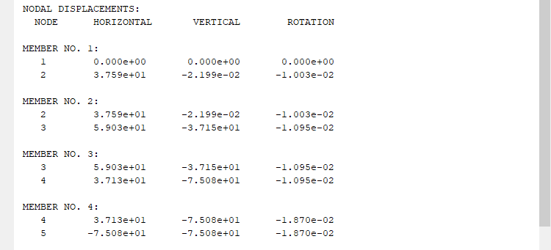

Fig 14) Nodal Displacements and rotations (in mm and rads resp.)

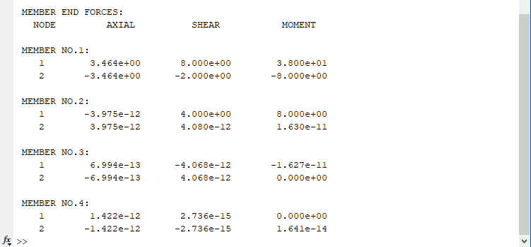

Fig 15) Member end Forces and Moments (in KN and KNm resp.)

**Prob 7) 2-D Truss with Non-Linear Spring MATLAB output:**

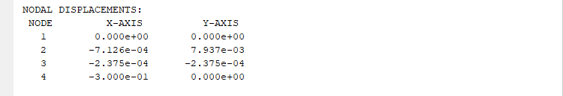

Fig 16) Nodal displacements for the 1st guess value considering constant component of the spring stiffness (in m)

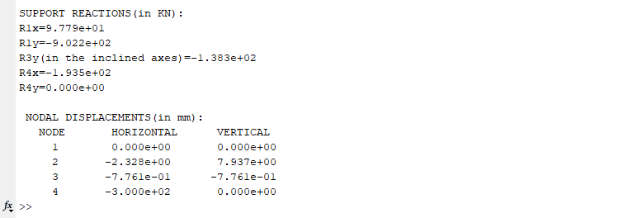

Fig 17) Final Nodal displacements (in mm) and Support Reactions (in KN)