1. Total Sales
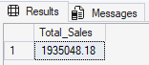
2.Total Profit
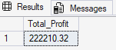
3.Total Orders
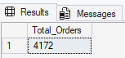
4.Average Order Sales
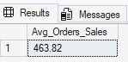
5.Total Quantity
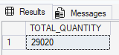
6.Monthly Sales Trend
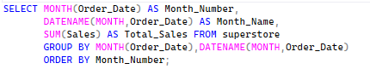
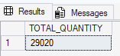
7.Category-Wise Total Sales
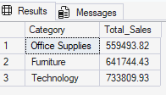
8.Region-Wise Total Sales
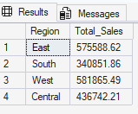
9.Top 10 Product_Name-Wise Sales
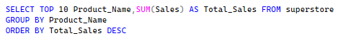
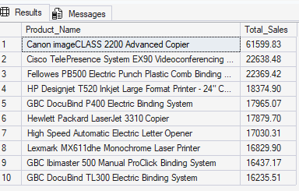
10.Sub-Category wise Total Profit
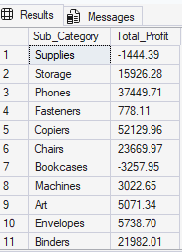
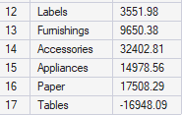
11.Segment-Wise Total Sales
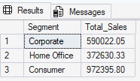
12.Category-Wise Profit_Margin
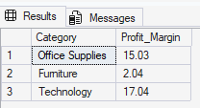
13.Top 10 Customer-Wise Total Sales
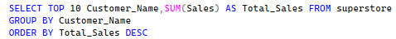
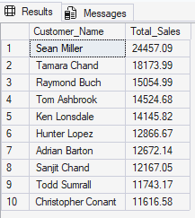
14.Top 10 Customer
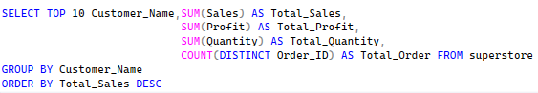
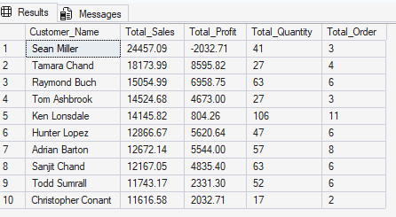
15.Discount Impact on Profit
