Nama : Budi Imam Prasetyo

Kelas : XII RPL 1  
Sekolah : SMKN 11 Bandung

No Peserta : 2400941

Link Tugas : [budi-imam-prasetyo/My-Profile-App](https://github.com/budi-imam-prasetyo/My-Profile-App)

Link Deploy : https://budi-imam-prasetyo.github.io/portofolio

Home Page  
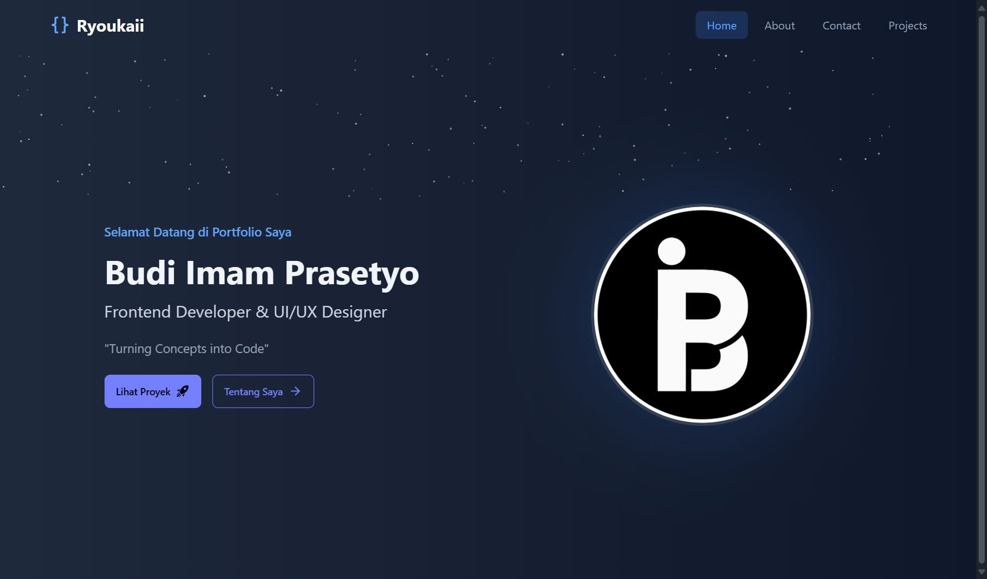

About Page

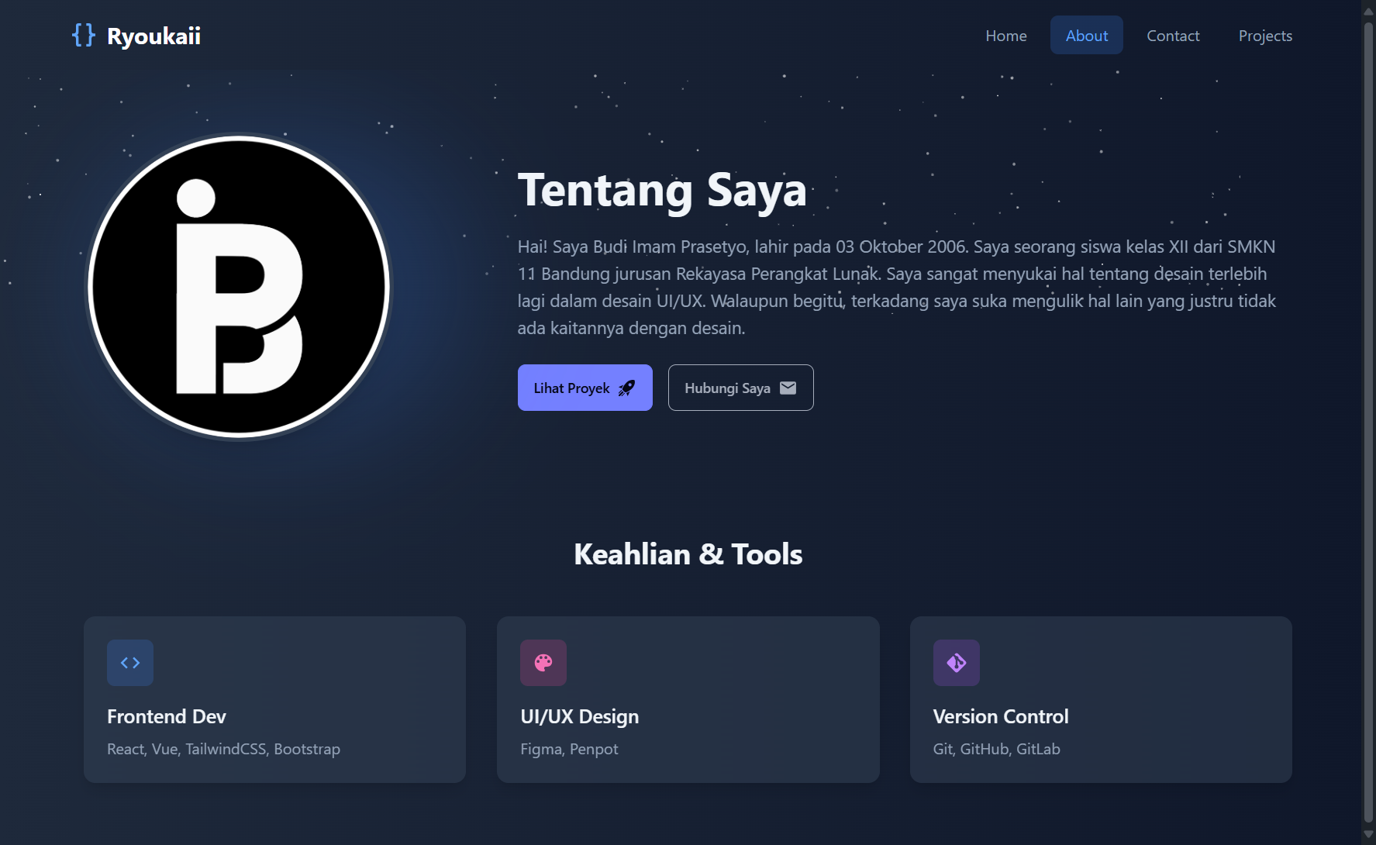

Contact Page

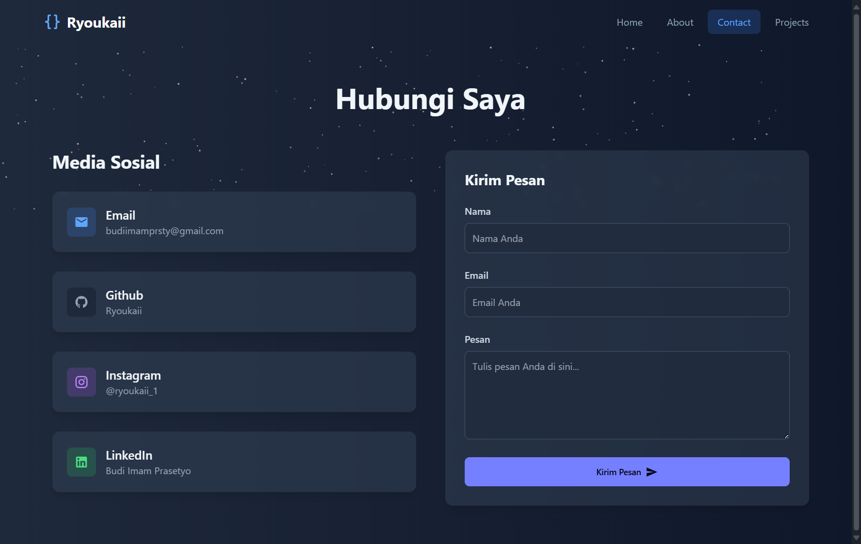

Projects Page

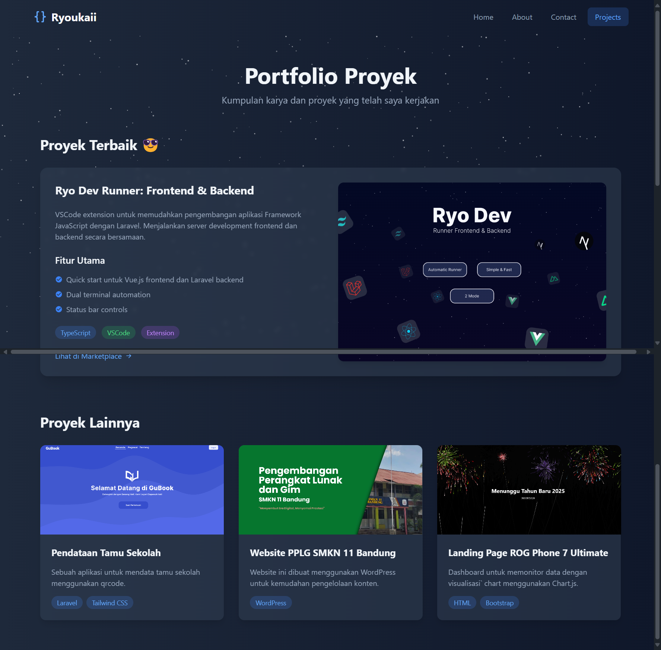

Modal Projects

