1. **Activemq:**

(<http://activemq.apache.org/getting-started.html>)

***Activemq is a message broker and it is a open source messaging server written in java(like emailing server)*** so we need JRE to run it. We keep it always running similar to apache server (point 2) j).we need to put its Binary files in server(but not in deep folders).it provides admin panel with password protection to view and manage activities. It supports cross language client’s / protocols(STOMP for PHP).

it is asynchronous.

It reduces database overheads to make message accessing faster and reduce latency it is compatible for bulk messaging environment for example thousands of messages per second, databases tend to fall over. With RDBMS, when you process a row of data, you typically update a flag indicating that the row has been processed so that the processing is not repeated.

However, with Message Queue, you only have to acknowledge a message and the next consumer will process the next one.

The difference is the UPDATE statement in a RDBMS is a really slow operation compared to the acknowledge in activmeq.

It follows FIFO to read messages.

Active MQ has great scheduler support (via GUI) that means you can schedule your message to be delivered at a particular time.

There are also other messaging queues IBMMQ, RabbitMQ.

Activemq real world use cases (remanded link):

http://stackoverflow.com/questions/1035949/real-world-use-of-jms-message-queues

For more study:

<http://stackoverflow.com/questions/2868800/what-is-an-mq-and-why-do-i-want-to-use-it>

<http://stackoverflow.com/questions/12805377/what-is-activemq-used-for>

1. **installation activemq**

(<http://activemq.apache.org/getting-started.html#GettingStarted-Pre-InstallationRequirements>)

1. every thing should be with in 64 bit with this installation (ex:XAMPP,JRE, php_stomp.dll),copy past files in server and inside bin/win64 dir run command activemq to run activemq server, follow the instruction.
2. download activemq:

<http://activemq.apache.org/activemq-590-release.html>

1. enable open_ssl in php.ini
2. JRE required
3. Set environment variable(JAVA_HOME with java dir path):

<http://stackoverflow.com/questions/2619584/how-to-set-java-home-on-windows-7>

<http://www.robertsindall.co.uk/blog/setting-java-home-variable-in-windows/>

1. Make shore following is inside <transportConnectors></transportConnectors>

In conf/activemq.xml yet, to enable STOMP, it is default:

<transportConnector name="stomp" uri="stomp://0.0.0.0:61613?maximumConnections=1000&amp;wireFormat.maxFrameSize=104857600"/>

1. Do following with activemq downloaded folder(amq) ,trigger command activemq inside amq dir to run server as bellow:

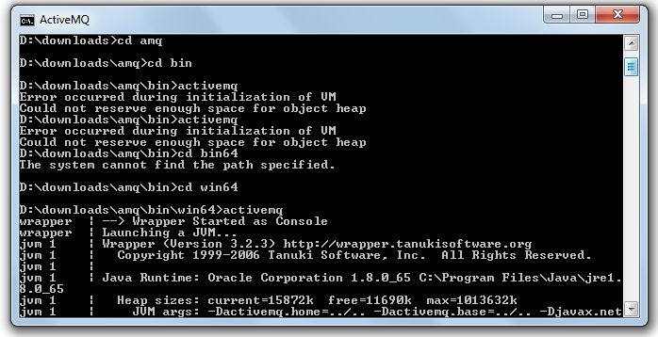

1. Test installation by using provided url(default) at time of running server: http://localhost:8161/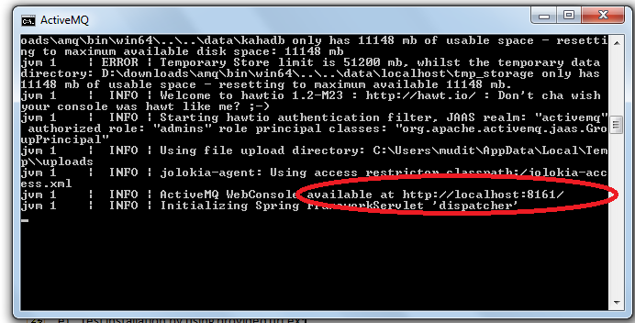
2. Default username and password is admin/admin we may reset it from php.ini.
3. <http://localhost:8161/> Output: is similar to admin panel, it,s working, so cool

