**Centralized Knowledgebase and Online Helpdesk**

Centralized Knowledgebase and Online Helpdesk is a web application which will help students ask questions regarding matters which concerns the Office of Student Affairs without going directly to the office. As of today, we have observed that news are spread to students by word-of-mouth or on posters on bulletins. Since computerization of the OSA System has started, creating an online helpdesk has a great potential to make a faster dissemination of reliable information to UPLB constituents. The proposed system will help OSA to manage all the concerns of the students. Also, using an FAQ, common misconceptions of students can be corrected.

**Objectives**

* To enable students to raise their questions using the OSA site, email and cellphone
* To provide OSA staff with a friendly user interface that enables them to answer the questions of the students online.
* To allow the OSA Staff to answer the questions of students sent from different medium

**System Features:**

* Ask a Question
* Allows users to raise their question to be answered by the OSA Staff (or any related departments).
* Search Question
* Displays questions related to the query supplied by the user
* Shows other tags related to query
* View FAQ
* Displays questions and answers that are frequently asked by the users
* [Can be displayed by category ex. department]
* Answer Question
* Allows the staff to answer a submitted question
* Delete Question
* Allows the staff to delete a submitted question
* View Question
* Allows the staff to go through questions submitted
* [Has an option to answer question]
* Add Question to FAQ
* Allows the staff to add a question to the frequently asked questions list
* Delete Question from FAQ
* Allows the staff to remove a question from the frequently asked questions list
* Edit a Question from FAQ
* Allows the staff to edit a question (ex. case wherein the staff would want to add the question in the FAQ)
* Update Answer
* Allows the staff to edit an answer (ex. change in system)

Entity Relationship Diagram

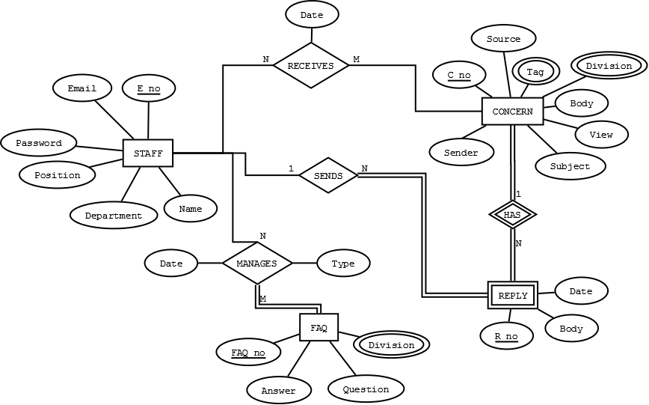

Database Tables

STAFF

|  |  |  |  |  |  |
| --- | --- | --- | --- | --- | --- |
| E_no | Email | Password | Position | Name | D_no |

CONCERN

|  |  |  |  |  |  |
| --- | --- | --- | --- | --- | --- |
| C_no | Subject | Body | Source | View | Sender |

FAQ

|  |  |  |
| --- | --- | --- |
| FAQ_no | Question | Answer |

REPLY

|  |  |  |  |  |
| --- | --- | --- | --- | --- |
| E_no | C_no | FAQ_no | Body | Date_sent |

RECEIVE

|  |  |  |
| --- | --- | --- |
| E_no | C­­_no | Date_received |

MANAGE_FAQ

|  |  |  |  |
| --- | --- | --- | --- |
| E_no | C_no | Date_updated | Type |

DIVISION_C

|  |  |
| --- | --- |
| C_no | D_no |

TAG_C

|  |  |
| --- | --- |
| C_no | T_no |

DIVISION_FAQ

|  |  |
| --- | --- |
| FAQ_no | D_no |

TAG_FAQ

|  |  |
| --- | --- |
| FAQ_no | T_no |

TAG

|  |  |
| --- | --- |
| T_no | Tag |

DIVISION

|  |  |
| --- | --- |
| D_no | Division |